

**Training Management System**

User Manual

|  |  |
| --- | --- |
| **Submitted By** | GAMP Lifetech Pvt. Ltd. |
| **Version No.** | **V1** |

For clarifications, please contact

**Samar Doshi**

Head Product Development

**GAMP Lifetech Pvt. Ltd.**

Copyright © GAMP Lifetech Pvt. Ltd. All rights reserved.

No part of this document may be reproduced, stored in a retrieval system or transmitted in any form, or by any means, electronic, mechanical, photocopying, recording or otherwise without the prior permission in writing from GAMP Lifetech Pvt. Ltd..

**Table of Contents**

Table of Contents

Purpose 5

Scope 5

Definitions & Abbreviations 6

System Overview 6

Roles and Responsibilities 12

Login 13

Dashboard 16

System Admin 30

User Master 30

1. Adding User 31

2. Editing User 34

3. Deactivating User 36

Department Master 37

2. Editing Department 39

3. Deactivating Department 41

Designation Master 42

1. Adding a New Designation 42

**2.** Editing an Existing Designation 44

3. Deactivating a Designation 46

Role Master 47

1. Accessing Role Master 47

2. Viewing Roles 47

Plant Master 48

1. Adding Plant 48

**2.** Editing an Existing Plant 50

3. Deactivating a Plant 52

User personal Details 53

1. Edit User personal details 53

Password Reset 55

Induction 58

1.Induction Assign 58

2.Job Responsibility 61

3.Induction Sign 66

Document Management 70

Document Registration 70

1) Add a New Document 71

2) View a Document 73

3) Edit a Document 73

4) Deactivate a Document 75

Document Approval 76

Questionnaire Preparation 79

Viewing Existing Questionnaire 82

Questionnaire Approval 84

OJT Master 87

5. View Existing OJT Trainings 90

7. Editing Existing OJT 92

6.OJT Approval 94

Course Code 97

Course Code Registration 97

Editing Course code 100

Deactivating Course codes 101

Course Code Approval 103

Course Code Assignment 105

Editing Course Code Assignment 107

Viewing Assignment Details 108

Deactivating Course Code Assignment 109

Training Module 110

1.Trainer Registration 110

Adding New Trainer Registration 112

Editing Trainer Registration 115

Deactivating Trainer Registration 116

2.Trainer Approval 116

3.Yearly Planning 119

Adding New Training Events 120

Editing Training Events 123

Deleting Training Events 123

4.Yearly Planning Approval 124

5.On-Job Training 126

6.Self-Training 136

7.Scheduled Trainings 142

8.UnScheduled Trainings 152

Configurations 163

Permission Assignment 163

Notification Configuration 175

Password Configuration 176

Module Configuration 177

Reports 181

Reports Dashboard 181

Audit Report 181

User Report 184

User Personal Report 186

Department Master Report 187

Designation Master Report 189

Role Master 191

Plant Master Report 193

Schedule Report 195

Document Report 202

On-job Training Report 203

User Activity Report 207

Trainee Report 208

Print Approval 212

Authorization Certificate 223

Toast Notifications 229

Success Messages 229

Error Messages 233

Warning Messages 241

# Purpose

The purpose of this manual is to provide a comprehensive reference for the effective use, administration, and maintenance of the Training Management System (TMS).

It is intended to ensure that all users—regardless of role—can operate the system in a manner that is consistent, efficient, and compliant with applicable pharmaceutical industry regulations, including USFDA 21 CFR Part 11, EU Annex 11, and other Good Manufacturing Practice (GMP) guidelines.

The manual serves the following objectives:

* To describe the features, functions, and workflows of the TMS.
* To define role-based responsibilities for administrators, trainers, trainees and the coordinators.
* To guide users through step-by-step processes for creating, assigning, completing, and tracking trainings.
* To ensure that training records are accurately maintained, securely stored, and readily retrievable for regulatory inspections or internal audits.
* To promote standardized use of the TMS across departments, thereby reducing errors and improving compliance.

This manual should be used in conjunction with relevant Standard Operating Procedures (SOPs), IT policies, and department-specific training instructions.

# Scope

This manual applies to all personnel who have authorized access to the TMS, including but not limited to:

* System Administrators responsible for configuration, user management, and reporting.
* Trainers/ responsible for creating, uploading, and maintaining training materials.
* Learners/Employees assigned to complete training courses.
* Quality Assurance personnel responsible for monitoring compliance, reviewing audit trails, and ensuring regulatory adherence.

The scope of this manual covers:

* System Access & Security Controls – including login, authentication, and role-based permissions.
* Course Creation & Approval – including uploading materials, setting prerequisites, and approval workflows.
* Training Assignment & Completion – including due date setting, reminders, and escalation.
* Compliance Features – including electronic signature processes, audit trails, and data retention requirements.
* Reporting & Analytics – including generating, exporting, and interpreting compliance reports.
* Troubleshooting & Support – including common issues, resolution steps, and escalation contacts.

**Exclusions**:  
This manual does not cover:

* Detailed IT infrastructure setup or system development procedures (refer to IT SOPs).
* Vendor-supplied technical specifications or source code documentation.
* Non-GxP related learning platforms or informal training processes.

# Definitions & Abbreviations

* **User:** Any person using the application is a User of this application.
* **Plant:** It is a classification created to differentiate between two or more wings of same establishment. Each site will have its own set of users, departments, designation, workflow, group, assets & schedules.
* **Department:** A group of people working on homogenous tasks
* **Designation:** job titles and positions within the organization
* **SOP:** **Standard Operating Procedure**, Documented procedures providing step-by-step instructions for routine operations.
* **TMS: Training Management System,** A comprehensive software system for managing employee training, documentation, and compliance activities
* **OJT: On-the-Job Training, Practical training provided to employees at their workplace to develop job-specific skills**
* **Course Code:** Unique identifier assigned to training courses for tracking and management
* **Electronic Signature (e-Sign) :** Digital authentication method used to approve and validate actions within the system

# System Overview

1. Login

Users access the system by entering their **unique username** and **password** assigned by the System Administrator. After successful login, users are directed to their **role-based dashboard**, where available modules and permissions are displayed according to their assigned role.It also includes features such as **Password reset, forgot password, Account lockout** and **Session timeout**.

1. Dashboard

The **Dashboard** provides real-time insights into training progress, performance metrics, and participation across various training formats.

It enhances visibility into the training ecosystem, enabling employees to track their own progress while giving managers the tools to evaluate and support team development.

1. My Dashboard

* It provides a quick summary of a trainee's activities over a selected date range.
* It shows total training time, exam results, upcoming events, and progress across different training types along with filters.

1. Team Dashboard

* It provides supervisors or managers with an overview of their team’s training progress within a selected date range.
* It displays metrics such as total training time, exam results, and training statuses across different training types.
* A team table at the bottom lists all team members along with their employee ID, department, designation, and system role. Filters also allow users to view data for individual team members or the entire team.

1. System Admin
2. User Master

Allows administrators to create, edit, delete, and search user accounts. This ensures that only authorized individuals have access to the system and that user information is accurate and up to date.

1. Department Master

Facilitates the creation, modification, deletion, and search of departments within the organization. This helps maintain a structured hierarchy and ensures that each user is associated with the correct department.

1. Designation Master

Enables the management of designations or job titles. Administrators can add, update, remove, and locate designation records, ensuring alignment with the organization’s HR structure.

1. Plant Master

Manages plant or site-level details. Administrators can maintain a record of all operational plants, enabling accurate assignment of users and activities to specific locations.

1. Role Master

Controls the creation and management of roles within the system. Roles determine the level of access and permissions available to different categories of users, supporting secure and role-based access control.

1. User Personal Details

Allows HR or authorized personnel to edit personal details of users, such as contact information, address, and emergency contact details, ensuring that records are always accurate and complete.

1. Password Reset

Provides a secure way for administrators to reset user passwords when required after the number of wrong password attempts have reached the max limit.

1. Induction
2. Induction Assign  
   This module is used to assign induction programs to newly joined employees. Authorized personnel can select users, set a due date, assign inductions, and update the status based on progress — *Assigned*, *In Progress*, and *Completed*.
3. Job Responsibility :  
   The Job Responsibility module is for formally defining and managing employee roles following the completion of their induction. It provides a centralized platform where administrators can assign official job titles, create detailed role descriptions, and outline specific responsibilities for each staff member.
4. Induction Sign  
   It presents the employee with a definitive, read-only summary of their organizational details and the full scope of their assigned job responsibilities. This serves as the formal mechanism for the employee to review and attest to their understanding of their role and duties.
5. Document Management

The **Document Management** module streamlines the creation, review, approval, and tracking of all training-related documents to ensure accuracy, consistency, and compliance

.

1. Document Registration

Allows users to register, edit or deactivate training documents in the system, capturing essential metadata such as document title, version number, author, department, and applicable regulations.

1. Document Approval

Enables a defined approval workflow where designated role approvers can review the registered documents, provide comments and approve/return/reject them for official use in training programs.

1. Questionnaire Preparation

Facilitates the creation, edition or deactivation of training questionnaires linked to specific documents or training modules.

1. Questionnaire Approval

Enables a defined approval workflow where designated role approvers can review the registered questionnaire, provide comments and approve/return/reject them for official use in training programs.

1. OJT Master

Maintains the master list of **On-the-Job Training (OJT)** modules where one can add new OJT, edit or deactivate them

1. OJT Approval

Enables a defined approval workflow where designated role approvers can review the registered **On-the-Job Training (OJT)**, provide comments and approve/return/reject them for official use in training programs.

1. Course Code

The **Course Code** module manages the creation, approval, and assignment of course codes, which are uniquely defined combinations of **OJT (On-the-Job Training)** and related documents. These course codes form the foundation for both **self-training** and **OJT-based training** activities

1. Course Code Registration

Authorized users can create and register new course codes by linking specific training documents and OJT modules.

1. Course Code Approval

Enables a defined approval workflow where designated course code approvers can review the registered course codes, provide comments and approve/return/reject them for official use in training programs.

1. Course Code Assignment

Once a course code is approved, it can be assigned to the relevant training programs along with the **specific users who require that training**. Once assigned, the corresponding training activities are **automatically reflected in the relevant sections of the TMS menu** for each user, ensuring they can easily access and complete their required training.

1. Training
2. Trainer Registration

Allows authorized users to register new trainers in the system by capturing their qualifications, expertise areas, and department associations.

1. Trainer Approval

Implements an approval process for newly registered trainers, ensuring that only qualified and authorized trainers are eligible to conduct training.

1. Yearly Planning

Enables the creation of an annual training plan, mapping out courses, trainers, target trainees, and timelines in alignment with business and compliance needs.

1. Yearly Planning Approval

Routes the yearly training plan for review and approval by management or training coordinators to ensure feasibility and compliance.

1. On-Job Training

Facilitates the scheduling, execution, and tracking of OJT sessions where trainees gain practical skills under supervision.

1. Self-Training

Provides a platform for trainees to complete assigned training by reading approved documents or e-learning content and answering its related questionnaires.

1. Schedule Training

Consists of planned training events that originate from the approved yearly Planning schedule. These sessions are pre-defined in terms of course content, trainer, dates, and participants, ensuring structured delivery.

1. Unscheduled Training

Supports the quick setup of training sessions outside of the planned schedule, often in response to urgent needs, changes, or corrective actions.

1. Configuration

The **Configuration** module allows system administrators to customize and manage key TMS settings, ensuring that the platform operates according to organizational policies, security requirements, and compliance standards.

1. Permission Assignment

Provides tools to assign or revoke role based permissions for accessing specific modules, features, or actions.

1. Module Configuration

Allows administrators to enable, disable, or customize modules and their functionalities based on organizational needs.

1. Password Configuration

Enables the definition of password policies such as complexity, expiry duration, and reuse restrictions to enhance system security.

1. Notification Configuration

Manages system-generated(both inapp and email notifications for training assignments, due dates, approvals, and other important actions, ensuring timely communication to relevant users.

1. Reports
2. Reports Dashboard

A central interface for viewing and generating various training reports. Users can filter data and export reports in multiple formats for analysis or audit purposes.

1. Print Approval

Controls and manages the approval process for printing official training documents, reports, or certificates.

1. Document Training Certificate

Generates official certificates for trainees who have successfully completed document-based self-training or assessments. Certificates include course details, completion date, trainee name, and approval signatures.

1. Authorization Certificate

Issues formal certificates authorizing trainees to perform specific tasks or responsibilities after successful completion of relevant OJT or competency-based training. These certificates serve as compliance records and proof of qualification.

# Roles and Responsibilities

|  |  |
| --- | --- |
| IT System Admin | • Full access to all modules and transactions. • Manage user accounts, roles, and permissions. • Configure system settings and workflows. • Maintain backups, performance, and security. • Ensure data integrity and regulatory compliance. |
| Central Training Coordinator | • Manage all document control activities except document obsolete action. • Maintain and update course codes. • Manage training sessions, including adding/editing trainers. • Create and update yearly training plans except yearly approval. • Generate and review all system reports. |
| Quality Assurance Admin | • Manage all induction-related activities. • Oversee all document management except document obsolete action. • Maintain and update course codes. • Manage training sessions, trainers, and schedules. • Generate and review all reports for compliance tracking. |
| Department Head | • Perform induction tasks related to departmental job responsibilities. • View questionnaires, documents, and OJT records. • View trainer details and yearly training plans. • Assign course codes to staff. • Review departmental reports. |
| Department Training Coordinator | • View induction records for department staff. • Create, update, and manage documents, questionnaires, and OJT. • Register and assign course codes without approval rights. • Manage trainer details in training sessions. • View yearly planning. • Review reports but can’t do print approval. |
| Human Resource(HR) | • Update user personal details in the system. • Assign induction training to staff. • Generate and review reports. |
| Trainee | • View assigned documents and OJT materials. • Access dashboard reports. • Participate in all types of training. |

**Detailed Explanation**

# Login

**Step 1: Access the Login Page**

* Open a web browser and navigate to the **designated system URL** provided by your administrator.
* Example: https://<company-tms-portal>.com
* The login page will display fields for **User ID** and **Password**.

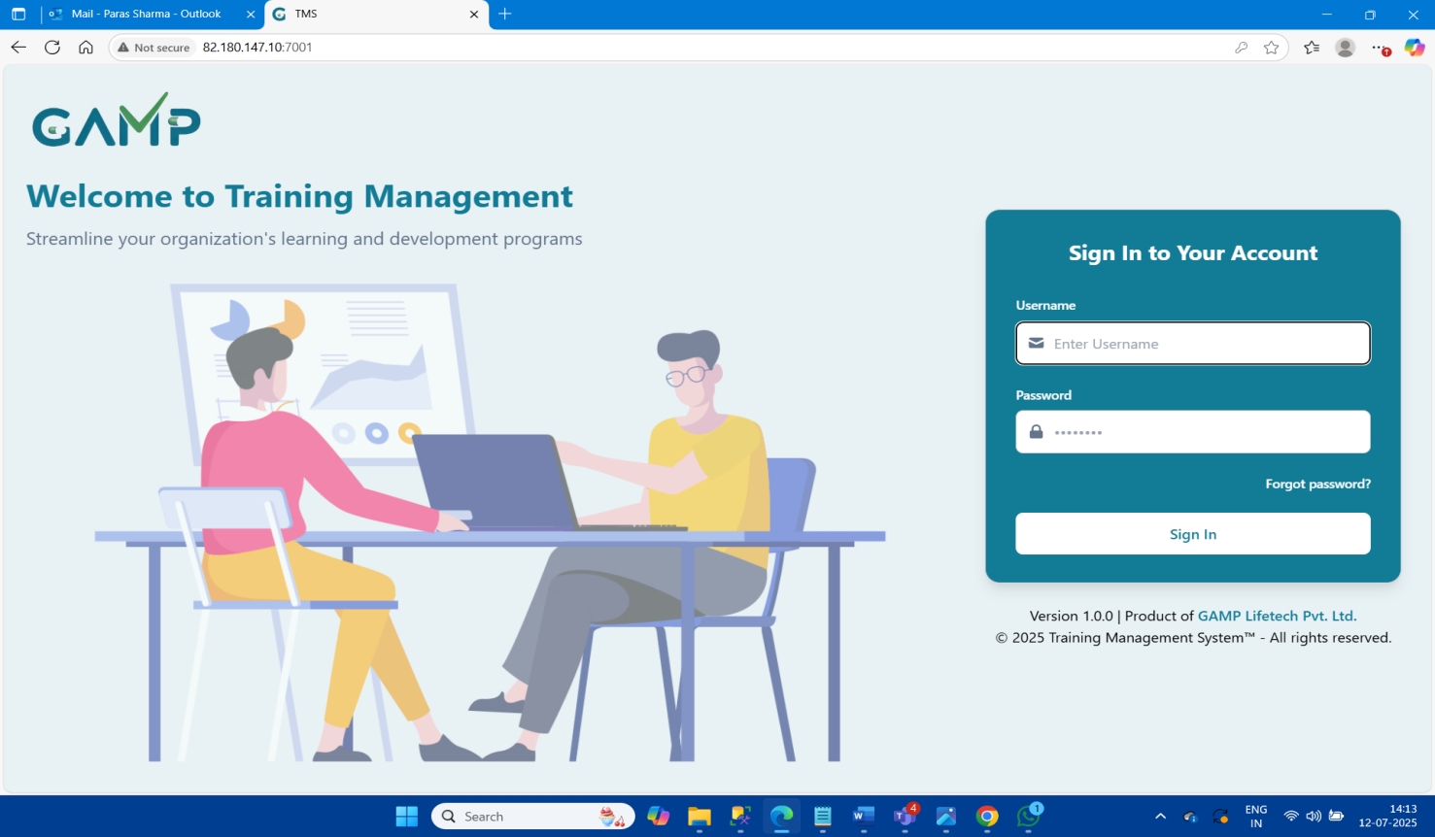

**Step 2: First-Time Login Credentials**

* When your user account is created, the system automatically sends an **email** to your **registered email address** containing your initial login credentials.
* The email will include:
  1. **User ID** (unique to you)
  2. **Temporary Password**
* Use these credentials to log in for the first time.

**Step 3: First-Time Password Reset**

* On your **first login**, the system will prompt you to **change your password** for security purposes.
* The new password must contain uppercase and lowercase letters, at least one digit, one special character (e.g., @, !, #, $, %), and meet the configured length requirement according to the password configuration.
* Enter your **new password** in both the "New Password" and "Confirm Password" fields, then click **Submit.**

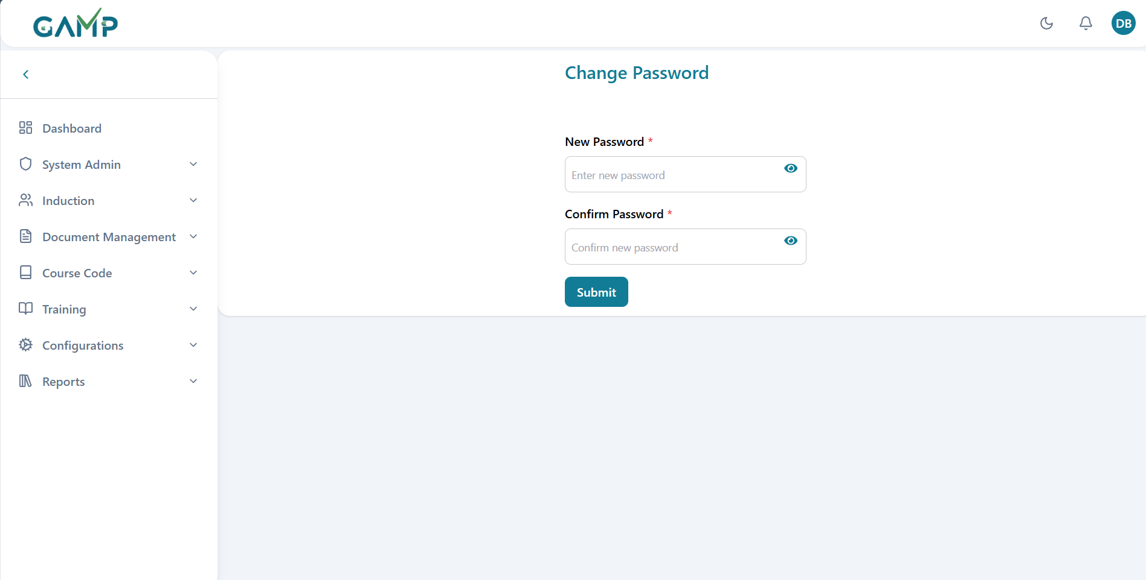

* Then you will have prompted to login again with the username and new password that you have created.

**Step 4: Plant Selection (if applicable)**

* If you are assigned to **multiple plants**, the system will display a **Plant Selection Screen** after login.
* Select the plant in which you want to perform your activities.
* You can switch plants later by logging out, logging in again and then choosing the desired plant. 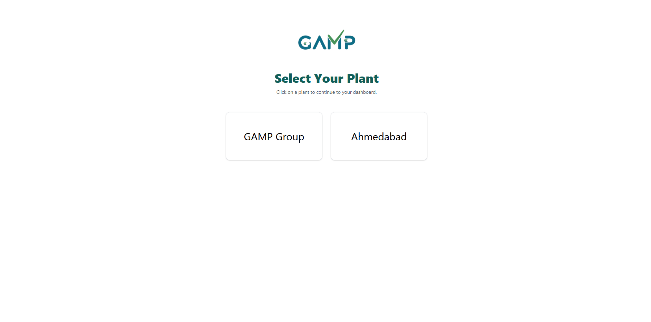

**Step 5: Successful Login**

* After entering valid credentials and selecting the plant (if required), you will be redirected to the **TMS Dashboard**.
* From here, you can access the modules and perform actions as per your assigned **roles and permissions**.

**Additional Notes**

* **Incorrect Password Attempts**: After a defined number of unsuccessful login attempts (e.g., 10), your account will be locked. You will then need to request a password reset from your **reporting manager**.
* **Security Reminder**: Do not share your login credentials with anyone. Any activity performed under your User ID is considered your responsibility.
* **Logout**: Always log out of the system when you have completed your tasks, especially if you are using a shared or public computer.

# Dashboard

The Dashboard module is a core component of the Training Management System (TMS), designed to provide a consolidated view of training performance and compliance status for both individual users and supervisors. It facilitates effective monitoring of training activities in a structured, validated, and regulatory-compliant manner.

For all users, one will be able to see only the my dashboard- where all the metrics related to training records along with date filters.

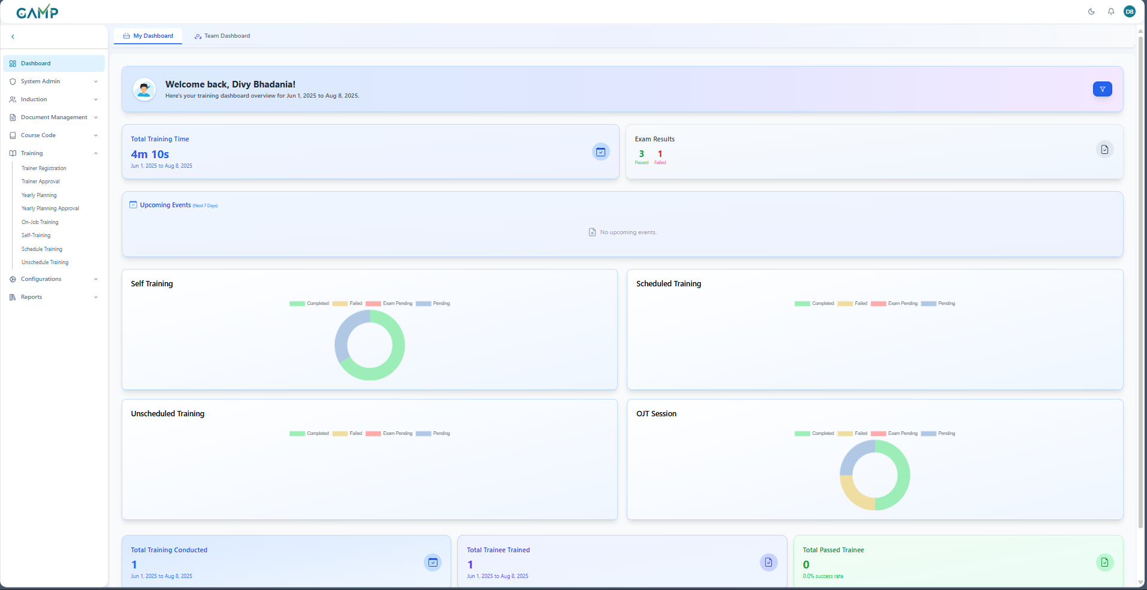

**Key features of dashboard**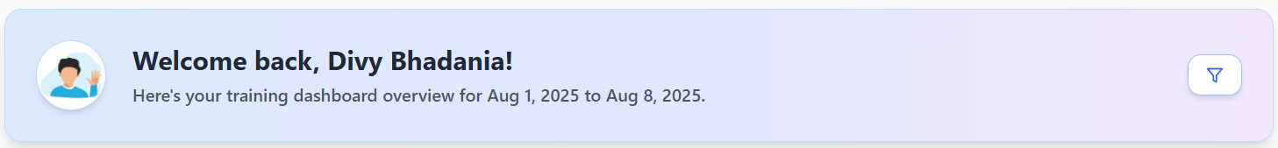

**1. User Welcome Panel:**Displays the trainee’s name and the date range for which the training data is being displayed.

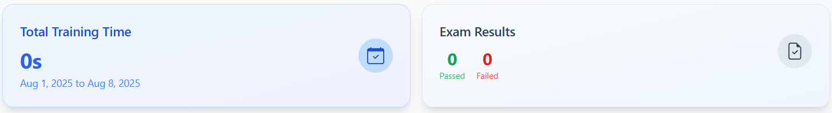

**2. Total Training Time**Displays the cumulative time spent by the user or team on training activities within the selected date range.

**3. Exam Results**

Shows the number of exams passed and failed, providing a snapshot of training effectiveness.



**4. Upcoming Events**:

Lists events or sessions scheduled in the next 7 days. If no events are available, a message is shown accordingly

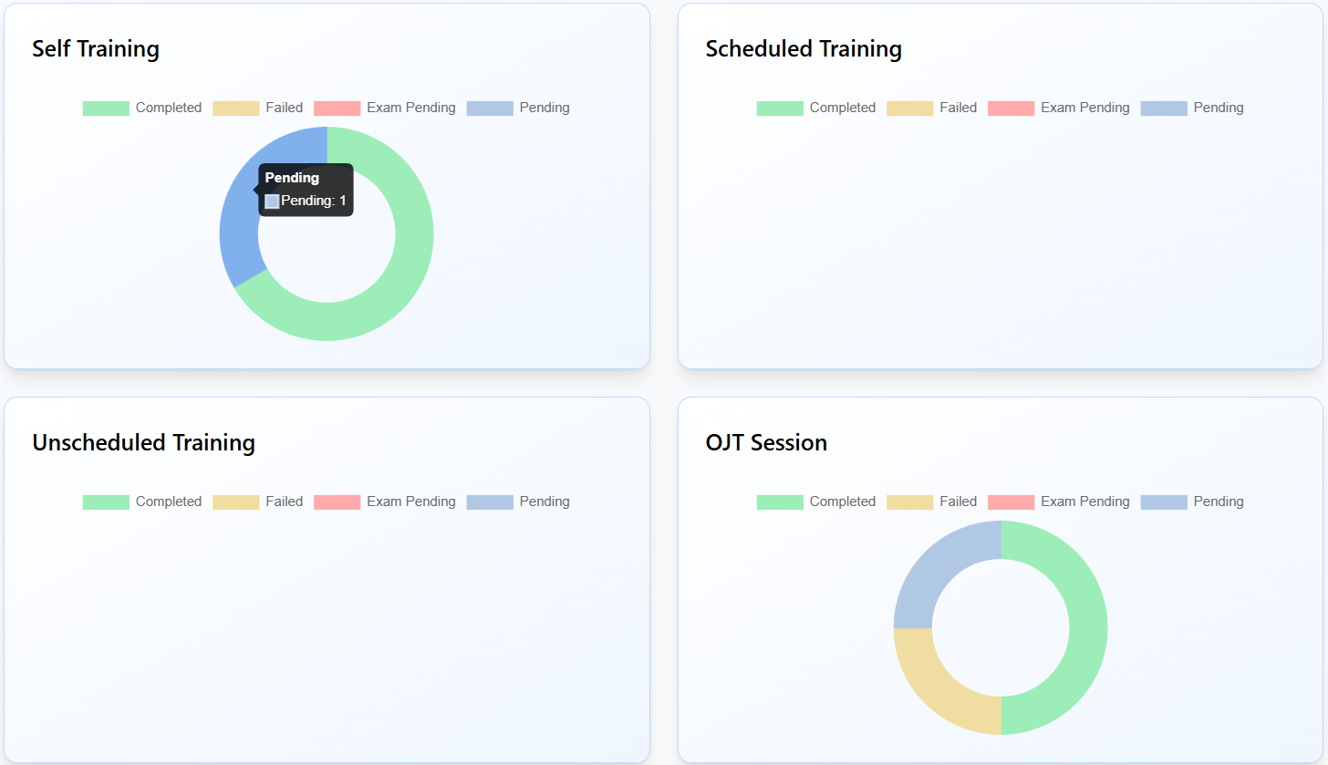

**5. Exam Results**

Shows the number of exams passed and failed, providing a snapshot of training effectiveness.

It displays four key **training categories (Self Training, Scheduled Training, Unscheduled Training and OJT Session**) representing different types of training activities assigned to employees. Each category is tracked and visualized with **color-coded charts**, enabling users and managers to quickly assess progress and compliance. Various statuses along with their colour and functionalities are mentioned below

|  |  |  |
| --- | --- | --- |
| Completed | Green | Passed exam associated with the training |
| Failed | Yellow | Failed exam associated with the training |
| Exam Pending | Red | Training completed, but exam not attempted |
| Pending | Blue | Training assigned, but not yet started |

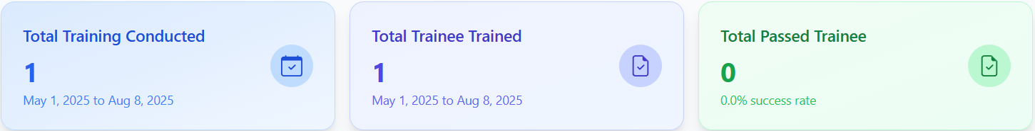

**6. Total Training Conducted**

Represents the total number of training sessions carried out where the user is the trainer in the selected time frame.

**7. Total Trainee Trained**

Indicates the number of unique users who participated in trainings in which the user was the trainer during the selected period.

**8. Total passed Trainee**

Shows the number of trainees who successfully completed and passed their assessment in which the user was the trainer, along with the calculated **success rate** percentage.

**Team Dashboard**

The trainee role users would have access to only my dashboard but the roles except that have additional features for team dashboard tab. Here, in this the dashboard displays training data for the entire team. It is useful for the managers to track team performance.

1. In the tabs switching bar below the navbar, click on the **Team Dashboard** and you will be able to see the team dashboard.
2. Below is the view for the team dashboard

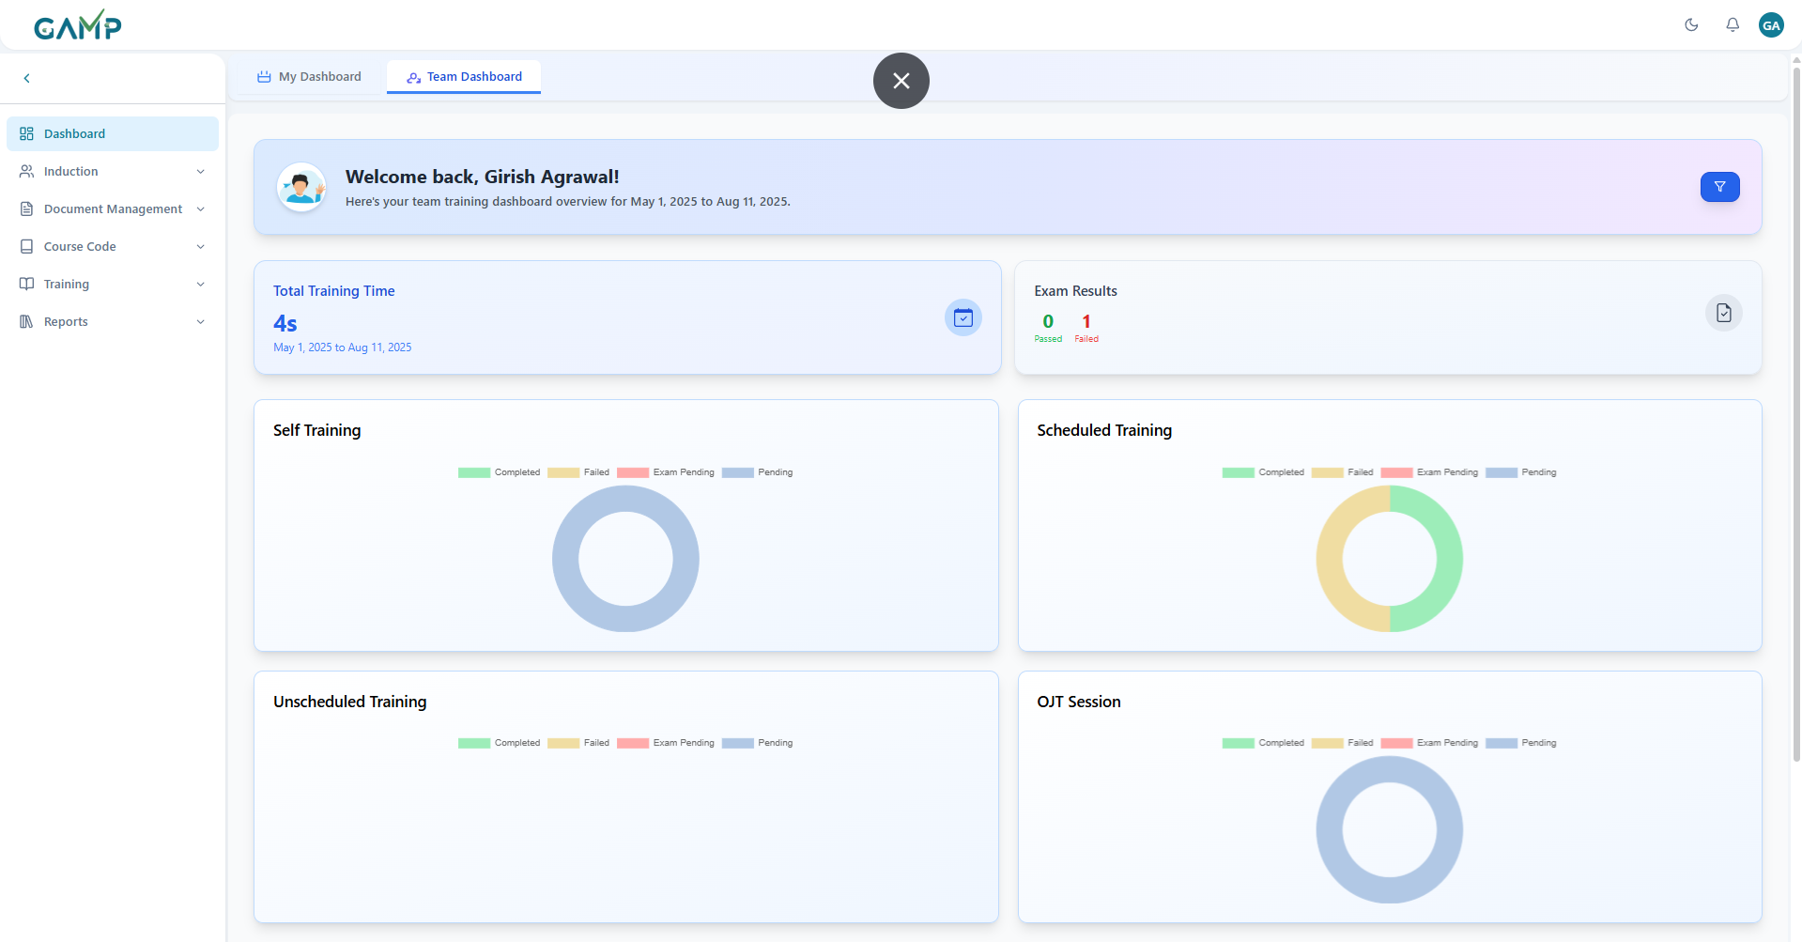

1. My Team

Lists team members along with employee ID, department, designation, and assigned system role, aiding in structured supervision. The location of my team grid is below the different training charts in team dashboard. We can also search in the team members grid for the team members.

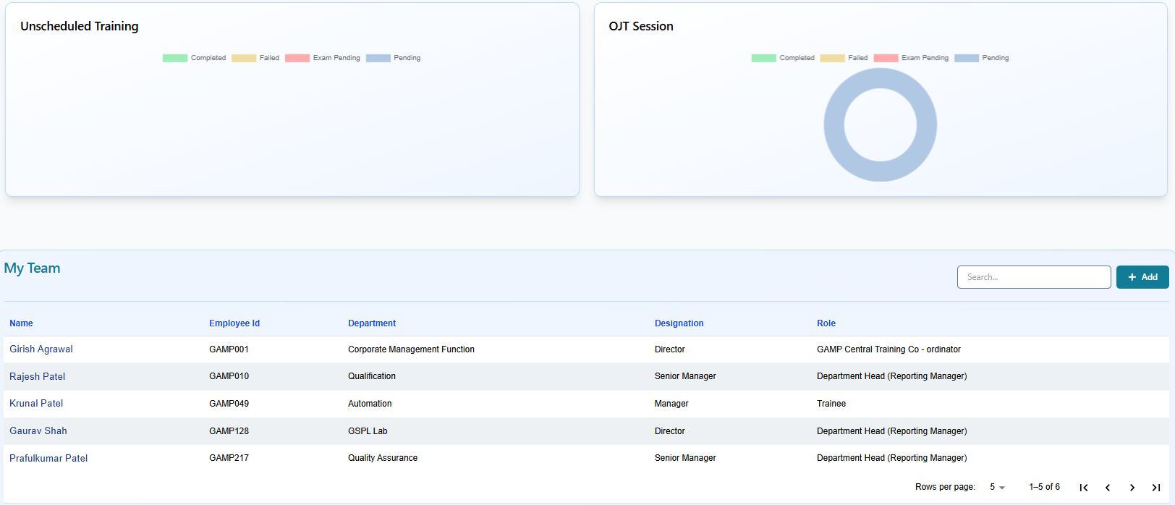

1. **Filter and view options**

When we click on the funnel button in welcome panel, a popup modal will open which has multiple options for filtering- namely according to the date range, team members and department. It allows users to configure their dashboard by applying specific timeframes and viewing preferences.  
It ensures that the displayed analytics are relevant to the required period, team scope, or department view.

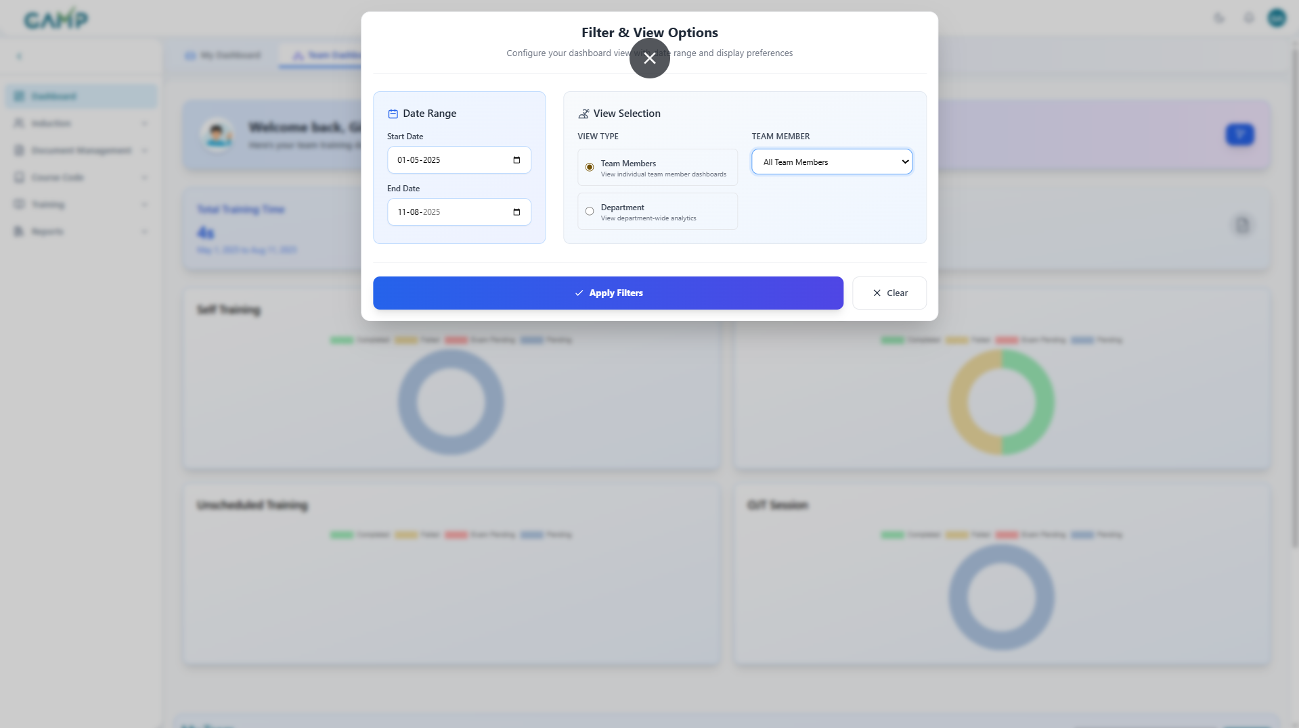

**Date Range**

* + It defines the period for which data will be displayed on the dashboard.
    1. **Start Date** – Select the beginning date from which you want to display data.
    2. **End Date** – Select the ending date up to which you want to display data.
  + Use the calendar picker to choose dates or enter them manually in DD-MM-YYYY format.
  + Both date fields are mandatory to generate filtered results.
  + When a new date range is applied, the dashboard changes when the apply filter button is clicked to show results within the selected period.

**View Selection**

* + This section controls what kind of data is displayed — either for specific individuals or the entire department.
  + **View Type Options:**–
  1. **Team Members**
     + - Displays dashboards for individual team members.
       - When selected , the **Team Member** dropdown becomes active. You can choose **All Team Members** to display combined results, or select a specific name from the dropdown list to focus on that individual’s performance.
       - This option is useful for monitoring individual contributions, tracking personal progress, or conducting performance reviews.
  2. **Department**
     + - Displays analytics for the entire department as a whole.
       - This view ignores individual-level data and presents consolidated statistics.
       - It is ideal for analysing department-wide productivity, trends, or workload distribution.

**Team Member Dropdown** *(Enabled when ‘Team Members’ view is selected)*

* **All Team Members** – Shows the aggregated data for all members in the selected date range.
* **Specific Member** – Displays results for the chosen individual only.

**Action Buttons**

* **Apply Filters** – Activates the selected Date Range and View settings. The dashboard will reload with updated results according to the applied filters.
* **Clear** – Resets all filters to their default state. The dashboard will then display unfiltered data.

**Usage Example:**  
If you want to see **how an individual performed in the last three months**, select:

* **Start Date**: 01-05-2025
* **End Date**: 11-08-2025
* **View Type**: Team Members
* **Team Member**: Select the required user  
  Then click **Apply Filters**. The dashboard will display only that person’s performance for the given period.

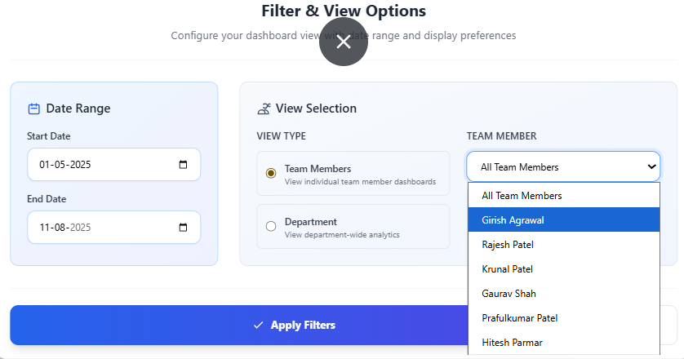

This is the selected user dashboard with all the details including all its training records and metrics.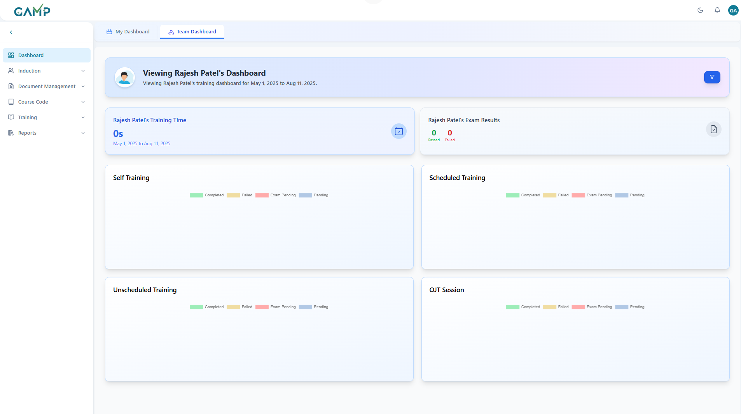

If we choose the Department view type in View Selection, then we will have the option to choose the department for which we want to see the analytics for.

**Usage Example – Department View with Search**  
If you want to review **overall departmental performance for a specific time period** and quickly locate a particular metric:

* **Start Date**: 01-05-2025
* **End Date**: 11-08-2025
* **View Type**: **Department** (select this option to view combined departmental analytics)
* **Search** using this option to search for the department that you want to from the department dropdown.
* Click **Apply Filters**.

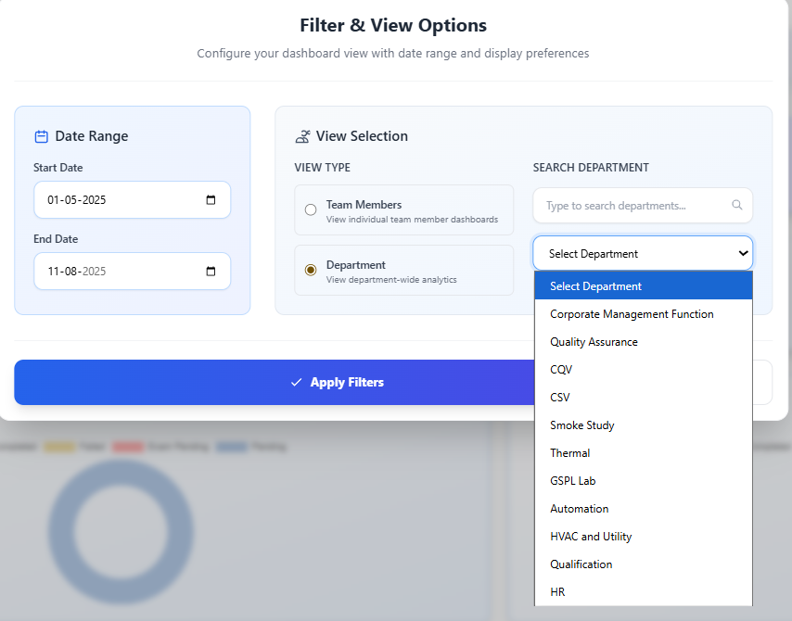

If we choose CSV from the department dropdown, then this is the dashboard for CSV department.

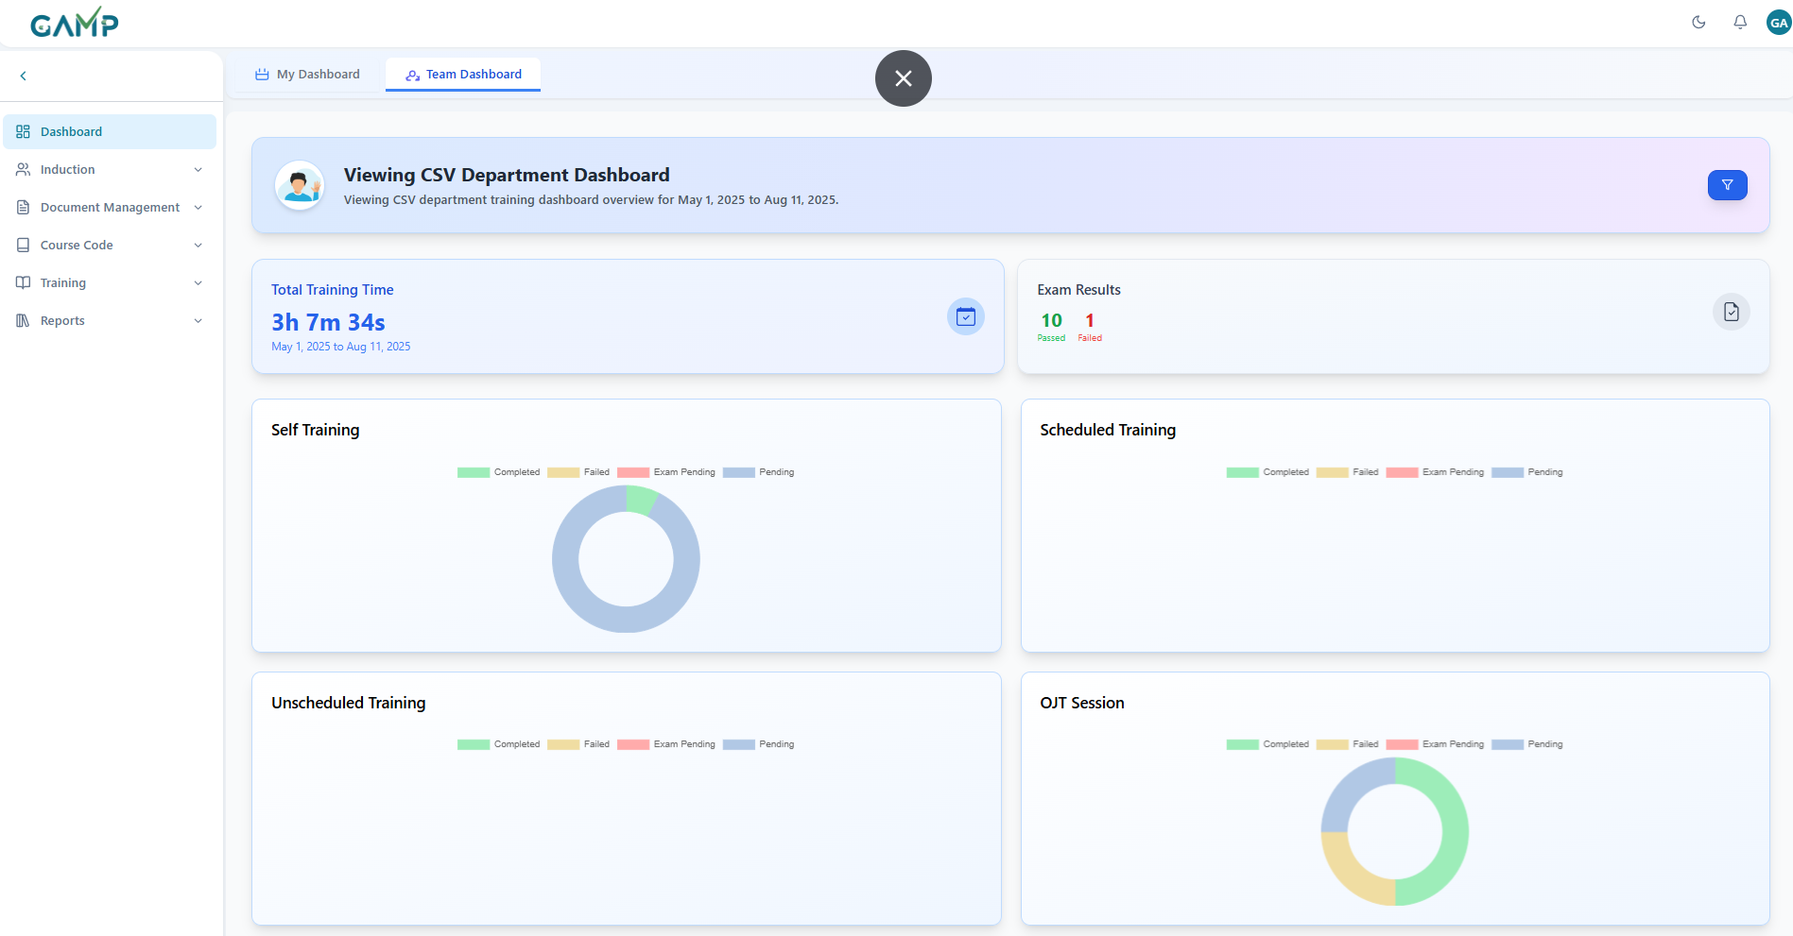

This is the demonstration for search functionality in the department dropdown. Here, if we enter q then department having q in the department name will be filtered in the dropdown.

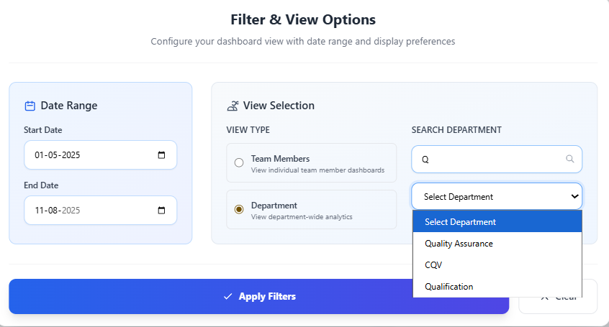

If we select the **quality assurance** department, then this is the view of the quality assurance department.

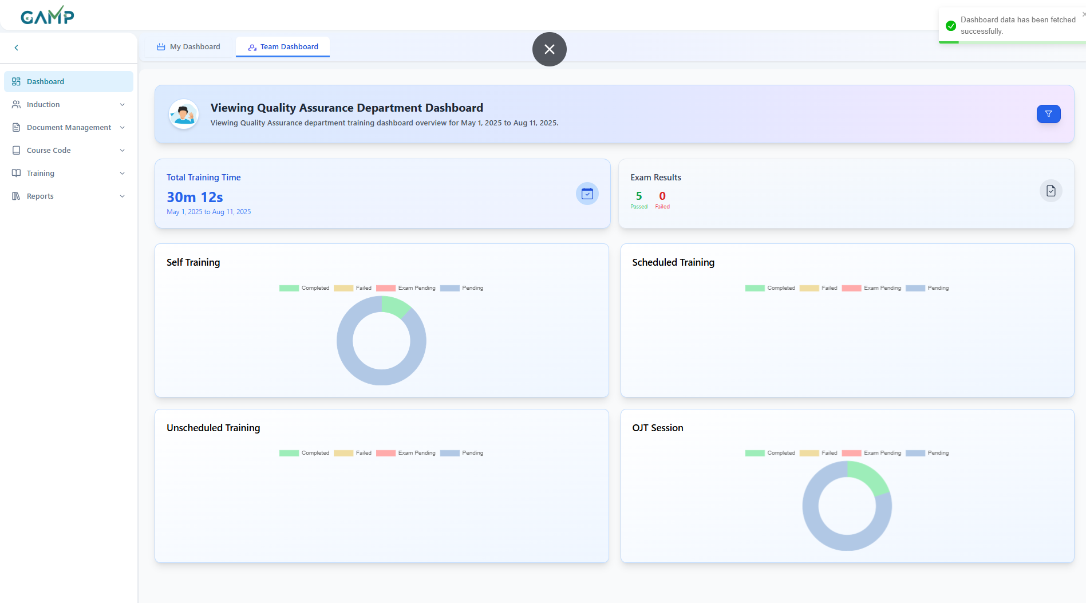

For role – **Department Head**

This is the team dashboard for the user which looks like this. It also has welcome panel, training metrics and pie charts for all four types of trainings.

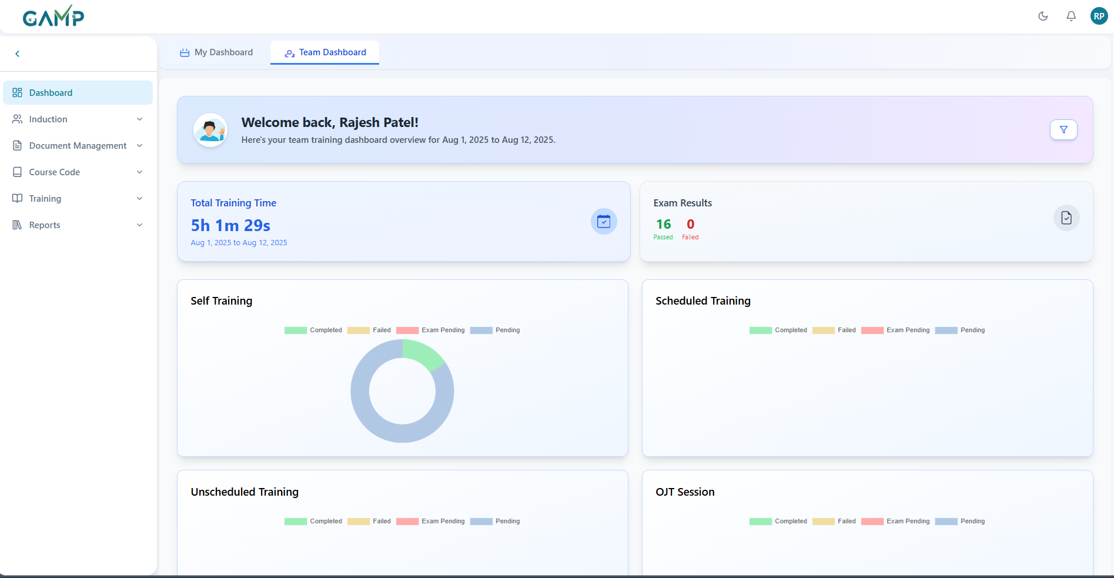

Below it is the my team section where all the users which are in the managers department and report to him. The manager can all the training metrics and records for all of this users which are under him.

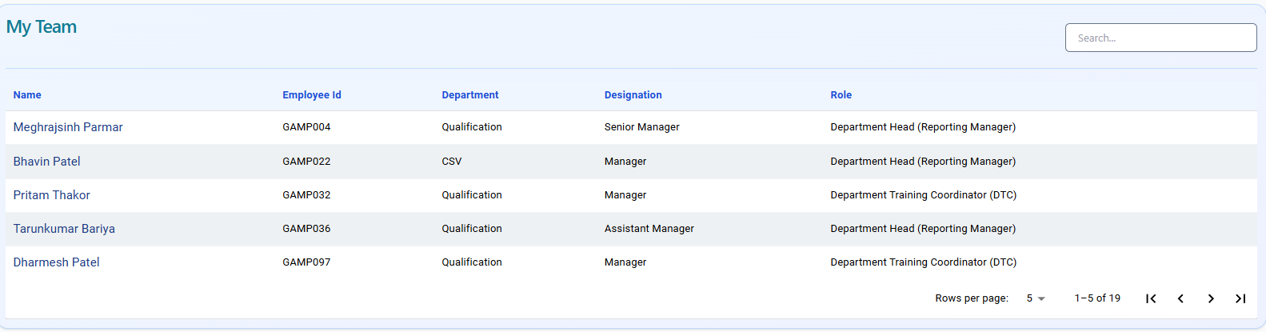

The filter and view options also change slightly according to the role. For this, the date range selection and the view type selection are mostly the same.

If all the view type is team members and all team members are selected in team member dropdown, then the view of the dashboard is one which is default for my team dashboard

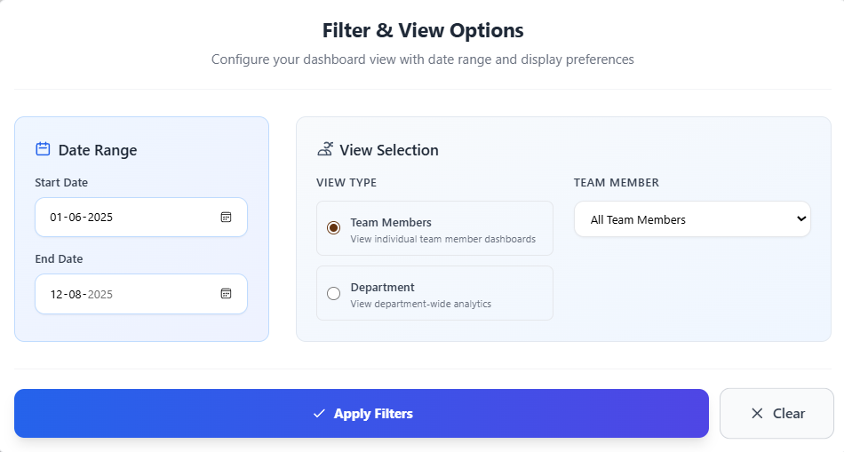

If we want, we can select a particular user from the dropdown of the users who report to that particular user and then the dashboard of that selected user will be available.

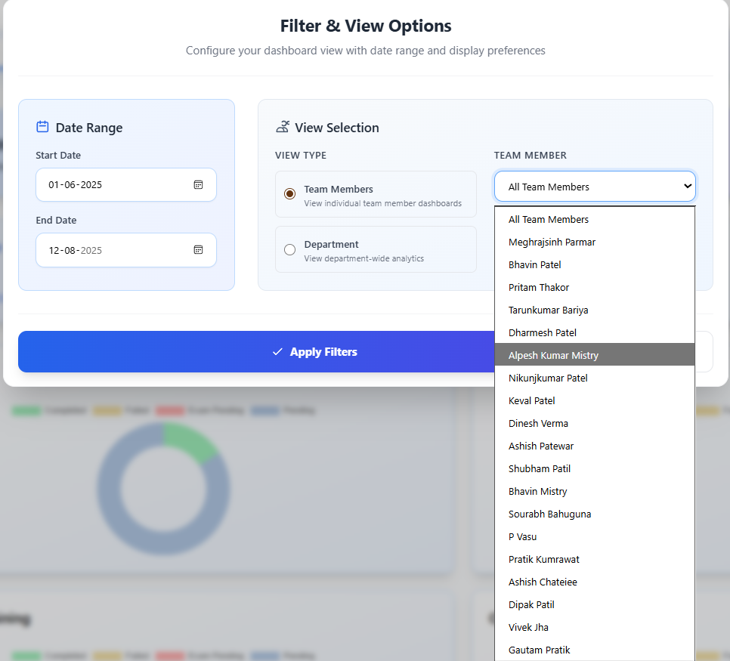

This is the dashboard of that particular user.

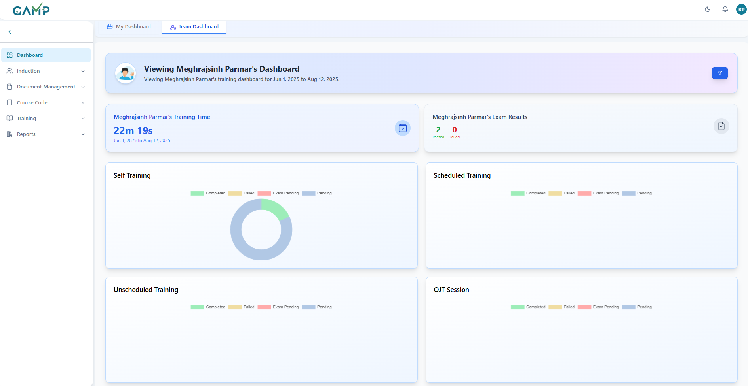

In the department view type, here he has the option of choosing only the department which he is a part of and is the reporting manager.

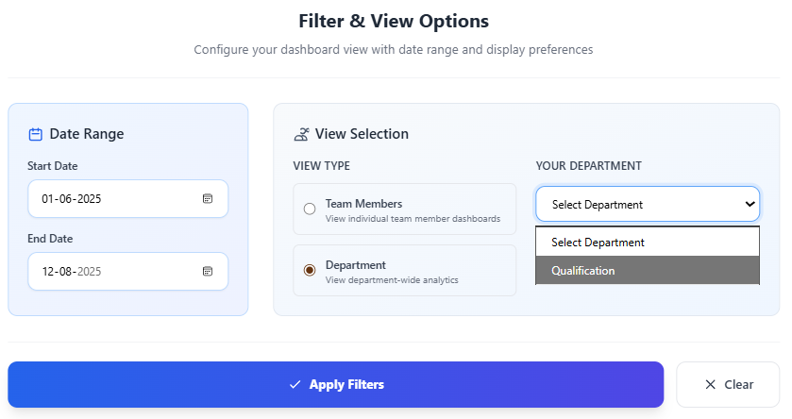

Below is the department dashboard in the team dashboard screen.

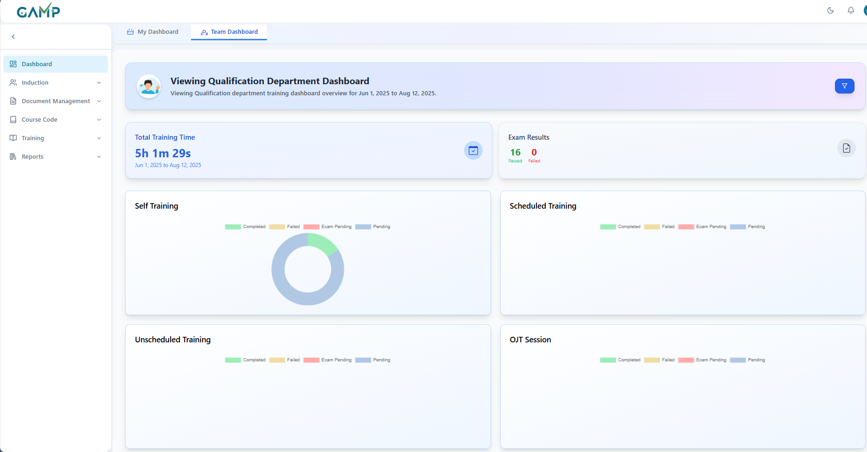

For system admin role, the team dashboard has filters and view in such a way where the default filter is for all the team members and there is also an option to choose the current user from the dropdown.

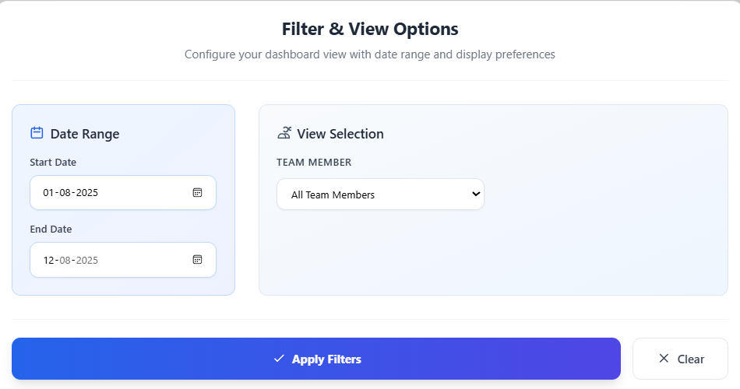

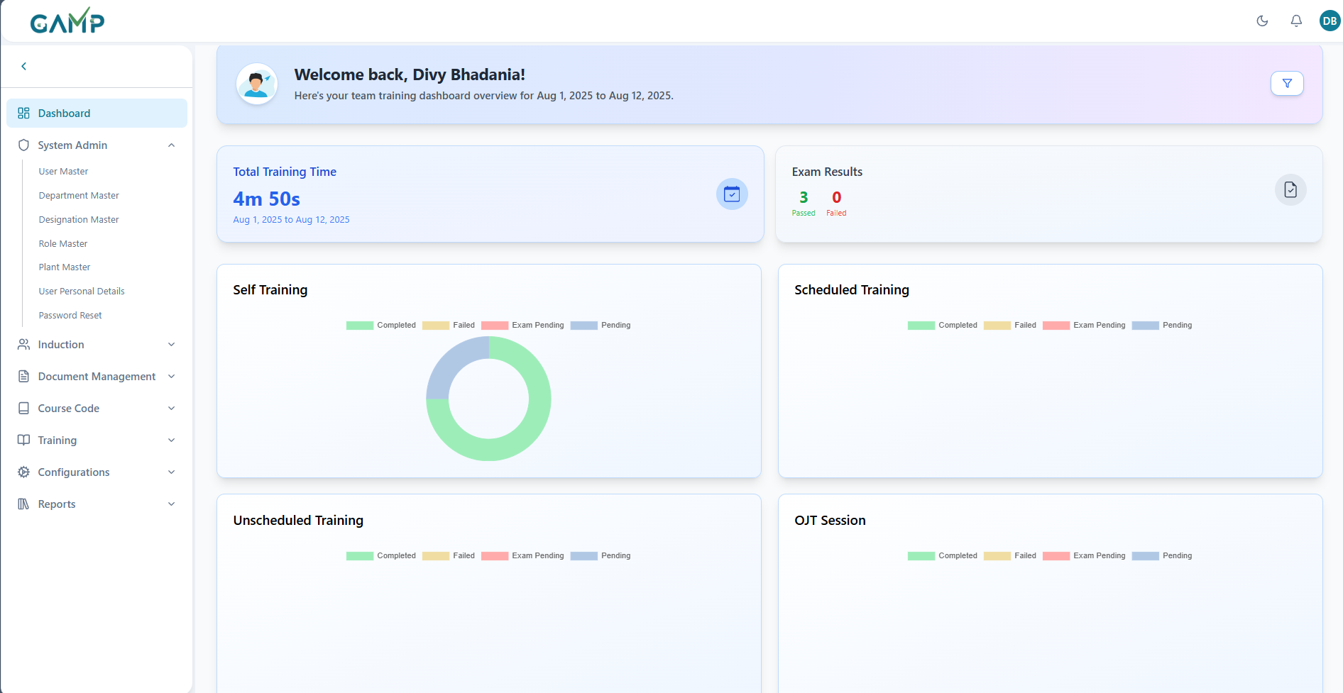

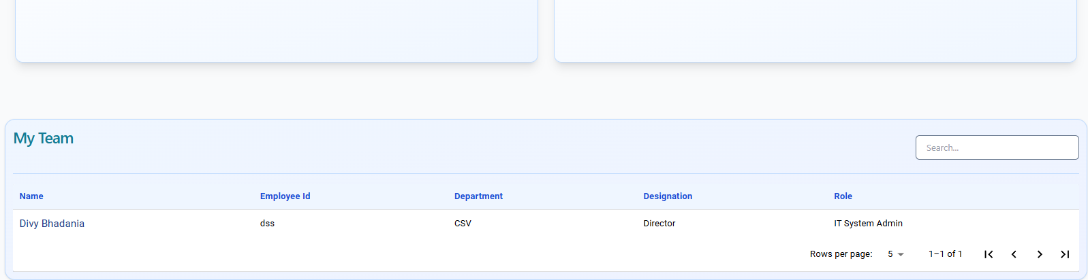

For normal trainees, there is no option for team dashboard and only the user’s dashboard is available for viewing.

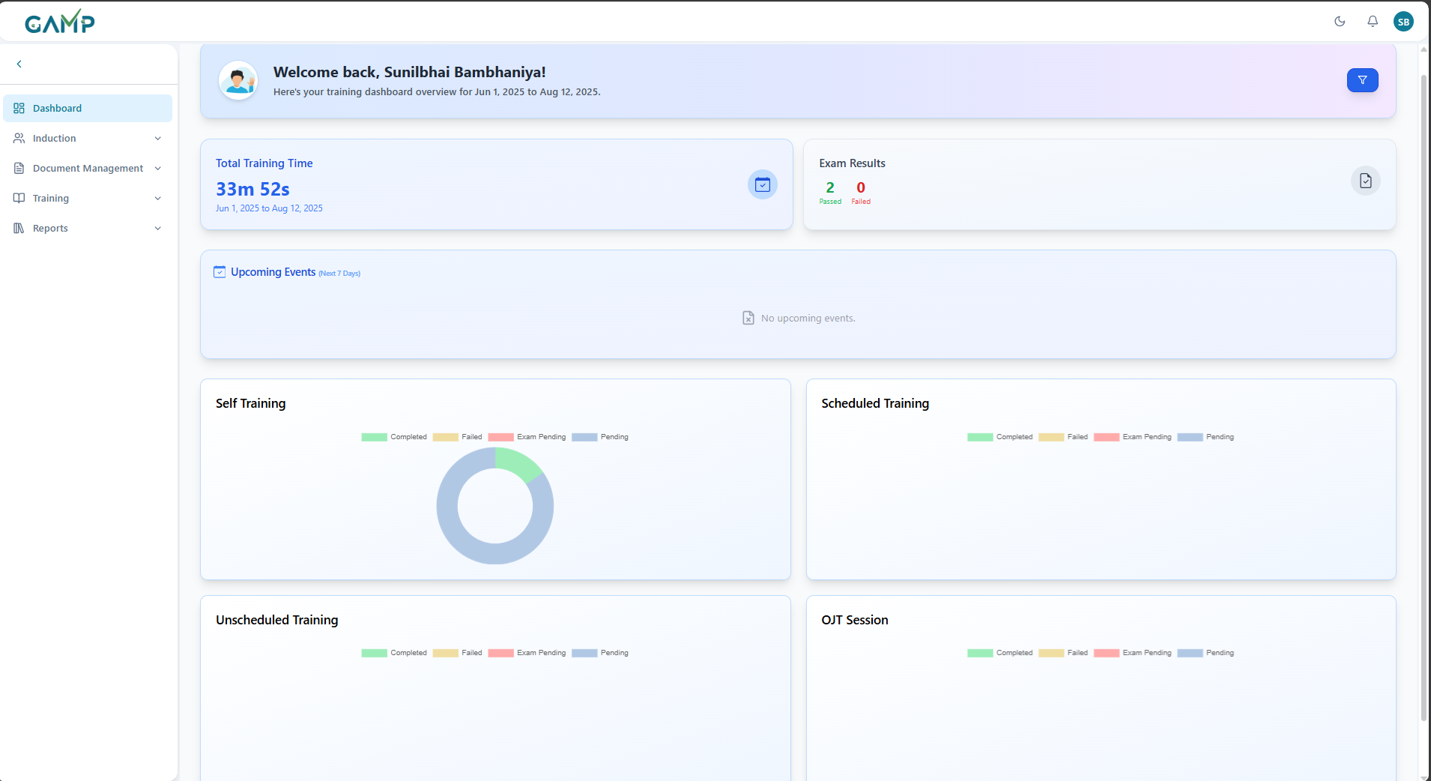

The filters and view is for the date range only. There are no action view options available.

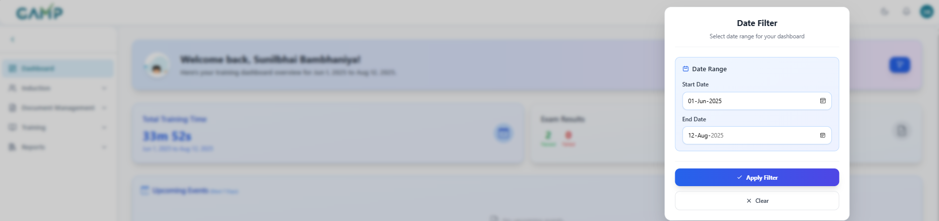

# System Admin

## User Master

The User Master module is used to create, manage, and maintain user accounts in the Training Management System (TMS). It allows administrators to record user details, assign roles, configure permissions, and ensure only authorized personnel have access to relevant modules.

**Functions of User Master**

* **Add** new users to the system.
* **Edit** existing user details.
* **Deactivate** users who no longer require system access.

### 1. Adding User

**Step 1 – Access User Master**

1. Log in to the TMS with **Administrator** credentials.
2. From the main menu, navigate to **System Admin → User Master**.
3. The **User Master Listing Page** is displayed.

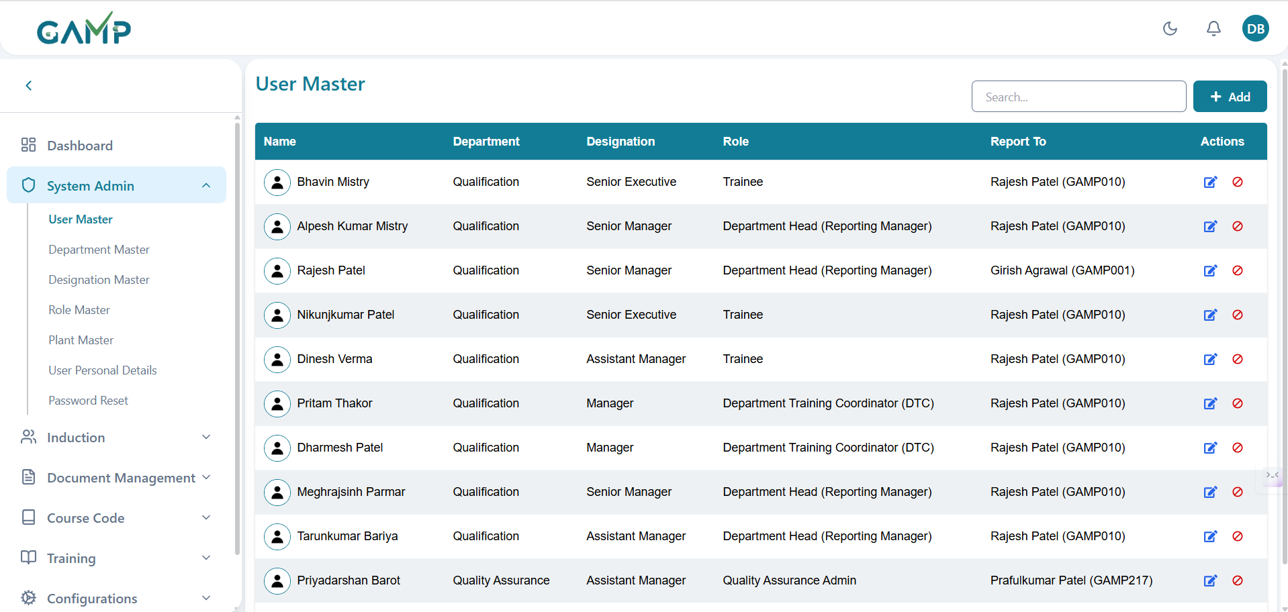

**Figure 1 – User Master Listing Page**  
Screenshot here showing the User Master list with Add/Edit/Deactivate options

**Step 2 – Open Add User Form**

1. Click the **Add** button on the User Master page.
2. The Add User form appears. *(See Figure 2)*

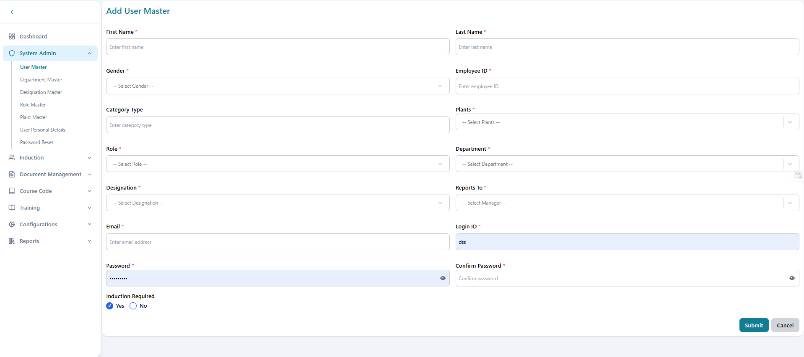

**Step 3 – Fill in User Details**

In the **Add User Master** form, fill in the following fields:

1. **First Name** – Enter the user’s first name *(Mandatory)*.
2. **Last Name** – Enter the user’s last name *(Mandatory)*.
3. **Gender** – Select the appropriate gender from the dropdown list.
4. **Employee ID** – Enter the employee identification number.
5. **Category Type** – Enter the user category (e.g., permanent, temporary, contractual, etc)
6. **Plant(s)** – Choose the plant(s) to which the user belongs from the dropdown of all plants.
7. **Role** – Select the appropriate role (e.g., System Admin, Trainer, Trainee) from the dropdown of all available roles. *(Mandatory)*
8. **Department** – Select the department associated with the user from the dropdown of all available departments *(Mandatory)*.
9. **Designation** – Select the user’s job designation from the dropdown of all available designation
10. **Reports To** – Choose the manager/supervisor to whom the user reports from the dropdown of all the users.
11. **Email** – Enter a valid official email address with prp format as that of a email*(Mandatory)*. 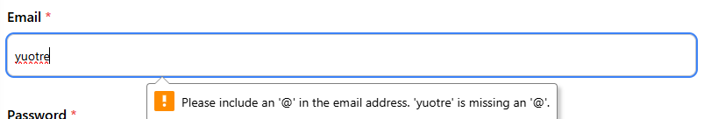
12. **Login ID** – Enter the username/login ID for system access. *(Mandatory)*
13. **Password** – Enter a secure password following the organization’s password policy. *(Mandatory)*
14. **Confirm Password** – Re-enter the password to confirm *(Mandatory)*.
15. **Induction Required** – Select **Yes** if the user must undergo induction training, or **No** if not required.

Once all fields are filled, proceed to **Step 4 – Save the User**.

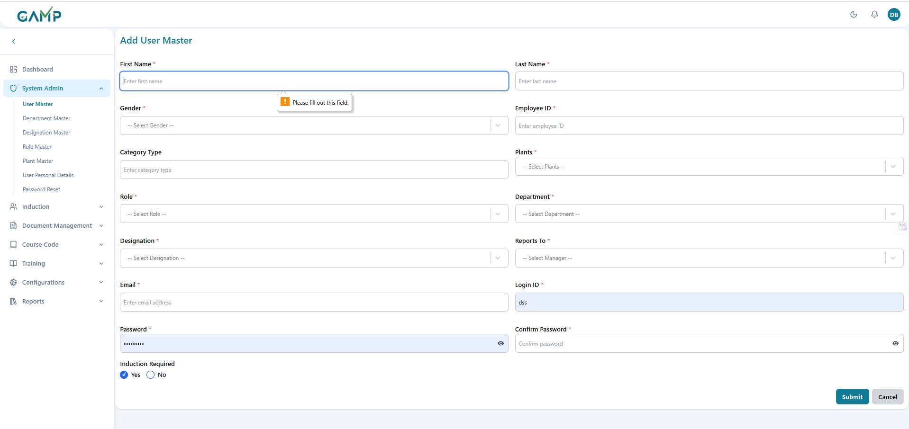

**Step 4 – Save the User**

1. Click **Submit**.
2. The **Electronic Signature(if enabled)** pop-up will appear.
3. The **Username** is fetched automatically.
4. Enter your **Password** to authenticate the action.
5. If the password is correct, the system will execute the action and proceed.
6. If the password is incorrect, the system will prompt you to re-enter the password until correct authentication is provided. 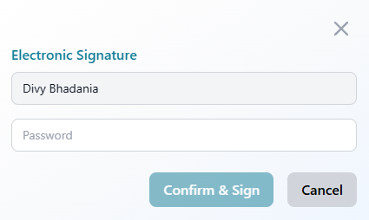
7. Upon successful authentication, a **confirmation message** is displayed indicating the user has been created.
8. The newly created user appears in the User Master list.

**Features of dropdown**The dropdown consists of all the options available to choose from, it has infinite scrolling and also has a search functionality to search in the dropdown.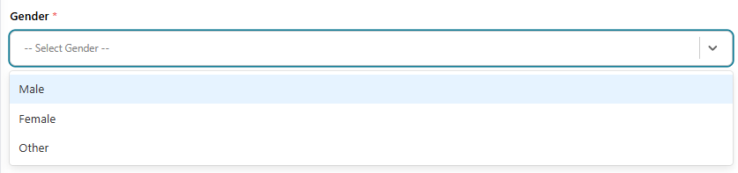

### 2. Editing User

**Step 1 – Locate the User**

1. Use the search bar to find the required user by **name** or **Employee ID**.

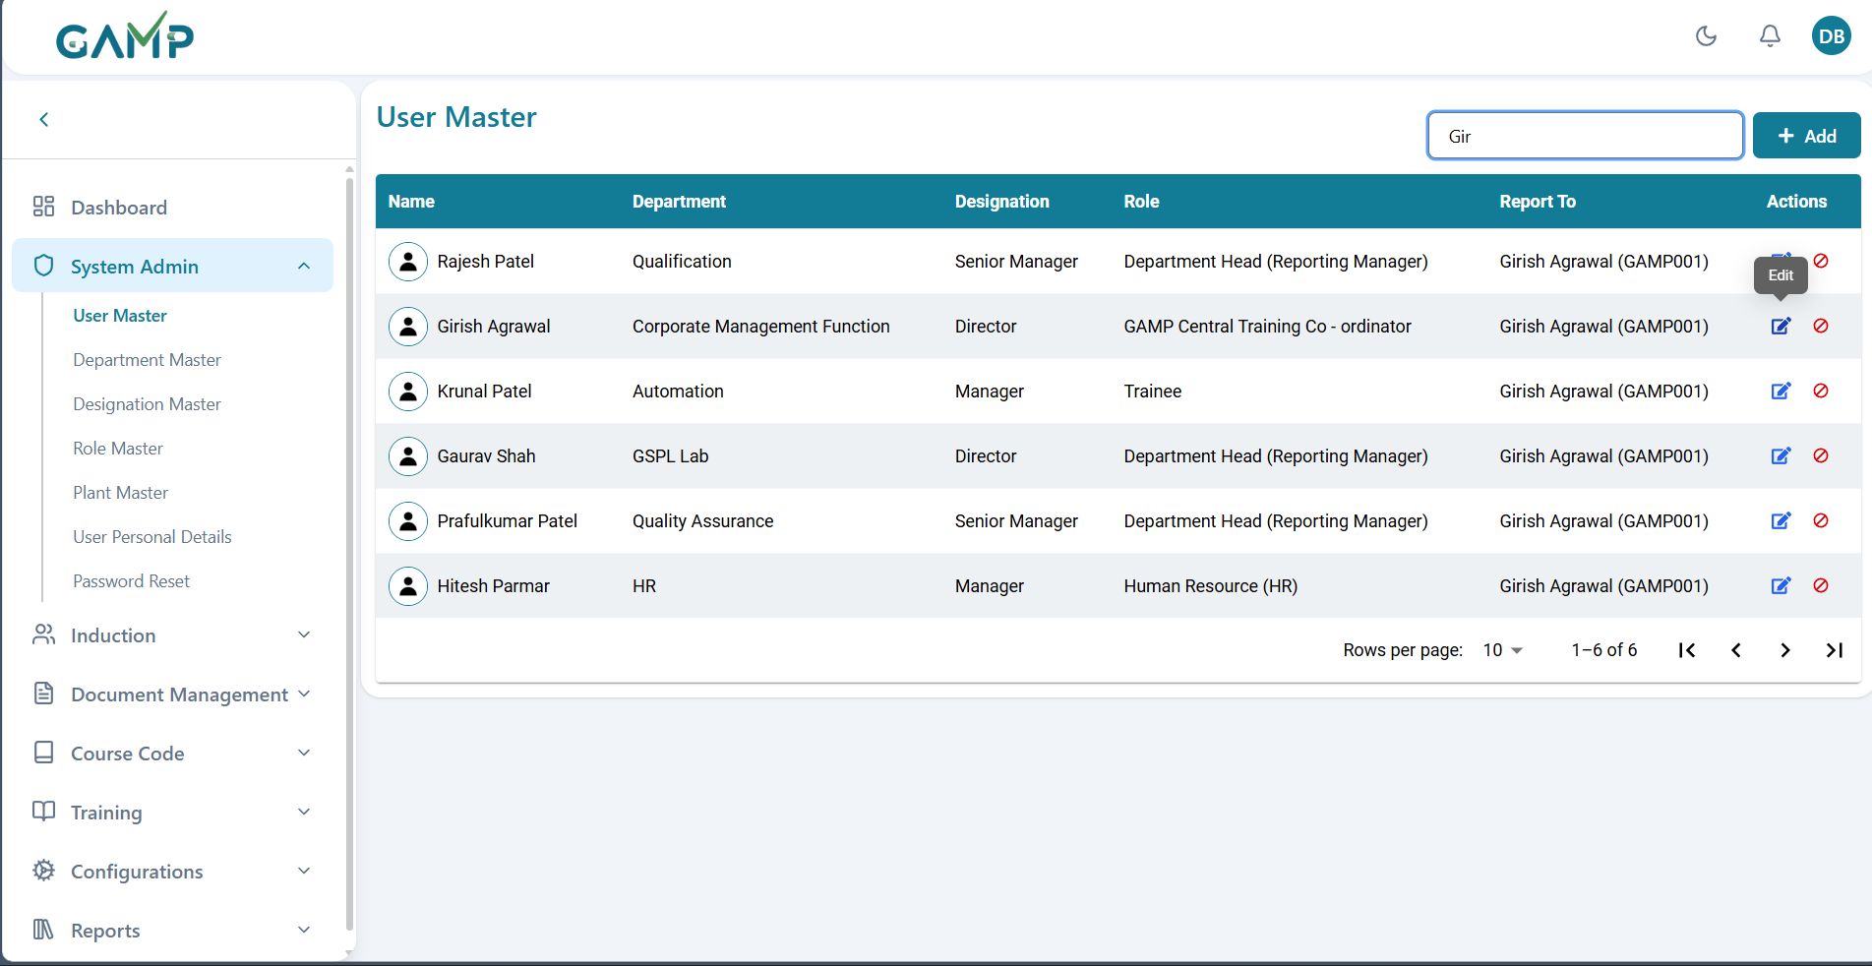

**Step 2 – Modify User Details**

1. Click the **Edit** icon in the Actions column for the respective user.
2. The **Edit User Form** will open with the existing details pre-filled.
3. Update the required fields (e.g., department change, role update).

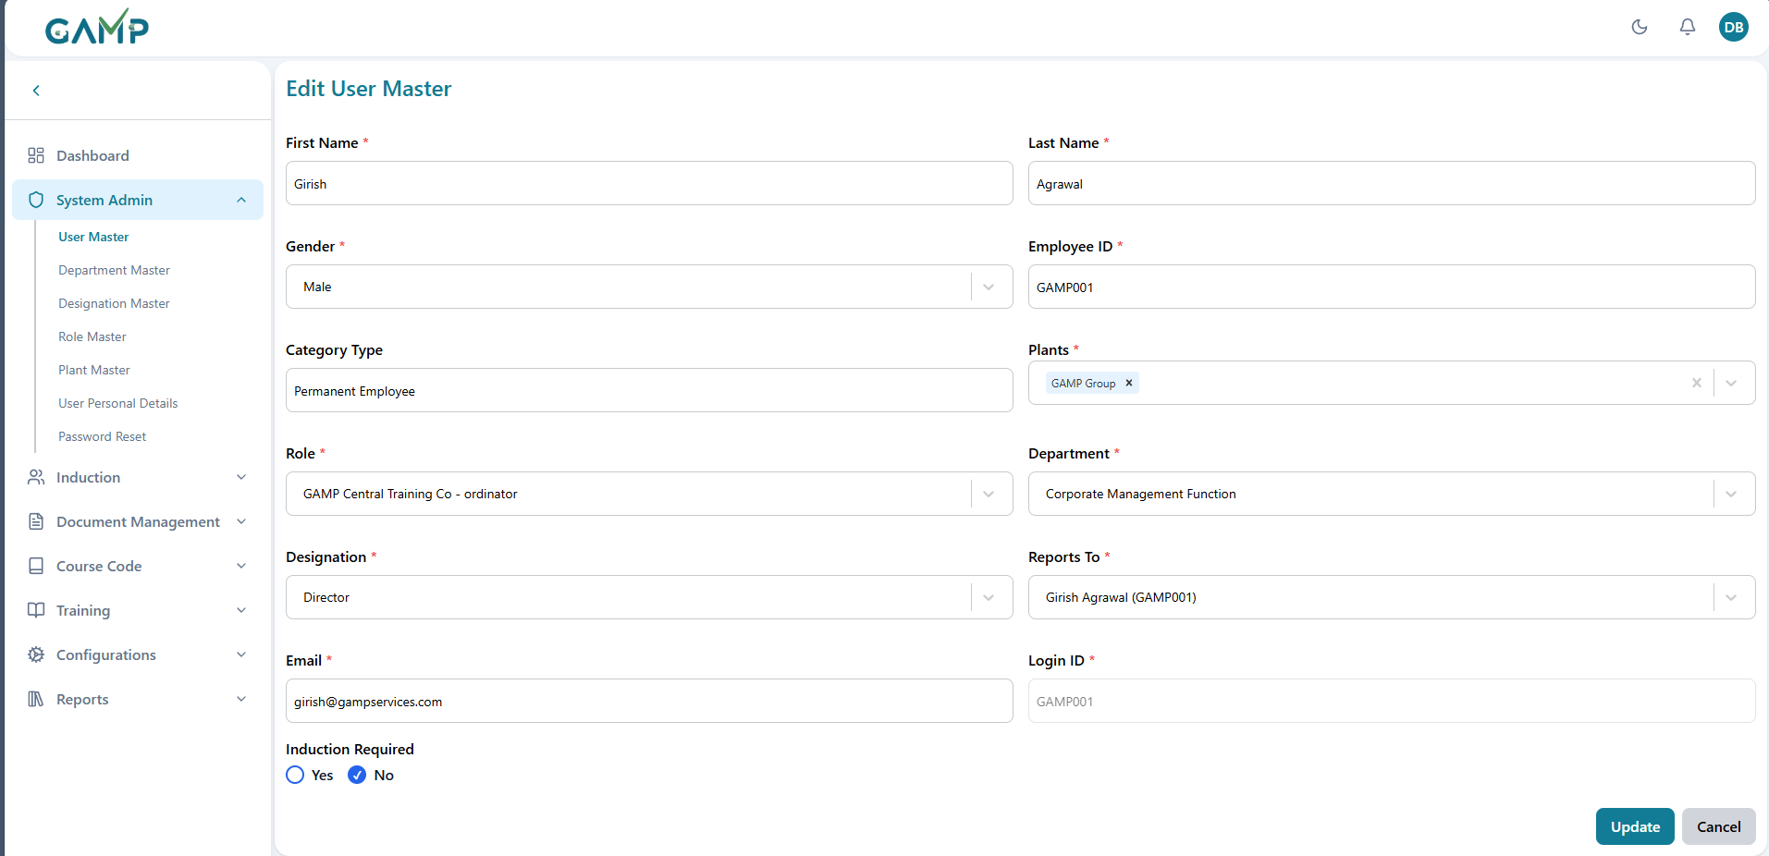

**Step 3 – Save the User**

1. Click **Update**.
2. The **Electronic Signature(if enabled)** pop-up will appear.
   1. The **Username** is fetched automatically.
   2. Enter the reason for change for performing the action.
   3. Enter your **Password** to authenticate the action.
   4. If the password is correct, the system will execute the action and proceed.
   5. If the password is incorrect, the system will prompt you to re-enter the password until correct authentication is provided.
3. Upon successful authentication, a **confirmation message** is displayed indicating the user has been updated.

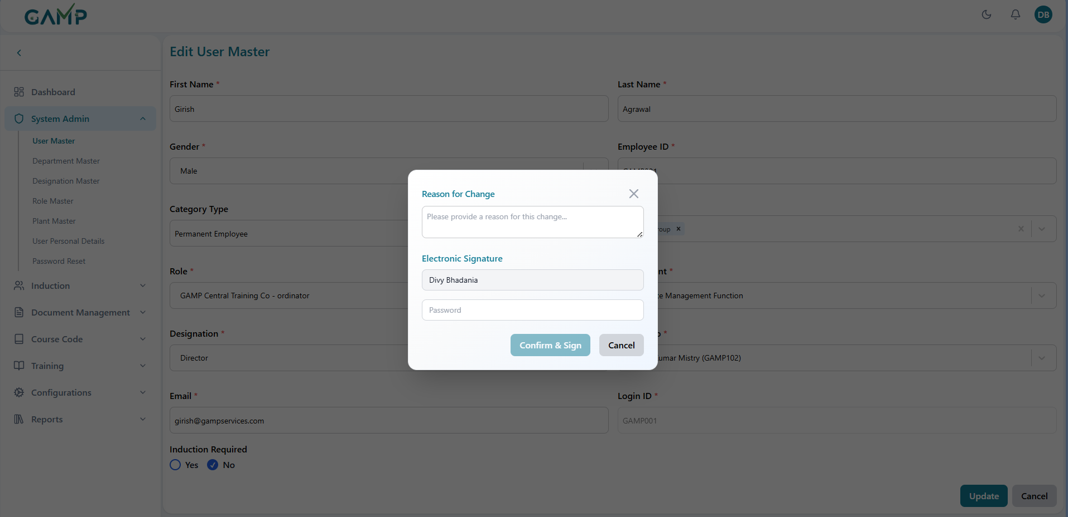

### 3. Deactivating User

**Step 1**: Locate the user in the listing using the **search bar** or **pagination controls**.

**Step 2** : Click the **Deactivate** button in the Actions column.

**Step 3** : A confirmation pop-up will appear asking for the **reason for change** and your **Electronic Signature (if enabled)** where the username is fetched automatically and the password needs to be written in the input.

**Step 4** : Click **Confirm & Sign** to proceed.

**Step 5** : A success message will confirm the action and the user will no longer have system access.

## Department Master

The **Department Master** module is used to create, manage, and maintain department records in the Training Management System (TMS). It ensures that each department is uniquely defined and available for assignment to users, courses, and training programs.1. Adding Department

**Step 1 – Access Department Master**

1. Log in to the TMS with Administrator credentials.
2. From the main menu, navigate to **System Admin → Department Master**.
3. The Department Master Listing Page is displayed.

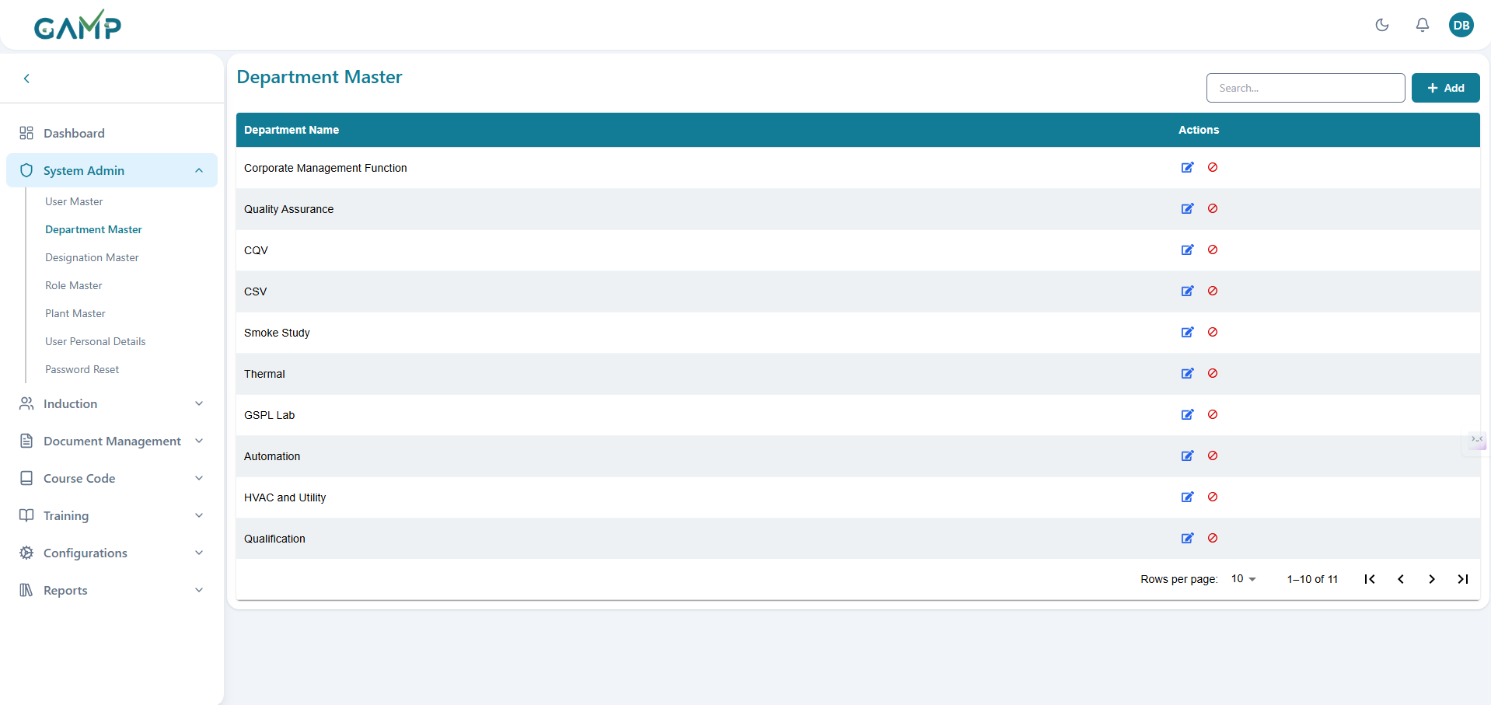

**Step 2 – Open Add Department Form**

1. Click the **Add** button on the Department Master page.
2. The Add Department form appears. *(See Figure 2)*

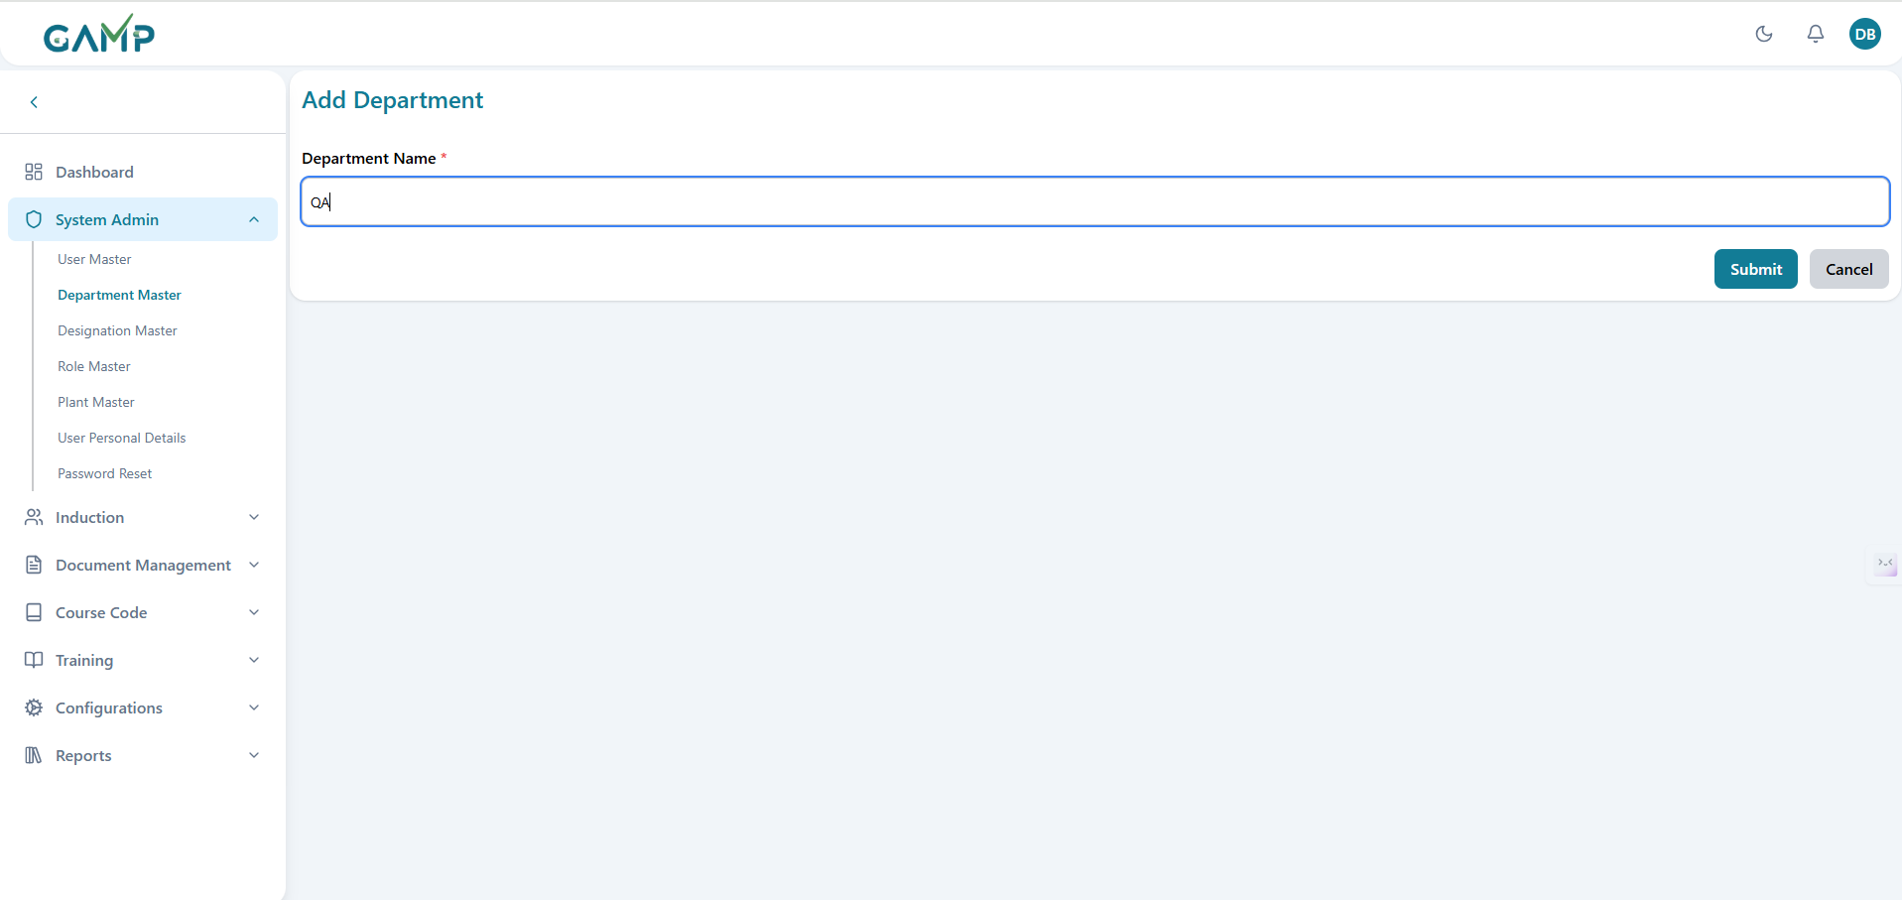

**Step 3 – Fill in Department Details**  
In the Add Department form, fill in the following fields:

1. **Department Name** – Enter the name of the department.

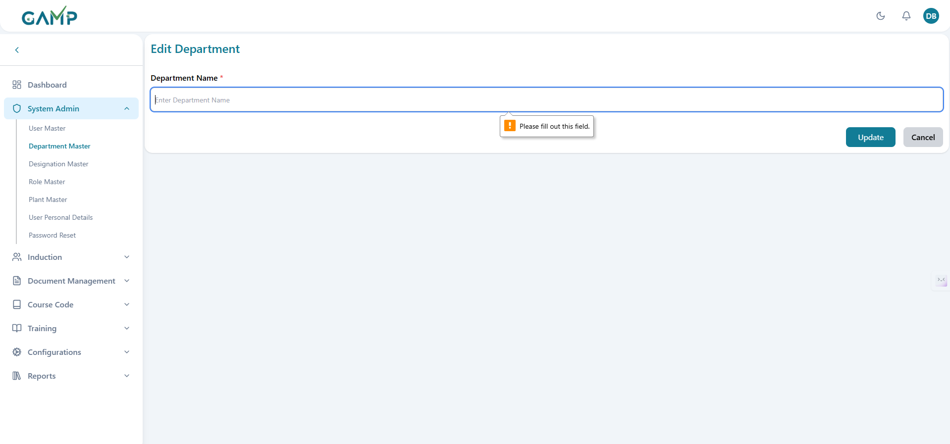

**Step 4 – Save the Department**

1. Click **Submit**.
2. The **Electronic Signature(if enabled)** pop-up will appear.
   1. The Username is fetched automatically.
   2. Enter your **Password** to authenticate the action.
   3. If the password is correct, the system will execute the action and proceed.
   4. If the password is incorrect, you will be prompted to re-enter it until correct authentication is provided.



1. Upon successful authentication, a confirmation message is displayed indicating the department has been created.
2. The newly created department appears in the Department Master list.

### 2. Editing Department

**Step 1 – Locate the Department**

1. Use the search bar to find the required department by name or code.

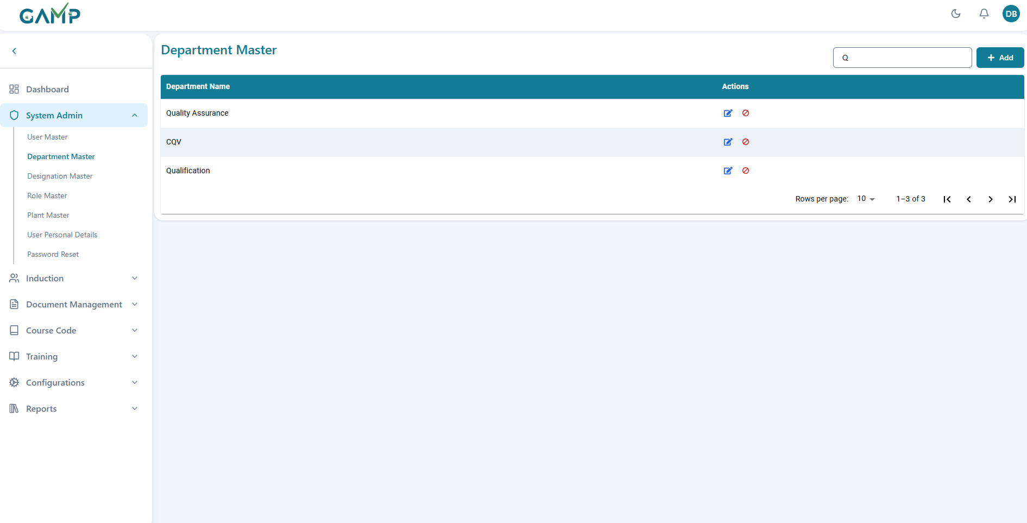

**Step 2 – Modify Department Details**

1. Click the **Edit** icon in the Actions column for the respective department.
2. The Edit Department form will open with the existing details pre-filled.
3. Update the required fields.

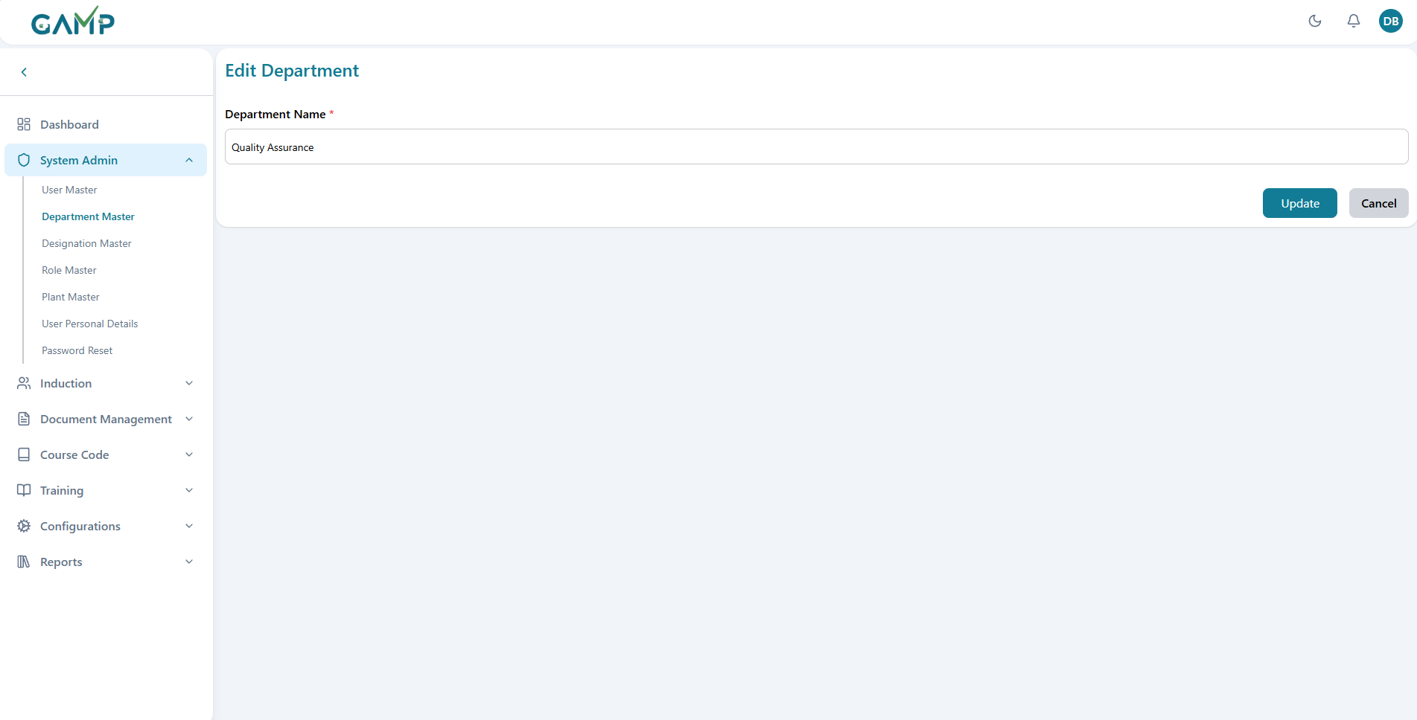

**Step 3 – Save the Department**

1. Click **Update**.
2. The **Electronic Signature(if enabled)** pop-up will appear.
   1. The Username is fetched automatically.
   2. Enter the **reason for change**.
   3. Enter your **Password** to authenticate the action.
   4. If correct, the action will execute; if incorrect, the system will prompt for the correct password.

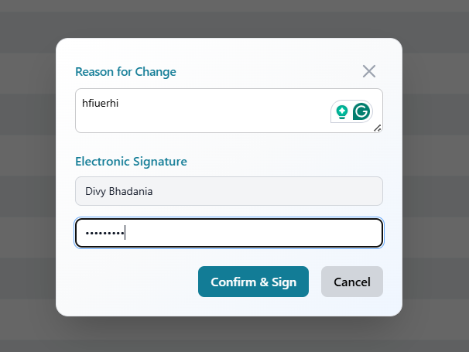

1. Upon successful authentication, a confirmation message will be displayed.

### 3. Deactivating Department

**Step 1** – Locate the department in the listing using the search bar or pagination controls.  
**Step 2** – Click the **Deactivate** button in the Actions column.  
**Step 3** – A confirmation pop-up will appear asking for the **reason for change** and your **Electronic Signature(if enabled)** where the username is fetched automatically and the password needs to be written in the input.

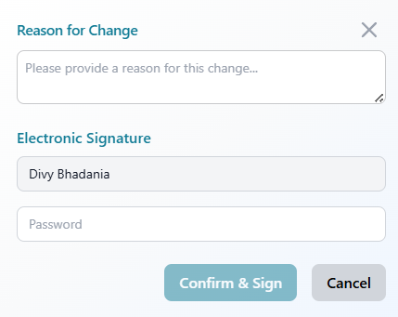

**Step 4** – Click **Confirm & Sign** to proceed.  
**Step 5** – A success message will confirm the action, and the department will be marked inactive and no longer available for assignment.

## Designation Master

The **Designation Master** module is used to create, manage, and maintain designations (job titles) in the Training Management System (TMS). It ensures consistent job role definitions across the organization.

### 1. Adding a New Designation

**Step 1 – Access Designation Master**

1. Log in to the TMS with Administrator credentials.
2. From the main menu, navigate to **System Admin → Designation Master**.
3. The Designation Master Listing Page is displayed.

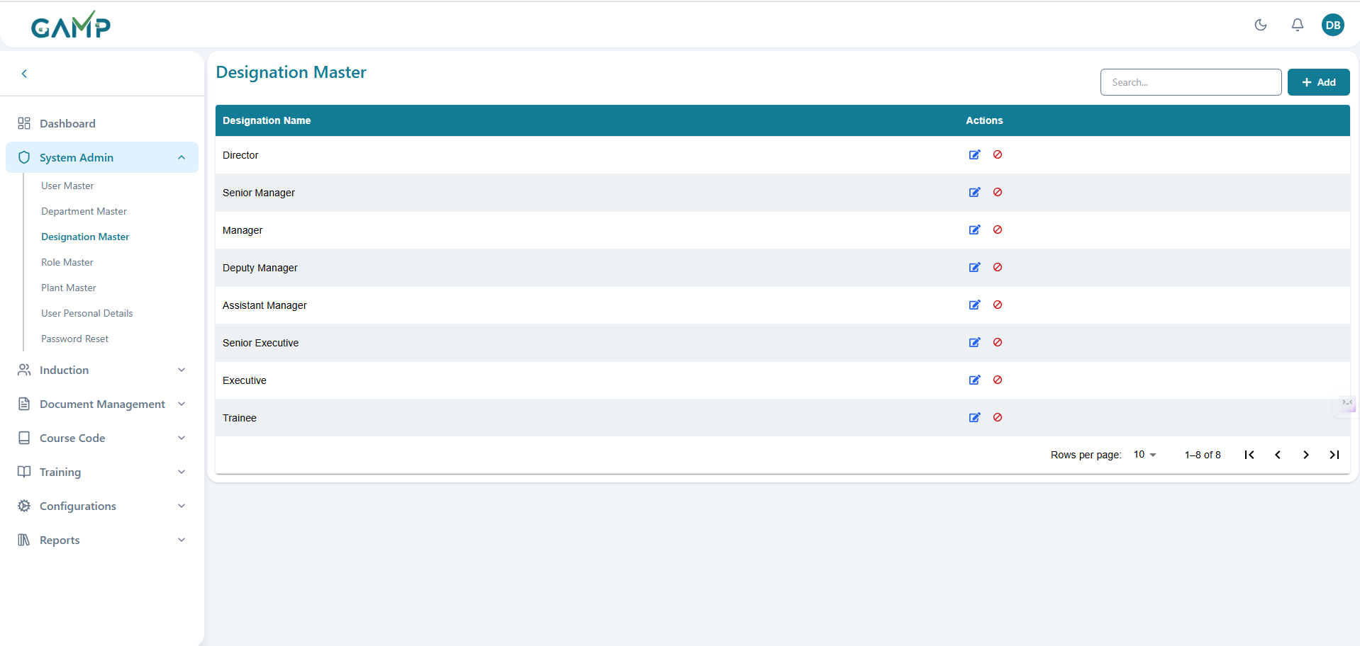

*(Screenshot – Designation Master Listing Page)*

**Step 2 – Open Add Designation Form**

1. Click the **Add** button on the Designation Master page.
2. The Add Designation form appears.

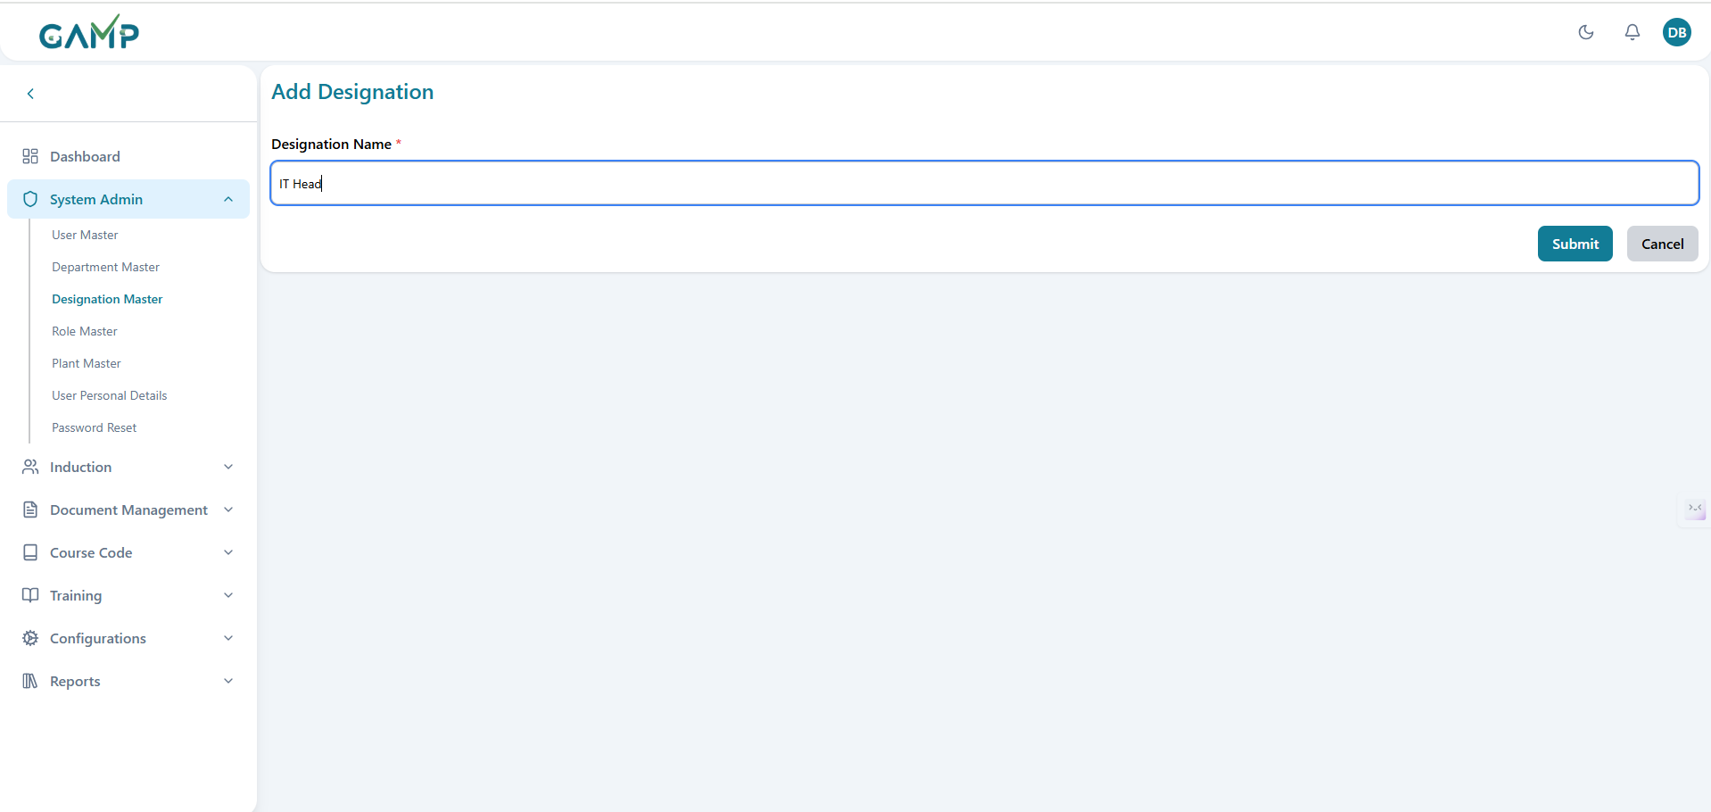

**Step 3 – Fill in Designation Details**  
In the Add Designation form, fill in the following fields:

1. **Designation Name** – Enter the job title (Mandatory).
2. **Description** – Optionally describe the job role’s responsibilities.

Once all fields are filled, proceed to **Step 4 – Save the Designation**.

**Step 4 – Save the Designation**

1. Click **Submit**.
2. The **Electronic Signature** pop-up will appear.
   * The Username is fetched automatically.
   * Enter your **Password** to authenticate the action.
   * If the password is correct, the system will execute the action and proceed.
   * If incorrect, you will be prompted to re-enter it.

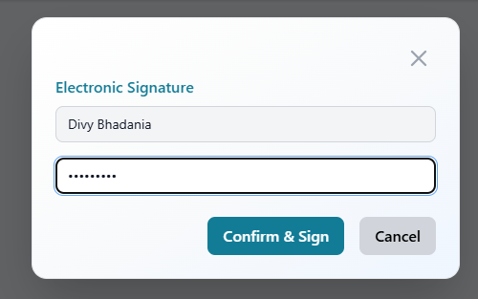

1. Upon successful authentication, a confirmation message is displayed indicating the designation has been created.
2. The newly created designation appears in the Designation Master list.

**2.** Editing an Existing Designation

**Step 1 – Locate the Designation**

1. Use the search bar to find the required designation by name.

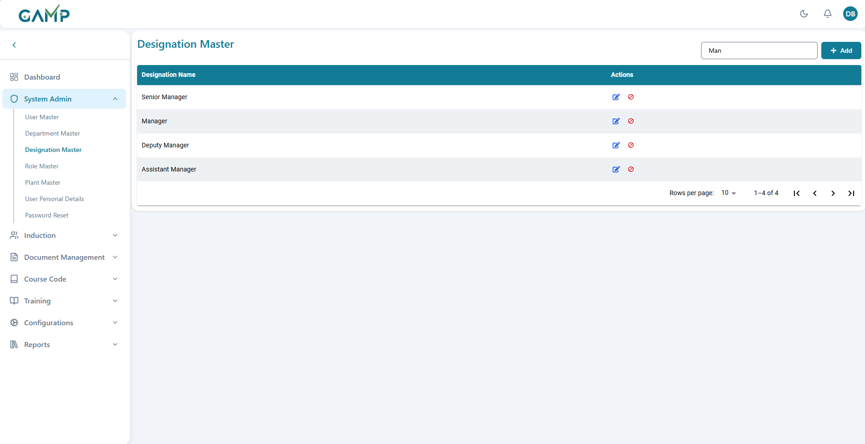

**Step 2 – Modify Designation Details**

1. Click the **Edit** icon in the Actions column for the respective designation.
2. The Edit Designation form will open with the existing details pre-filled.
3. Update the required fields.

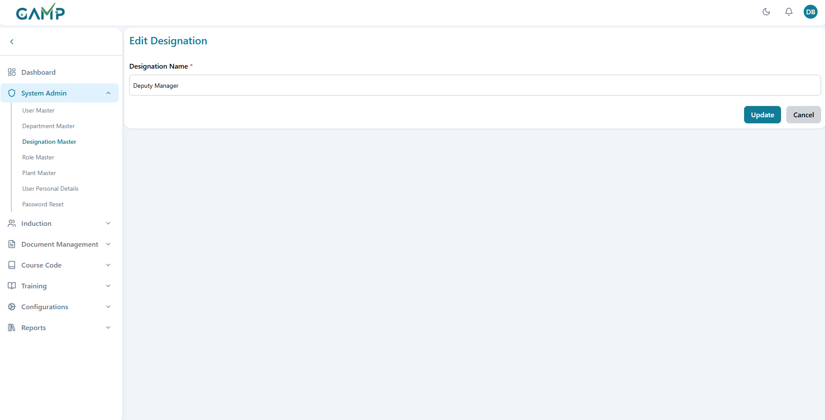

**Step 3 – Save the Designation**

1. Click **Update**.
2. The **Electronic Signature** pop-up will appear.
   * The Username is fetched automatically.
   * Enter the **reason for change**.
   * Enter your **Password** to authenticate the action.

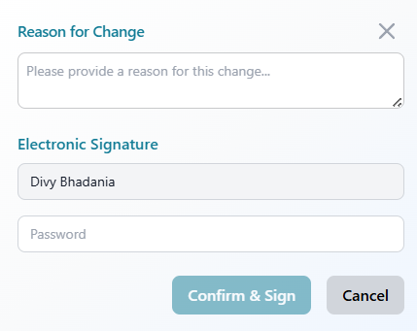

1. Upon successful authentication, a confirmation message is displayed.

### 3. Deactivating a Designation

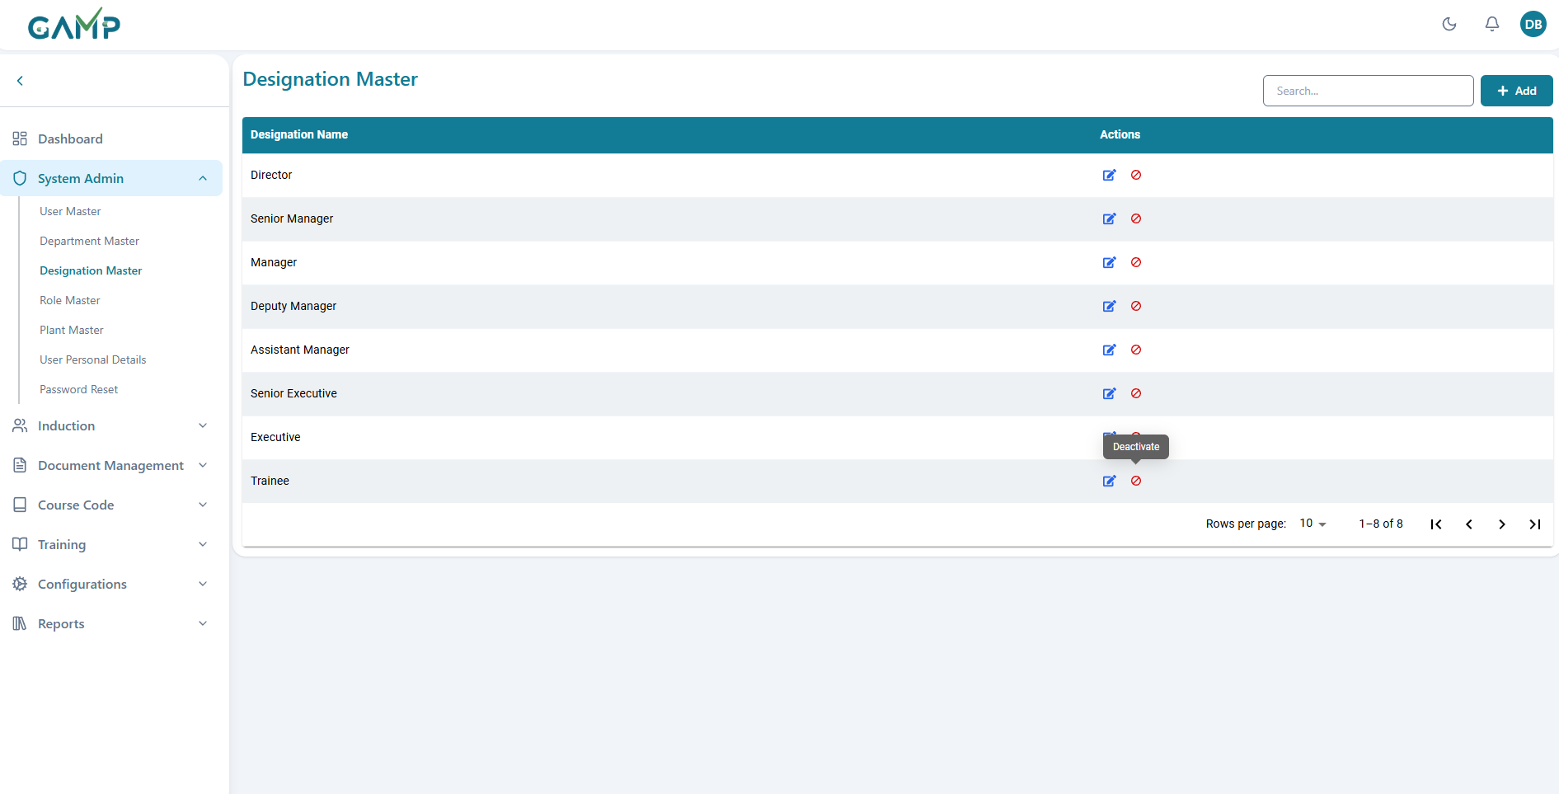

**Step 1** – Locate the designation in the listing using the search bar or pagination controls.  
**Step 2** – Click the **Deactivate** button in the Actions column.  
**Step 3** – A confirmation pop-up will appear asking for the **reason for change** and your **Electronic Signature**.

  
**Step 4** – Click **Confirm & Sign** to proceed.  
**Step 5** – A success message will confirm the action, and the designation will be marked inactive.

## Role Master

The Role Master module displays the list of system roles. This module is **view-only**; users cannot add, edit, or deactivate roles.

### 1. Accessing Role Master

1. From the **Masters** menu on the left sidebar, click **Role Master**.
2. The Role Master listing screen will appear, displaying all defined roles in the system

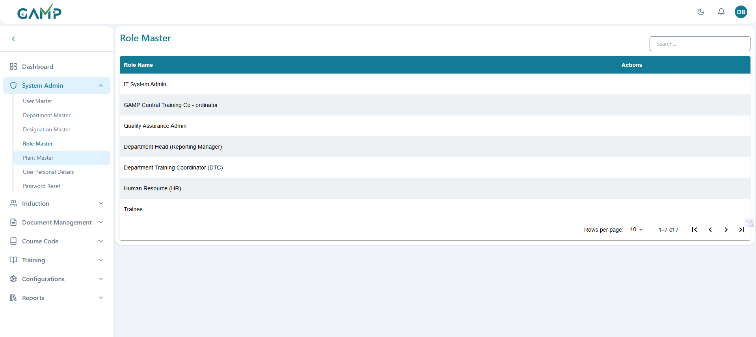

### 2. Viewing Roles

* The listing shows each roles in the software.
* No Add, Edit, or Deactivate options are available for this module.
* Use the search bar to filter roles by name.  
  *(Insert Screenshot – Search in Role Master)*

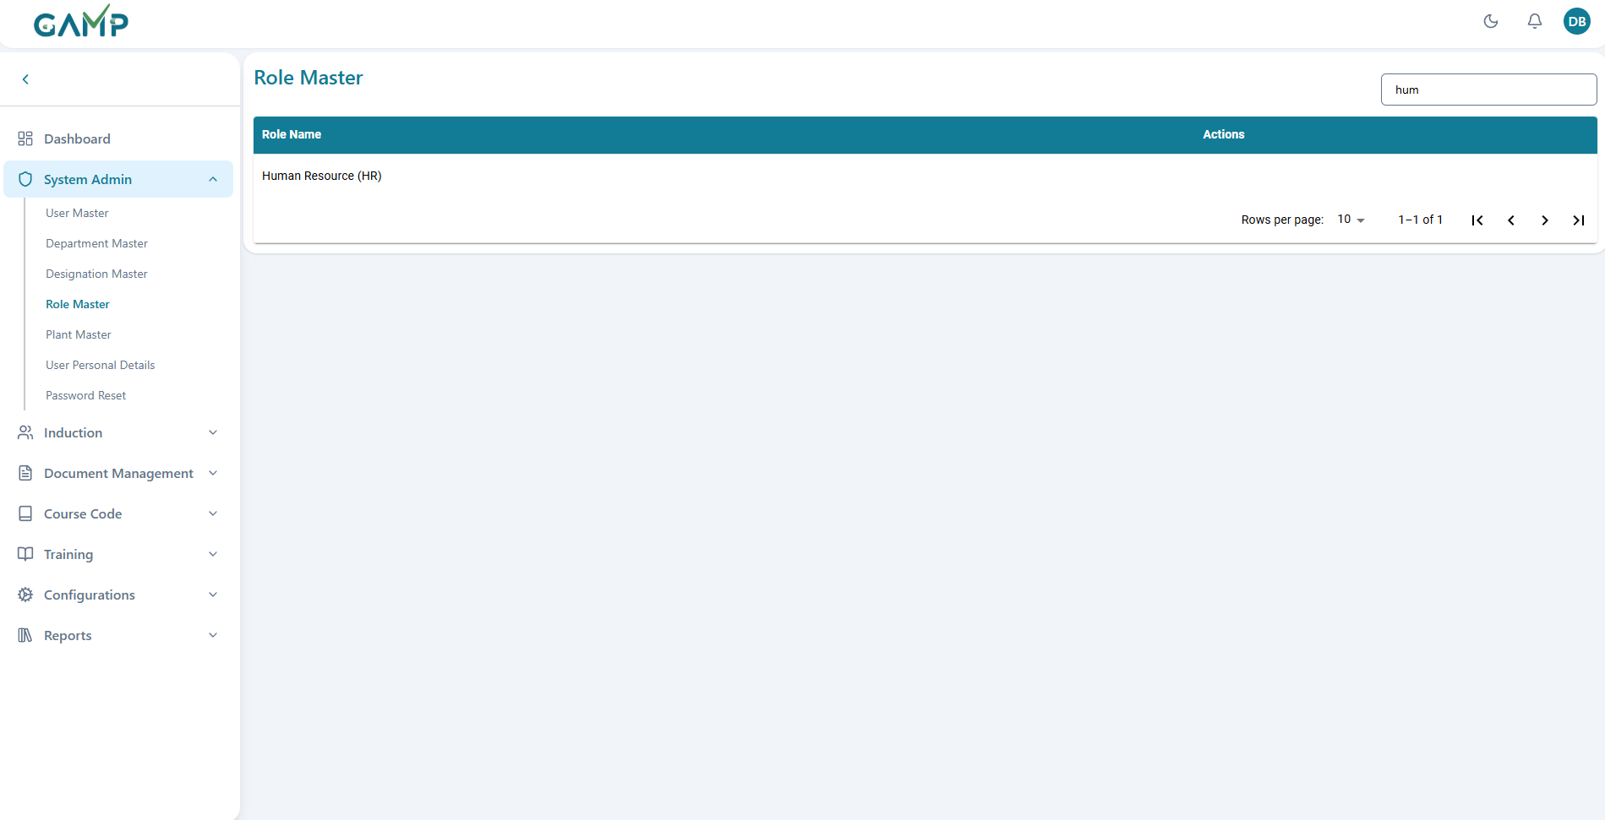

## Plant Master

The Plant Master module allows the user to manage plant records in the system, including adding, editing, and deactivating plants.

### 1. Adding Plant

**Step 1 – Access Plant Master**

1. Log in to the TMS with Administrator credentials.
2. From the main menu, navigate to **System Admin → Plant Master**.
3. The **Plant Master** Listing Page is displayed.

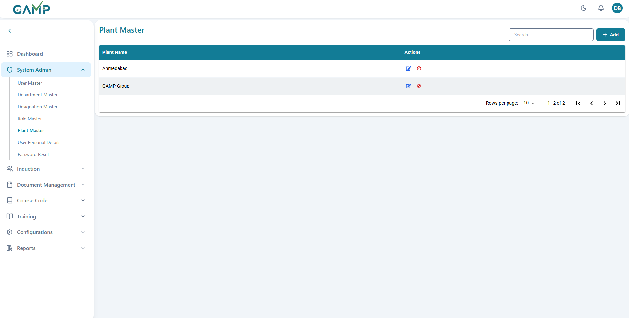

**Step 2 – Open Add Plant Form**

1. Click the **Add** button on the lant Master page.
2. The Add Plant form appears.

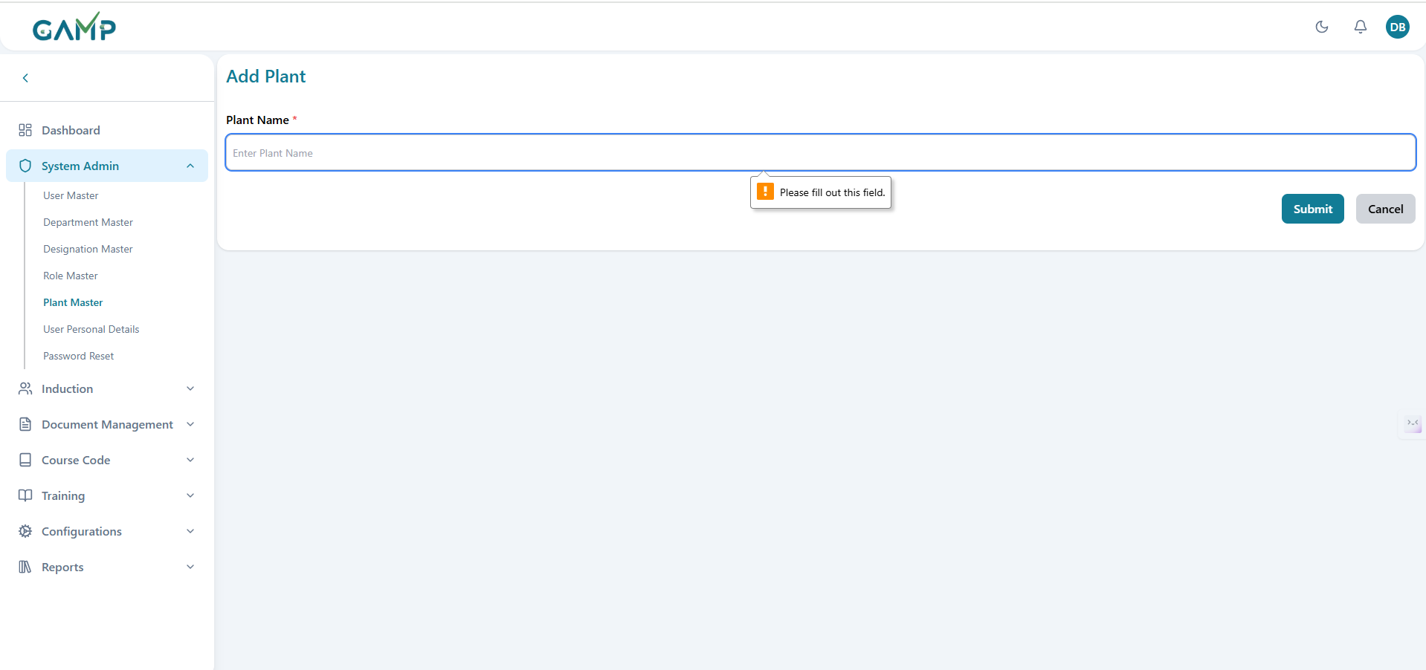

**Step 3 – Fill in Plant Details**  
In the Add Plant form, fill in the following fields:

**Plant Name** – Enter the Plant Name (Mandatory).

Once all fields are filled, proceed to **Step 4 – Save the Plant**.

**Step 4 – Save the Plant**

1.Click **Submit**.

2.The **Electronic Signature(if enabled)** pop-up will appear.

* 1. The username is fetched automatically.
  2. Enter your **Password** to authenticate the action.
  3. If the password is correct, the system will execute the action and proceed.
  4. If incorrect, you will be prompted to re-enter it.



1. Upon successful authentication, a confirmation message is displayed indicating the plant has been created.
2. The newly created plant appears in the plant master.

**2.** Editing an Existing Plant

**Step 1 – Locate the Plant**

1. Use the search bar to find the required plant by name.

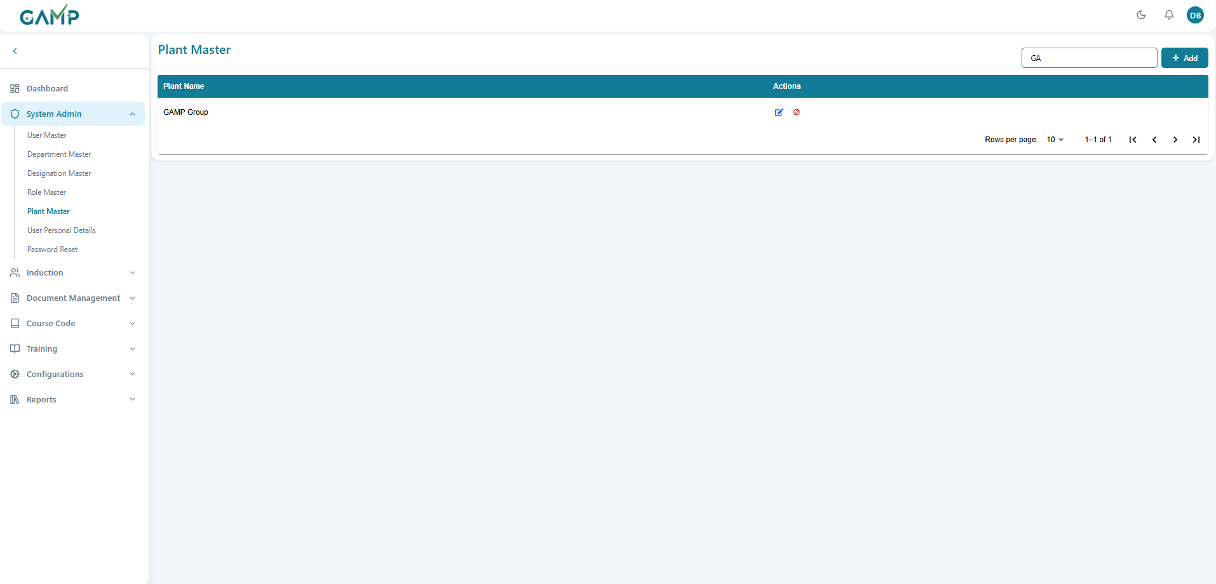

**Step 2 – Modify Plant Details**

1. Click the **Edit** icon in the Actions column for the respective plant.
2. The Edit plant form will open with the existing details pre-filled.
3. Update the required fields.

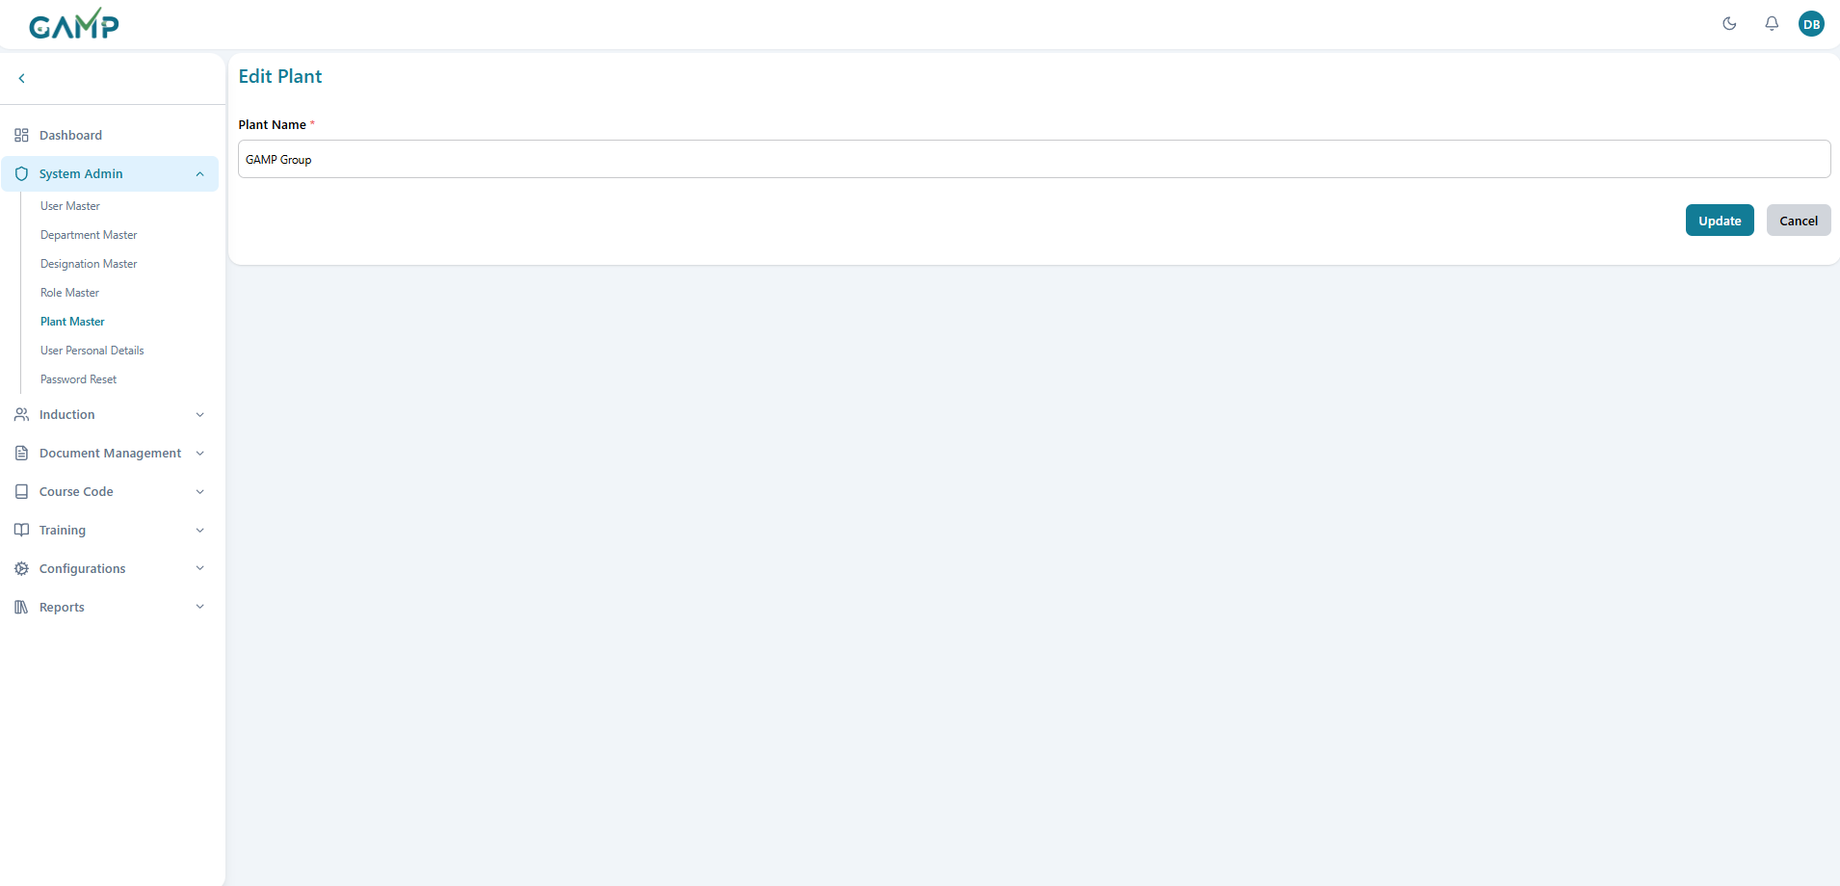

**Step 3 – Save the Plant**

1. Click **Update**.
2. The **Electronic Signature** pop-up will appear.
   1. The Username is fetched automatically.
   2. Enter the **reason for change**.
   3. Enter your **Password** to authenticate the action.



1. Upon successful authentication, a confirmation message is displayed.

### Deactivating a Plant

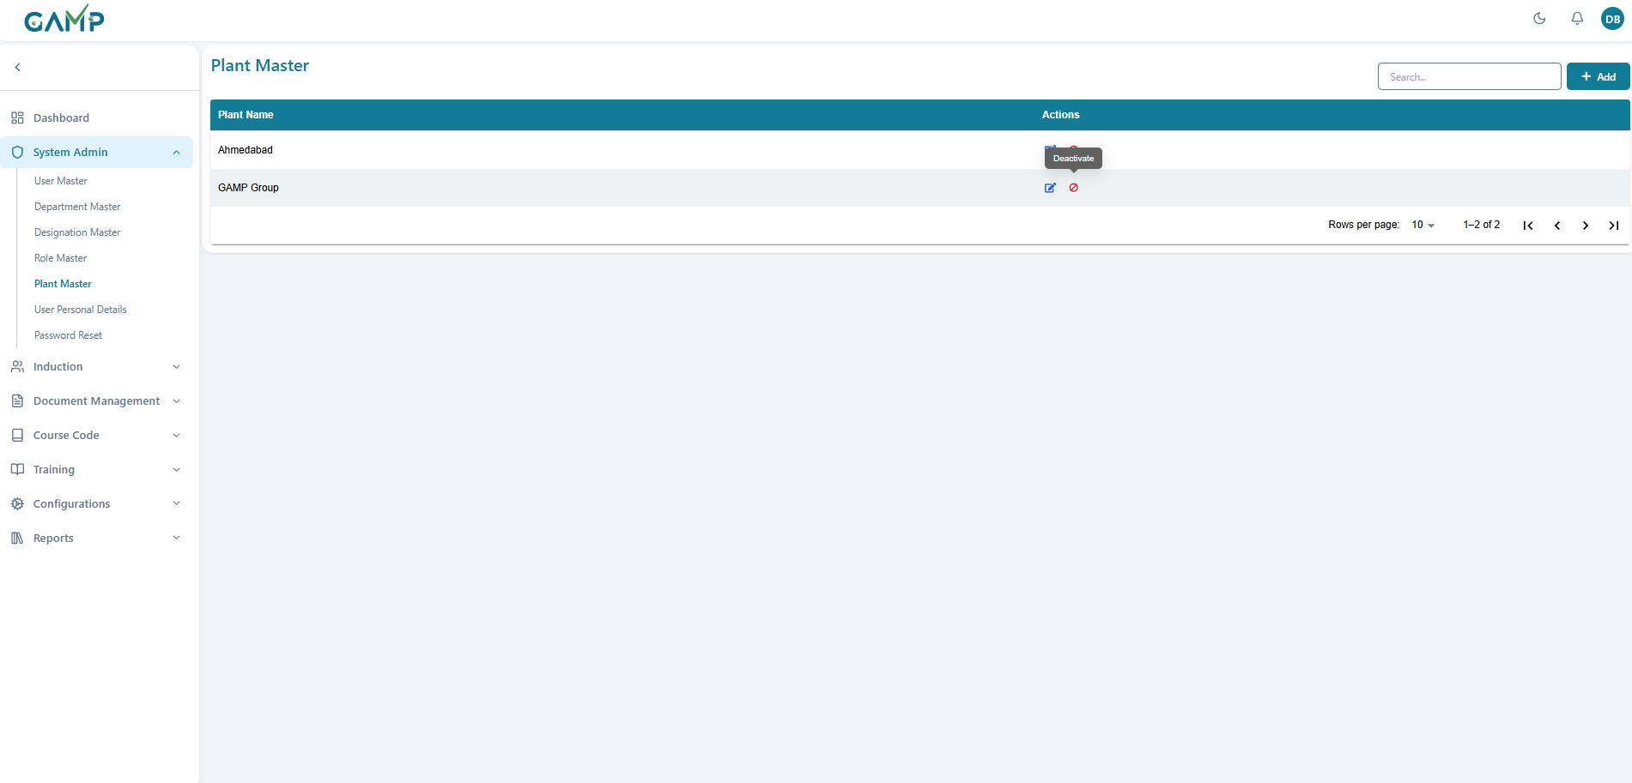

**Step 1** – Locate the plant in the listing using the search bar or pagination controls.  
**Step 2** – Click the **Deactivate** button in the Actions column.  
**Step 3** – A confirmation pop-up will appear asking for the **reason for change** and your **Electronic Signature**.

  
**Step 4** – Click **Confirm & Sign** to proceed.  
**Step 5** – A success message will confirm the action, and the plant will be marked inactive.

## User personal Details

The **User Personal Details** screen allows you to view and update the personal details of users. Only existing user records which are there in user master can be modified — no new records can be created from this section.

### 1. Edit User personal details

**Step 1 – Navigate to the User Personal Details Module**

1. From the **Dashboard**, go to **System Admin** → **User Personal Details**.
2. A list of all users with their **Name**, **Address**, **Contact Info**, **Date of Birth (DOB)**, and **Date of Joining (DOJ)** will appear.

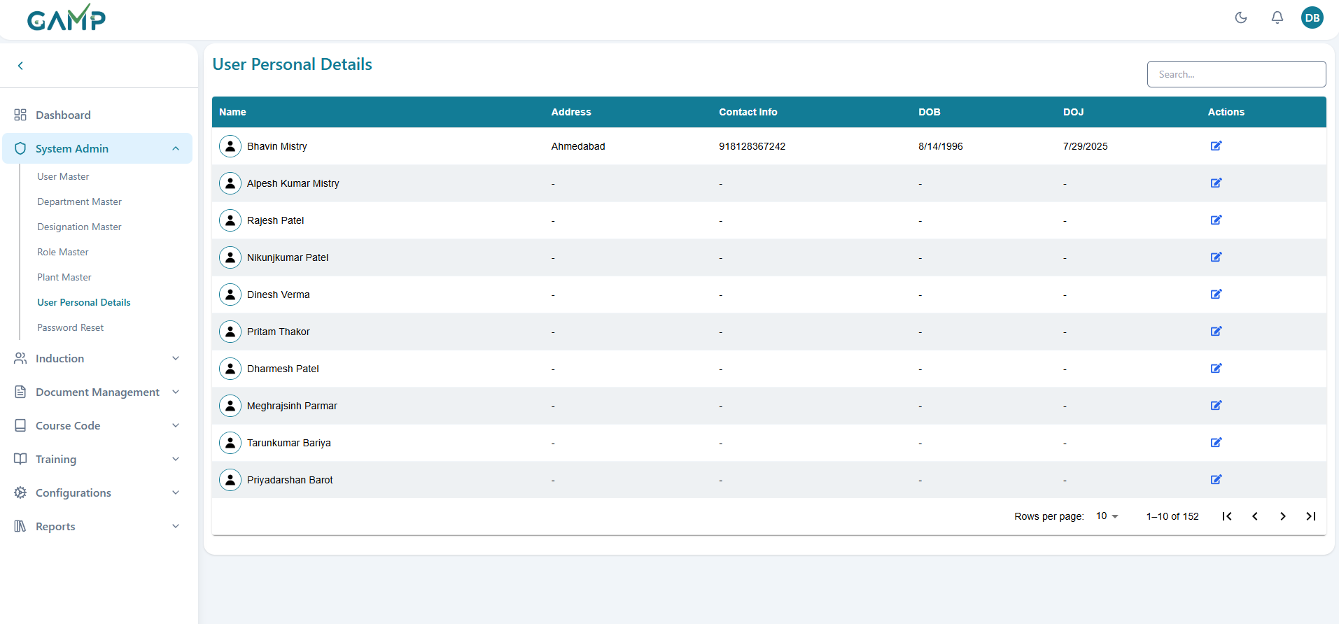

**Step 2 – Search for the User**

1. Use the **Search** box on the top-right to quickly find a specific user by name or other details.

**Step 3 – Open the Edit Screen**

1. Locate the user whose details you want to update.
2. Click the **Edit** icon (pencil symbol) under the *Actions* column.

**Step 4 – Update the User Details**

1. On the **Edit User Personal Details** screen, you can modify the following fields:
   * **First Name** and **Last Name**
   * **Date of Birth** and **Date of Joining**
   * **Address**
   * **Contact No** and **Emergency No**
   * **Blood Group**
   * **Father’s Name** and **Mother’s Name**
   * **Total Experience** (Years and Months)
2. Ensure that all **mandatory fields** (marked with a red asterisk *) are filled in correctly.

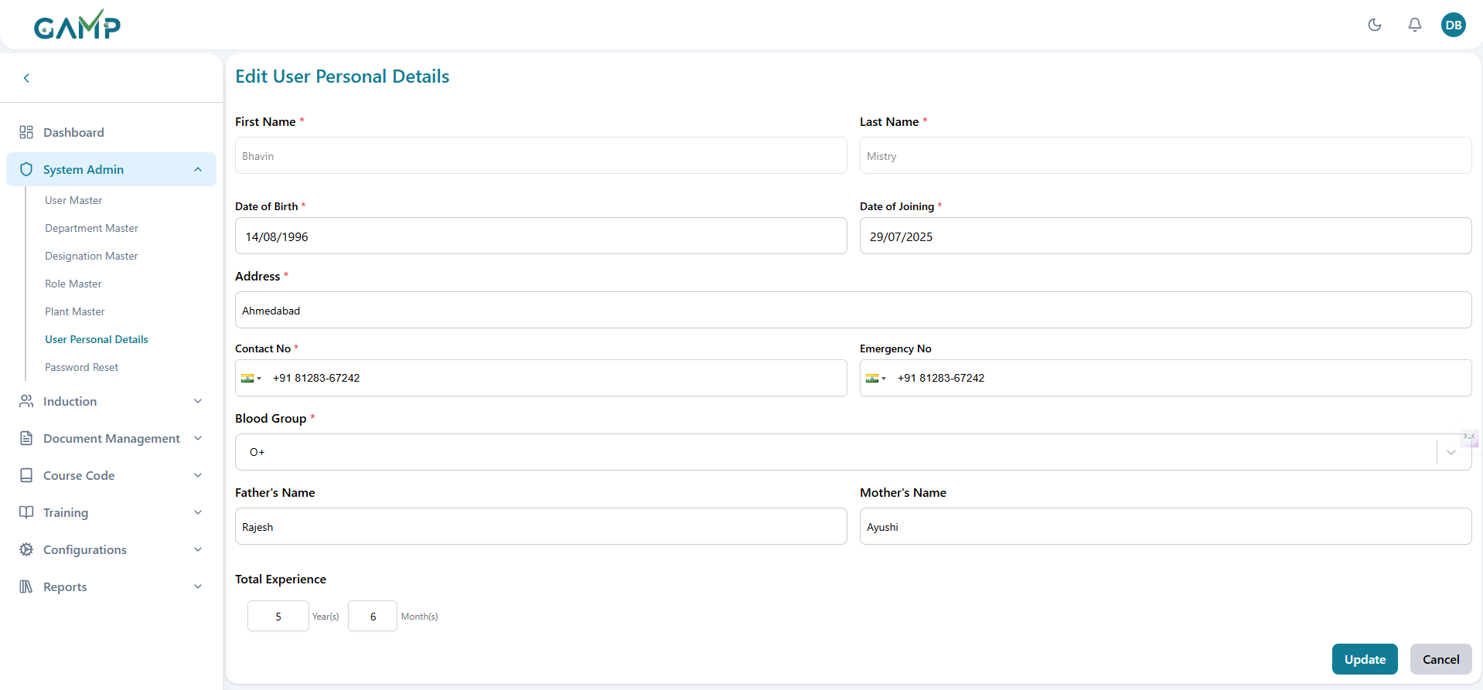

**Step 3 – Save the User Personal Details**

1. Click **Update**.
2. The **Electronic Signature** pop-up will appear.

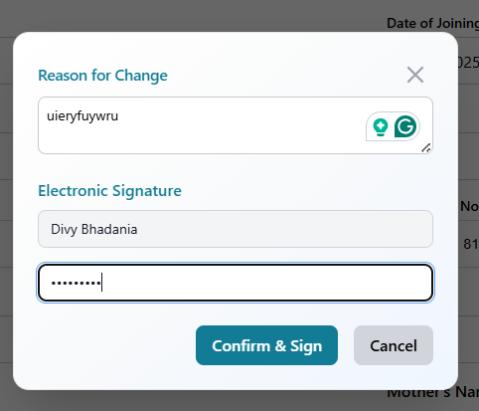

* 1. **Username** – Fetched automatically from the logged-in user’s account (read-only).
  2. **Reason for Change** – Mandatory text field where the user must provide a clear reason for modifying the personal details.
  3. **Password** – Enter your account password to authenticate the change request.

1. Upon successful authentication, a confirmation message is displayed and the updated personal details are saved in the system.

## Password Reset

When a user reaches the maximum limit for incorrect password attempts, their account is automatically locked. In this situation, the user has the option to initiate a password reset request.

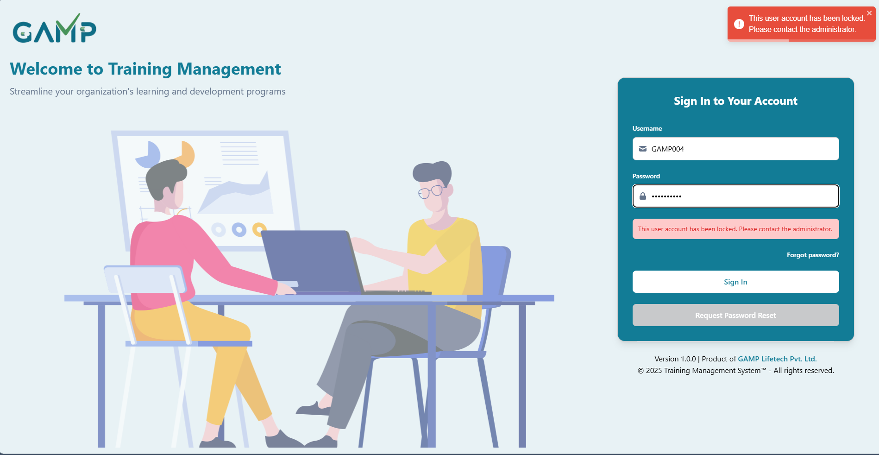

1. **Initiating the Request**

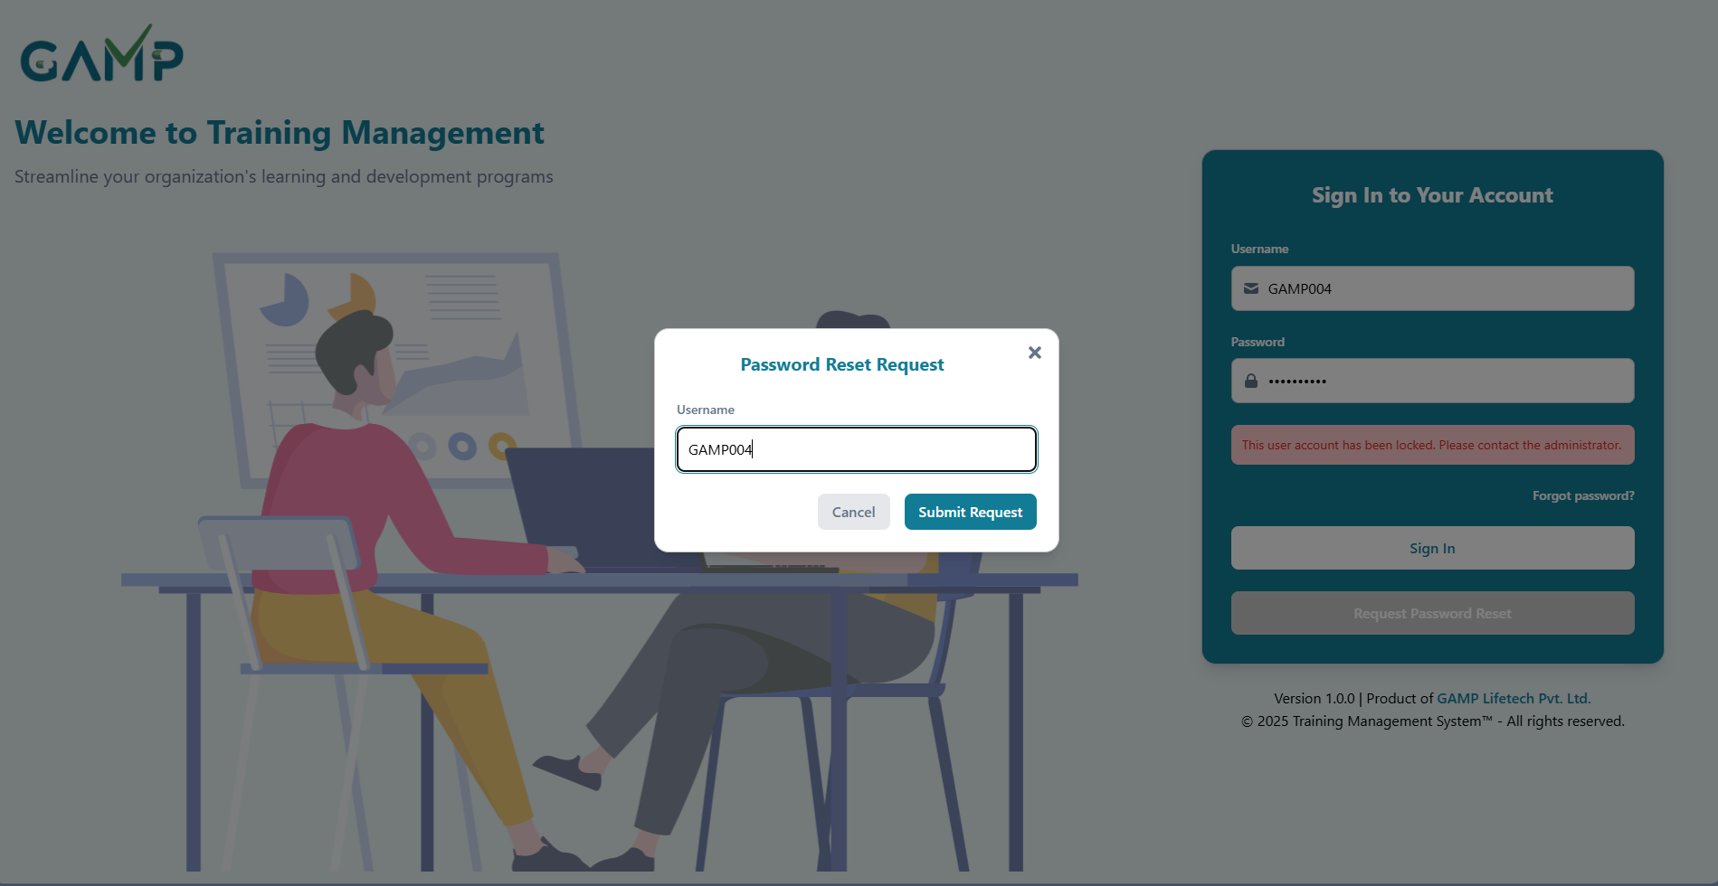

* + The locked-out user clicks the **Reset Password** button on the login page.
  + They enter their **username** in the provided field and submit the request.

1. **Request Queue (Manager’s View)**
   * The request is sent to the **Password Reset Request** section of the user’s **Reporting Manager**.
   * This section displays a list of all pending reset requests from users who directly report to the manager.
   * For each request, the following details are displayed:
     1. **Employee ID**
     2. **Name of the user** who requested the reset
     3. **New Password** – Input field where the manager can enter a new password
     4. **Action Icon** – A save button (floppy disk icon) to submit the password reset
2. **Resetting the Password**
   * The Reporting Manager selects the request.
   * An **input field** is available to set a **new password** for the concerned user.
   * The manager enters the new password and clicks the **Action** (confirm/reset) button.
3. **Post-Reset**
   * Once the password is reset, the concerned user can log in using the **new password**.
   * Upon successful login, normal system access is restored.

**Note:** Managers should follow the organization’s password policy when assigning a new password.

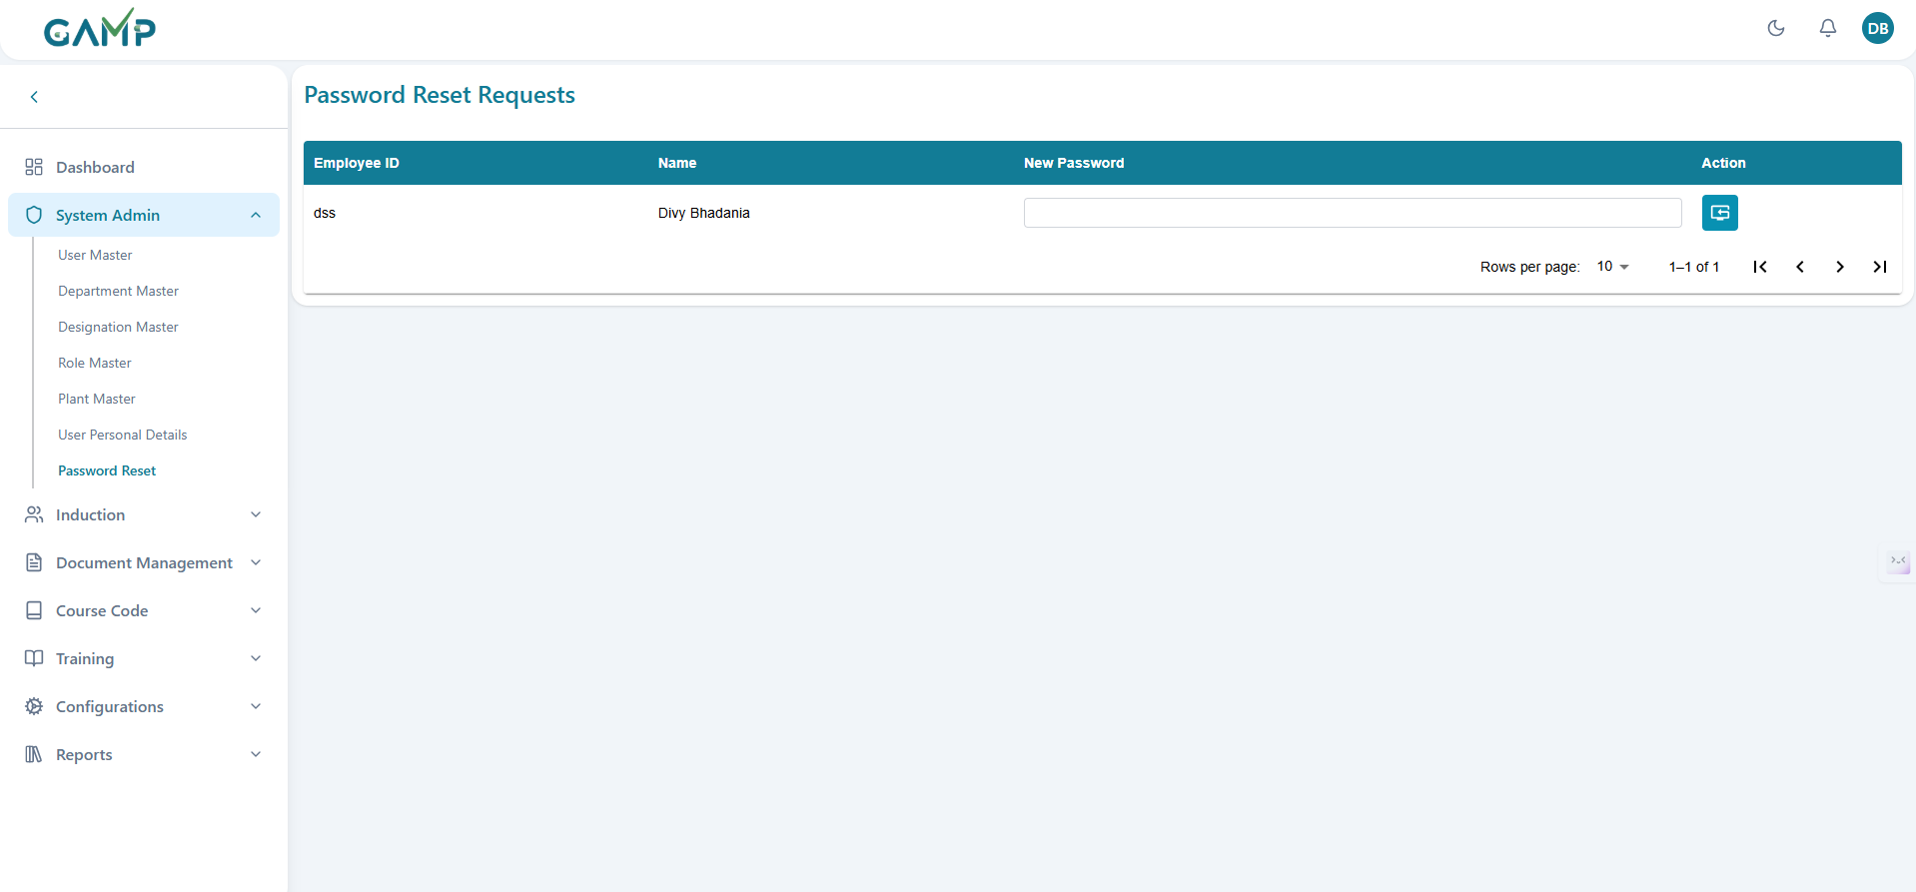

# Induction

## 1.Induction Assign

The Induction Assign module is used to assign induction training to users, specify due dates, and track the status of completion.

**Step 1: Navigate to the Induction Assignment Module**

* Login to the system using your assigned credentials.
* From the dashboard, go to **Induction → Induction Assignment**.

**Step 2: View Existing Assignments**

Columns shown: **User Name**, **Due Date**, **Induction Status**, **Assigned By**, **Assigned On**, **Action**s.

**Step 3: Assign Induction to a User** 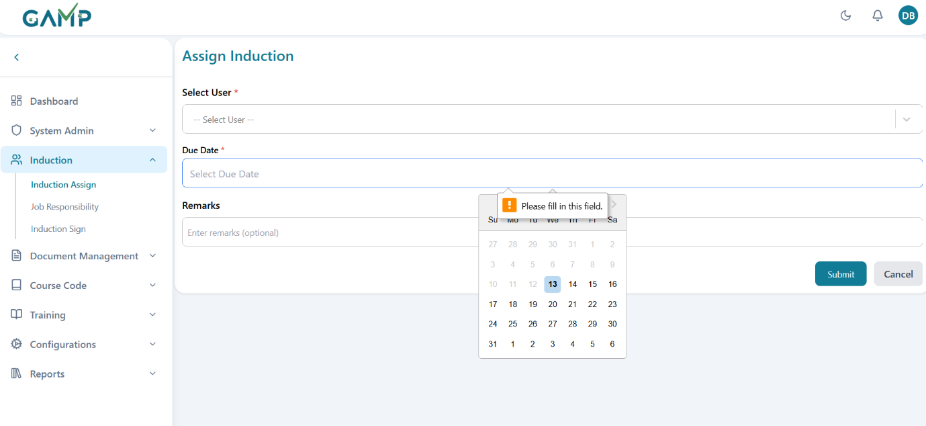

1. Click the **Add New Assignment** button.
2. Fill in the details:

* **Select User**\* – Choose the user from the dropdown.It must be an user who has not been assigned any induction before;
* **Due Date**\* – Select a completion deadline.It must be **today or a future date**; cannot be before *Assigned On*.
* **Remarks** *(Optional)* – Free text for additional notes.

Default status after save: **Assigned**

1. Click **Save** to confirm.
2. **Electronic Signature(if enabled)** pop-up appears:
3. **Username** – auto-filled (read-only).
4. **Password** – enter your login password to authorize.
5. If authentication succeeds, a **confirmation message** appears and the record is added to the list.
6. If the password is incorrect, the system prompts you to re-enter it; no data is saved until successful authentication.

**Note:** Once saved, the user will be notified via system notification or email (if configured).

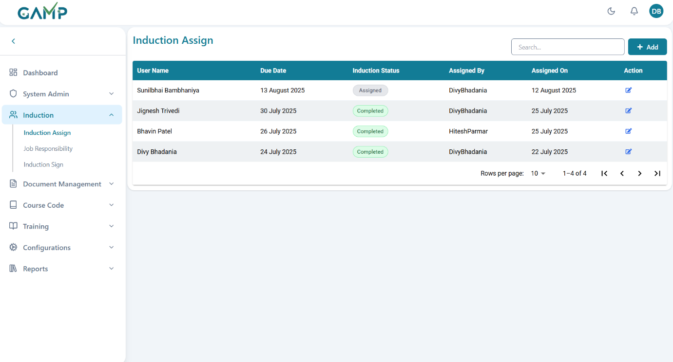

**Step 4: Edit an Existing Assignment**

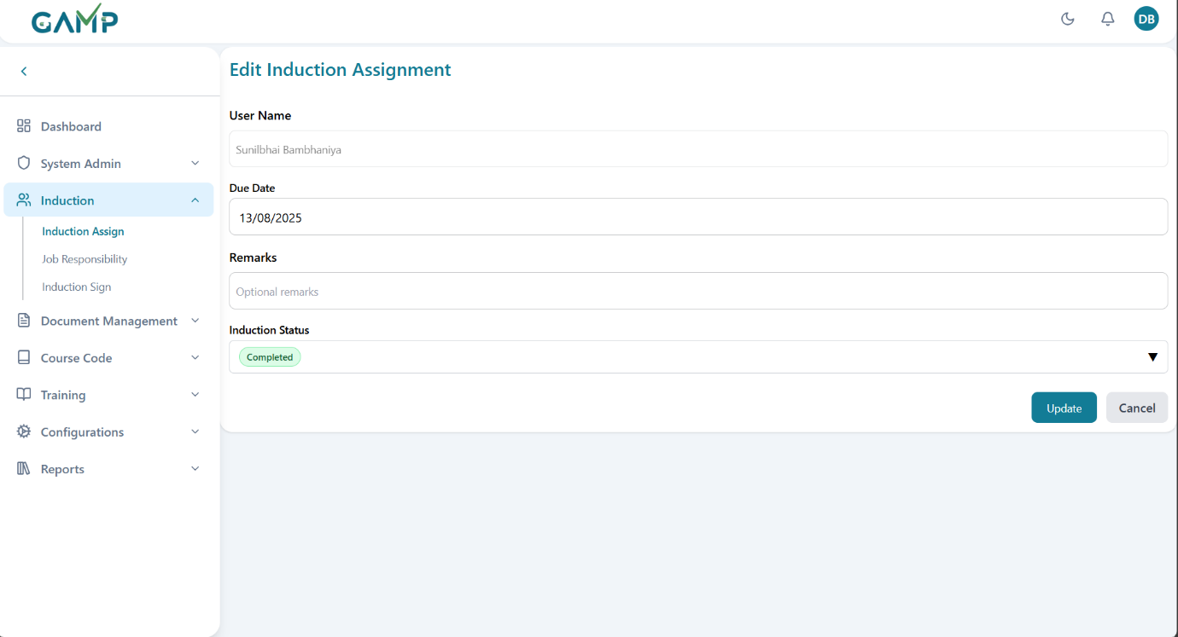

1. From the listing page, click **Edit** **(pencil) icon** in the Actions column.
2. Update allowed fields (typically **Due Date** and **Remarks**).
3. Save the changes
4. **Electronic Signature** pop-up appears:

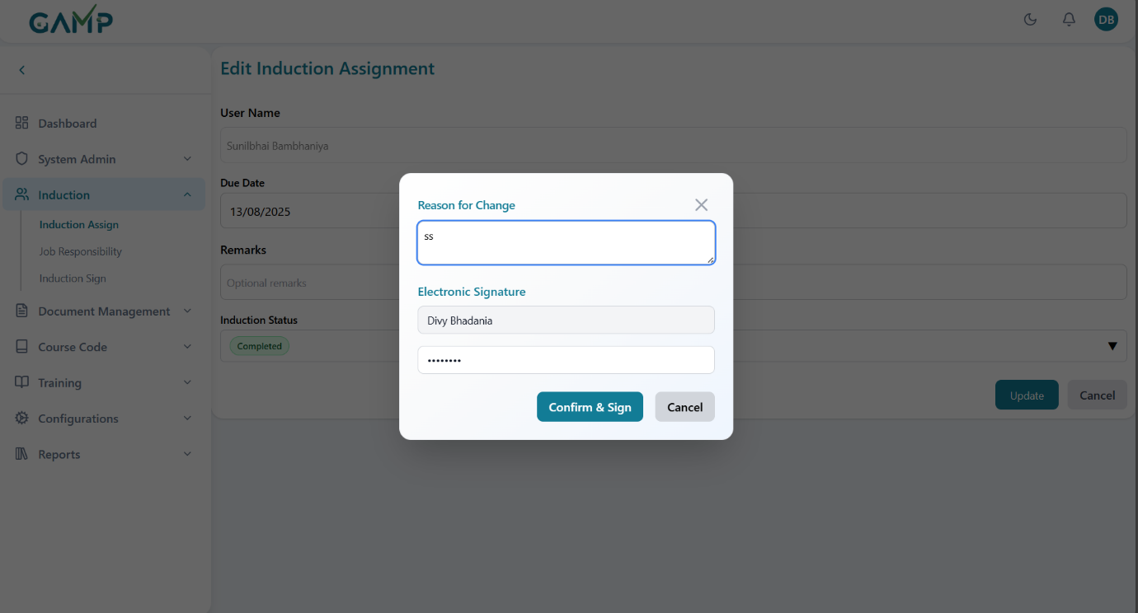

* 1. **Username** – auto-filled.
  2. **Reason for Change** – **mandatory** (min 5, max 200 chars).
  3. **Password** – enter to authenticate.

1. On success, a confirmation message is shown and the list reflects the changes.  
     
   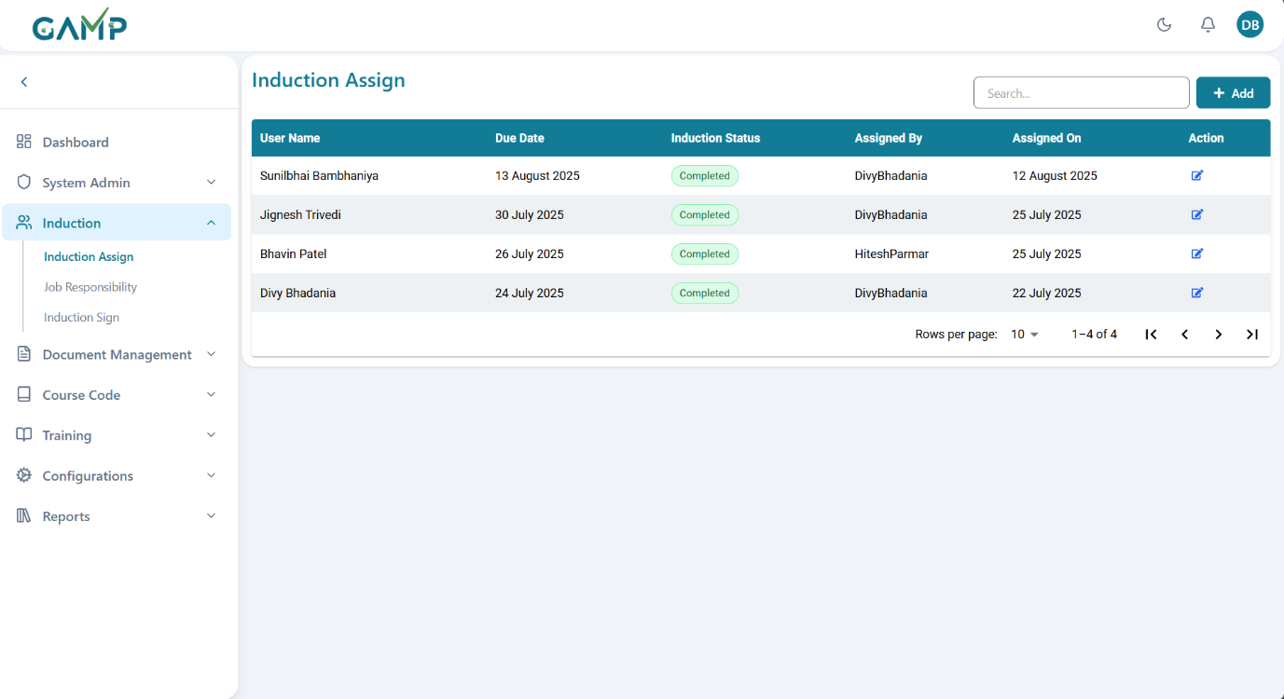

**Note** If **Notification Configuration** is enabled, users receive assignment and due-date reminders automatically.

## 2.Job Responsibility

The **Job Responsibility** module maintains a controlled master list of role-specific responsibilities and (optionally) links them to departments/designations for training and compliance references.

1) Adding a New Job Responsibility

**Step 1 – Access Job Responsibility**

1. Go to **Induction → Job**
2. The **Job Responsibility Listing** page opens.

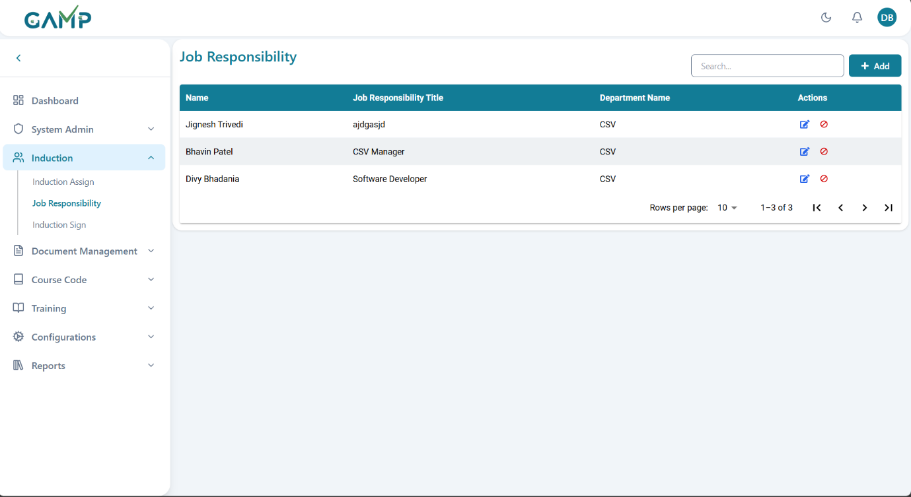

**Step 2 – Open Add Form**

1. Click **Add** to create a new entry.

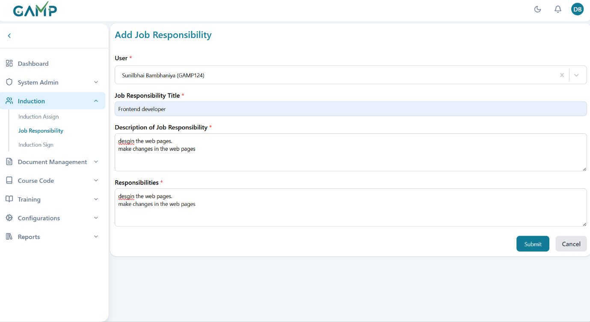

**Step 3 – Fill in Details**

In the **Add Job Responsibility** form, enter the following details:

1. **User** *(Mandatory)* – Select the user from the dropdown. The dropdown supports search and infinite scrolling. Only the users who have been assigned induction are available for selection.
2. **Job Responsibility Title** *(Mandatory)* – Enter a clear title summarizing the role.
3. **Description of Job Responsibility** *(Mandatory)* – Provide a detailed description of the role’s purpose, scope, and expectations.
4. **Responsibilities** *(Mandatory)* – Enter a list of key tasks and obligations associated with the role.

**Step 4 – Save the Job Responsibility**

1. Click **Submit**.

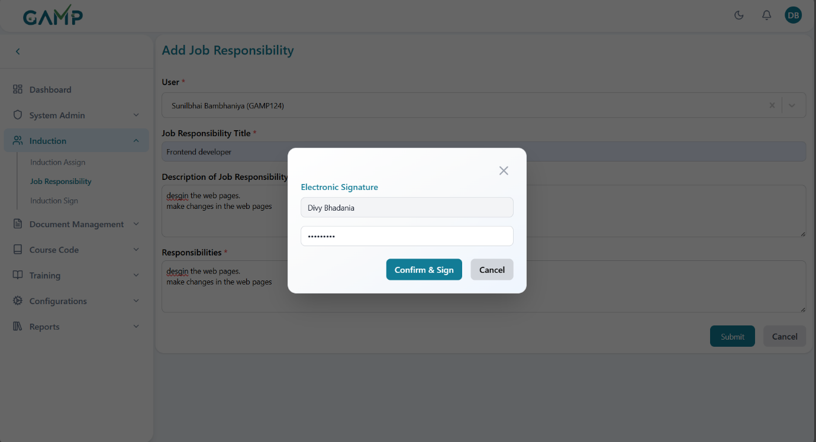

1. The **Electronic Signature(if enabled)** pop-up will appear:
   1. The **Username** is auto-fetched.
   2. Enter your **Password** to authenticate the action.
   3. If the password is incorrect, the system prompts for re-entry until correct.
2. Upon successful authentication, a confirmation message appears.
3. The newly created job responsibility will be listed in the Job Responsibility List page.

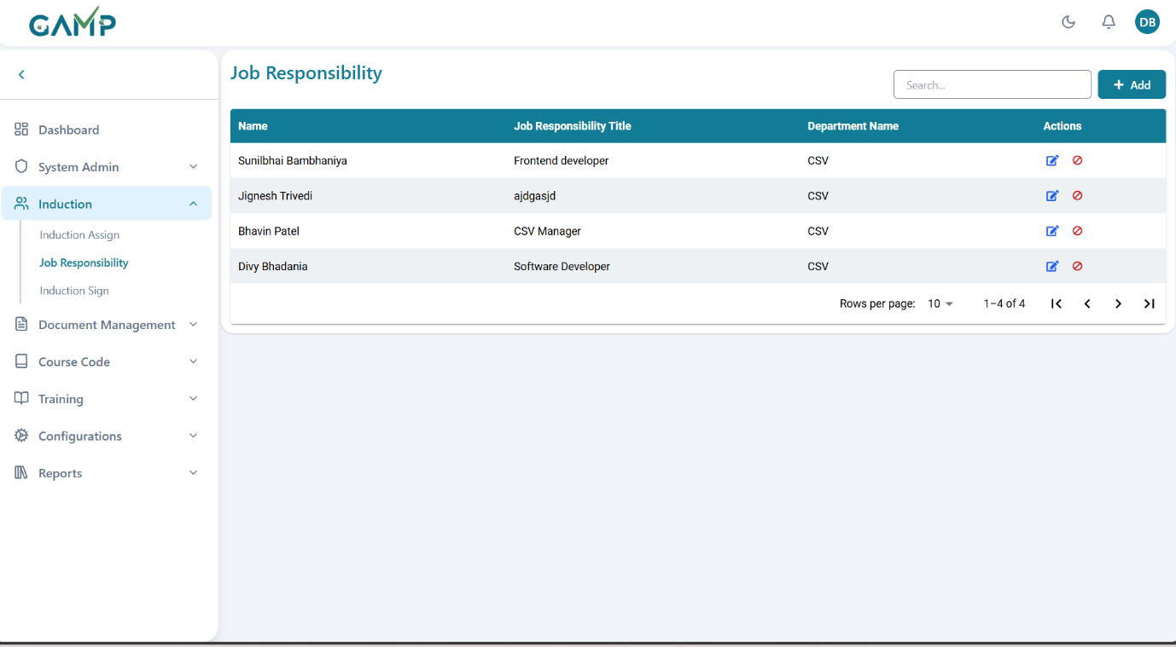

**2**) Editing an Existing Job Responsibility

**Step 1 – Locate the Job Responsibility**

1. Use the **Search** bar to find the required record by user name or responsibility title.

**Step 2 – Modify Job Responsibility Details**

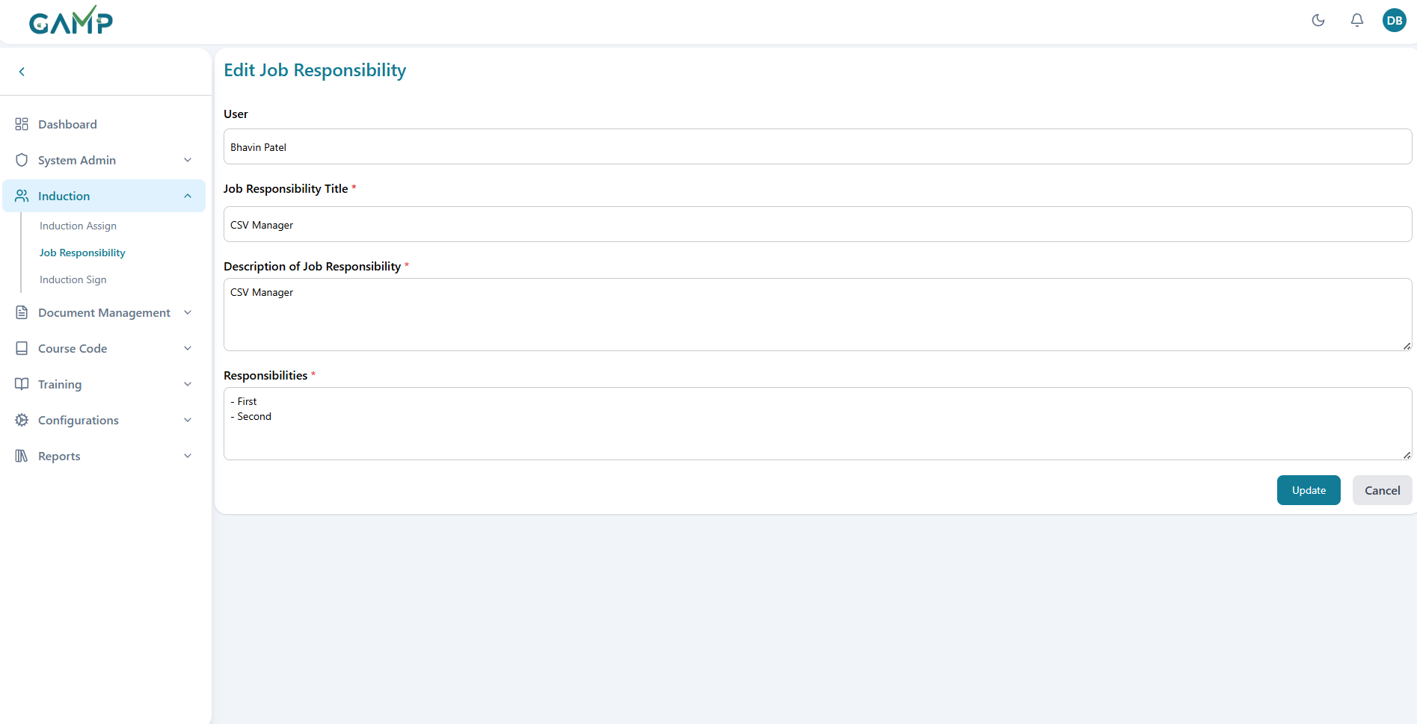

1. Click the **Edit** icon in the *Actions* column.
2. The **Edit Job Responsibility** form will appear with pre-filled data.
3. Update the relevant fields:
   * User (if applicable)
   * Job Responsibility Title
   * Description of Job Responsibility
   * Responsibilities

**Step 3 – Save the Updated Job Responsibility**

1. Click **Update**.

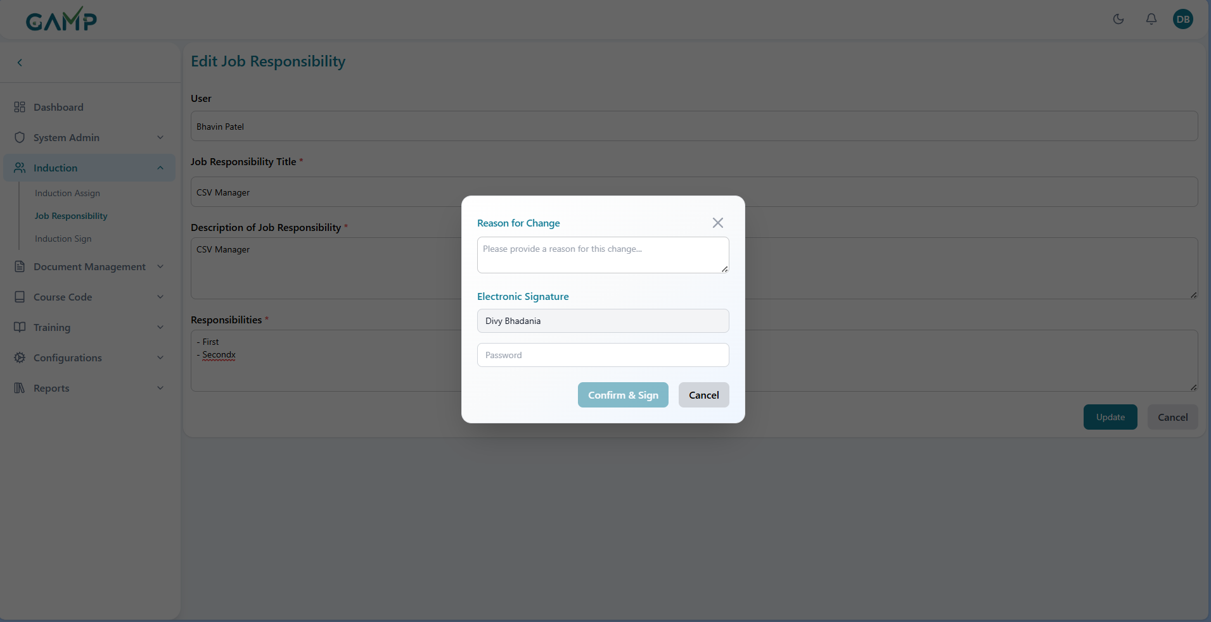

1. The **Electronic Signature(if enabled)** pop-up will appear:
   1. **Username** is auto-fetched.
   2. Enter **Reason for Change**.
   3. Enter your **Password** to authenticate.
2. Upon successful authentication, a confirmation message will display indicating that the job responsibility has been updated.

3) Deactivating (Retiring) a Job Responsibility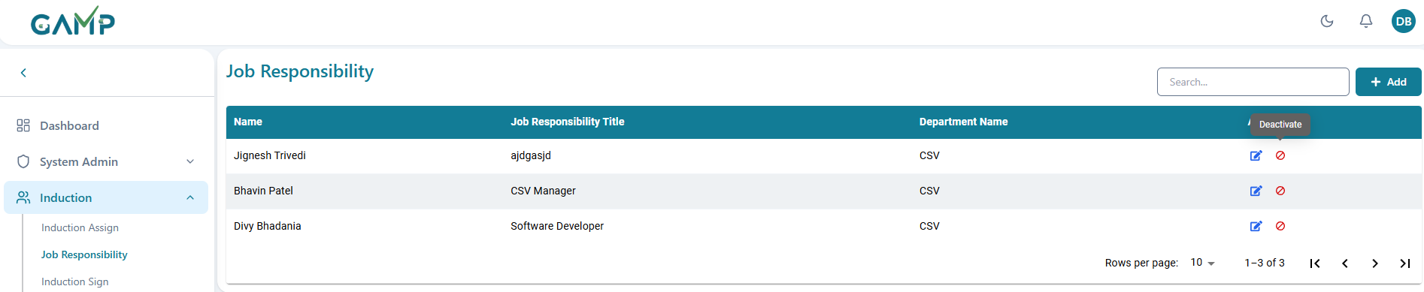

1. Click **Deactivate** in Actions for the selected record.
2. In the **Electronic Signature** pop-up, provide **Reason for Change** (mandatory) and **Password**.

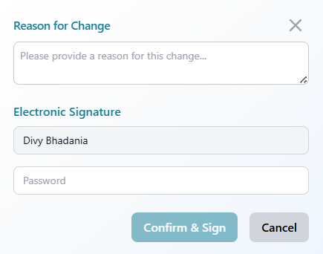

1. **Confirm & Sign**.
2. Record is marked **Inactive** and hidden from new mappings (remains in audit reports).

3.Induction Sign  
**Preconditions**

1. **Job Responsibility Assignment**.The user must have at least one valid *Job Responsibility* assigned.
2. **Induction Assignment**. The user must have his Induction as completed.
3. **System Validation**
   * If **either** the induction assignment or job responsibility assignment is missing:
     + The system will not allow the sign off.

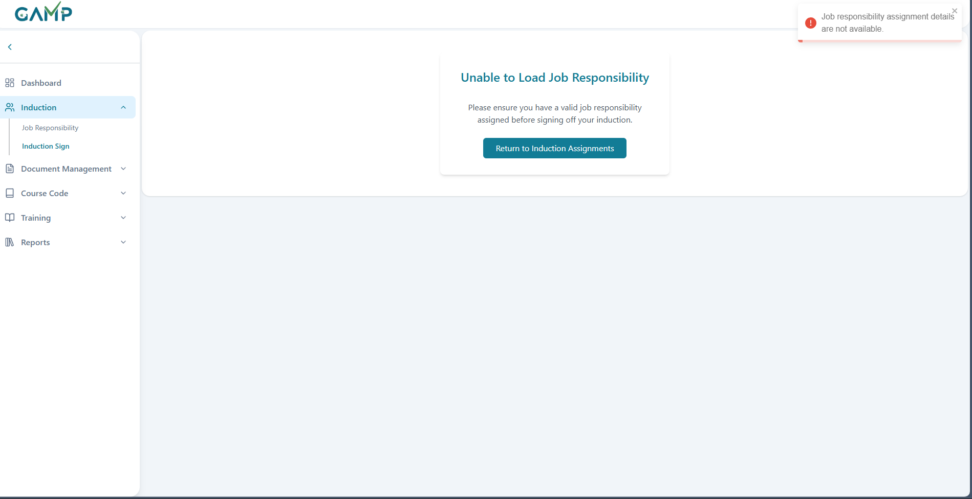

**Steps to Perform Induction Sign-Off**

**Step 1 – Access Induction Sign-Off Screen**

* Navigate to **Induction → Induction Sign** in the left-hand menu.
* The screen displays:

**Employee Name & ID**, **Plant Name & Department, Assigned Job Description Title, Description of Responsibilities** and **Responsibilities**

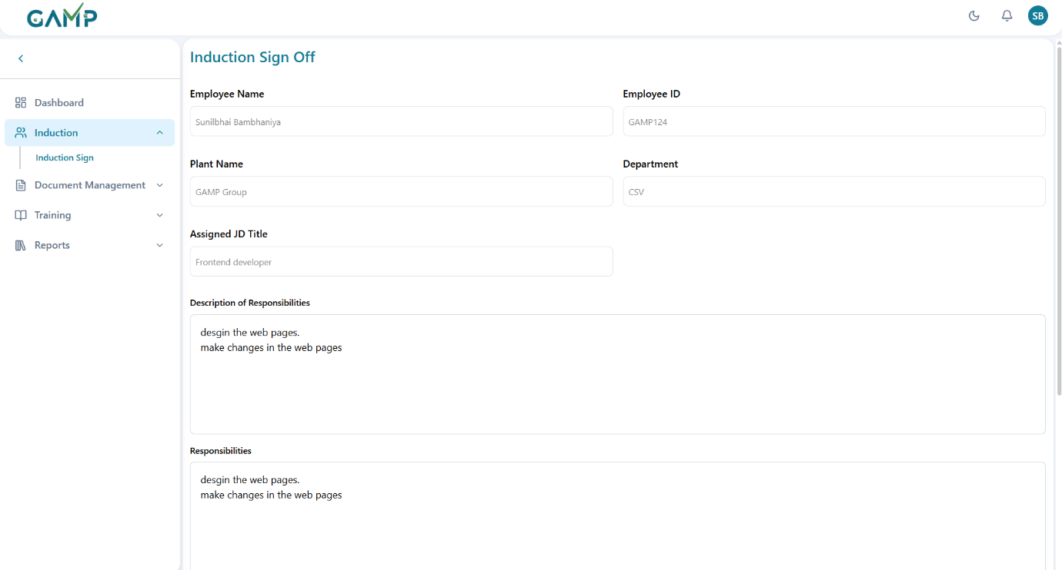

**Step 2 – Review Assigned Job Responsibility**

* Read through the **Description of Responsibilities** carefully.
* Verify that the listed **Responsibilities** match your role.

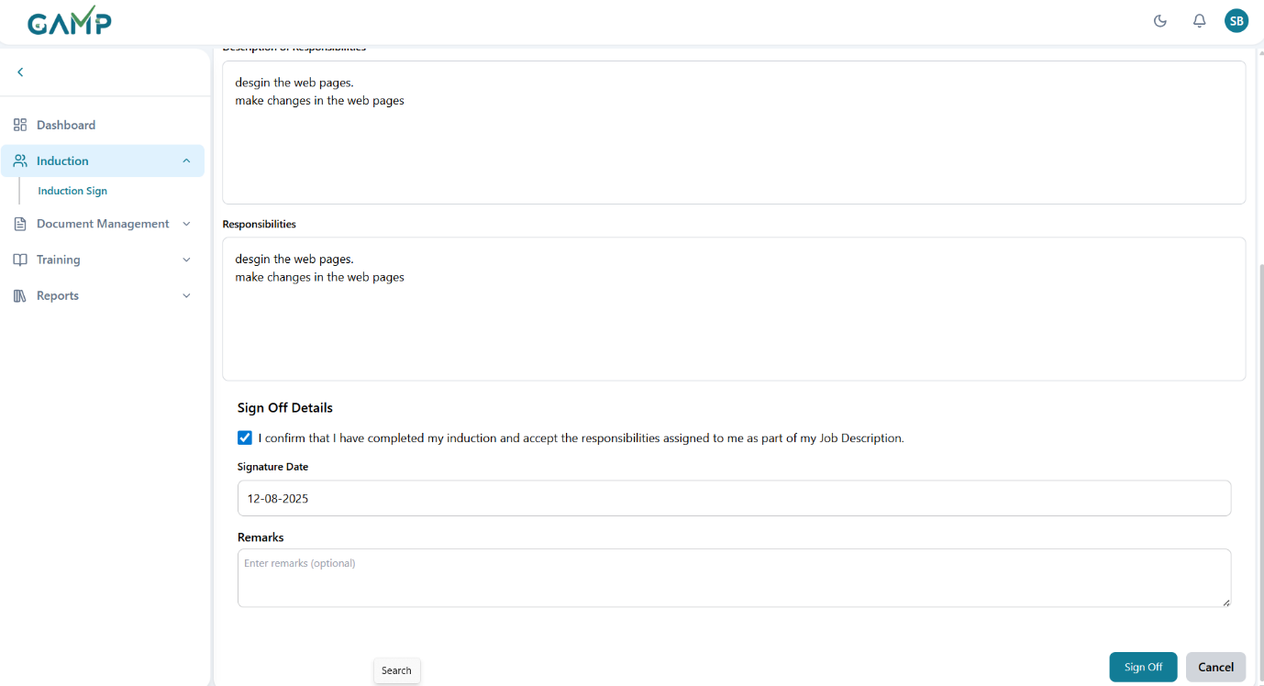

**Step 3 – Acknowledge Completion**

* Check the **confirmation box**:
  + *"I confirm that I have completed my induction and accept the responsibilities assigned to me as part of my Job Description."*

**Step 4 – Provide Electronic Signature**

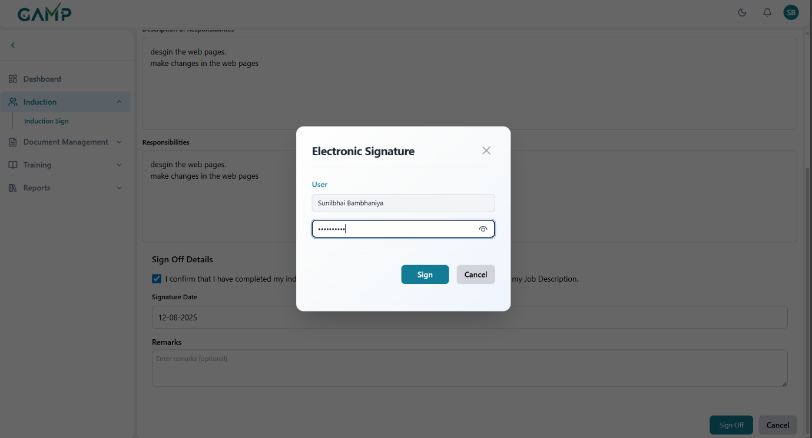

* **Electronic Signature Components**:
  1. **Signature Date** – Select or auto-populate current date.
  2. **Digital Confirmation** – The act of checking the confirmation box combined with your system login credentials serves as your e-signature.

**Step 5 – Submit Sign-Off**

* Click **"Sign Off"** to save your acknowledgment.
* The system locks **induction** and **job responsibility** content for editing unless reassignment occurs.

**Special Rule – Re-Sign After Changes**

* If **any change** is made to:
  1. **Induction content** OR
  2. **Job Responsibility details**
* The previous sign-off becomes invalid.
* User **must** complete the Induction Sign-Off process **again**.

# Document Management

## Document Registration

Register controlled documents (e.g., SOPs, Policies, Protocols, Videos) with the metadata and source file required for training and compliance. The module also lets you view, edit, supersede, and set effective/review dates.

**1) Access the Module**

1. Log in to TMS.
2. Go to **Document Management → Document Registration**.

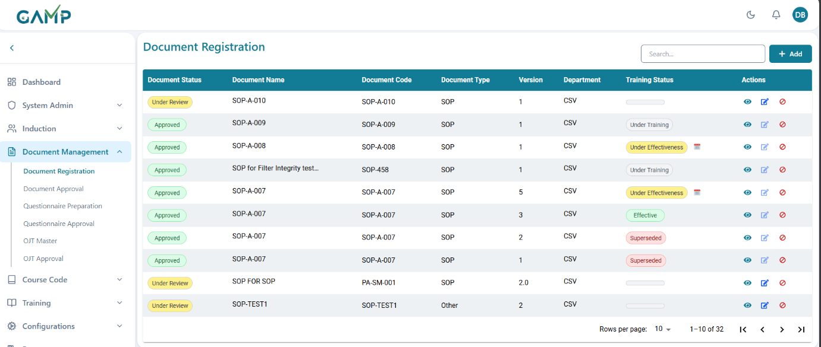

1. The **Listing** shows each record with columns:
   * **Document Status**-Indicates the current stage of the document
2. **Under Review**: Pending approval.
3. **Approved**: Authorized for use.
4. **Rejected**: Not valid for use
5. **Returned**: Returned to maker for changes
   * **Document Name** - The official title of the document, giving clarity on content
   * **Document Code / Unique Code -** Alphanumeric code ensuring each document is uniquely identifiable (e.g., *SOP-QA-001*)
   * **Document Type** (SOP/Policy/Protocol/Other…)
   * **Version** - Reflects controlled revisions of the document. Ensures traceability of changes (e.g., Version 1.0, 2.0)
   * **Department -** The responsible functional area (e.g., QA, QC, Production, HR) which helps in ownership & training allocation.
   * **Training Status** - Links document lifecycle with employee training compliance:
     1. **Under Training**: Employees assigned but training incomplete.
     2. **Under Effectiveness**: Training done, effectiveness checks ongoing.
     3. **Effective**: Training completed, document in official use.
     4. **Superseded**: Replaced by a newer version, not valid for training/use.
   * **Actions**:
     1. **View**
     2. **Edit**
     3. **Deactivate**
     4. *calendar icon* (set **Effective Date** & **Next Review Date** when applicable)

### 1) Add a New Document

**Step 1 – Open the Add Form**

Click **Add** on the listing page. The **Document Registration** form opens.

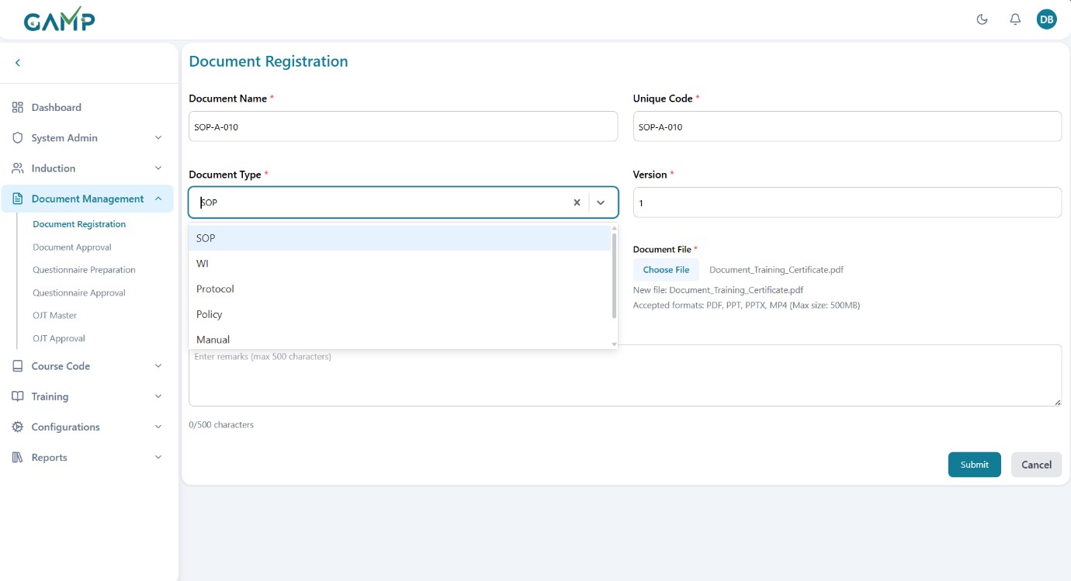

**Step 2 – Complete the Fields**

1. **Document Name**\* – 5–150 characters. Use your organization’s naming convention.
2. **Unique Code**\* – e.g., SOP-001.It must be unique; accepts letters/numbers/- and /
3. **Document Type**\* – select from the dropdown (SOP, WI, Policy, Protocol, Manual, Other,).
4. If it is Other, then an input field named Custom Document Type will be there next to the Document Type dropdown where you can enter the name of the custom document type.
5. **Version**\* – e.g., 1 or 1.0.It must be numeric/decimal and cannot be less than an existing version for the same code.
6. **Estimated Reading Time (minutes)**\* – total time a trainee needs to read/watch.
7. **Document File**\* – upload the source file. Allowed file formats are **PDF, PPT, PPTX, MP4**; **max 500 MB** (as displayed on the screen).
8. **Remarks** – optional; up to **500 characters**.

**Step 3 – Submit & E-Sign**

1. Click **Submit**.

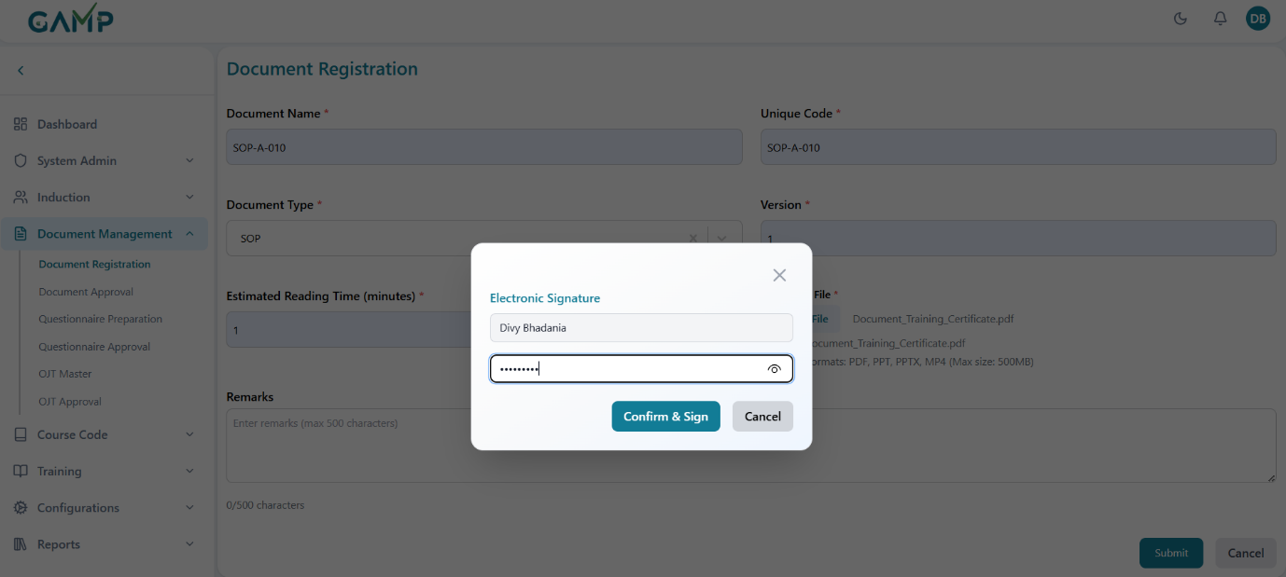

1. **Electronic Signature** **(if enabled)** pop-up appears:
   * **Username** is auto-fetched.
   * Enter your **Password** to authenticate.
   * On wrong password, you’ll be prompted to re-enter.
2. On success, a confirmation message appears.
3. **Result:** the document is created and typically goes to **Under Review** (to be processed in *Document Approval*).

For all roles other than QA, they can see the documents of their departments only in the grid, but for QA, they can see the documents of all the departments and can edit/deactivate them also.

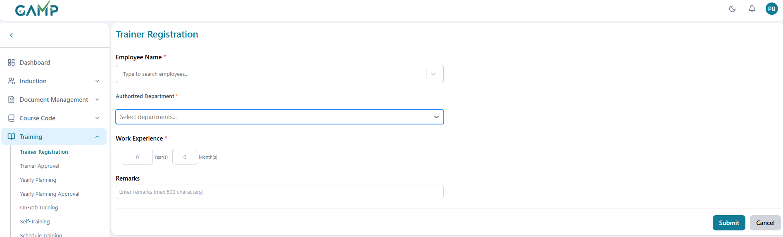

### 2) View a Document

1. In the listing, click **View**.

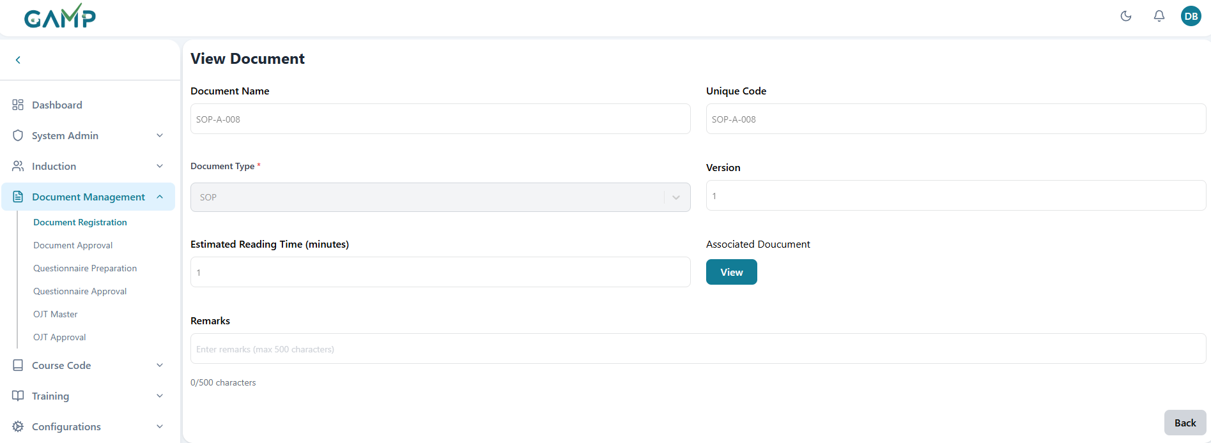

1. The **View Document** page shows read-only metadata and a **View** button to open the **Associated Document** file.
2. The Associated Document gets downloaded in your device and you can view it accordingly.
3. Click **Back** to return to the list.

### 3) Edit a Document

**Step 1 – Open Edit**

* In the listing, click **Edit** for the target document. The form opens with current values.
* The **Edit** action is disabled for the documents with **Document Status** as **Approved.** Only **under review** documents are allowed for editing.

**Step 2 – Update Fields**

* You may update the desired fields which needs to be updated.
* **Versioning rules:**
* If you replace the **Document File** or make a controlled change, update **Version** according to your SOP (e.g., from 1.0 → 2.0).
* The system does not allow decreasing the version.

**Step 3 – Update & E-Sign**

1. Click **Update**.
2. **Electronic Signature** **(if enabled)** pop-up appears:
   * **Username** auto-fetched
   * **Reason for Change** (mandatory)
   * **Password** (mandatory)
3. On success, you’ll see a confirmation and the record is updated.
4. Depending on your process, edits may re-route the document for **Approval**.

**5) Set Effective Date & Next Review Date**

*(Available once the document is Approved and training status is* ***Under Effectiveness*** *and the calendar icon is visible.)*

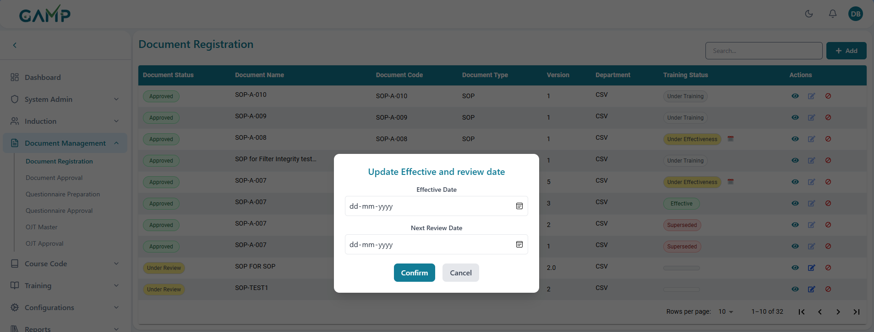

**Step 1 – Open the Date Dialog**

* Click the **calendar icon** in the **Training Status** column.

**Step 2 – Enter Dates**

1. **Effective Date**\* – the date the document becomes active. It must be *today or a future date*
2. **Next Review Date**\* – the due date for periodic review. It must be **on/after Effective Date**.

**Step 3 – Confirm & E-Sign**

1. Click **Confirm**.
2. **Electronic Signature** pop-up appears (Username auto-fetched, Password required).
3. On success, dates are saved and the **Training Status** updates according to workflow (e.g., remains **Under Effectiveness** until all training/effectiveness tasks are complete, then becomes **Effective**).

### 4) Deactivate a Document

Use this when a new version replaces the old one or the document is no longer valid.

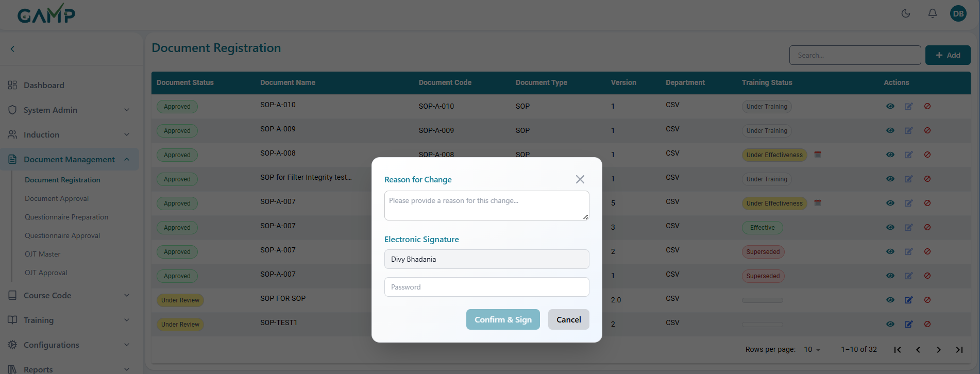

**Step 1 – Initiate**

Click **Deactivate** in the **Actions** column.

**Step 2 – E-Sign & Reason**

**Electronic Signature** **(if enabled)** pop-up appears:

* 1. **Username** auto-fetched
  2. **Reason for Change** (mandatory)
  3. **Password** (mandatory)

Confirm to proceed.

**Step 3 – Result**

* The document disappears from the document registration grid.
* The record is retained for audit; **view** is restricted to authorized roles.
* Training assignments on the superseded version are blocked; users are guided to the latest effective version.

**7) Understanding Status Labels**

**Document Status**

* **Under Review** – submitted for review/approval; not yet effective.
* **Approved** – approved by the designated approver(s) in the *Document Approval* module.

**Training Status**

* **Under Training** – training assignments are open; trainees still completing.
* **Under Effectiveness** – effectiveness evaluation period or date setting pending; use Calendar icon to set **Effective** and **Next Review** dates.
* **Effective** – document is live; only latest effective version is distributed for use.
* **Superseded** – replaced by a newer version; kept for audit only.

## Document Approval

The **Document Approval** module allows authorized users to review, approve, or reject documents that have been submitted for approval. Each document goes through this process before it can be officially released for use.

1. **Navigate to Document Approval**
   * From the left menu, click **Document Management → Document Approval**.
   * A list of documents pending approval in the role which has been configured for **Approval** will be displayed.

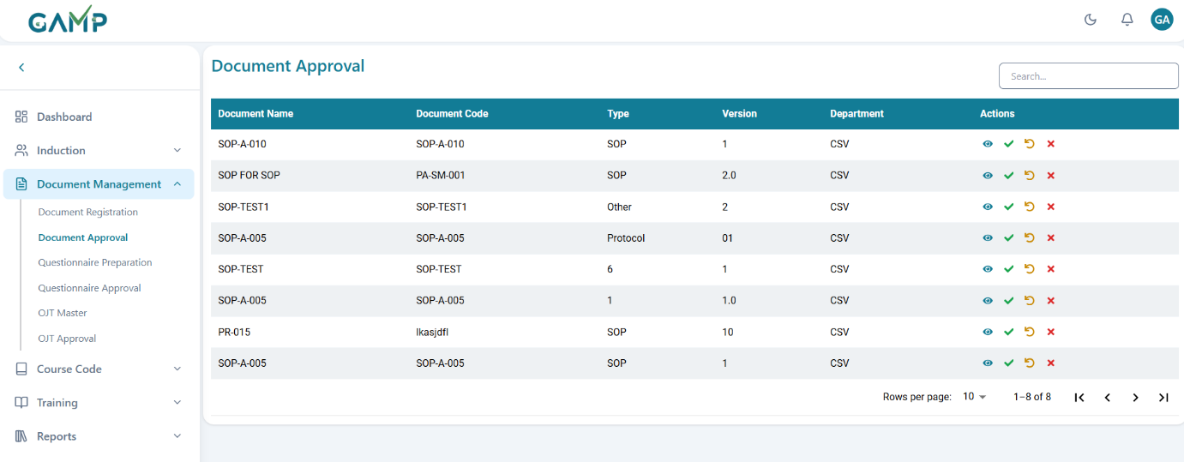

1. **Review the Document List**

Each row displays key details:

* + **Document Name** – Title of the document.
  + **Document Code** – Unique identifier/code for the document.
  + **Type** – Document type (e.g., SOP, Protocol, Other).
  + **Version** – Current version of the document under review.
  + **Department** – Department to which the document belongs.

1. **Search for a Document**
   * Use the **Search bar** on the top right to quickly locate a specific document by name or code.
2. **View Document Details**

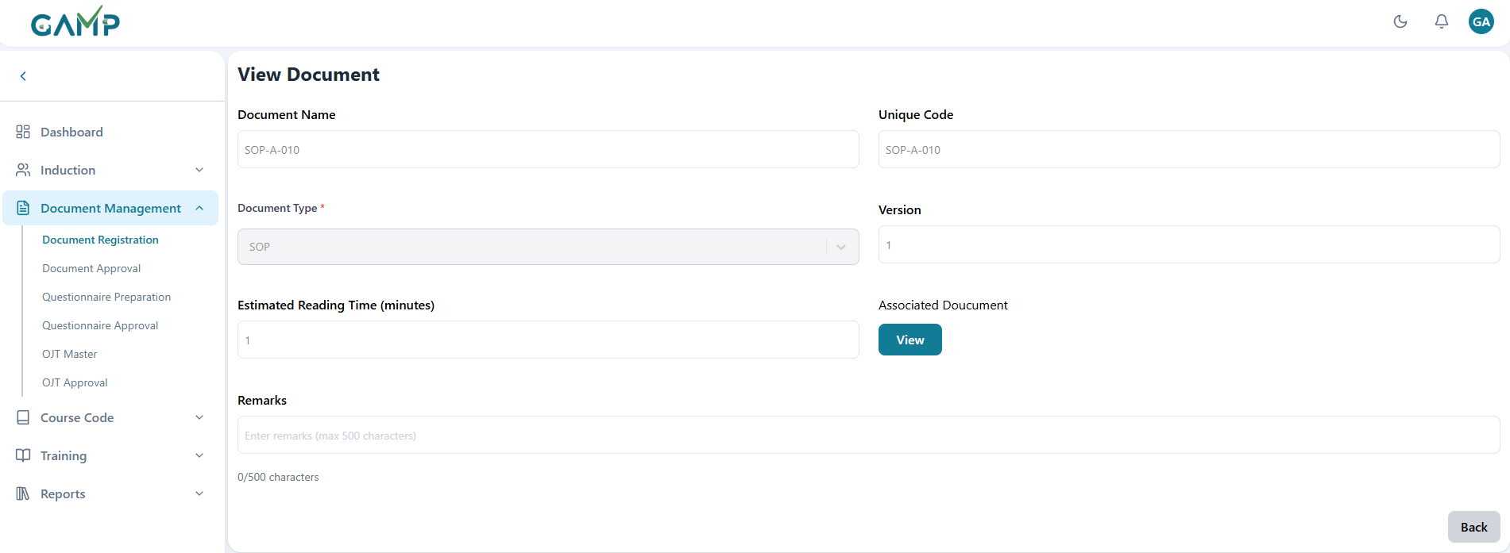

* + Click the **Eye icon**  under the **Actions** column to open and review the **document detail**s added as it is as the document registration.
  + When the user clicks on the **View** button in the *Associated Document* field, the attached document opens in a separate document viewer
  + The viewer allows the user to conveniently navigate through and read all pages of the document in detail.

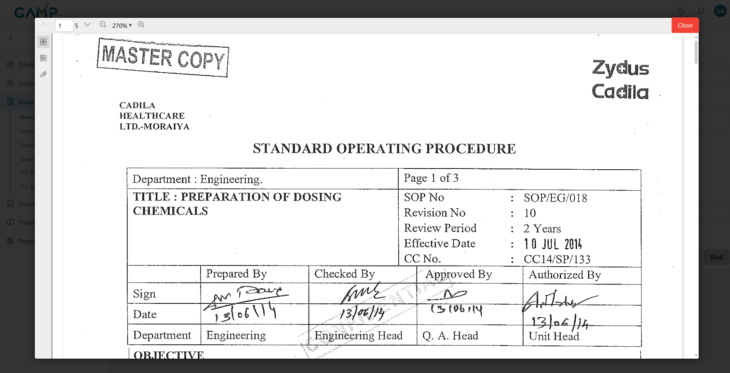

1. **Approve a Document**
   * Click the **Green Check (✔)** icon to approve the document.
   * The **Electronic Signature** pop-up will appear:
     1. Enter the approval remarks in the reason for change input field.
     2. The **Username** is auto-fetched.
     3. Enter your **Password** to authenticate the action.
   * If the password is incorrect, the system prompts for re-entry until correct.
   * Upon successful authentication, a confirmation message appears.
   * Once approved, the document becomes available for use within the system.
2. **Reject a Document**
   * Click the **Red Cross (✖)** icon to reject the document.
   * The **Electronic Signature** pop-up will appear:
     1. Enter the rejection remarks (why it is rejected**)** in the reason for change input field.
     2. The **Username** is auto-fetched.
     3. Enter your **Password** to authenticate the action.
   * If the password is incorrect, the system prompts for re-entry until correct.
   * Upon successful authentication, a confirmation message appears.
   * The document will be removed from the system and no further transactions can be done with that document.
3. **Send Back / Return**
   * Click the **Circular Arrow (↺)** icon to return the document back for revisions without outright rejecting it.
   * The **Electronic Signature** pop-up will appear:
     1. Enter the return remarks (why it is returned or changes which needs to be done**)** in the reason for change input field.
     2. The **Username** is auto-fetched.
     3. Enter your **Password** to authenticate the action.
   * If the password is incorrect, the system prompts for re-entry until correct.
   * The document will be returned to the creator for corrections.

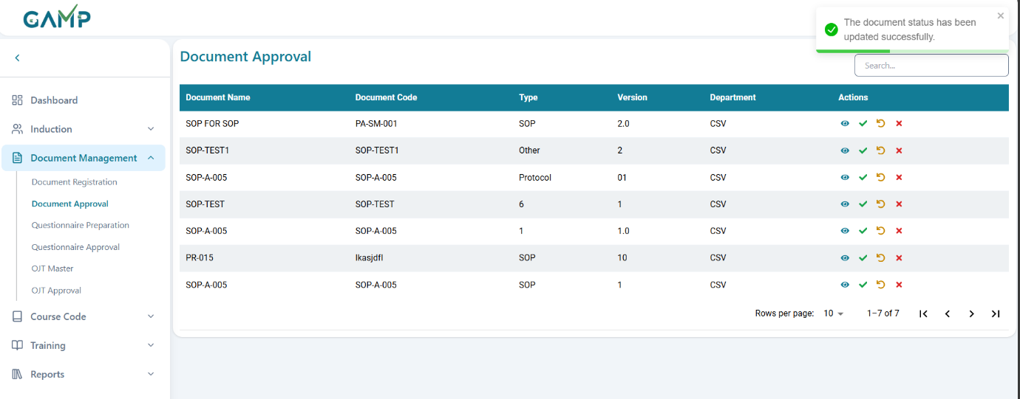

1. **Pagination Controls**
   * At the bottom of the screen, use the **Rows per page** dropdown and navigation arrows to view additional pages of documents.

## Questionnaire Preparation

The Questionnaire Preparation module allows Training Coordinators or Administrators to create and manage questionnaires linked to approved training documents (SOPs, Policies, Protocols, etc.). These questionnaires are later used for trainee assessments and training effectiveness checks.

**Step 1: Accessing the Questionnaire Preparation Module**

1. Log in to the TMS with authorized credentials.
2. From the **left-side navigation menu**, expand **Document Management**.
3. Click on **Questionnaire Preparation**.
4. The system will display a list of all documents with existing questionnaires (as shown in the list view).
   * Information available includes: **Document Name, Document Code, Version, Total Questions, Status, Department, and Actions**.

**Step 2: Creating a New Questionnaire**

For all roles other than QA, they can see the questionnaires of their departments only in the grid, but for QA, they can see the questionnaires of all the departments and can edit/deactivate them also.

1. Click on the **“+ Add”** button in the top-right corner.
2. The **Create New Question Set** screen will open.
3. Under **Document Details**:
   * Select the **Linked Document** from the dropdown list (only Approved documents/OJTs(which have online questionnaire and exam required) will be available).
   * Enter the **Total Questions required in the exam** (defines how many questions will appear in the exam for this document).

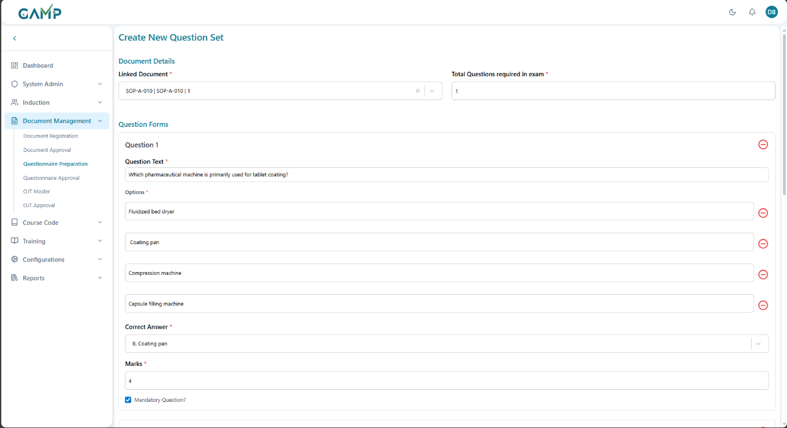

**Step 3: Adding Questions**

Each questionnaire consists of **Question Text, Options, Correct Answer, Marks, and Mandatory Status**.

1. **Question Text**:
   * Enter the question statement (e.g., *“Which pharmaceutical machine is primarily used for tablet coating?”*).
2. **Options**:
   * Provide multiple-choice answers (min 2, max 4).
   * Click the **“+” or “–”** button to add or remove options.
3. **Correct Answer**:
   * Select the correct option from the dropdown.
4. **Marks**:
   * Assign marks to the question (default value is 0, needs to be changed to number > 0).
5. **Mandatory Question**:
   * Tick the checkbox if the question must appear in every test attempt.
   * Unticked questions will be randomized based on the required number of questions.
6. To add more questions, click on **“Add Question”**.
   * Repeat the above steps for each new question.

**Note** We can add more questions than the total questions required in the exam but keep an eye while marking the questions as mandatory.

If the questions marked as mandatory are same as the questions required in the exam, then no more questions will be allowed to add.

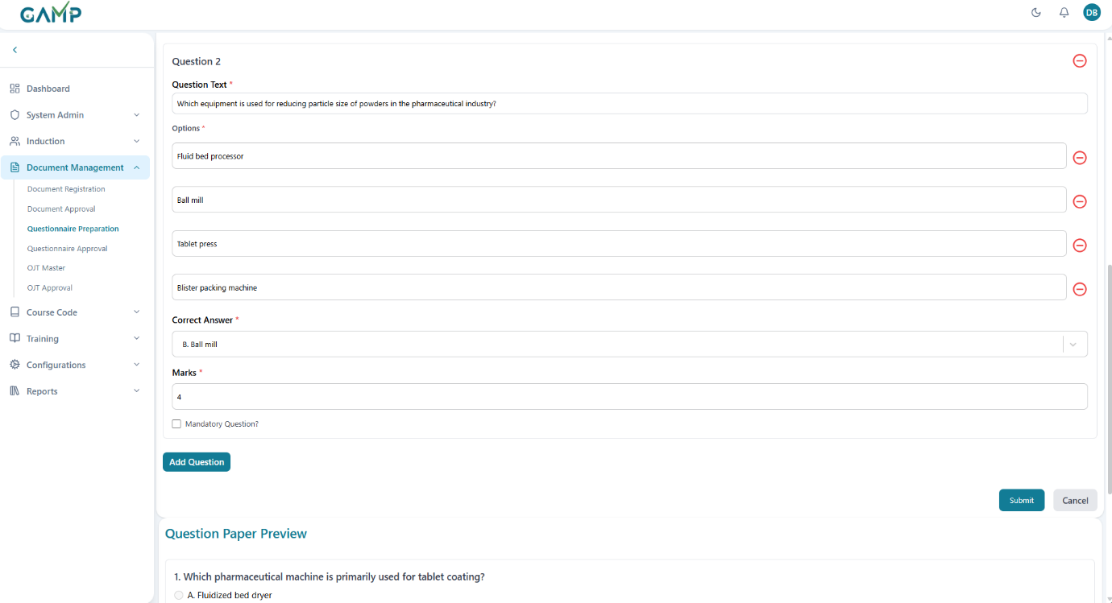

**Step 4: Previewing the Questionnaire**

1. As questions are added, the system generates a **Question Paper Preview** at the bottom of the screen.
2. This allows the creator to review the entire questionnaire with options before submission.

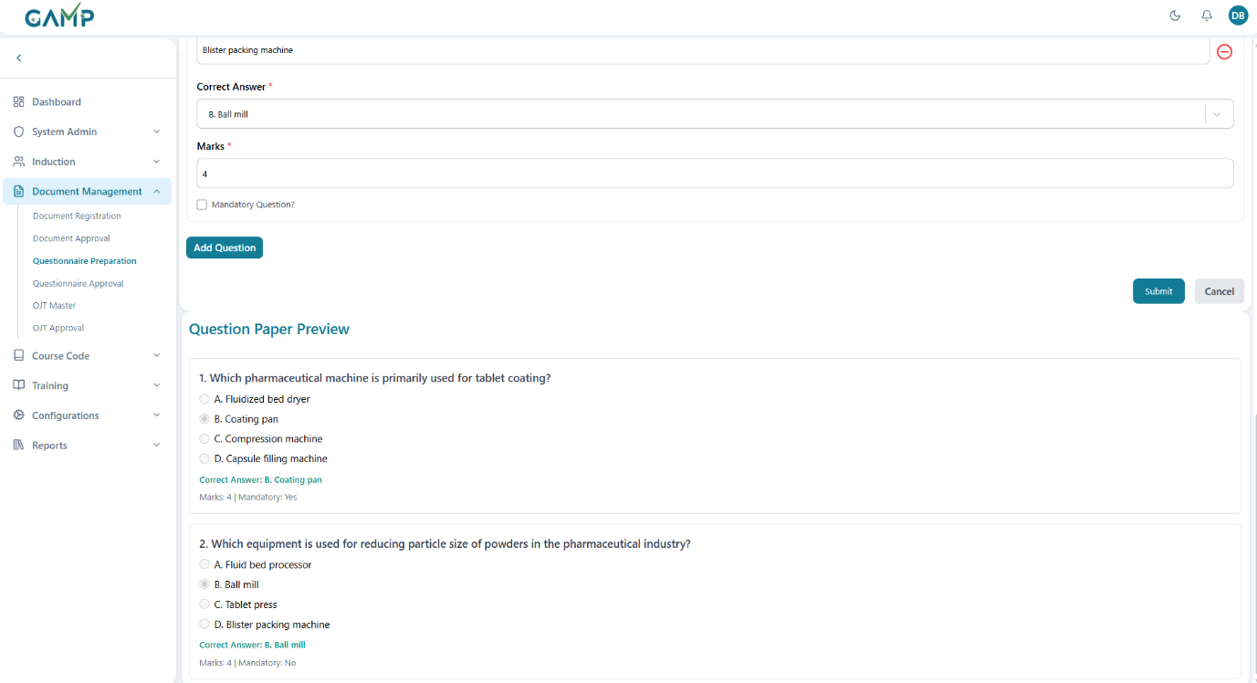

**Step 5: Saving the Questionnaire**

1. After completing all questions, click **Submit** to save the questionnaire.
2. The **Electronic Signature** pop-up will appear:
   * 1. The **Username** is auto-fetched.
     2. Enter your **Password** to authenticate the action.
3. If the password is incorrect, the system prompts for re-entry until correct.
4. Upon successful authentication, a confirmation message appears.
5. The questionnaire will now appear in the main list view under **Questionnaire Preparation** with:
   * Linked **Document Code**
   * **Version**
   * **Total Questions**
   * **Status** (*Pending Approval*).

### Viewing Existing Questionnaire

1. When the user clicks on the **View** button in the actions column of the grid, a detailed pop-up window opens displaying all questions linked with the selected document.
2. The questionnaire view includes:
   * **Total Questions** count
   * **Mandatory Questions** count
   * Each question with its available options (e.g., A, B, C, etc.)
   * **Correct Answer** highlighted for reference
   * **Marks Assigned** to each question
   * **Mandatory/Optional Status** of each question
3. Users can scroll through the pop-up to review all questions and their respective details easily.

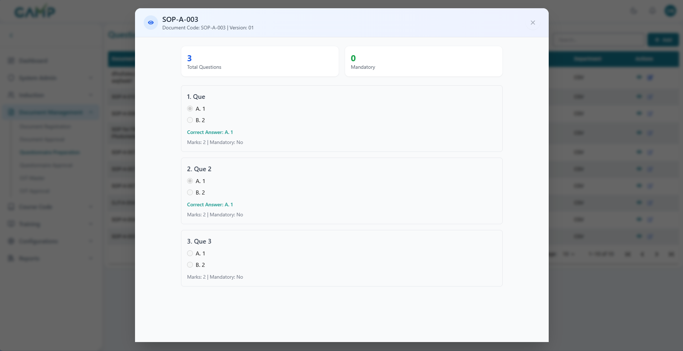

Editing Questionnaire

**Step 1 – Open Edit**

* In the listing, click **Edit** for the target questionnaire. The form opens with current values.
* The **Edit** action is disabled for the documents with **Status** as **Approved.** Only **under review** are allowed for editing.

**Step 2 – Update Fields**

* You may update the desired fields which needs to be updated.
* **Versioning rules:**
  1. If you replace the **Document File** or make a controlled change, update **Version** according to your SOP (e.g., from 1.0 → 2.0).
  2. The system does not allow decreasing the version.

**Step 3 – Update & E-Sign**

1. Click **Update**.
2. **Electronic Signature** pop-up appears:
   1. **Username** auto-fetched
   2. **Reason for Change** (mandatory)
   3. **Password** (mandatory)
3. On success, you’ll see a confirmation and the record is updated.
4. Depending on your process, edits may re-route the questionnaire for **Approval**.

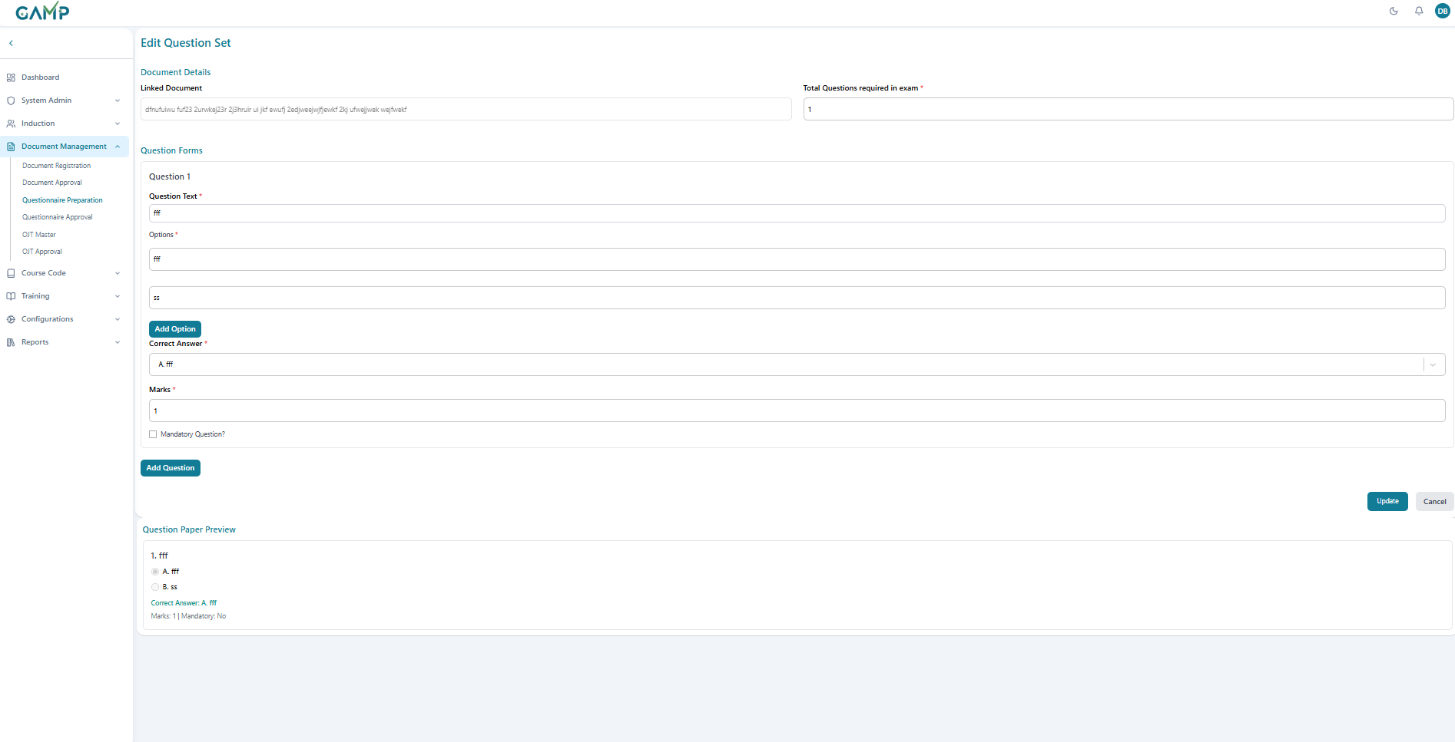

**Key Notes**

* Only **Approved Documents** can be linked to questionnaires.
* All changes are recorded in the **Audit Trail** for compliance with regulatory standards (21 CFR Part 11).
* Questionnaires are directly used in **Course Codes and Training Exams.**

## Questionnaire Approval

The Questionnaire Approval module allows authorized users to review, approve, reject, or return questionnaires that are linked to documents. Each questionnaire must pass through this approval process before it can be officially released for training or assessment purposes.

**Navigate to Questionnaire Approval**

* From the left menu, click **Document Management → Questionnaire Approval**.
* A list of questionnaires pending approval in the role which has been configured for **Approval** will be displayed.

1. **Review the Questionnaire List**

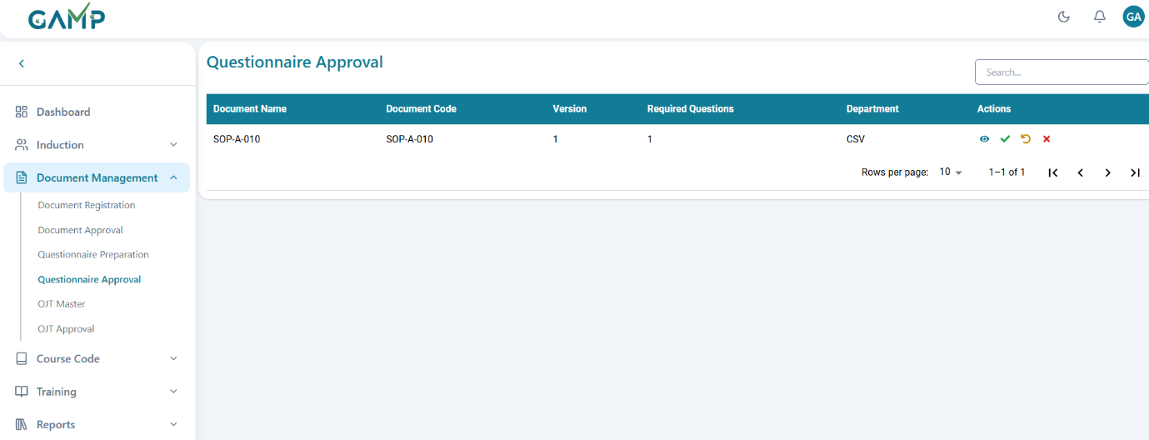

Each row displays key details:

* + **Document Name** – Title of the document to which the questionnaire belongs.
  + **Document Code** – Unique identifier/code of the document.
  + **Version** – Current version of the questionnaire under review.
  + **Required Questions** – Number of mandatory questions.
  + **Department** – Department associated with the document/questionnaire.

**3. Search for a Questionnaire**

Use the **Search bar** at the top right to quickly locate a specific questionnaire by name or code.

**4. View Questionnaire Details**



* Click the **Eye** icon under the **Actions** column to open and review the questionnaire.
* The questionnaire viewer displays:
  1. **Total Questions** count.
  2. **Mandatory Questions** count.
  3. Each question along with its options.
  4. **Correct Answer** highlighted.
  5. **Marks Assigned** and **Mandatory/Optional status**.
* Users can scroll through and review all questions in detail.

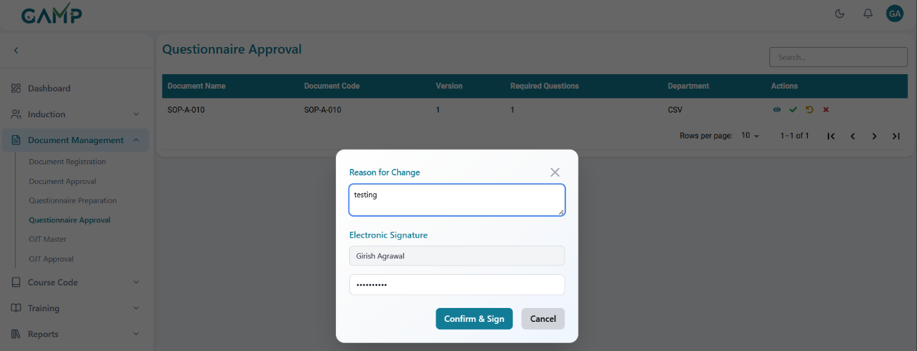

**5. Approve a Questionnaire**

* Click the **Green Check (✔)** icon to approve the questionnaire.
* The **Electronic Signature** pop-up will appear:  
  a) Enter the approval remarks in the *Reason for Change* input field.  
  b) The Username is auto-fetched.  
  c) Enter your Password to authenticate the action.
* If the password is incorrect, the system prompts for re-entry until correct.
* Upon successful authentication, a confirmation message appears, and the questionnaire is approved for system use.

**6. Reject a Questionnaire**

* Click the **Red Cross (✖)** icon to reject the questionnaire.
* The **Electronic Signature** pop-up will appear:  
  a) Enter the rejection remarks (reason for rejection) in the *Reason for Change* input field.  
  b) The Username is auto-fetched.  
  c) Enter your Password to authenticate the action.
* If the password is incorrect, the system prompts for re-entry until correct.
* Upon successful authentication, the questionnaire is rejected and cannot be used further.

**7. Send Back / Return a Questionnaire**

* Click the **Circular Arrow (↺)** icon to return the questionnaire for revision without rejecting it.
* The **Electronic Signature** pop-up will appear:  
  a) Enter the return remarks (changes required) in the *Reason for Change* input field.  
  b) The Username is auto-fetched.  
  c) Enter your Password to authenticate the action.
* Upon successful authentication, the questionnaire is returned to the creator for corrections.

## OJT Master

The **OJT Master** module allows administrators and trainers to create, configure, and manage On-the-Job Training (OJT) programs. Each OJT record includes training details, activity steps, associated documents, and evaluation methods.

**Steps for Managing OJT Master**

**1. Navigate to OJT Master**

* From the left menu, click **Document Management → OJT Master**.
* The system displays a list of existing OJT trainings along with their status. Information available includes:
  1. **Title** – Training title.
  2. **Code** – Unique OJT code.
  3. **Evaluation Type** – Selected evaluation method.
  4. **Status** – Current approval status (e.g., Under Review, Approved, Rejected).
  5. **Department** – Department to which the OJT belongs.

**2. Add a New OJT Training**

* Click the **Add (+)** button on the top-right corner.
* A new OJT entry form opens.

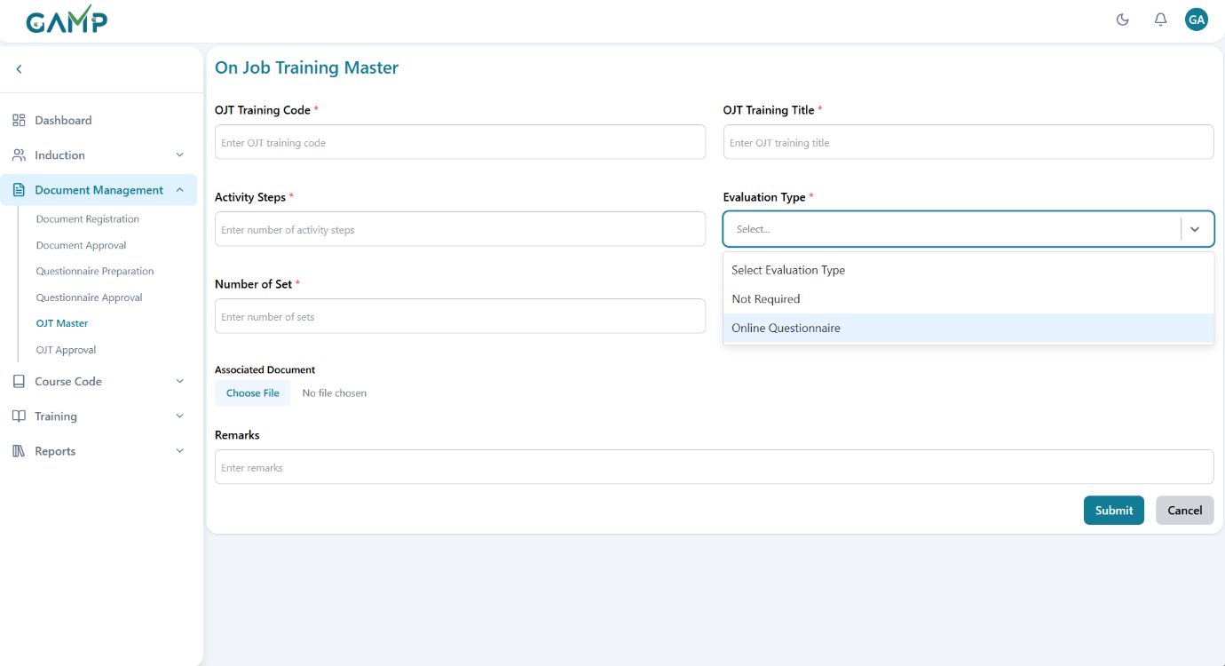

1. **Fill in OJT Training Details**

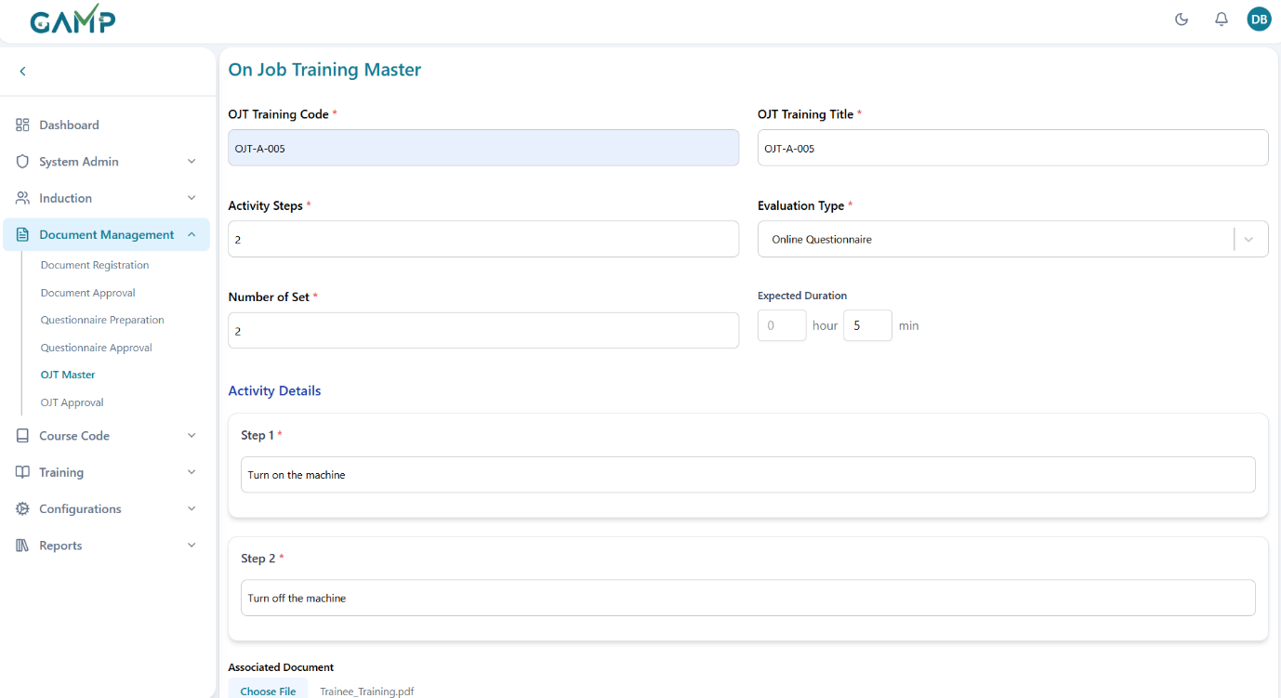

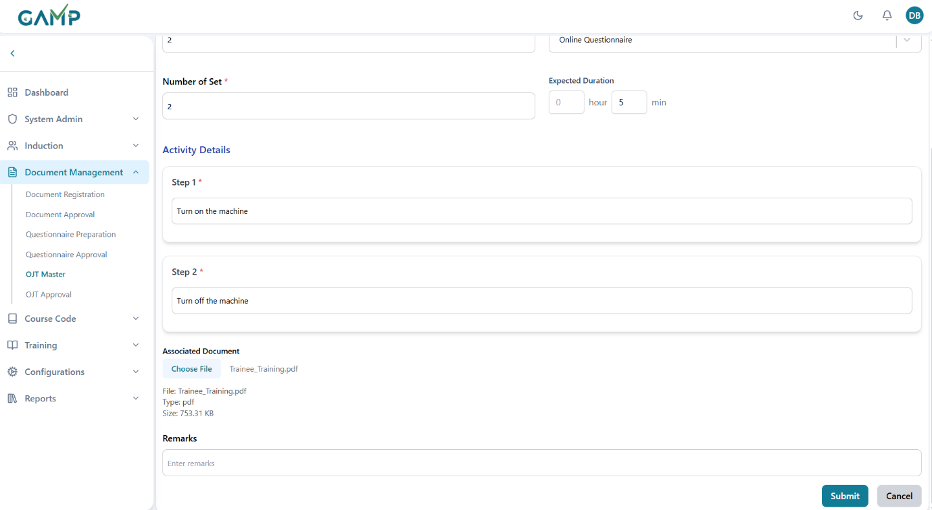

* **OJT Training Code** – Enter a unique identifier for the training (e.g., OJT-A-005).
* **OJT Training Title** – Provide the name/title of the training.
* **Activity Steps** – Enter the number of activity steps the trainee must perform.
* **Number of Sets** – Specify how many sets/repetitions are required.
* **Expected Duration** – Define the estimated time needed to complete the OJT.
* **Evaluation Type** – Select how the trainee will be evaluated:
  1. **Not Required** – No evaluation is needed.
  2. **Online Questionnaire** – Trainee must complete an associated questionnaire for evaluation.
* **Activity Details** – Define each step of the training (e.g., Step 1: Turn on the machine, Step 2: Turn off the machine).
* **Associated Document** – Upload any relevant supporting document (e.g., SOP, training material).
* **Remarks** – Enter additional information or notes, if needed.

**4. Save the OJT Training**

* Click **Submit** to save the OJT record.

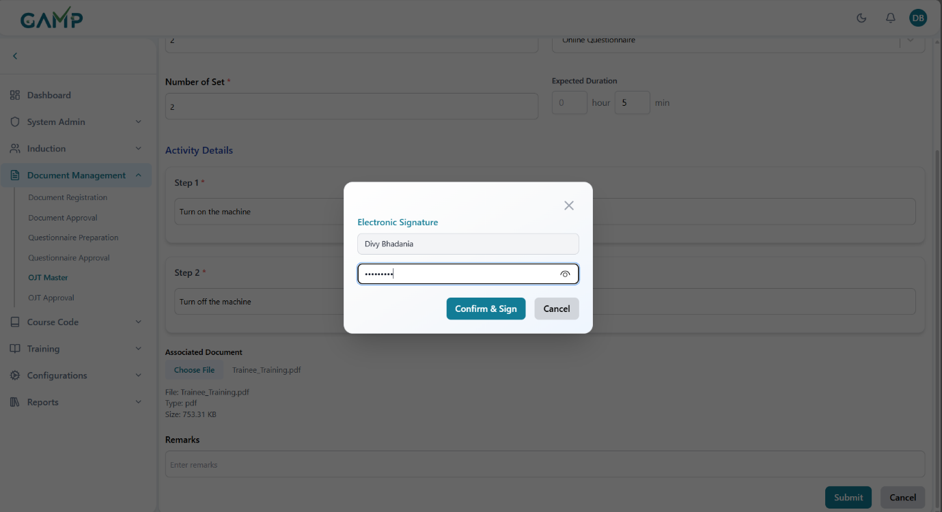

* The **Electronic Signature** pop-up will appear:
  1. The **Username** is auto-fetched.
  2. Enter your **Password** to authenticate the action.
  3. If the password is incorrect, the system prompts for re-entry until correct.
* Upon successful authentication, a confirmation message appears.
* The training will be marked as **Under Review** until approved.

For all roles other than QA, they can see the OJTs of their departments only in the grid, but for QA, they can see the OJTs of all the departments and can edit/deactivate them also.

### View Existing OJT Trainings

1. In the listing, click **View**.

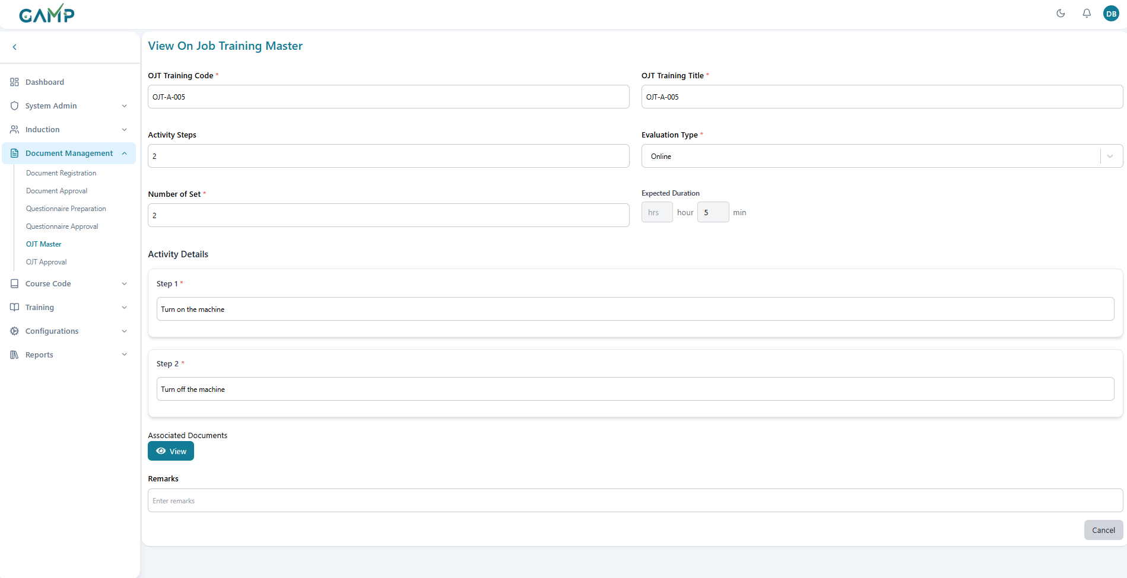

1. The **View OJT** page shows read-only metadata and a **View** button to open the **Associated Document** file.
2. The Associated Document gets opened in a separate document viewer and you can navigate in it and click on cross to exit the viewer.

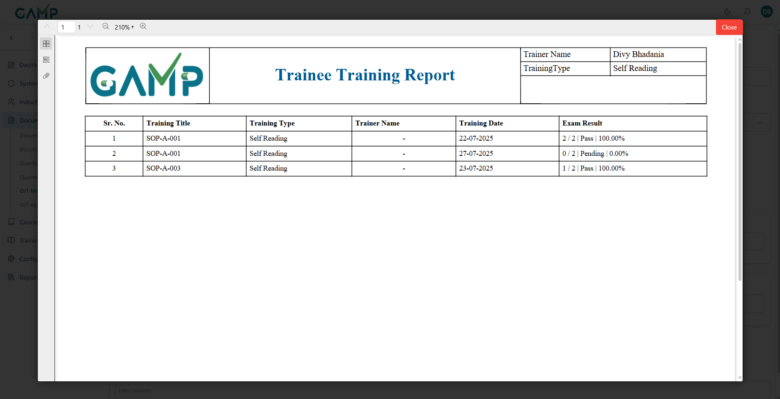

**6. Approval Workflow**

* Once created, OJT trainings must go through the **OJT Approval** module where authorized users can approve, reject, or return them for correction.
* Only **Approved OJT trainings** can be assigned to employees for execution.

### Editing Existing OJT

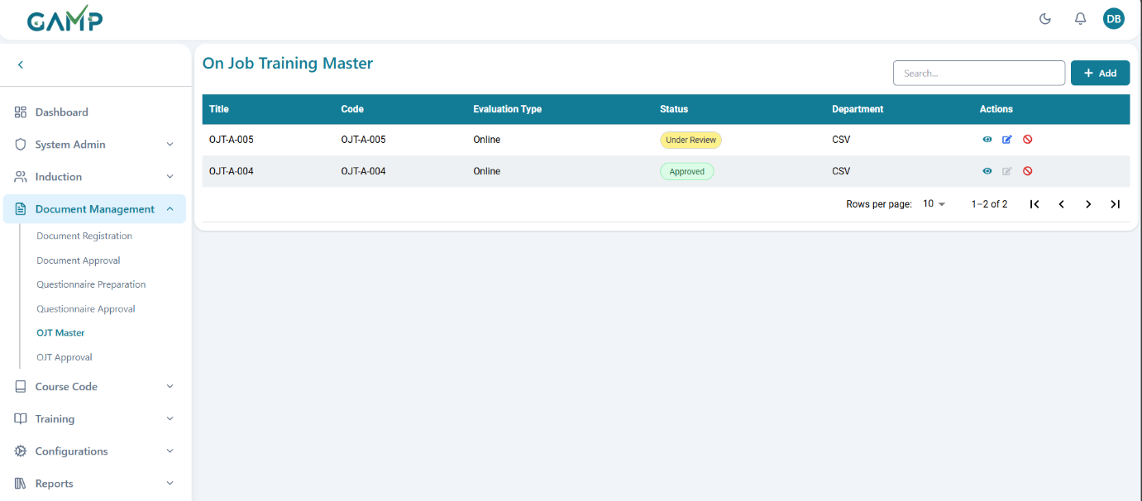

**Step 1 – Open Edit**

* In the **OJT Master** listing, click **Edit** for the target OJT.
* The form opens pre-filled with the current OJT values.
* Note: The **Edit** action is disabled for OJTs with **Status** as ***Approved*.** Only OJTs in ***Under Review*** status are allowed for editing.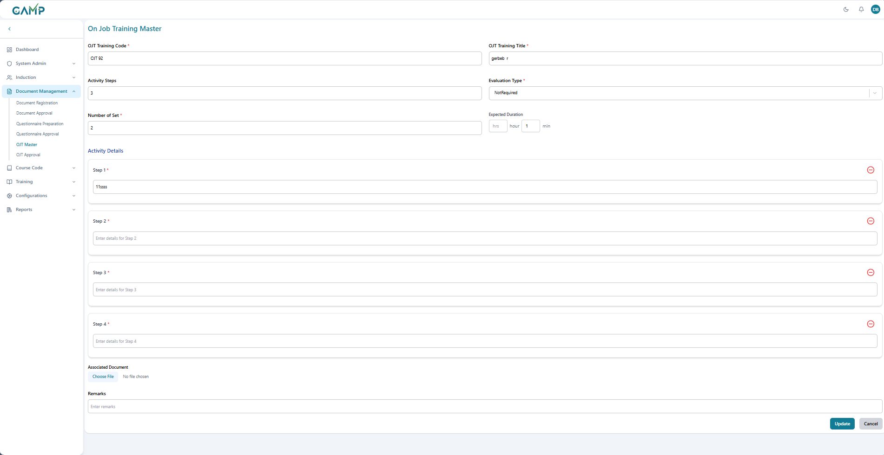

**Step 2 – Update Fields**

* Update the desired fields such as OJT Title, Activity Steps, Number of Sets, Evaluation Type, Activity Details, Associated Document, or Remarks.
* You can decrease or increase the activity steps accordingly.

**Step 3 – Update & E-Sign**

1. Click **Update**.
2. The **Electronic Signature** pop-up appears:
   1. **Username** auto-fetched.
   2. Reason for Change (mandatory).
   3. **Password** (mandatory).

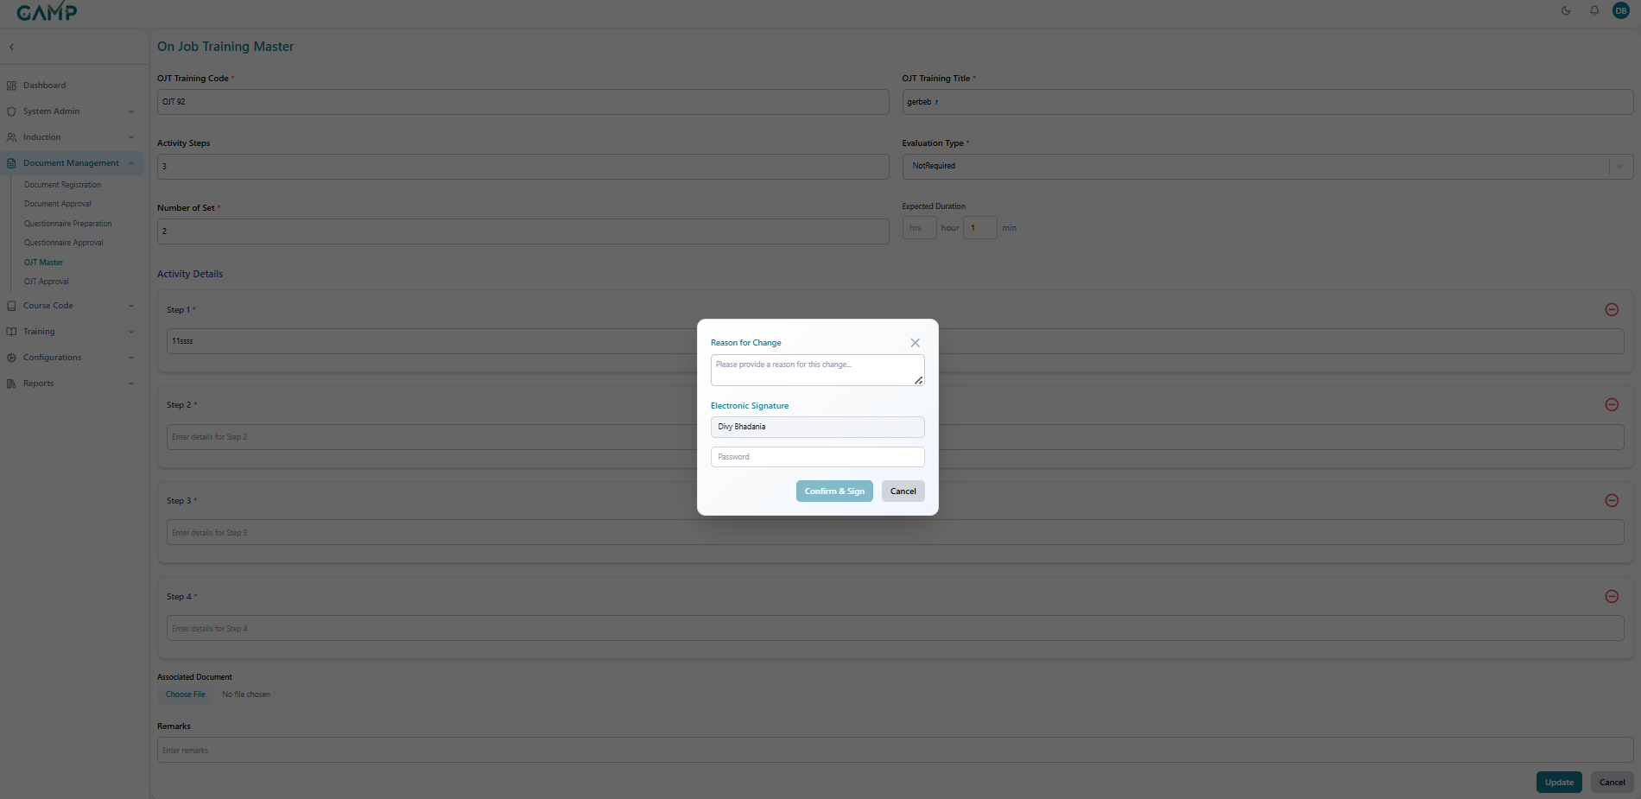

1. On success, a confirmation message appears and the **OJT** record is updated.
2. Depending on your workflow, the OJT may be re-routed for **OJT Approval** before it becomes active again.

**8**. Deactivating OJT

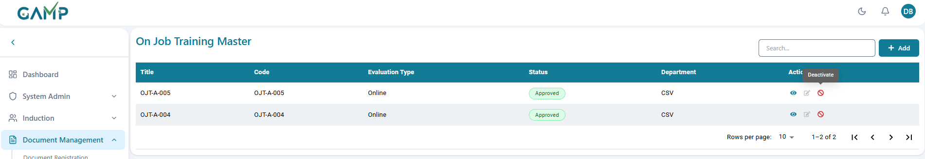

**Step 1 – Open Deactivate Action**

In the OJT Master listing, click the **Deactivate (✖ / toggle off)** action for the target OJT.

**Note:** Only OJTs in *Approved* status can be deactivated.

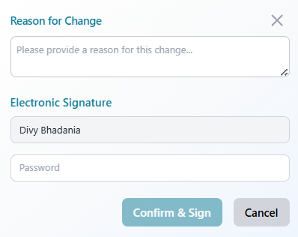

**Step 2 – Confirm Deactivation & E-Sign**

The **Electronic Signature** pop-up appears:

* + Username auto-fetched.
  + **Reason for Change** (mandatory – e.g., OJT retired, replaced, or obsolete).
  + **Password** (mandatory).

**Step 3 – Completion**

* A confirmation message is displayed.
* Once deactivated, the OJT can no longer be assigned or used in training.
* If needed, a new OJT record must be created to replace the old one.

**Tips & Good Practices**

* Keep **Activity Steps** concise and testable; avoid combining multiple actions in one step.
* Use **Number of Set(s)** to enforce repetition where skill proficiency requires practice.
* If using **Online Questionnaire**, align questions with the activity steps and marks/mandatory flags defined in Questionnaire Preparation.

6.OJT Approval  
The OJT Approval module allows authorized users (such as Supervisors, Trainers, or Managers) to review, approve, reject, or return On-the-Job Training (OJT) sessions submitted by trainees. This ensures that OJT records are verified before being considered as successfully completed.

**Steps for OJT Approval**

**1. Navigate to OJT Approval**

* From the left menu, click **Document Management → OJT Approval**.
* A list of OJT sessions pending approval will be displayed.

1. **Review the OJT List**

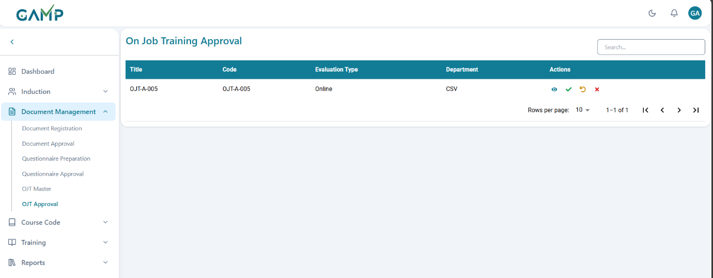

Each row displays key details:

* + **Trainee Name** – Name of the employee who underwent the OJT.
  + **Training Title** – Title or subject of the OJT session.
  + **Trainer/Supervisor** – Name of the person who conducted or supervised the session.
  + **Department** – Department of the trainee.
  + **Date of Training** – When the OJT was conducted.
  + **Status** – Current approval status (Pending/Approved/Rejected/Returned).

**3. Search for an OJT Record**

Use the **Search bar** at the top right to quickly locate a specific trainee or training session.

**4. View OJT Details**

* Click the **Eye (👁)** icon under the **Actions** column to open and review details of the OJT session.
* The OJT record includes:
  1. Training objectives and scope.
  2. Step-by-step activities or tasks performed.
  3. Trainer/Supervisor remarks.
  4. Any attached supporting documents or evidence.

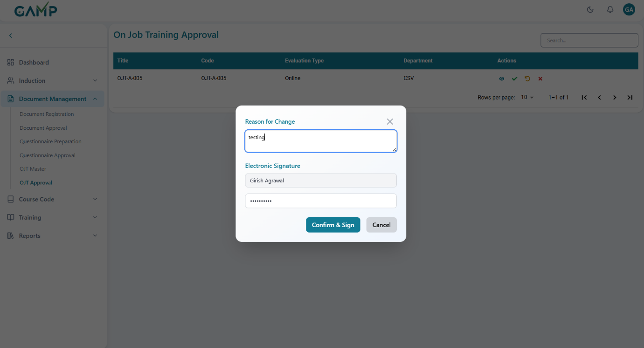

**5. Approve an OJT Session**

* Click the **Green Check (✔)** icon to approve the OJT.
* The **Electronic Signature** pop-up will appear:  
  a) Enter the approval remarks in the *Reason for Change* input field.  
  b) The Username is auto-fetched.  
  c) Enter your Password to authenticate the action.
* If the password is incorrect, the system prompts for re-entry until correct.
* Upon successful authentication, the OJT is marked as **Approved**, and the trainee’s training record is updated.

**6. Reject an OJT Session**

* Click the **Red Cross (✖)** icon to reject the OJT.
* The **Electronic Signature** pop-up will appear:  
  a) Enter the rejection remarks (reason for rejection) in the *Reason for Change* input field.  
  b) The Username is auto-fetched.  
  c) Enter your Password to authenticate the action.
* Upon successful authentication, the OJT is marked as **Rejected** and does not count towards trainee completion.

**7. Send Back / Return an OJT Session**

* Click the **Circular Arrow (↺)** icon to return the OJT record for revision.
* The **Electronic Signature** pop-up will appear:  
  a) Enter the return remarks (e.g., missing information or correction required) in the *Reason for Change* input field.  
  b) The Username is auto-fetched.  
  c) Enter your Password to authenticate the action.
* Upon successful authentication, the OJT is sent back to the trainer or trainee for correction and resubmission.

# Course Code

The **Course Code** module standardizes how trainings are created, reviewed, and assigned. It has three parts: **Course Code Registration (CCR)** to create a course and link approved learning content (SOPs/OJTs); **Course Code Approval (CCA)** where authorized approvers review and approve the course; and **Course Code Assignment** where approved courses are mapped to employees/roles with a required training frequency (e.g., Monthly, Quarterly, Half-Yearly, Yearly). This controlled flow ensures only vetted; up-to-date content is assigned to learners.

## Course Code Registration

**Step1 Navigate**

* Left Sidebar→ **Course Code → Course Code Registration**.
* The list shows existing courses with **Title, Course Code, Department, Status, Actions**.

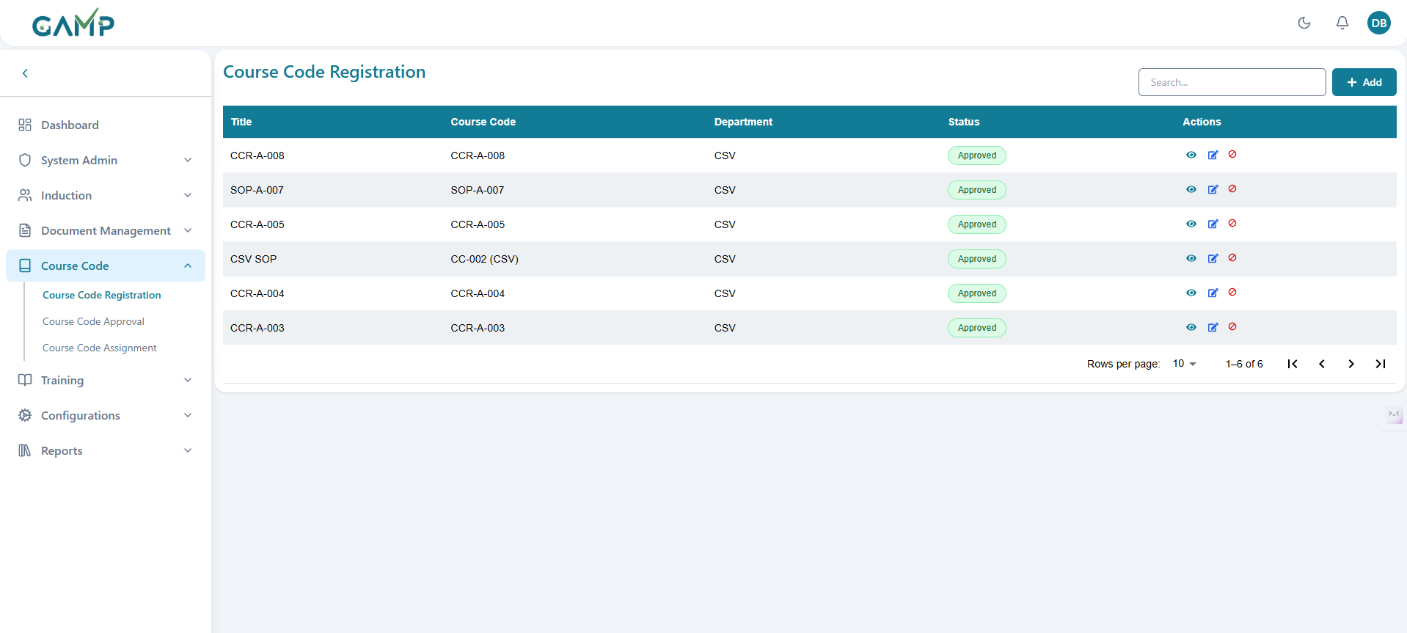

**Step 2 Add a new course**

* Click **+ Add** (top-right) to open the **Course Code Registration** form.

**Step 3 Enter header details**

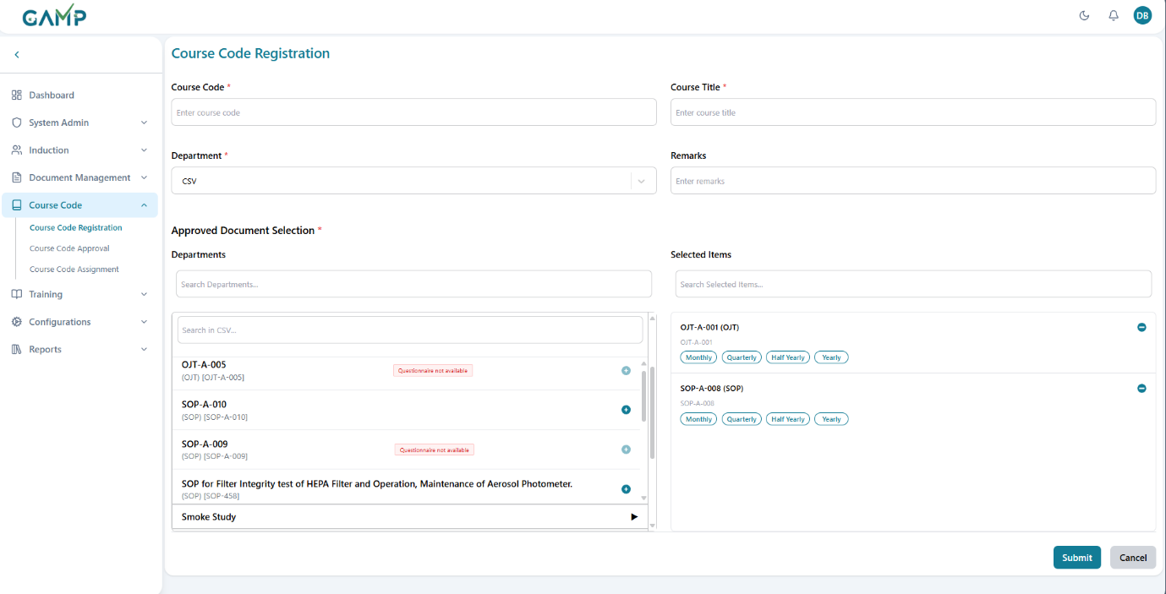

* **Course Code** : Enter a unique identifier (e.g., CCR-A-003).
* **Course Title** : Enter a clear, descriptive name (e.g., *CSV SOP Training*).
* **Department**: Select the owning department (e.g., CSV, QA).
* **Remarks**: Optional notes for approvers/assignees.

Note: Course Code must be unique; required fields are mandatory.

**Step 4 Select approved documents**

* In **Approved Document Selection \***:

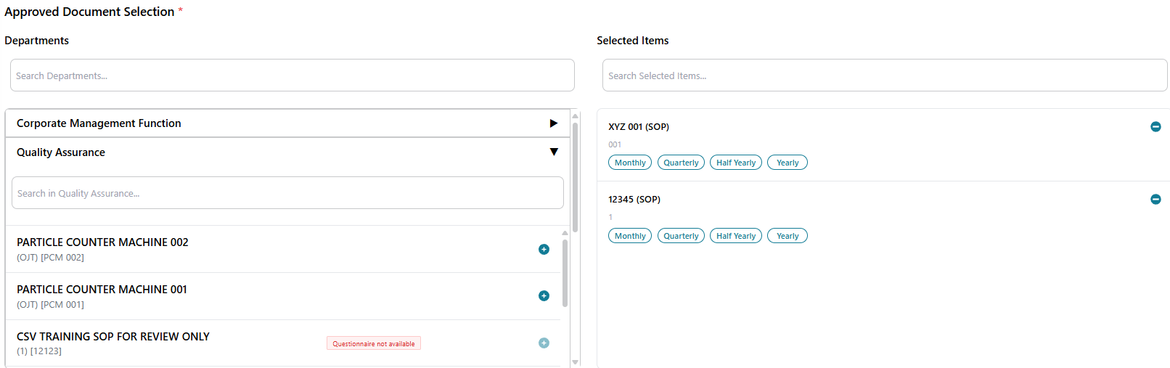

* 1. The left panel has all the departments listed and inside it is approved documents and OJT associated with the departments.
  2. Click on the arrow button to expand and see the documents and OJTs in that department
  3. Use the search by finding the required department to find specific **SOP** or **OJT** items.
  4. Click **(Add)** beside an item to move it to **Selected Items** (right panel).
  5. Repeat to add all required SOPs/OJTs for this course.

**Notes & indicators**

* Only **Approved** documents are listed.
* Items marked **“Questionnaire not available”** indicate no approved questionnaire exists for that document.
  + If your organization requires *Online* evaluation for that item, ensure the questionnaire is created and approved before assignment (or proceed per your configuration rules).

**Step 5 Set training frequency (per selected item)**

* In **Selected Items** (right panel), choose the frequency for each item by clicking **Monthly / Quarterly / Half Yearly / Yearly**.
* You can change the selection by clicking a different frequency.
* Use the small **remove** icon to take an item out of the list if added by mistake.

**Step 6 Review your selections**

* Confirm all needed SOPs/OJTs are listed under **Selected Items**.
* Ensure the combination reflects how the course will be delivered and refreshed.

**Step 7 Submit (and e-sign if enabled)**

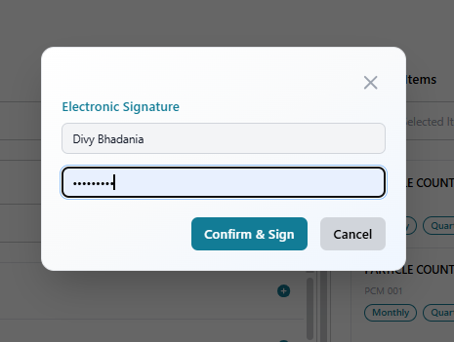

* Click **Submit**.
* If electronic signatures are enabled, an **E-Signature** modal appears:
  + **Username** auto-fetched
  + **Password** (mandatory)
* On success, a confirmation is shown and the course moves to **Under Review** status.

**Step 8 What happens next**

* The newly registered course appears in the list with status **Under Review**.
* It is routed to **Course Code Approval (CCA)**. Only **Approved** courses can be used in **Course Code Assignment**.

### Editing Course code

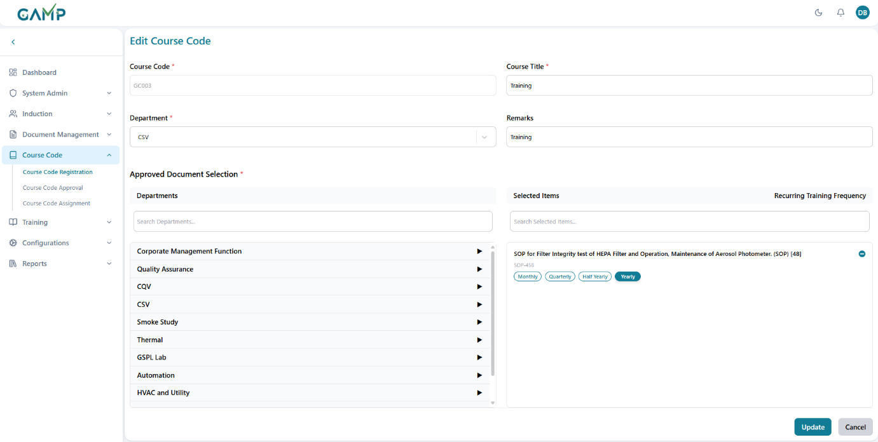

**Step 1 – Open Edit**

* In the listing, click **Edit** for the target course.
* The registration form opens with current values pre-filled.

**Step 2 – Update Fields**

* Modify **Course Title, Department, Remarks** if needed.
* To adjust learning content:
  + Add new SOPs/OJTs via **Approved Document Selection**.
  + Remove or change frequencies in **Selected Items**.
* Ensure version control rules are followed as per SOP (e.g., increasing version if major changes are made).

**Step 3 – Save & E-Sign**

1. Click **Update**.
2. An **Electronic Signature** pop-up appears:
   * **Username** auto-fetched
   * **Reason for Change** (mandatory)
   * **Password** (mandatory)
3. On success, you’ll see a confirmation message.
4. The course remains **Under Review** and will re-route for approval if required.

**Viewing Course codes**

**Step 1 – Open List**

* Navigate to **Course Code → Course Code Registration**.
* The grid displays existing course codes with **Course Code, Title, Department, Status, Actions**.

**Step 2 – View Action**

* Click **👁 View** beside the desired course.
* The **Course View screen** opens in read-only mode.

**Step 3 – Review Details**

* Header information: **Course Code, Title, Department, Status, Remarks**.
* Linked Documents: grouped separately as **SOPs** and **OJTs**.
* Training Frequency: shows Monthly, Quarterly, Half-Yearly, or Yearly selection per item.
* No fields are editable in this mode.

### Deactivating Course codes

**Step 1 – Open List**

* Navigate to the **Course Code Registration** listing.

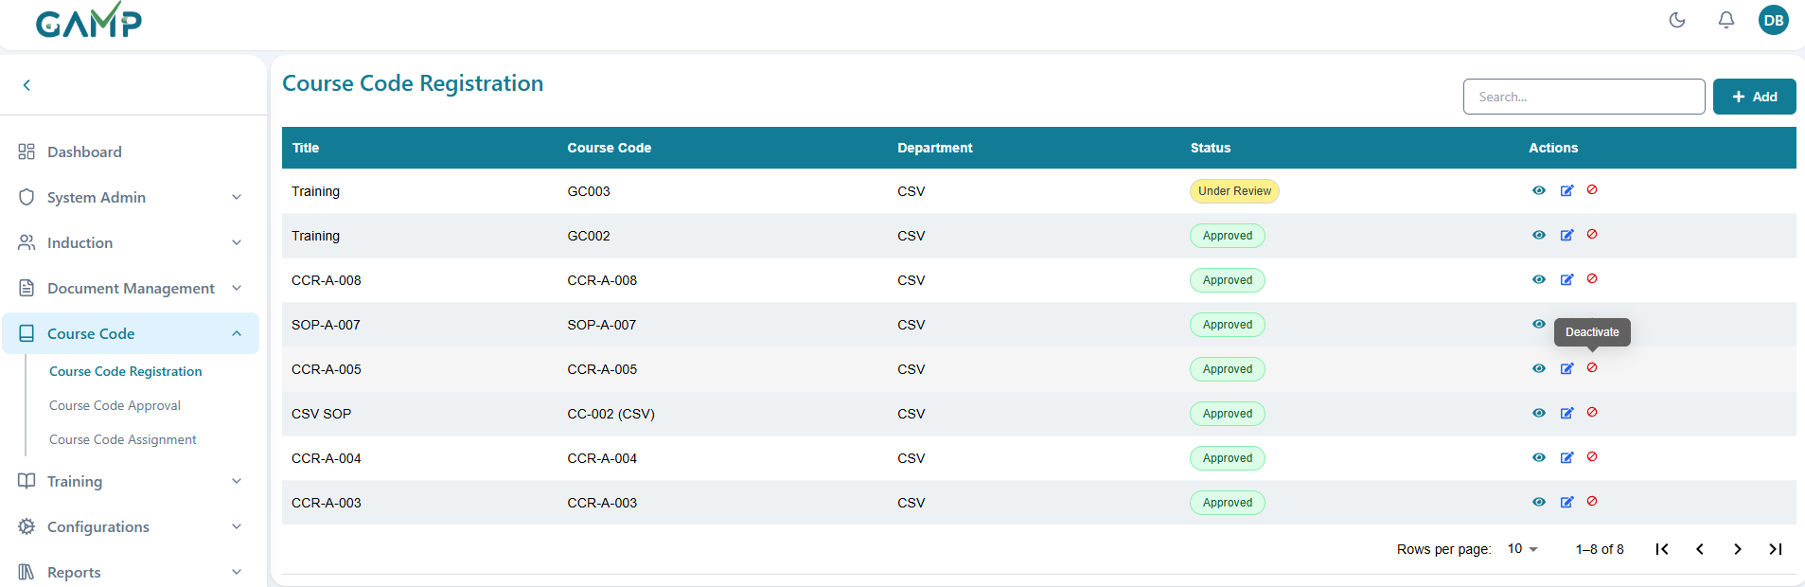

**Step 2 – Select Deactivate**

* In the row actions, click  **Deactivate** for the target course.

**Step 3 – Confirm & E-Sign**

* A confirmation dialogue appears.
* If electronic signatures are enabled:
  + **Username** auto-fetched
  + **Reason for Change** (mandatory, e.g., *Course superseded by CCR-005*)
  + **Password** (mandatory)

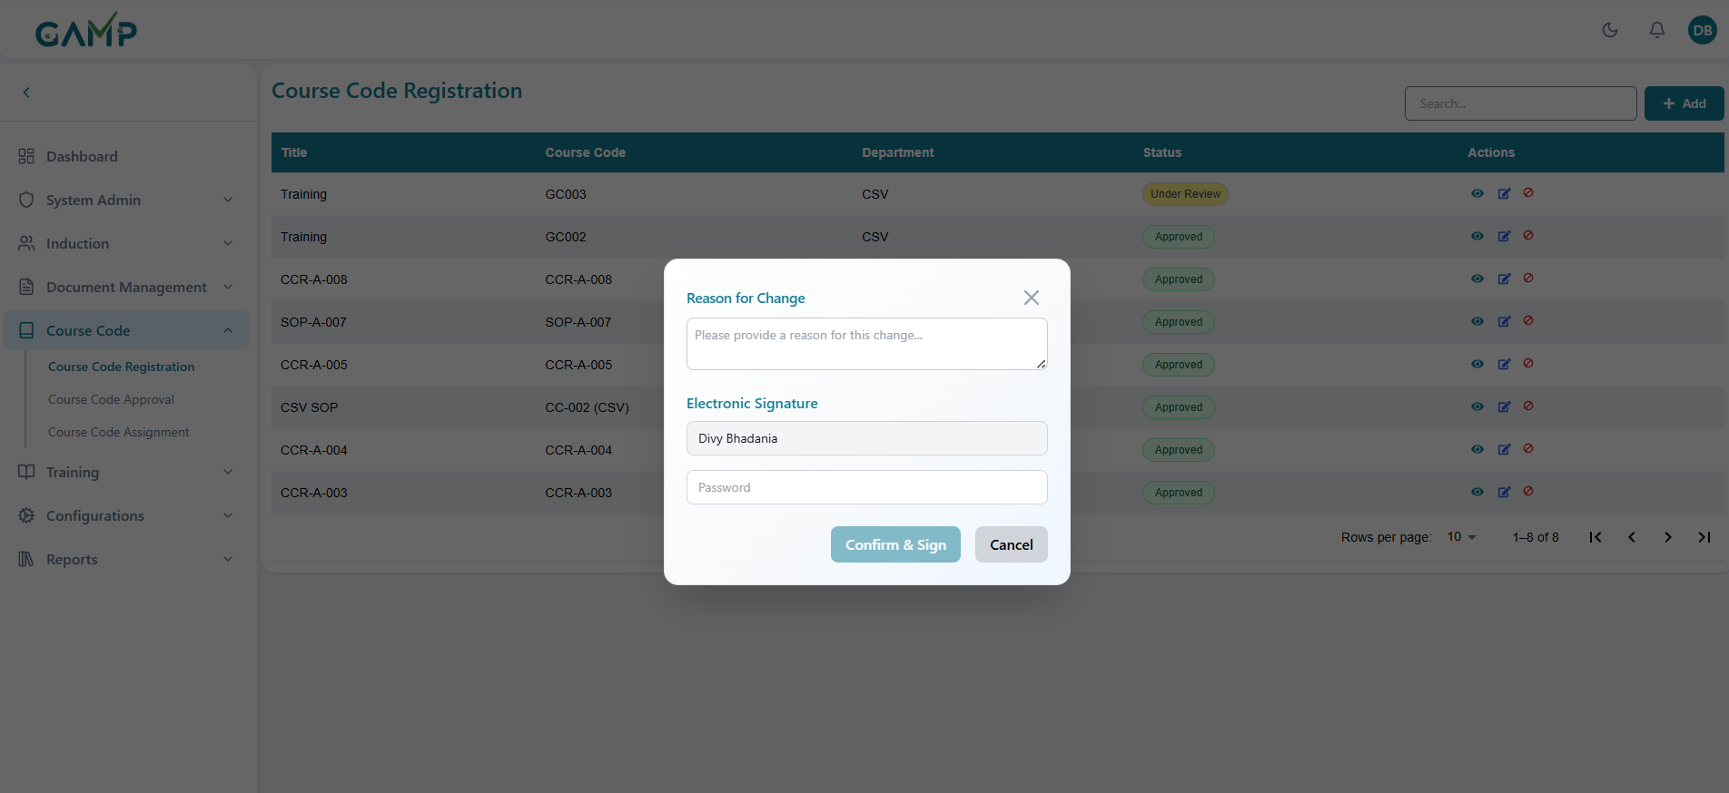

* Click **Confirm**.
* Inactive courses cannot be assigned in training assignments.
* Historical records remain intact for audit purposes.

## Course Code Approval

**Steps for Course Code Approval**

**1. Navigate to Course code Approval**

* From the left menu, click **Course Code → Course Code Approval**.
* A list of Course codes pending approval in the role which has been configured will be displayed.

2. **Review the Course Code List**

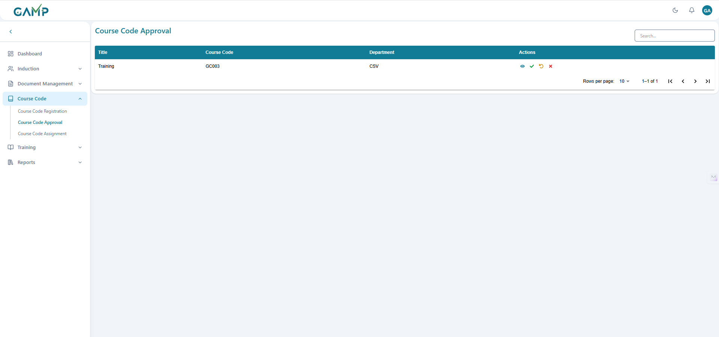

* Each row displays key details:
  + **Course code**  – Code of the course code
  + **Training Title** – Title or subject of the Course code
  + **Department** – Department of the trainee.
  + **Date of Training** – When the OJT was conducted.

**3. Search for an Course code**

Use the **Search bar** at the top right to quickly locate a course code.

**4. View Course Code Details**

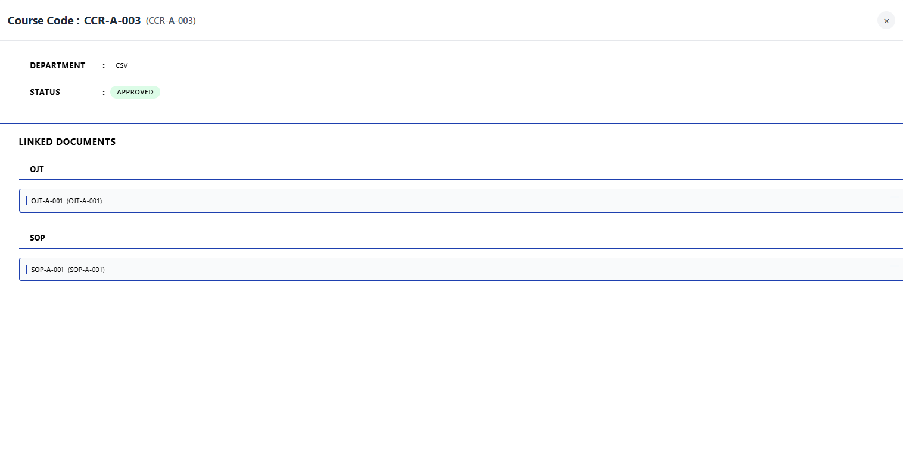

* Click the **Eye (👁)** icon under the **Actions** column to open and review details of the course code.
* The course code includes:
  + Course code name and its code.
  + Department and status.
  + Linked documents separated by their types.

**5. Approve a Course Code**

* Click the **Green Check (✔)** icon to approve the Course code.
* The **Electronic Signature** pop-up will appear:  
  a) Enter the approval remarks in the *Reason for Change* input field.  
  b) The Username is auto-fetched.  
  c) Enter your Password to authenticate the action.
* If the password is incorrect, the system prompts for re-entry until correct.
* Upon successful authentication, the Course code is marked as **Approved**.

**6. Reject a Course Code**

* Click the **Red Cross (✖)** icon to reject the Course code.
* The **Electronic Signature** pop-up will appear:  
  a) Enter the rejection remarks (reason for rejection) in the *Reason for Change* input field.  
  b) The Username is auto-fetched.  
  c) Enter your Password to authenticate the action.
* Upon successful authentication, the Course code is marked as **Rejected.**

**7. Return a Course Code**

* Click the **Circular Arrow (↺)** icon to return the Course code for revision.
* The **Electronic Signature** pop-up will appear:  
  a) Enter the return remarks (e.g., missing information or correction required) in the *Reason for Change* input field.  
  b) The Username is auto-fetched.  
  c) Enter your Password to authenticate the action.
* Upon successful authentication, the Course code is sent back to the creator for correction and resubmission.

**8. Pagination Controls**

* At the bottom of the screen, use the **Rows per page** dropdown and navigation arrows to view additional pages of Course code records.

## Course Code Assignment

The Course Code Assignment module allows administrators to assign approved course codes to specific users within the organization. This ensures that training requirements are properly distributed and tracked for compliance purposes.

**Step 1: Accessing Course Code Assignment**

**1.** Log in to the TMS system

2. Navigate to the main dashboard. From the sidebar menu click **Course Code → Course Code Assignment**

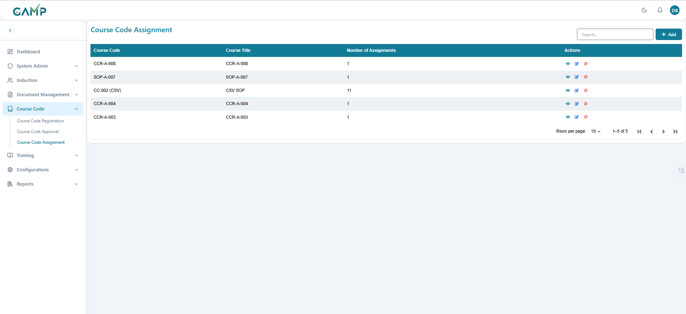

**Step 2: Viewing Course Code Assignments**

The main screen displays all existing course code assignments in a table format

* Information shown includes:
  + Course Code
  + Course Title
  + Number of Assignments
  + Actions (View, Edit, Delete)
* Use the search bar to find specific assignments by course code or user name
* Navigate through multiple pages of assignments by adjusting the number of records displayed per page (10, 25, 50, 100)

**Adding New Course Code Assignment**

**Step 1:** Click the "Add Assignment" button (+ icon) in the top-right corner

**Step 2:** Select Course Code

* Choose from the dropdown of approved course codes
* Only course codes with "Approved" status are available
* Search functionality helps find specific course codes

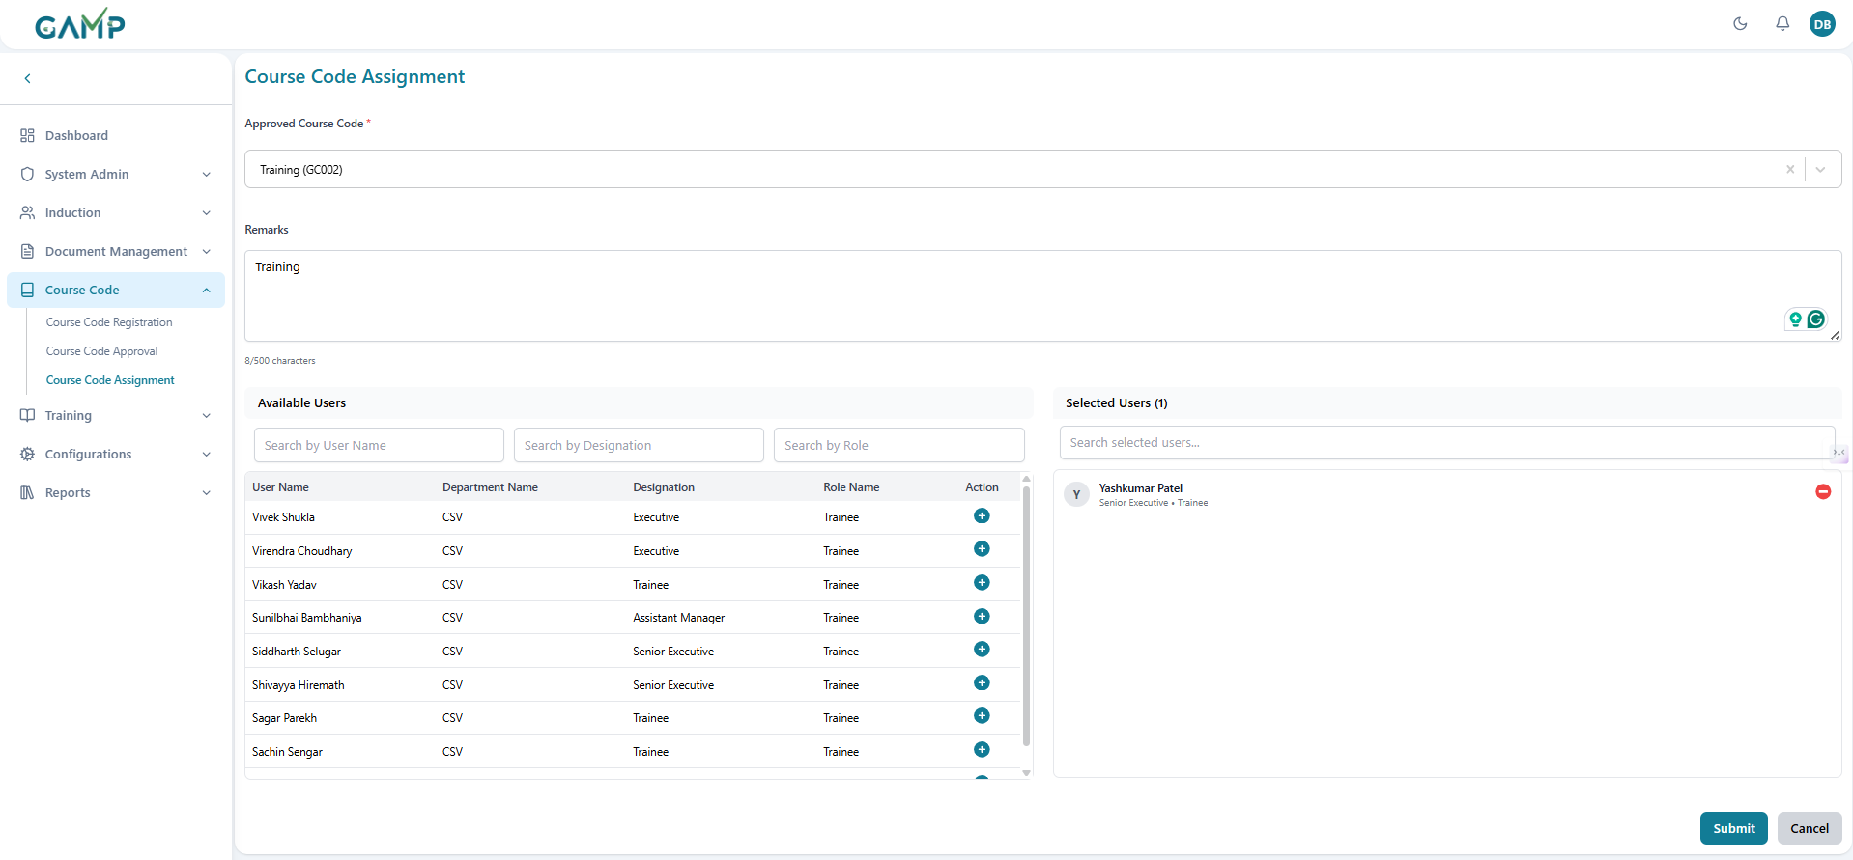

**Step 3:** Select Users

* Use the user search functionality to find employees
* Search by:
  + User Name
  + Designation
  + Role
* Multiple users can be selected for the same course code
* Selected users appear in a separate section

**Step 4:** Add Remarks (Optional)

* Enter any relevant comments or instructions
* This field supports up to 500 characters

**Step 5:** Review Selection

* Verify the selected course code and users
* Remove users if needed using the minus (-) icon
* Add additional users using the plus (+) icon

**Step 6:** Submit Assignment

* Click "Assign Course Code" button
* If electronic signature is enabled:
  + Enter reason for change
  + Provide electronic signature (password)
  + Click "Submit" to confirm

**Step 7:** Confirmation

* Success message appears upon successful assignment
* User is redirected to the assignment list
* New assignment appears in the table

### Editing Course Code Assignment

**Step 1:** Locate the assignment to edit in the list

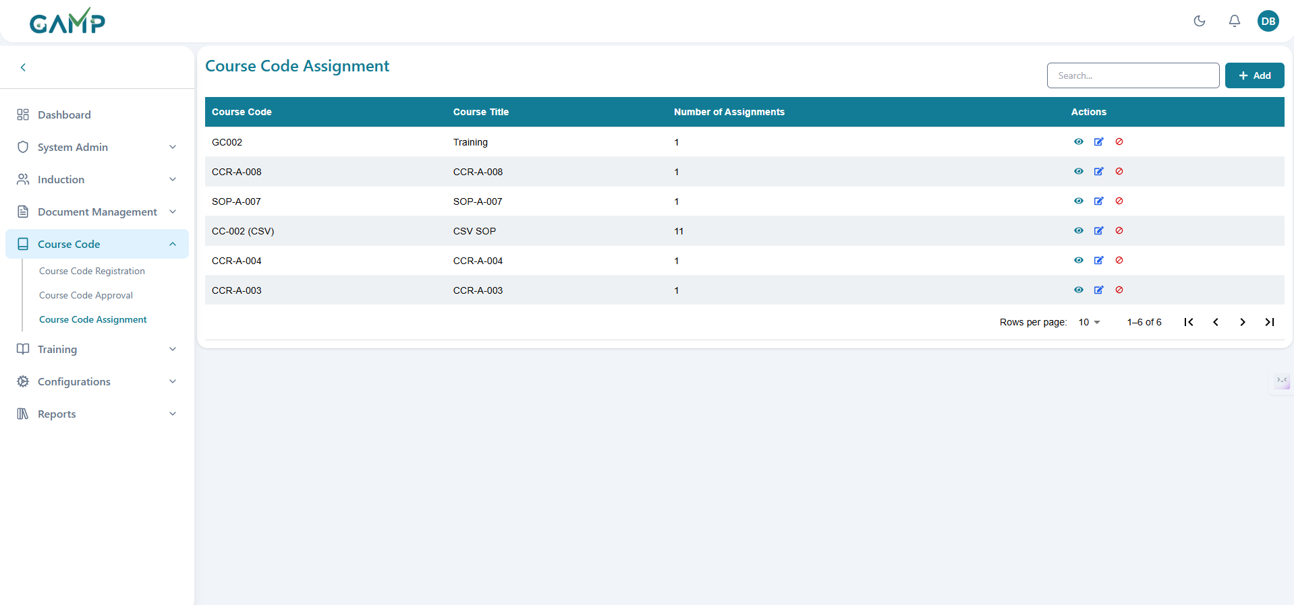

**Step 2:** Click the "Edit" icon (pencil) in the Actions column

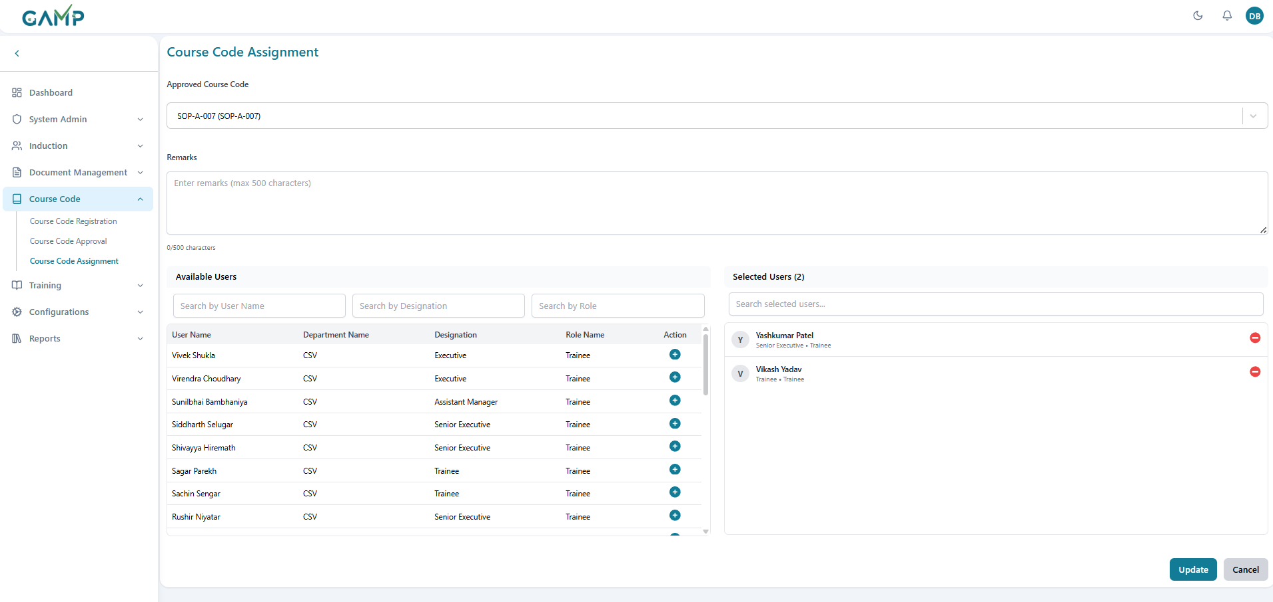

**Step 3:** Modify Assignment Details

* Course code can be changed (select from approved codes)
* Add or remove assigned users
* Update remarks if necessary

**Step 4:** User Management

* **Adding Users:**
  + Use search filters to find new users
  + Select users from the search results
  + Click the plus (+) icon to add them
* **Removing Users:**
  + Click the minus (-) icon next to users in the selected list

**Step 5:** Save Changes

* Click "Update Assignment" button
* If electronic signature is enabled:
  + Provide reason for change
  + Enter electronic signature
  + Confirm the update

### Viewing Assignment Details

**Step 1:** Click the "View" icon (eye) in the Actions column

**Step 2:** Review the detailed information:

* Course code and title
* Complete list of assigned users

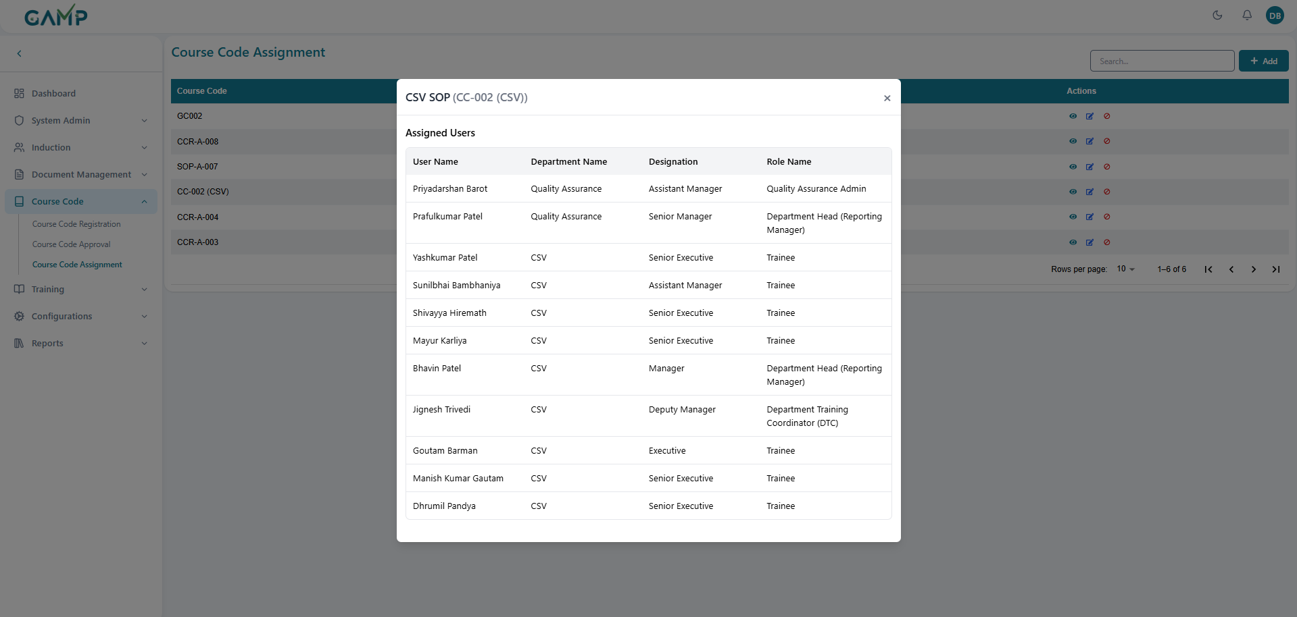**Step 3:** Close the modal when done reviewing

### Deactivating Course Code Assignment

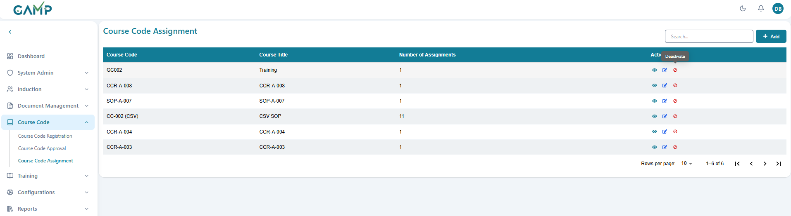

**Step 1:** Locate the assignment to deactivate

**Step 2:** Click the "Deactivate" icon (cancel) in the Actions column

**Step 3:** Confirm deactivation:

1. Enter reason for deactivation
2. Provide electronic signature (if enabled)
3. Click "Confirm" to proceed



# Training Module

## 1.Trainer Registration

The Trainer Registration module allows administrators to register qualified employees as trainers within the organization. This ensures that only authorized and experienced personnel can conduct training sessions and maintain compliance with training standards.

**Step 1: Accessing Trainer Registration**

**1.** Log in to the TMS system

2. Navigate to the main dashboard. From the sidebar menu click **Training → Trainer Registration**

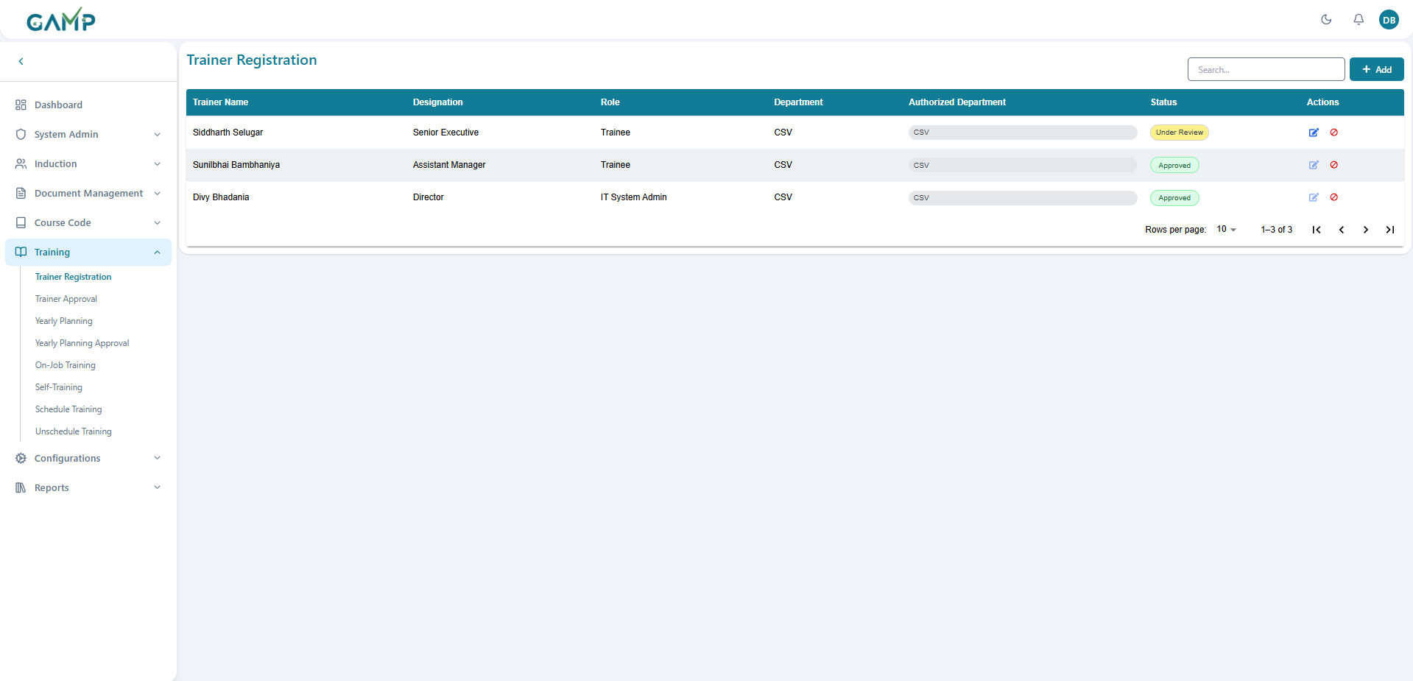

**Step 2: Viewing Trainer Registration**

Information shown includes:

* + **Employee Name**
  + **Employee ID**
  + **Department**
  + **Designation**
  + **Role**
  + **Experience (Years/Months)**
  + **Authorized Departments**
  + **Status (Under Review, Approved, Rejected)**
  + **Actions (Edit, Delete)**

### Adding New Trainer Registration

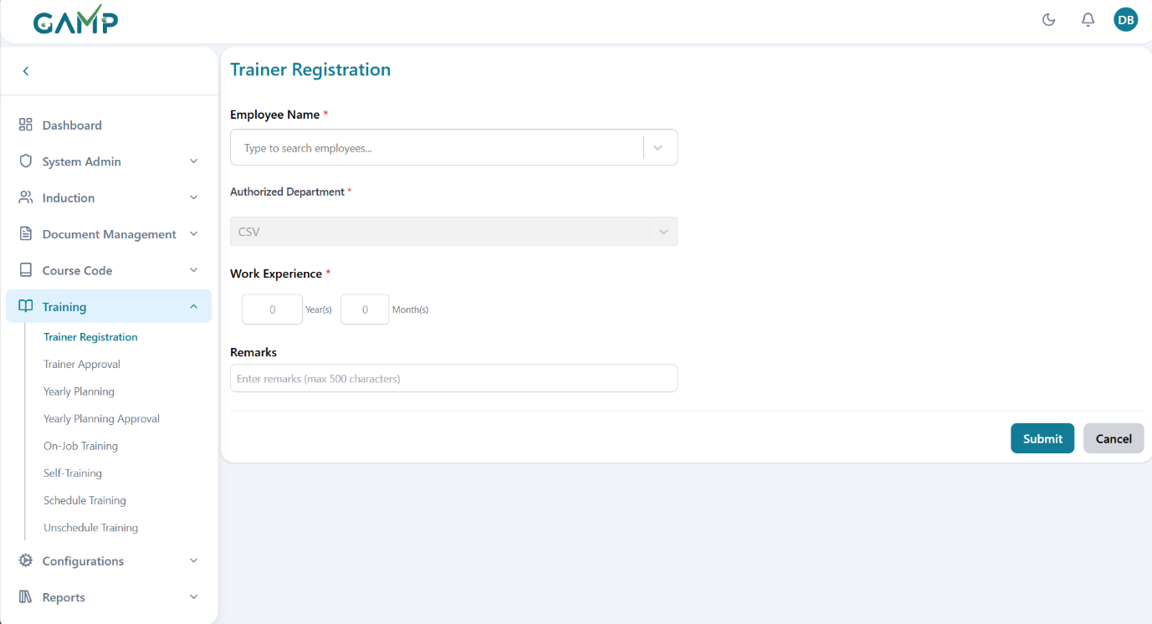

**Step 1:** Click the "**Add Trainer**" button (+ icon) in the top-right corner

**Step 2:** Select Employee

Choose from the dropdown of active employees. Search functionality helps find specific employees by:

* **Employee Name**
* **Employee ID**
* **Department**
* **Designation**
* Only active employees are available for selection

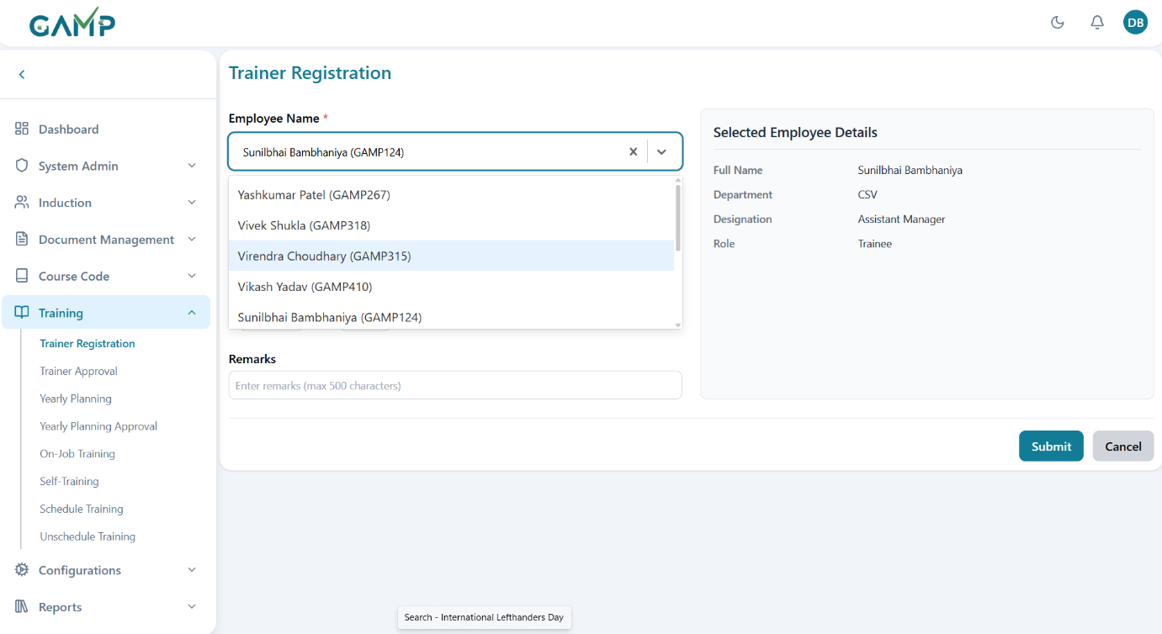

**Step 3:Employee Information** Once an employee is selected, the following fields are automatically populated:

* + - **Employee Name**
    - **Employee ID**
    - **Department**
    - **Designation**
    - **Role**

**Step 4: Set Authorized Departments**

* Select one or more **departments** the trainer is authorized to train
* Use the searchable dropdown to find departments
* Here, for normal trainees, they can be the authorized trainees for their department only but, for QA role , they can be authorized trainers for other departments other than QA also



**Step 5:** **Enter Experience Details**

* + - **Years of Experience**: Enter the number of years (0-50)
    - **Months of Experience**: Enter additional months (0-11)
    - Total experience is calculated automatically
    - Minimum experience requirements may apply based on organization policy

**Step 6: Add Remarks (Optional)**

* + Enter any relevant comments about the trainer's qualifications
  + Include special certifications, training background, or expertise areas
  + This field supports up to 500 characters

**Step 7: Review Registration Details**

* + Verify all entered information
  + Ensure authorized departments are correct
  + Check experience details for accuracy

**Step 8: Submit Registration**

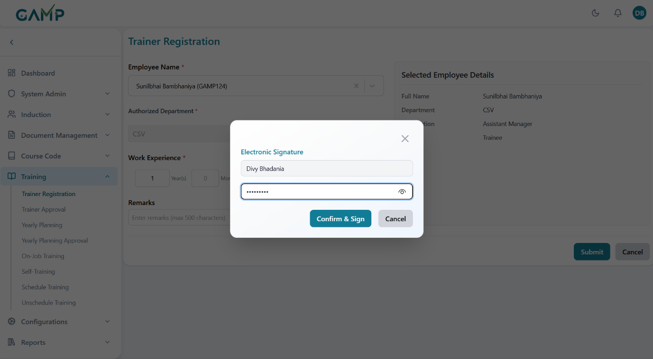

* + Click "**Register Trainer**" button
  + If **electronic signature** is enabled:

1. Enter **reason** for registration
2. Provide **electronic signature** (password)
3. Click "**Submit**" to confirm

**Step 9: Confirmation**

* + Success message appears upon successful registration
  + User is redirected to the trainer list
  + New trainer appears with "**Under Review**" status

### Editing Trainer Registration

**Step 1:** Locate the trainer to edit in the list

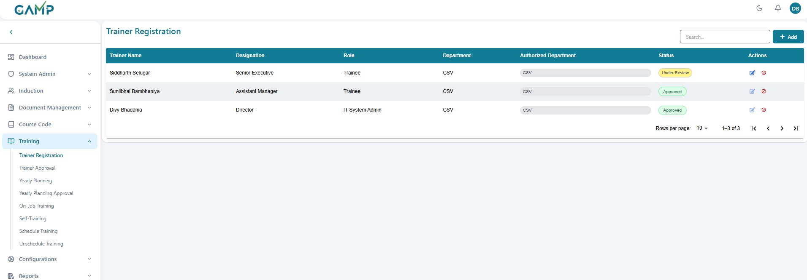

**Step 2:** Click the "**Edit**" icon (pencil) in the Actions column

Note: Trainers with "Approved" or "Rejected" status cannot be edited

**Step 3: Modify Registration Details**

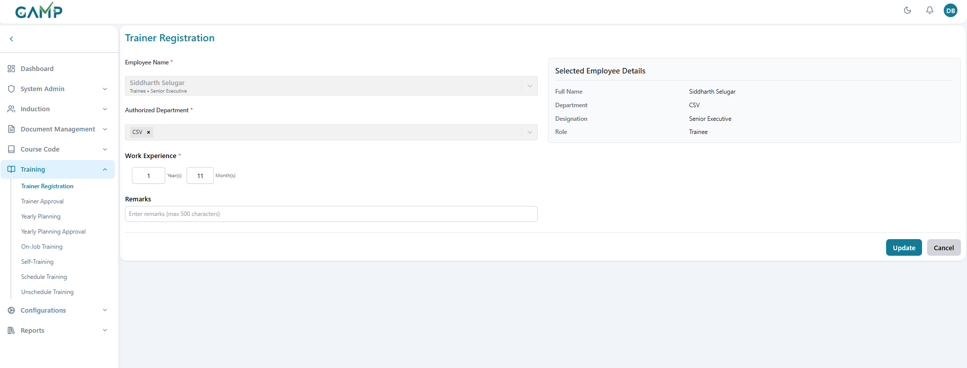

* **Employee** cannot be changed (read-only field)
* Update authorized **departments** if needed
* Modify **experience** years and months
* Update **remarks** as necessary
* Add or remove **departments** if needed
* Change the **experience** years and months

**Step 4: Save Changes**

• Click "**Update Trainer**" button

• If **electronic signature** is enabled:

* Provide **reason for change**
* Enter **electronic signature**
* Confirm the update

### Deactivating Trainer Registration

**Step 1**: Locate the **trainer** to deactivate

**Step 2:** Click the **"Delete"** icon (cancel) in the **Actions** column

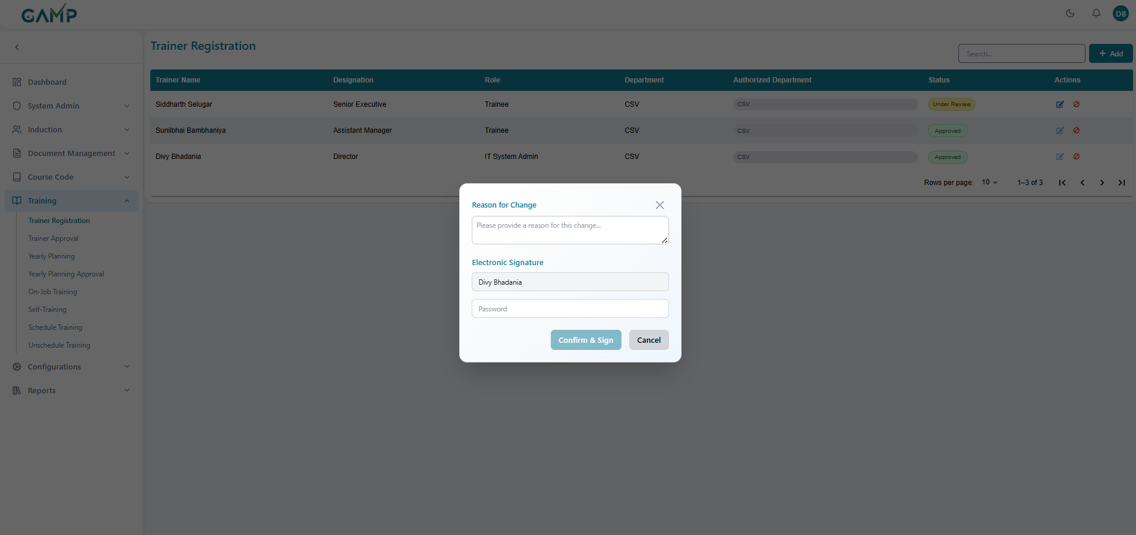

**Step 3:** Confirm **deactivation**:

* Enter **reason** for deactivation
* Provide electronic signature (if enabled)
* Click "**Confirm**" to proceed

**Step 4:** **Trainer registration** is removed from active list

## 2.Trainer Approval

The Trainer Approval module allows authorized personnel to review and approve trainer registrations submitted by administrators. This ensures that only qualified and verified trainers are authorized to conduct training sessions within the organization.

**Steps for Trainer Approval**

**1. Navigate to Trainer Approval**

* From the **left menu**, click **Trainer → Trainer Approval**.
* A list of trainers pending approval will be displayed.

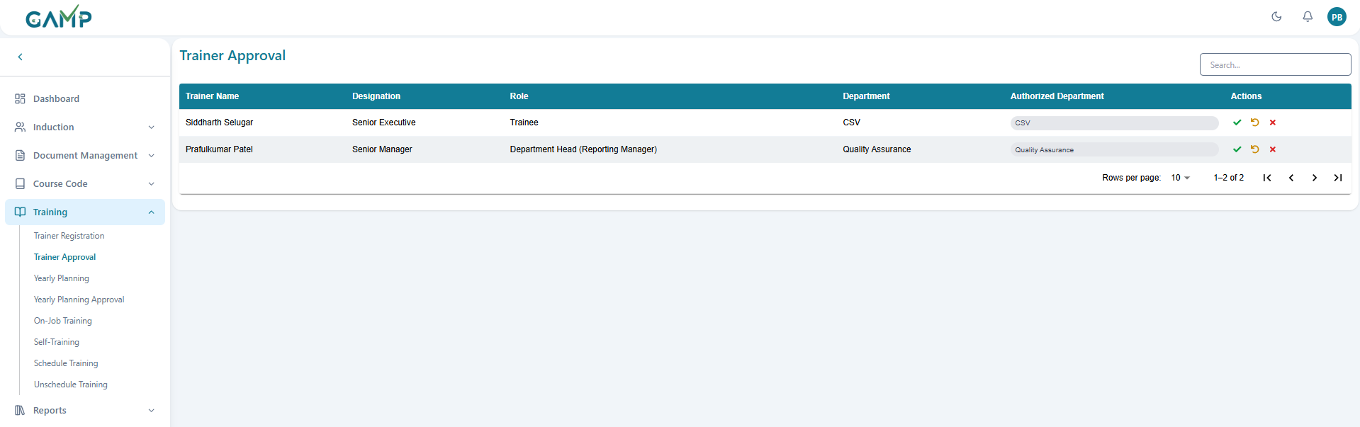

**2. Review the Trainer List**

* Each row displays key details:
* **Trainer Name**
* **Designation**
* **Role**
* **Department**
* **Authorized Departments**
* **Actions (Approve, Return, Reject)**

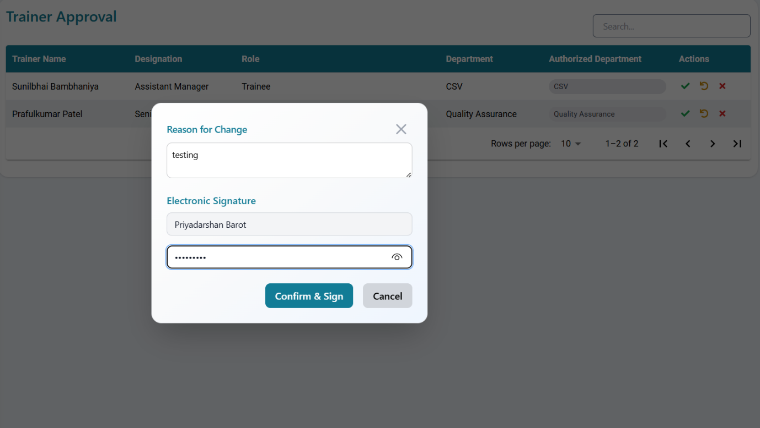

**3. Approve a Trainer**

* Click the **Green Check (✔) icon** to approve the trainer.
* The **Electronic Signature** pop-up will appear:
  1. Enter **approval remarks** in the *Reason for Change* input field.
  2. The **Username** is auto-fetched.
  3. Enter your **Password** to authenticate the action.
* If the password is incorrect, the system prompts for re-entry until correct.
* Upon successful authentication, the trainer is marked as **Approved** and becomes available for training assignments.

**4. Reject a Trainer**

* Click the **Red Cross (✖) icon** to reject the trainer.
* The **Electronic Signature** pop-up will appear:
  1. Enter **rejection remarks** (reason for rejection) in the *Reason for Change* input field.
  2. The **Username** is auto-fetched.
  3. Enter your **Password** to authenticate the action.
* Upon successful authentication, the trainer is marked as **Rejected** and will not be available for assignment.

**5. Return a Trainer for Revision**

* Click the **Circular Arrow (↺) icon** to return the trainer nomination for revision.
* The **Electronic Signature** pop-up will appear:
  1. Enter the **return remarks** (e.g., incomplete qualification details, missing documents) in the *Reason for Change* input field.
  2. The **Username** is auto-fetched.
  3. Enter your **Password** to authenticate the action.
* Upon successful authentication, the trainer record is sent back to the creator for correction and resubmission.

**Post-Approval Actions**

* Approved trainers become available in trainer assignment modules
* Approved trainers can be assigned to training sessions
* Trainer qualifications are recorded for compliance tracking

## 3.Yearly Planning

The **Yearly Planning** module allows administrators to create, manage, and schedule training events throughout the year. This module provides a calendar-based interface for planning training sessions, workshops, and other educational activities across different departments and timeframes.

**Step 1:**Log in to the **TMS** system

**Step 2**: Navigate to the main dashboard and in left sidebar menu, click on **Training Session → Yearly Planning**

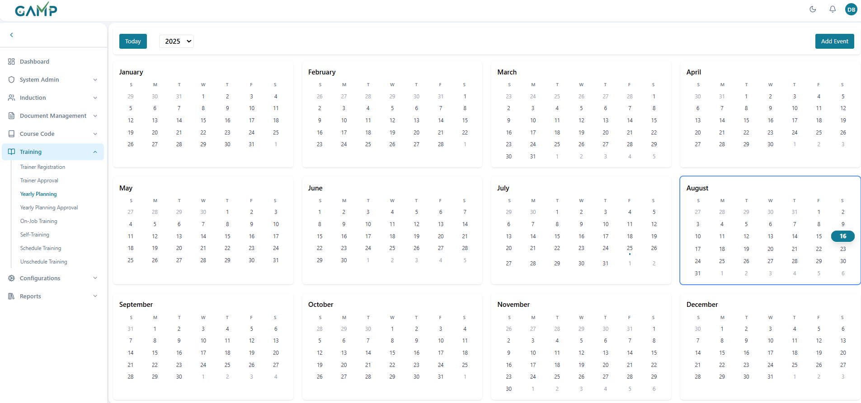

**Calendar Interface Overview**

**1. Calendar Views** The module provides two main view modes:

* **Year View:** Displays all 12 months in a grid format for the selected year
* **Month View:** Shows detailed daily view for a specific month

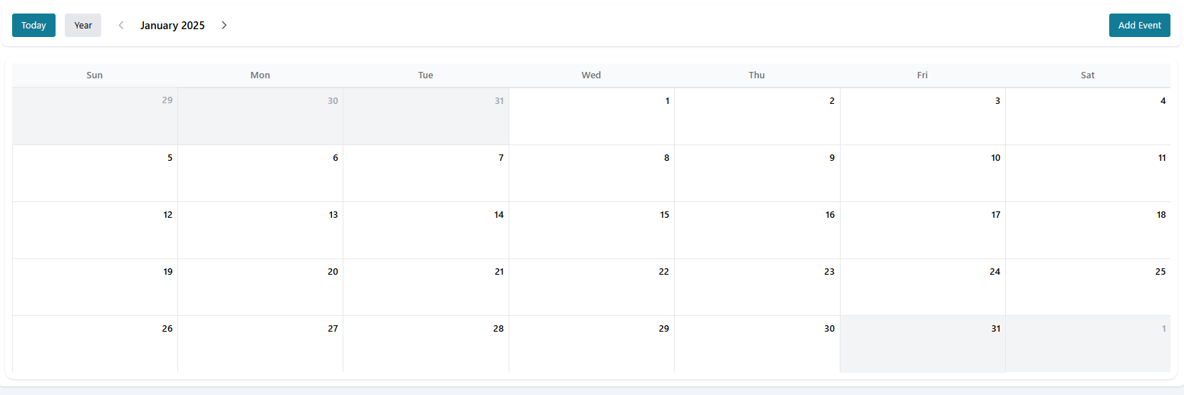

**2. Navigation Controls**

* **Year Selector:** Choose different years to view/plan events
* **Today Button:** Quickly navigate to the current date
* **View Toggle:** Switch between year and month views
* **Month Navigation:** Click on any month in year view to access detailed month view

**3. Event Display**

* Events appear as coloured items on calendar dates
* Each event shows training title and department information
* Multiple events per day are supported
* Past dates are distinguished from future dates

### Adding New Training Events

#### Quick Add Event (Date Click Method)

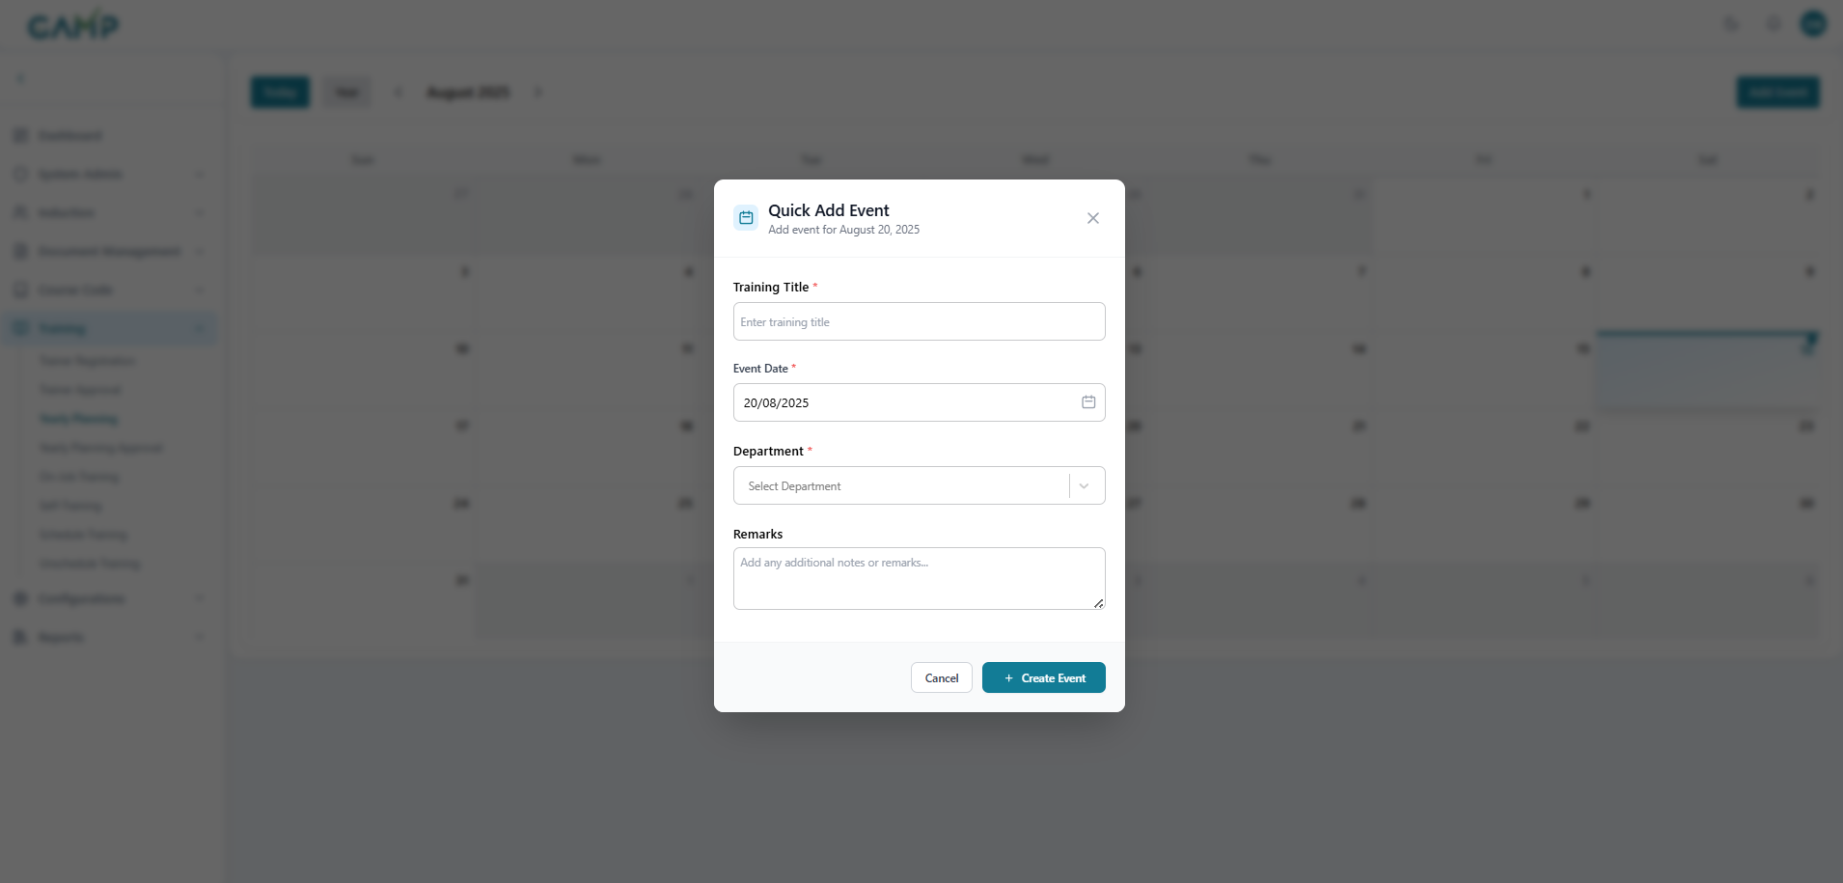

**Step 1:** **Navigate to desired date**

* Use year/month navigation to find the target date.
* Click on the specific date where you want to add an event
* Note: Cannot add events to past dates (system will show warning)

**Step 2:** **Quick Add Form**

* **Training Title:** Enter descriptive name for the training event
* **Date:** Automatically populated with selected date (can be modified)
* **Department:** Select from dropdown of available departments.
  + Use search functionality to find specific departments.
  + Only active departments are available
* **Remarks:** Add optional notes or descriptions (up to 500 characters)

**Step 3:** **Submit Quick Event**

* Click "**Add Event**" button
* If **electronic signature** is enabled:
  + Enter reason for adding event.
  + Provide **electronic signature** (password).
  + Click "**Submit**" to confirm

#### Detailed Add Event (Add Button Method)

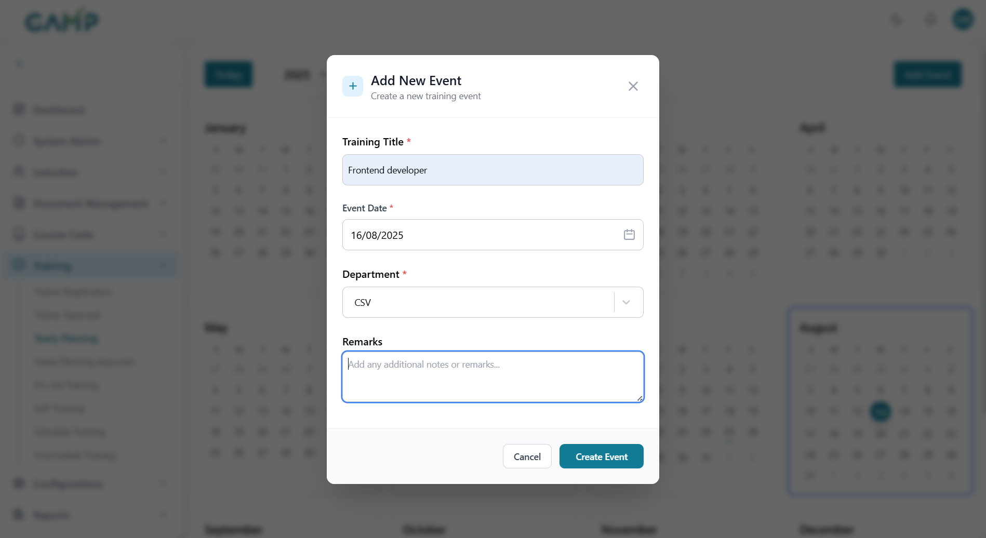

**Step 1:** Click "**Add Event**" button in the interface

**Step 2:** **Complete Event Details**

* **Training Title:** Enter comprehensive training name
* **Start Date:** Select event start date using date picker
* **End Date:** Select event end date (if multi-day event) • **Department:** Choose target department from searchable dropdown • **Description/Remarks:** Provide detailed event information

**Step 3:** **Validation and Submission**

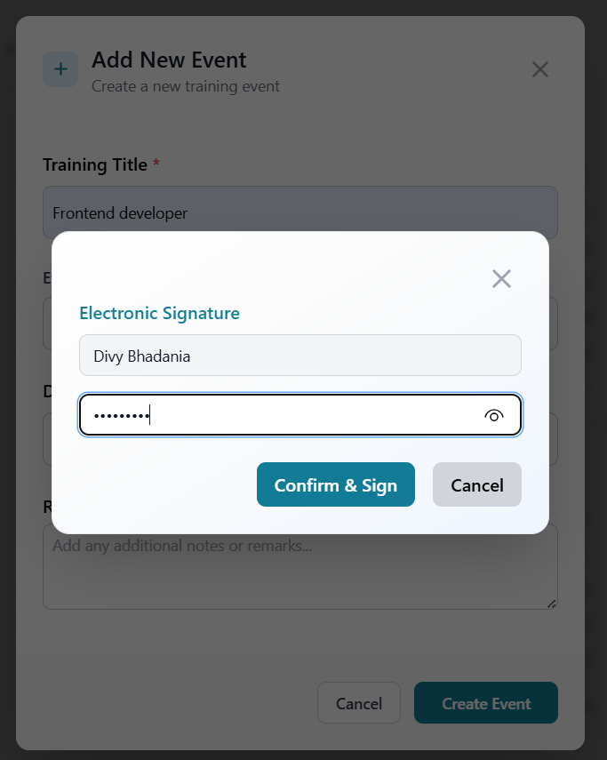

* System validates all required fields
* Submit with electronic signature if enabled
* Event appears on calendar upon successful creation

### Editing Training Events

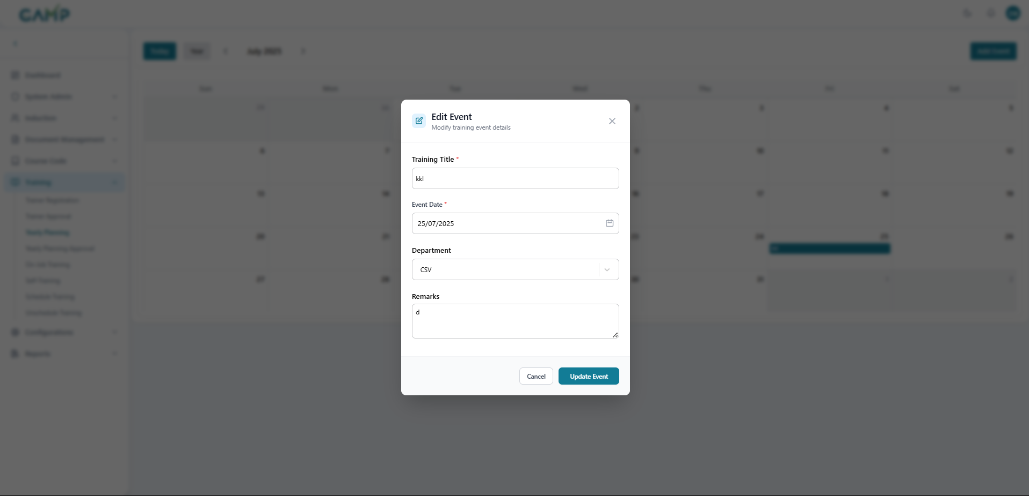

**Step 1:** **Locate Event on Calendar**

* Navigate to the date containing the event.
* Events are displayed as coloured blocks on calendar dates

**Step 2:** **Click on Event**

* Click directly on the event item to open edit modal.
* Event details populate in the edit form

**Step 3:** **Modify Event Details**

* **Training Title:** Update event name if needed
* **Date:** Change event date using date picker
* **Department:** Select different department if required
* **Remarks:** Update event description or notes

**Step 4:** **Save Changes**

* Click "Update Event" button
* If electronic signature is enabled:
  + Provide reason for change
  + Enter electronic signature
  + Confirm the update

### Deleting Training Events

**Step 1:** **Open Event for Editing**

* Click on the event in the calendar view
* Event edit modal opens

**Step 2:** **Initiate Deletion**

Click "Delete Event" button (trash/cancel icon) in the edit modal

**Step 3:** **Confirm Deletion**

* Provide reason for deletion
* Enter electronic signature (if enabled)
* Click "Confirm" to proceed
* Event is removed from calendar

**Calendar Synchronization**

* Events integrate with other TMS scheduling modules
* Real-time updates across all calendar views
* Automatic refresh of event data

## 4.Yearly Planning Approval

**1. Navigate to Yearly Training Planning Approval**

* From the **left menu**, click **Training Plan → Yearly Planning Approval**.
* A list of yearly training plans pending approval will be displayed.

**2. Review the Yearly Training Plan List**

The main screen displays all years with pending training plans requiring approval Information shown includes:

* Year (e.g., 2024, 2025)
* Click on any year to view detailed events for that year

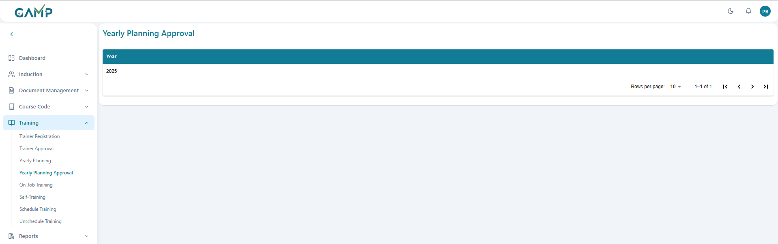

**3. View Yearly Training Plan Details**

**Step 1:** **Select Year for Review**

* Click on the desired year from the year list
* System navigates to the events view for that year

**Step 2:** **Review Event Details** The events grid displays all planned training events for the selected year:

* **Training Title:** Name of the training event
* **Department:** Target department for the training
* **Schedule Date:** Planned date for the training
* **Status:** Current approval status (Under Review, Approved, Returned)
* **Actions:** Available approval actions (Approve, Return)

**Step 3:** **Event Status Indicators**

* **Under Review:** Events pending approval decision
* **Approved:** Events that have been approved for implementation
* **Returned:** Events sent back for modifications

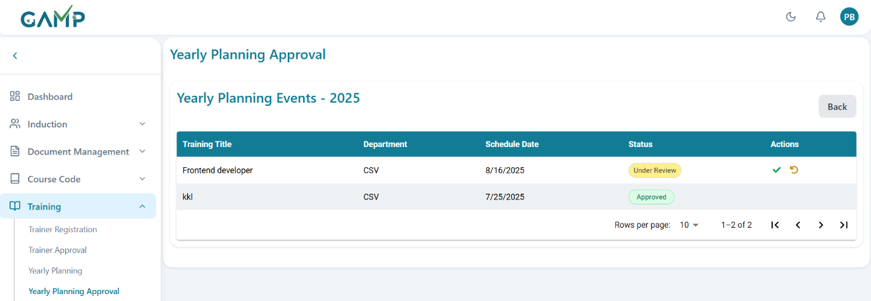

**4. Approve a Yearly Training Plan**

* Click the **Green Check (✔) icon** to approve the yearly training plan.
* The **Electronic Signature** pop-up will appear:
  1. Enter **approval remarks** in the *Reason for Change* input field.
  2. The **Username** is auto-fetched.
  3. Enter your **Password** to authenticate the action.
* If the password is incorrect, the system prompts for re-entry until correct.
* Upon successful authentication, the plan is marked as **Approved** and becomes active for scheduling and execution.

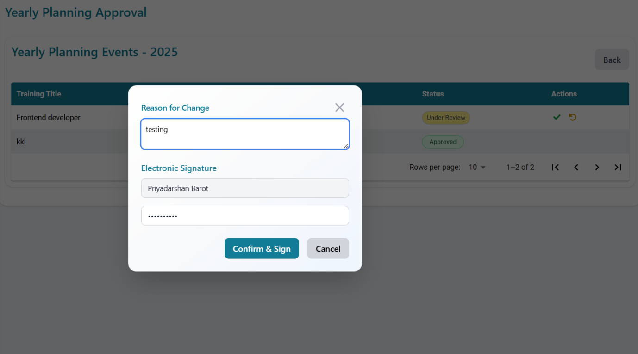

**5. Return a Yearly Training Plan for Revision**

* Click the **Circular Arrow (↺) icon** to return the plan for revision.
* The **Electronic Signature** pop-up will appear:
  1. Enter **return remarks** (e.g., missing training subjects, incorrect schedule, incomplete trainer mapping) in the *Reason for Change* input field.
  2. The **Username** is auto-fetched.
  3. Enter your **Password** to authenticate the action.
* Upon successful authentication, the plan is sent back to the creator for correction and resubmission.

## 5.On-Job Training

Manage and conduct On-the-Job Training sessions with structured activities, progress tracking, and documentation for compliance and skill development.

**Step 1:**Log in to the **TMS** system

**Step 2**: Navigate to the main dashboard and in left sidebar menu, click on **Training Session → On-Job Training**

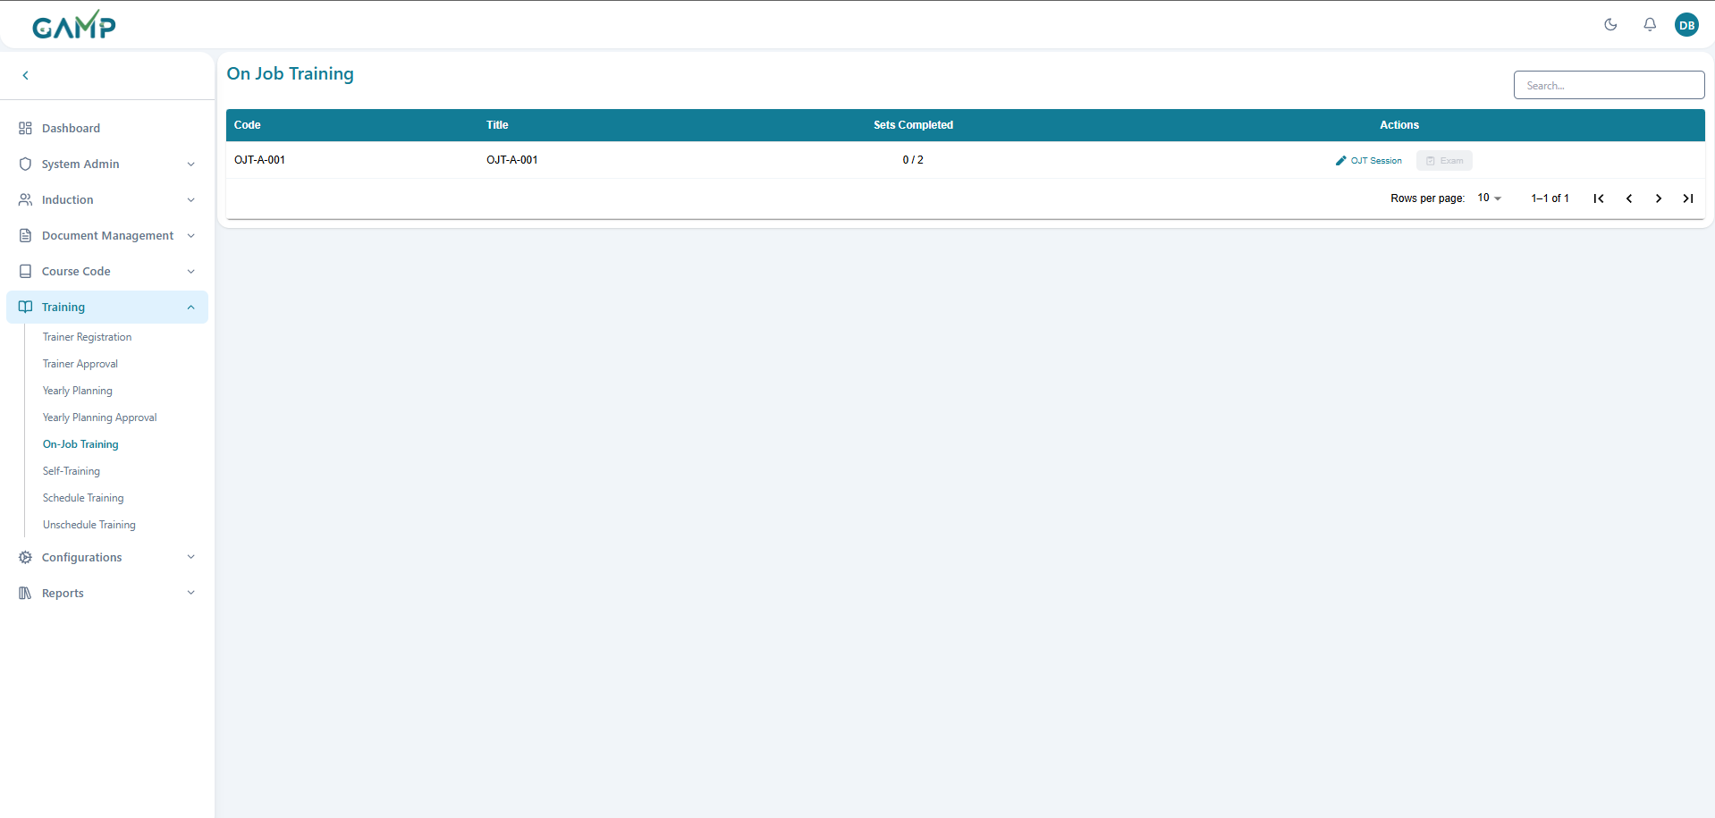

**Step 3: Review OJT Sessions Table**

**Table Columns:**

* **Code:** Unique OJT identifier
* **Title:** OJT session name
* **Sets Completed:** Progress indicator showing completed vs total sets (e.g., "0 / 2")
* **Actions:** Available actions for each OJT session
* **OJT Session:** Start or continue the training session
* **Exam:** (*Once OJT Session is completed, then exam gets activated*) Start or continue the exam for this OJT

**Step 4: Start OJT Session**

1. Click the " **OJT Session**" button for the desired training
2. The "**OJT Training Session**" interface will open
3. Review the session overview information

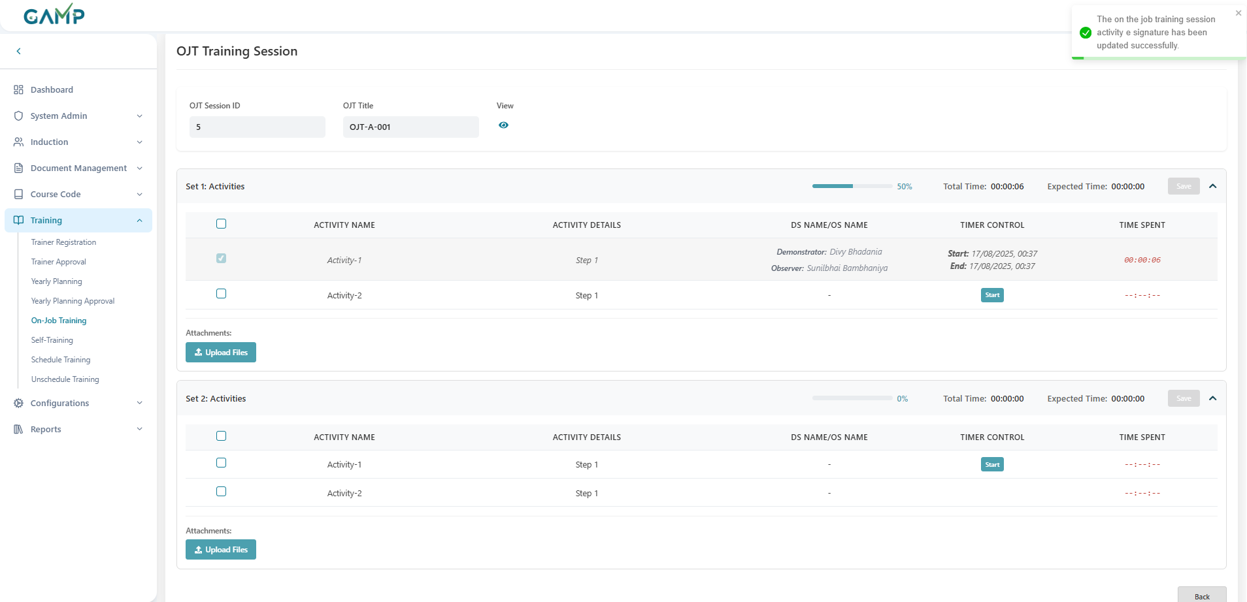

**Step 5: OJT Session Overview**

**Session Information Display:**

* **OJT Session ID:** Unique session identifier
* **OJT Title: Training session name**
* **View Button:** Icon for viewing the document associated with the OJT in a full screen file viewer

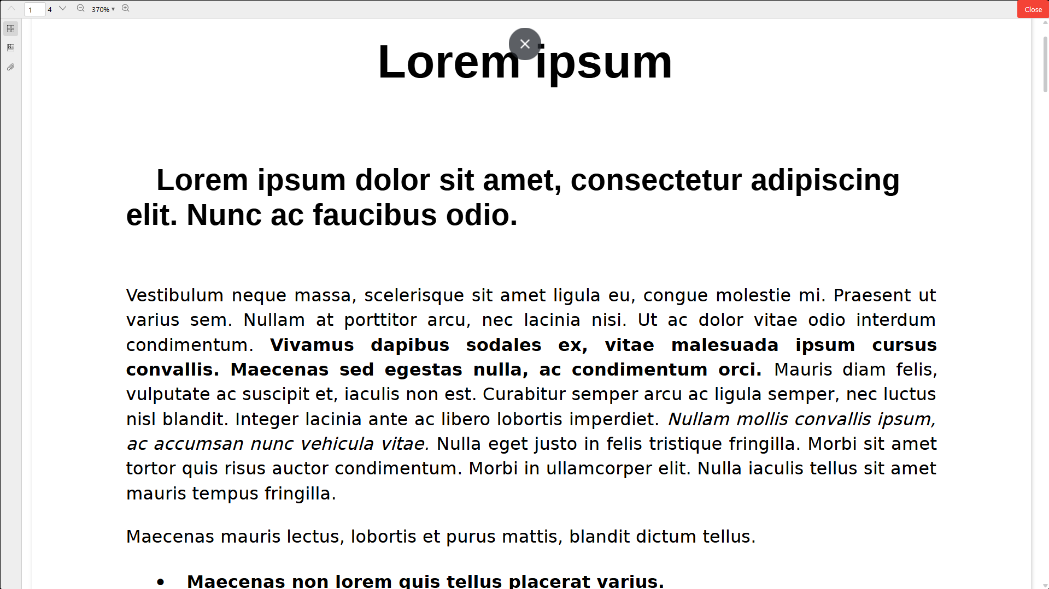

**Step 6: Understanding Activity Sets**

Each OJT session is divided into multiple sets:

**Set: Activities**

* **Progress Bar**:  Visual indicator showing completion percentage (e.g., 100% when complete)
* **Timing Information**:
  1. **Total Time**: Actual time spent
  2. **Expected Time**: Planned duration
* **Completion Rule** Total time must be **equal to greater** than the expected time

**Step 8: Activity Details Table**

**Column Headers:**

* **Checkbox**: Select/deselect activities for siging
* **ACTIVITY NAME**: Name of the specific activity
* **ACTIVITY DETAILS**: Description of what needs to be done in that step
* **DS NAME/OS NAME**: Demonstrator and Observer names
  1. **Demonstrator**: Person showing the activity
  2. **Observer**: Person observing/validating
* **TIMER CONTROL**: Start/stop timing for activities
* **TIME SPENT**: Actual time spent on each activity



**For Active Activities**

1. **Review Activity**: Check Activity details
2. **Assign Roles**:
   * Demonstrator shows the procedure
   * Observer validates the performance
3. **Timer Management**:
   * Activities show start/end times
   * Some activities may show "--:--:--" if not yet started
4. **Time Tracking**: Monitor time spent vs expected duration

**For Pending Activities (Set 2 example):**

1. **Start Button**: Click "Start" button to begin timing
2. **Activity Completion**: Follow same process as Set 1
3. **Progress Update**: Progress bar updates as activities complete

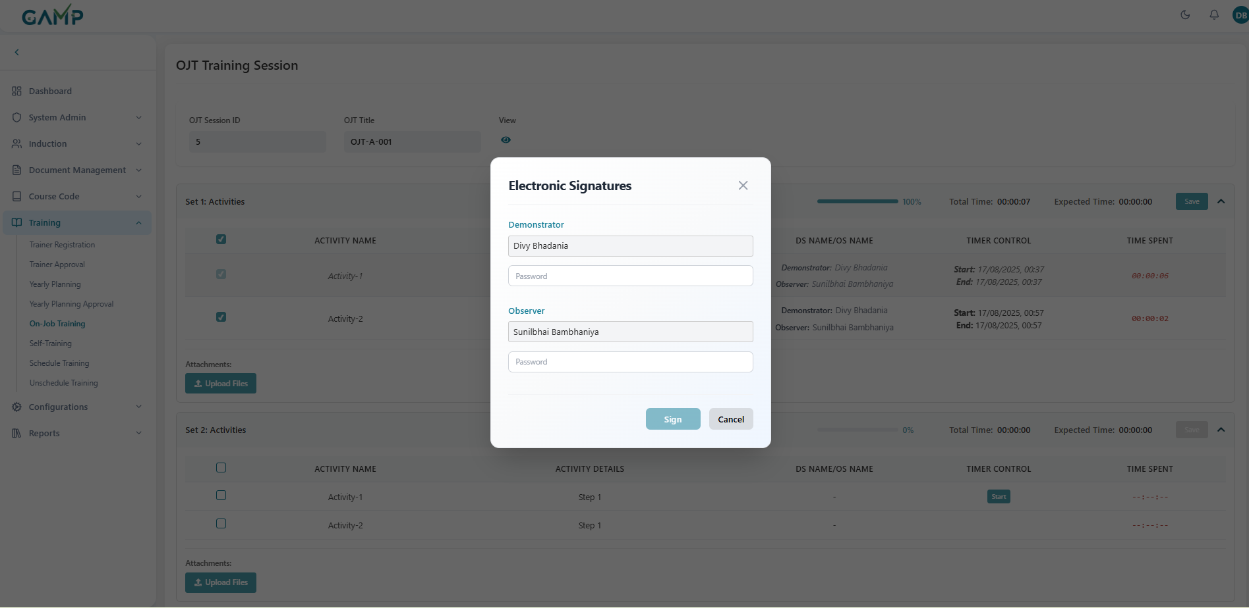

**Step 10: Electronic Signatures**

1. **Select Activity**: Click on any activity (single or multiple) to select it
2. **Complete Activity**: Ensure the activity is finished and timing requirements are met
3. **Save Activity**: Click the **"Save"** button to initiate the signature process
4. **Electronic Signatures Modal**: The system opens the Electronic Signatures dialog

**Demonstrator Section:**

* **Name Field**: Pre-populated with demonstrator name
* **Password Field**: Secure password entry for electronic signature

**Observer Section:**

* **Name Field**: Pre-populated with observer name
* **Password Field**: Secure password entry for electronic signature

**Action Buttons:**

* **Sign**: Confirm and apply both electronic signatures simultaneously
* **Cancel**: Close modal without applying signatures

1. **Enter Passwords**: Both demonstrator and observer enter their secure passwords
2. **Dual Validation**: System validates both signatures simultaneously
3. **Click "Sign"**: Apply both electronic signatures in one action
4. **Activity Status Update**: Completed activity becomes **greyed out** indicating completion

**Step 11: File Upload Process**

1. Click **"📎 Upload Files"** button in the relevant activity set
2. Select files from your computer
3. Supported formats: Documents, images, videos (as per system configuration)
4. Files attach to the specific activity set for reference

**Step 12: Monitor Training Progress**

1. **Overall Progress**: Check sets completion ratio in main table
2. **Individual Set Progress**: Monitor progress bars for each set
3. **Activity Status**: Track individual activity completion
4. **Time Management**: Compare actual vs expected times

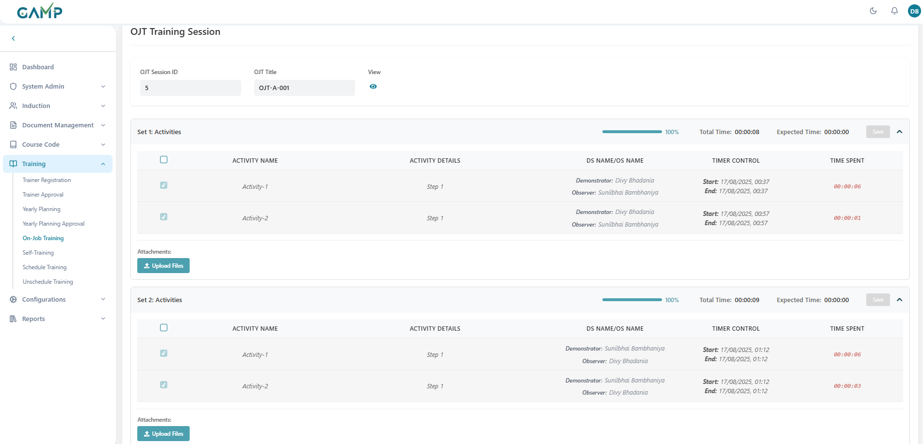

**Step 13: Session Completion**

1. **Complete All Activities**: Ensure all activities in all sets are finished
2. **Upload Required Documentation**: Add necessary supporting files
3. **Validate Signatures**: Ensure demonstrator and observer sign-offs
4. **Final Review**: Verify all requirements are met

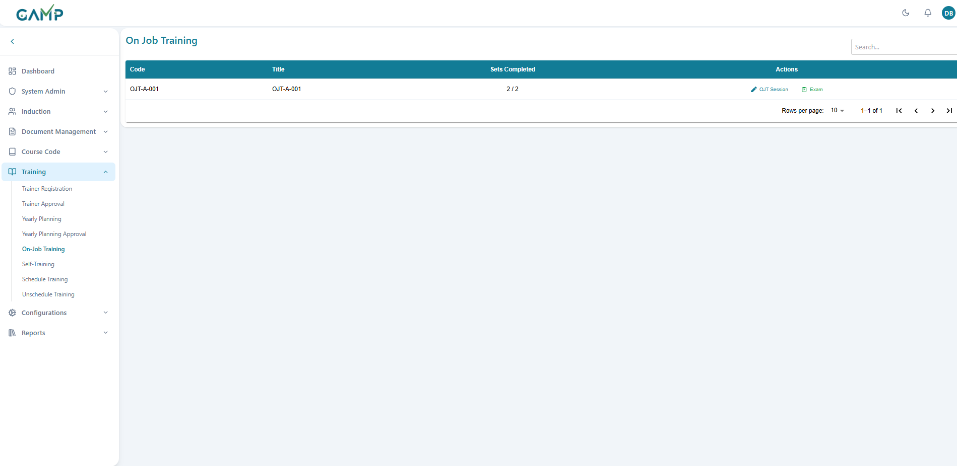

**Step 14: Navigation and Session Management**

1. **Back Button**: Return to main OJT overview
2. **Session Continuity**: Sessions can be paused and resumed
3. **Auto-Save**: System automatically saves progress
4. **Status Updates**: Real-time updates reflect in main overview

**Step 15: Exam Activation After OJT Completion**

1. **OJT Session Completion**: Complete all activity sets with electronic signatures
2. **Exam Button Activation**: Upon successful OJT completion, the **"Exam"** button becomes active
3. **Exam Availability**: System automatically enables examination feature
4. **Access Examination**: Click the activated **"Exam"** button to start the assessment

**Step 16: Examination Interface Overview**

**Exam Session Information:**

* **Training Code**: Displays the completed OJT code (e.g., "OJT-A-001")
* **Training Title**: Shows the OJT session name (e.g., "OJT-A-001")

**Question Interface Structure:**

* **Question Progress**: Shows current question number (e.g., "Question 1 of 1")
* **Question Type**: Indicates question format (e.g., "Multiple Choice Question")
* **Question Content**: Displays the actual question from the questionnaire
* **Answer Options**: Multiple choice options with radio button selection

**Right Panel Information:**

* **Total Questions:** Shows total number of questions attempted
* **Attempted:** Number of questions answered
* **Best Score:** Highest score achieved (if multiple attempts allowed)
* **Not Attempted:** Questions not answered (if applicable)

**Status Indicators:**

* **Answered**: Green circle indicator for completed questions
* **Best**: Blue indicator for best performance
* **Not Attempted**: Orange indicator for skipped questions
* **Current Question**: Yellow indicator for active question

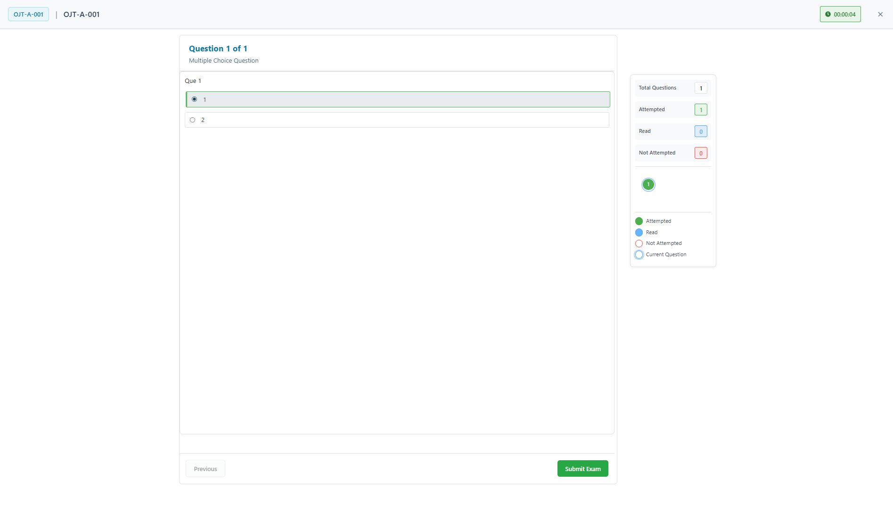

**Step 17: Taking the Examination**

**Question Navigation:**

1. **Question Display**: Each question appears individually on screen
2. **Question Type Identification**: System shows question format (Multiple Choice, True/False, etc.)
3. **Answer Selection**: Click radio buttons to select answers
4. **Progress Tracking**: Monitor current question vs total questions

**Sample Question Interface:**

* **Question 1**: Multiple choice format with selectable options
* **Answer Options**:
  1. Option 1 (radio button selection)
  2. Option 2 (radio button selection)
  3. Additional options as configured
* **Selection Feedback**: Selected answers are highlighted

**Step 18: Exam Submission and Results**

**During Examination:**

1. **Answer Selection**: Choose appropriate answers for each question
2. **Progress Monitoring**: Track completion through question sequence
3. **Review Answers**: Verify selections before submission
4. **Submit Exam**: Click **"Submit Exam"** button to complete assessment

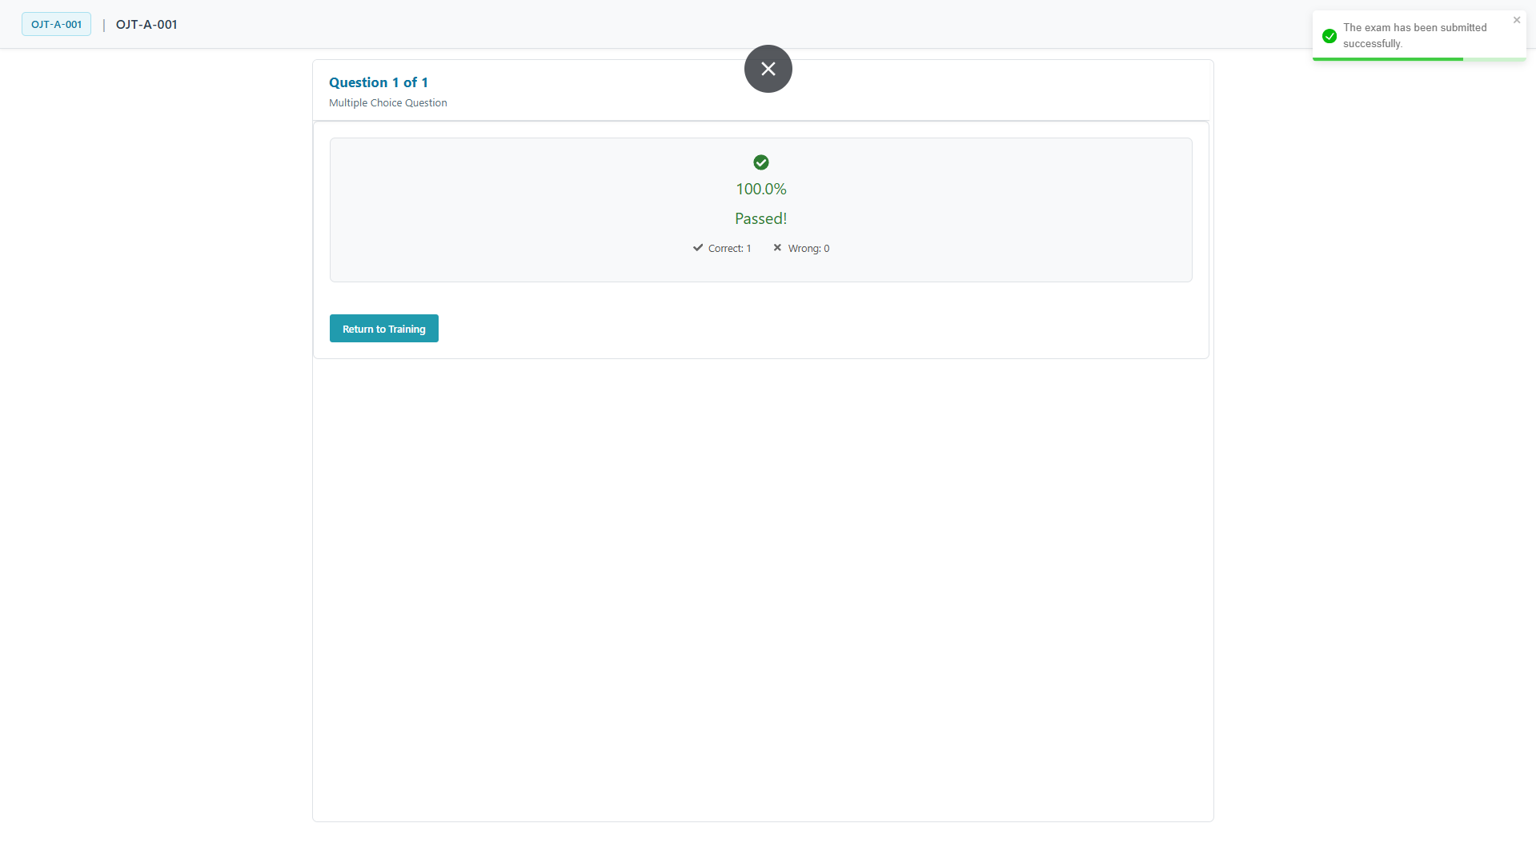

**Results Display:**

* **Success Indicator**: Green checkmark for successful completion
* **Score Display**: Shows percentage score (e.g., "100.0%")
* **Pass/Fail Status**: Clear indication of result (e.g., "Passed!")
* **Score Breakdown**:
  1. Correct answers count (e.g., "Correct: 1")
  2. Wrong answers count (e.g., "Wrong: 0")

**Step 19: Post-Exam Actions**

**Completion Actions:**

1. **Results Review**: Examine score and pass/fail status
2. **Return to Training**: Click **"Return to Training"** button to go back
3. **Record Keeping**: System automatically saves exam results
4. **Certification Update**: Results feed into overall training completion status
5. If exam is **passed**, the **On-job training** disappears from the ending on job training records

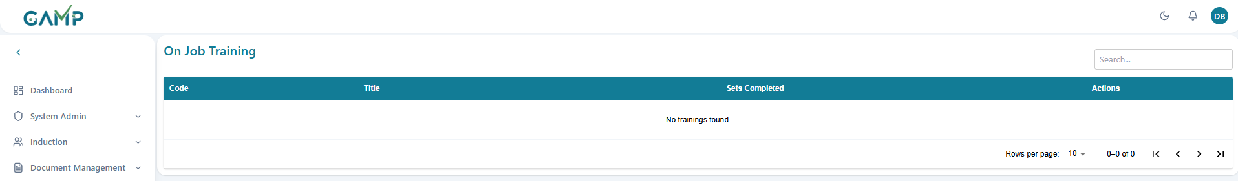

## 6.Self-Training

The Self Training module enables employees to independently study assigned training documents and complete examinations. This module supports both document-based training (PDF files) and video-based training (MP4 files) with comprehensive tracking, progress monitoring, and examination capabilities.

**Step 1:**Log in to the **TMS** system

**Step 2**: Navigate to the main dashboard and in left sidebar menu, click on **Training Session → Self Training**

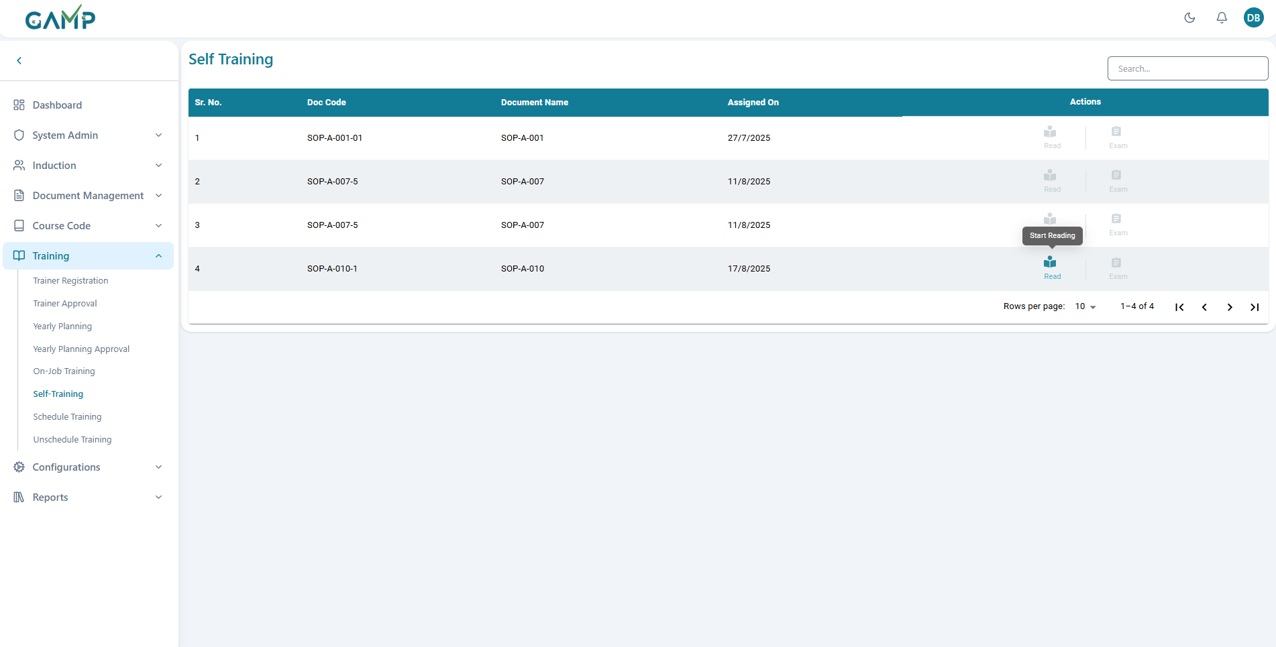

**Step 2: Understanding the Dashboard Interface**

Review the data table with columns:

* + **Sr. No.**
  + **Doc Code** Document code with version
  + **Document Name**
  + **Assigned On** Date when training was assigned
  + **Actions** Read/View and Exam buttons

**Step 3: Checking Document Availability**

* **Green "Read/View" Button:** Document available for reading
* **Gray Disabled Button:** Document under effectiveness
* **Green "Completed" Button:** Reading already finished
* **Tooltip Information:** Hover over buttons for status details

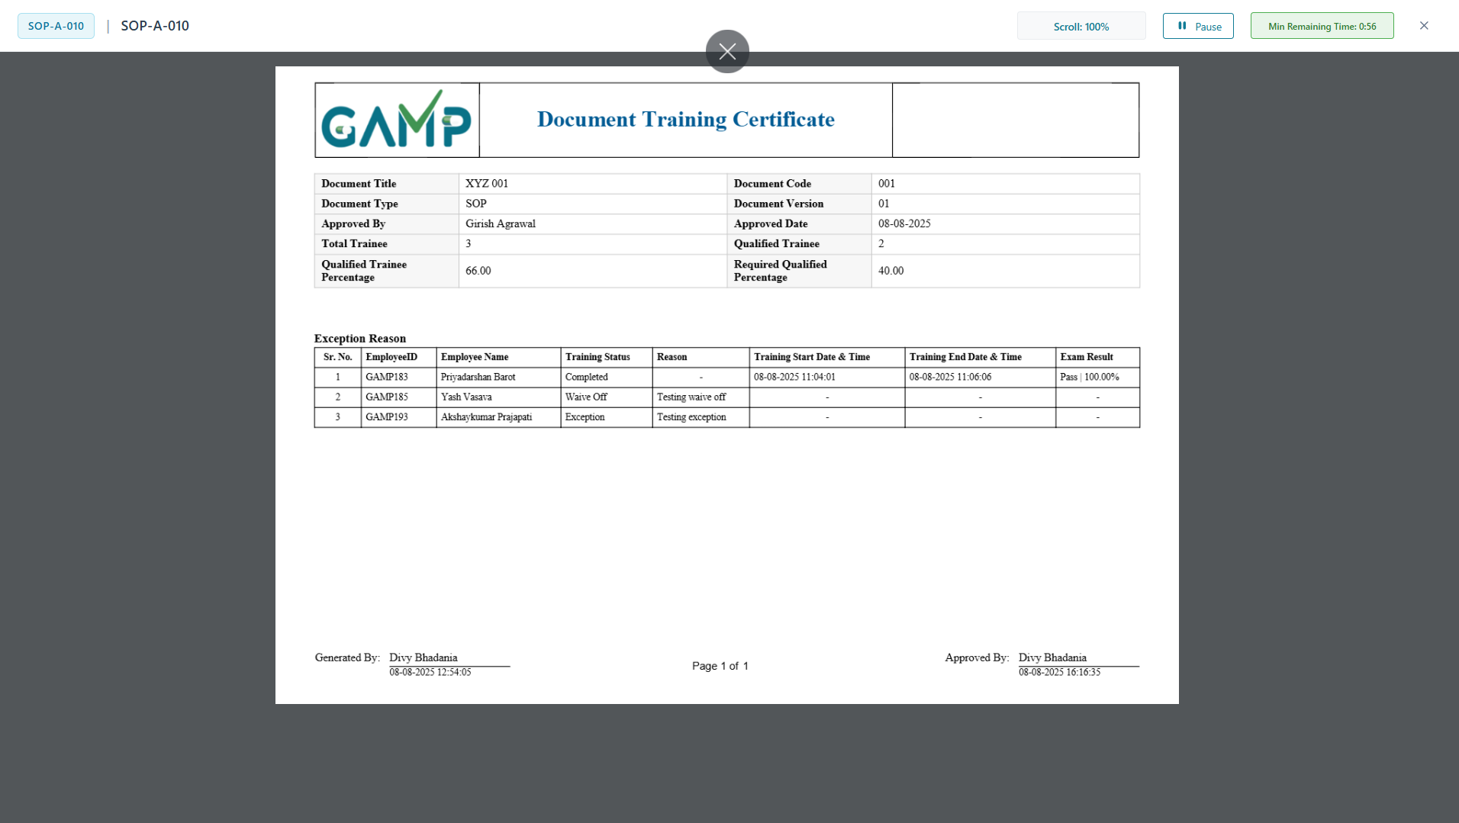

**Step 4: Starting Self Training**



**For PDF Documents:**

1. Click the **"Read"** button (book icon)
2. Document opens in f**ull screen** mode in separate document viewer with zoom and page navigation
3. Reading session **automatically starts**
4. **Back** button **disabled** during reading
5. Training pauses if user **switches tabs** or minimizes. Click on **resume** button to start from wherever left.
6. Warning on attempt to **exit full screen**
7. Progress saved every **30 seconds automatically**
8. System tracks **scrolling percentage**
9. **Progress Bar**: Visual indicator of completion percentage: (actual reading time/ required reading time) × 100
10. Must complete **minimum required** reading time

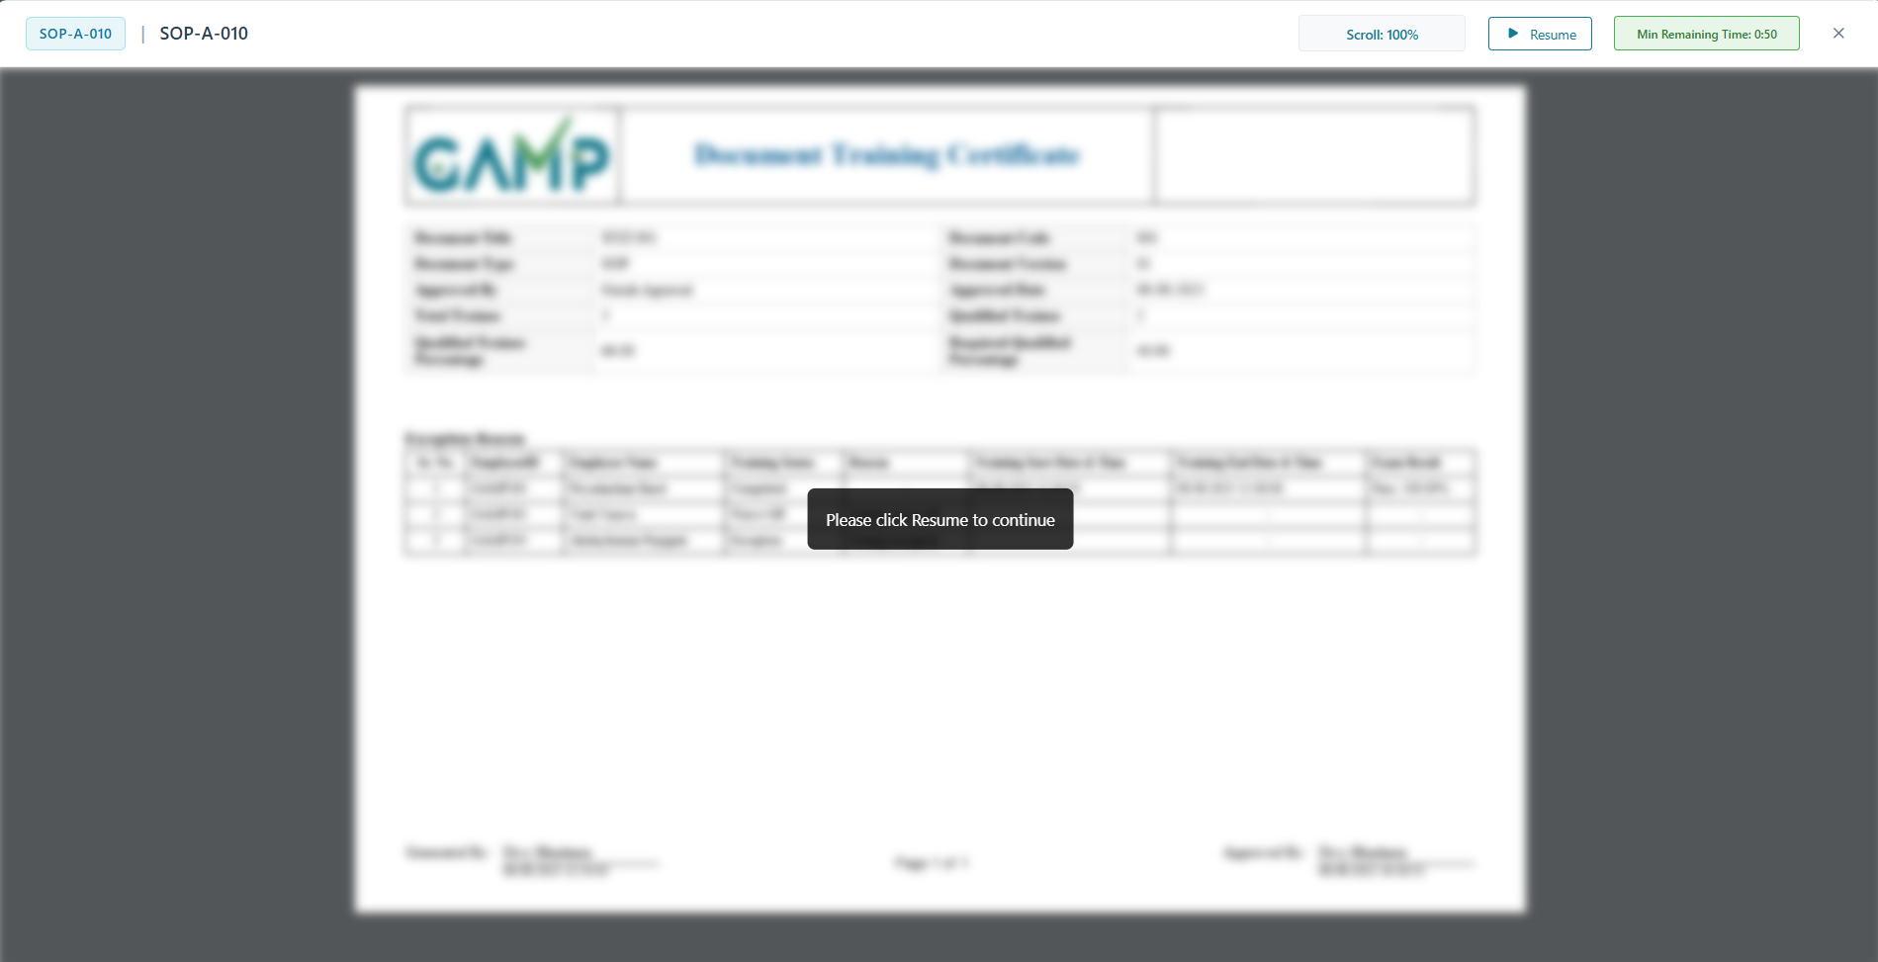

**For Video Trainings:**

1. Click the **"View"** button (video icon)
2. Video opens in full screen player with play, pause and seek controls
3. Viewing session automatically starts
4. **Back** button **disabled** during playing
5. Training pauses if user **switches tabs** or minimizes. Click on **resume** button to start from wherever left.
6. Warning on attempt to **exit full screen**
7. Progress saved every **30 seconds automatically**
8. **Progress Bar**: Visual indicator of completion percentage based on playback time: (actual reading time/ required reading time) × 100
9. Must complete minimum playing time

**Step 5: Completing Self Reading**

**Completion Criteria:**

1. **Time Requirement:** Must spend minimum required reading time
2. **Content Engagement:** (PDF) Must scroll through all pages
3. **Video Completion:** (Video) Must watch entire duration
4. **Progress Validation:** System validates actual engagement

**Completion Process:**

1. **Progress Reaches 100%:** Timer and content fully completed
2. **Submit Reading:** Click submit button when prompted
3. **Status Update:** Reading marked as completed
4. **Button Change:** Read button becomes green "Completed"
5. **Exam Activation:** Exam button becomes enabled

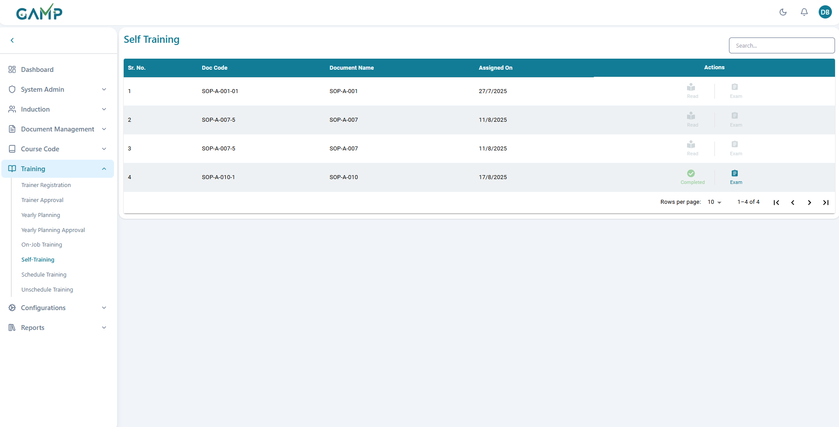

**Step 6: Exam Activation After Self Reading Completion**

1. **Exam Button Activation**: Upon successful Self Reading completion, the **"Exam"** button becomes active
2. **Exam Availability**: System automatically enables examination feature
3. **Access Examination**: Click the activated **"Exam"** button to start the assessment

**Step 6: Examination Interface Overview**

**Exam Session Information:**

* **Training Code**: Displays the completed Document code
* **Training Title**: Shows the Document name

**Question Interface Structure:**

* **Question Progress**: Shows current question number (e.g., "Question 1 of 1")
* **Question Type**: Indicates question format (e.g., "Multiple Choice Question")
* **Question Content**: Displays the actual question from the questionnaire
* **Answer Options**: Multiple choice options with radio button selection

**Right Panel Information:**

* **Total Questions:** Shows total number of questions attempted
* **Attempted:** Number of questions answered
* **Best Score:** Highest score achieved (if multiple attempts allowed)
* **Not Attempted:** Questions not answered (if applicable)

**Status Indicators:**

* **Answered**: Green circle indicator for completed questions
* **Best**: Blue indicator for best performance
* **Not Attempted**: Orange indicator for skipped questions
* **Current Question**: Yellow indicator for active question

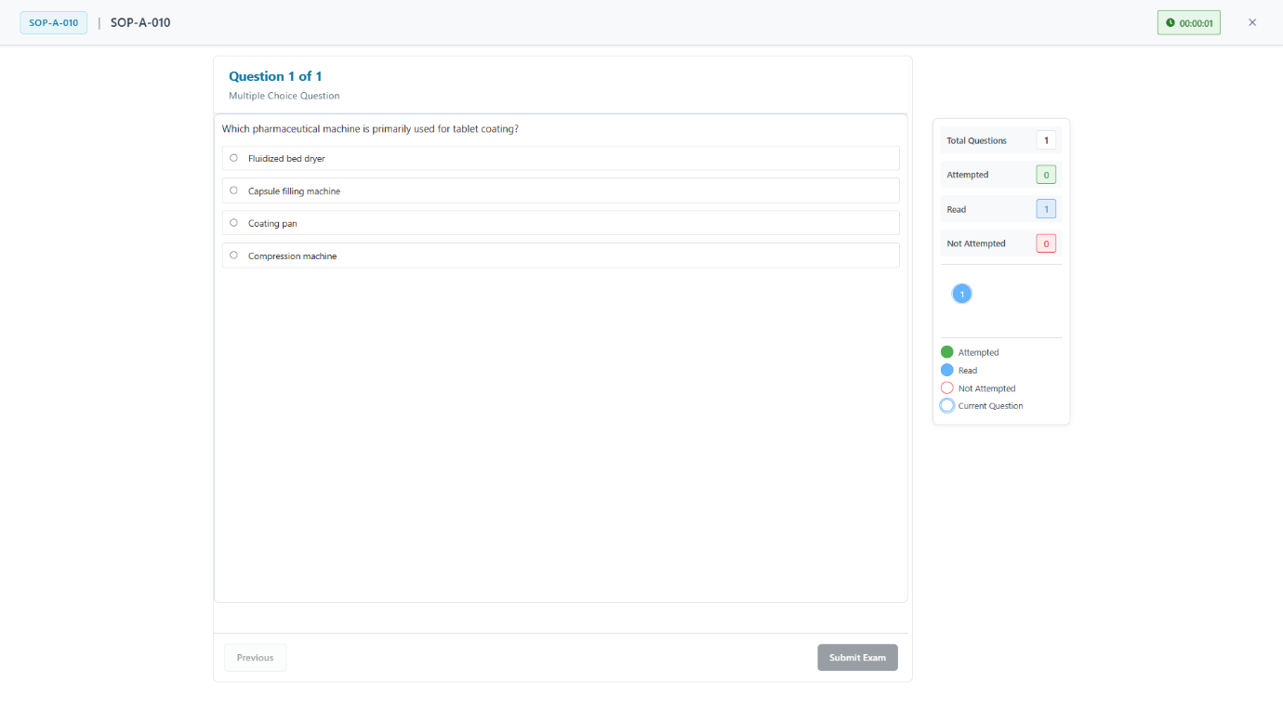

**Step 7: Taking the Examination**

**Question Navigation:**

1. **Question Display**: Each question appears individually on screen
2. **Question Type Identification**: System shows question format (Multiple Choice, True/False, etc.)
3. **Answer Selection**: Click radio buttons to select answers
4. **Progress Tracking**: Monitor current question vs total questions

**Sample Question Interface:**

* **Question 1**: Multiple choice format with selectable options
* **Answer Options**:
  1. Option 1 (radio button selection)
  2. Option 2 (radio button selection)
  3. Additional options as configured
* **Selection Feedback**: Selected answers are highlighted

**Step 8: Exam Submission and Results**

**During Examination:**

1. **Answer Selection**: Choose appropriate answers for each question
2. **Progress Monitoring**: Track completion through question sequence
3. **Review Answers**: Verify selections before submission
4. **Submit Exam**: Click **"Submit Exam"** button to complete assessment

**Results Display:**

* **Success Indicator**: Green checkmark for successful completion
* **Score Display**: Shows percentage score (e.g., "100.0%")
* **Pass/Fail Status**: Clear indication of result (e.g., "Passed!")
* **Score Breakdown**:
  1. Correct answers count (e.g., "Correct: 1")
  2. Wrong answers count (e.g., "Wrong: 0")

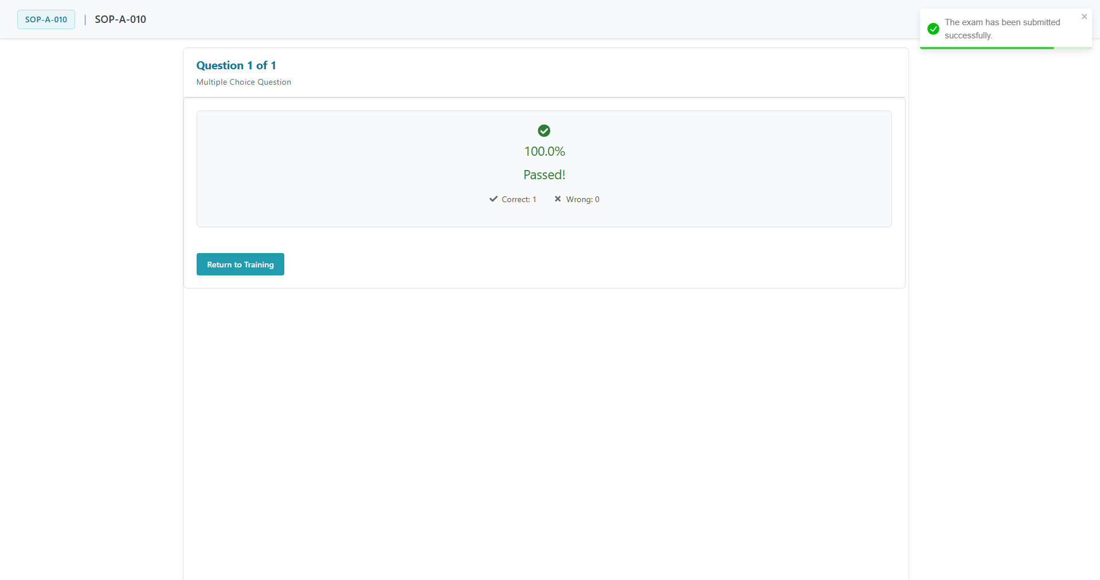

**Step 9: Post-Exam Actions**

**Completion Actions:**

1. **Results Review**: Examine score and pass/fail status
2. **Return to Training**: Click **"Return to Training"** button to go back
3. **Record Keeping**: System automatically saves exam results
4. **Certification Update**: Results feed into overall training completion status
5. If exam is **passed**, the **Self training** disappears from the ending on job training records

## 7.Scheduled Trainings

Scheduled Trainings are structured sessions planned as part of the **Yearly Training Plan**. Once the training event is approved, it can be scheduled, executed, and closed through this module.

**Step 1:**Log in to the **TMS** system. Navigate to the main dashboard and in left sidebar menu, click on **Training Session → Scheduled Training**

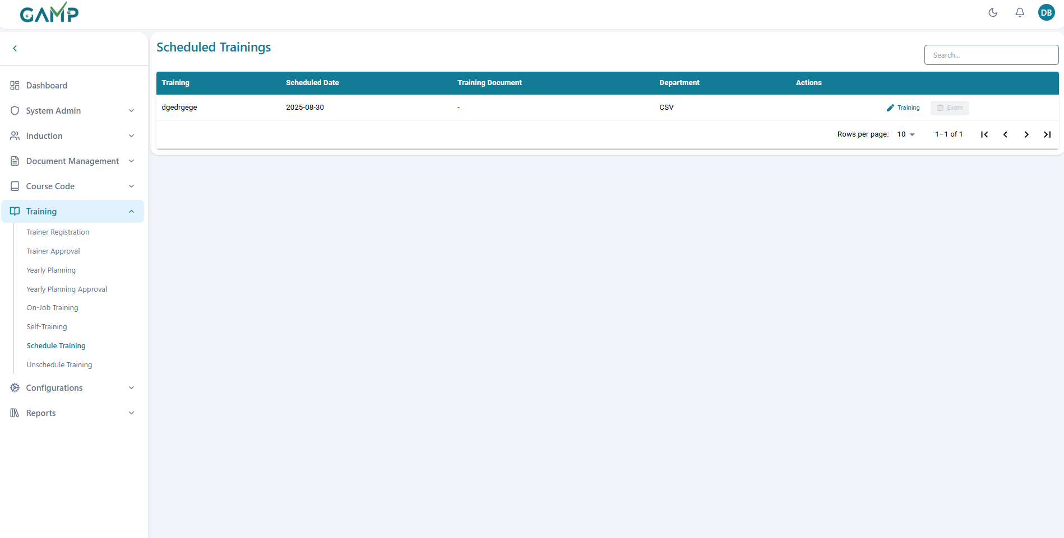

**Step 2: Understanding the Dashboard Interface**

1. Review the data table with columns:

* **Training:** Title of the scheduled training session
* **Scheduled Date:** Date when training is planned
* **Training Document:** Document used for training
* **Department:** Department conducting the training
* **Actions:** Available actions (Training/Exam buttons)

**Step 3: New scheduled Training**

1. Click "**Training**" button for desired training session
2. **Section Expansion:**

When it is opened, four different sections namely Training Setup, Trainee Registration, Training Execution and Trainee Exam are there with collapsible arrows for expanding the content for each of them and filling the details wherever required

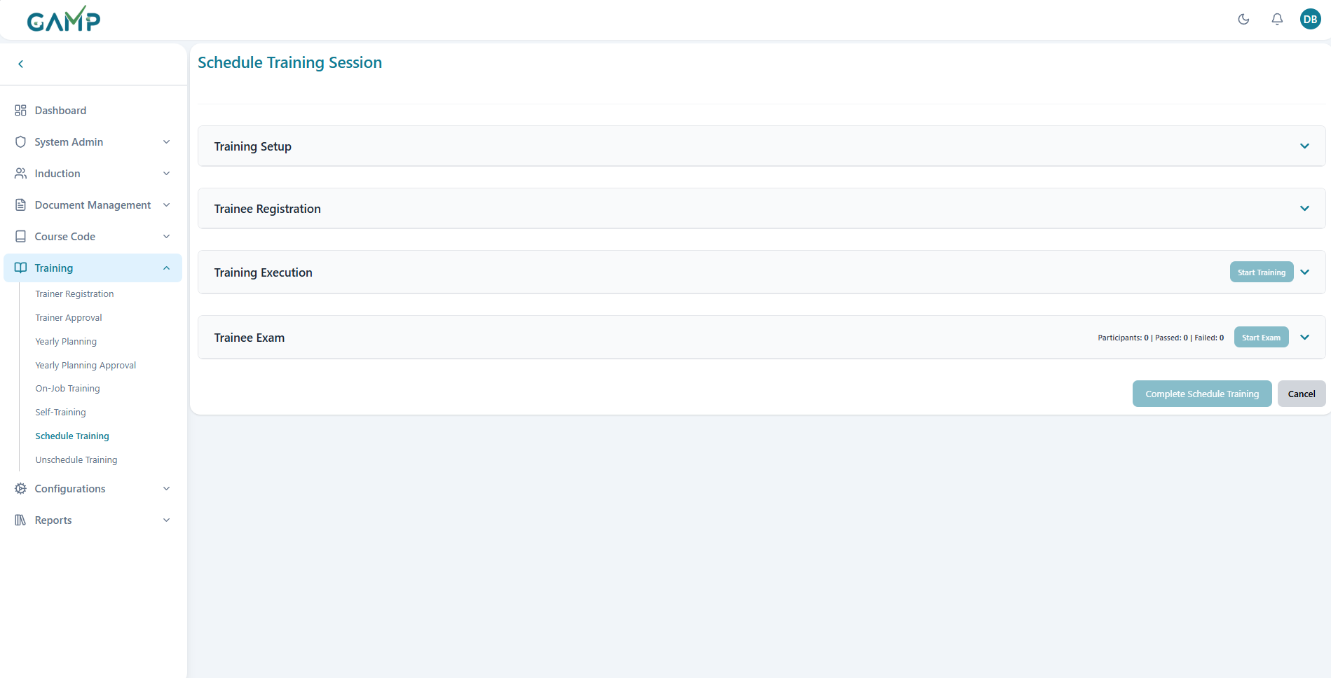

**Step 4: Training Setup:**

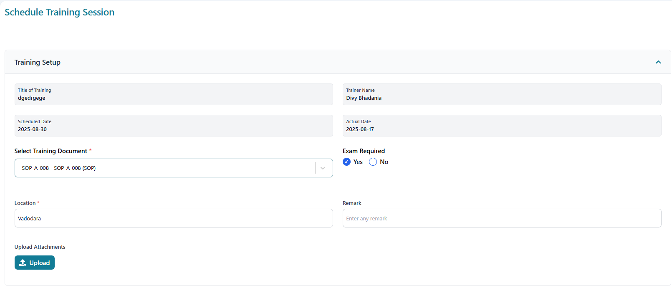

Fill in the training setup form:

* **Training title- prefeeded from the yearly planning**
* **Trainer** – Is the user who has started this training
* **Documents** – Select training material (SOP, Policy, Protocol, etc.).
* **Scheduled Date -** Planned training date
* **Actual Date -** Records actual training start date
* **Exam Required** – Toggle **Yes/No** depending on whether an exam is linked.
* **Location** – Enter location/room for physical training or virtual link.
* **Remarks** – Provide any additional notes.
* **Attachment Upload** – Upload supporting files if required

**Step 5: Trainee Registration**

* Go to the **Trainee Registration section header**.
* Two-column layout with departments and selected employees opens where the departments are listed in a stack, which, on clicking the arrow next to it, expands to open the list of all users of that particular department.
* Search is first for searching the department and then searching for the user in the expanded department.
* Add trainees by clicking the **“+” icon** next to their name.
* Selected users will move to the trainee list on the right for the session.
* You can also click the **–** icon to remove the trainee from right side
* Once all are added, click **Save**.
* The training status updates to **“Planned”** with trainees registered.

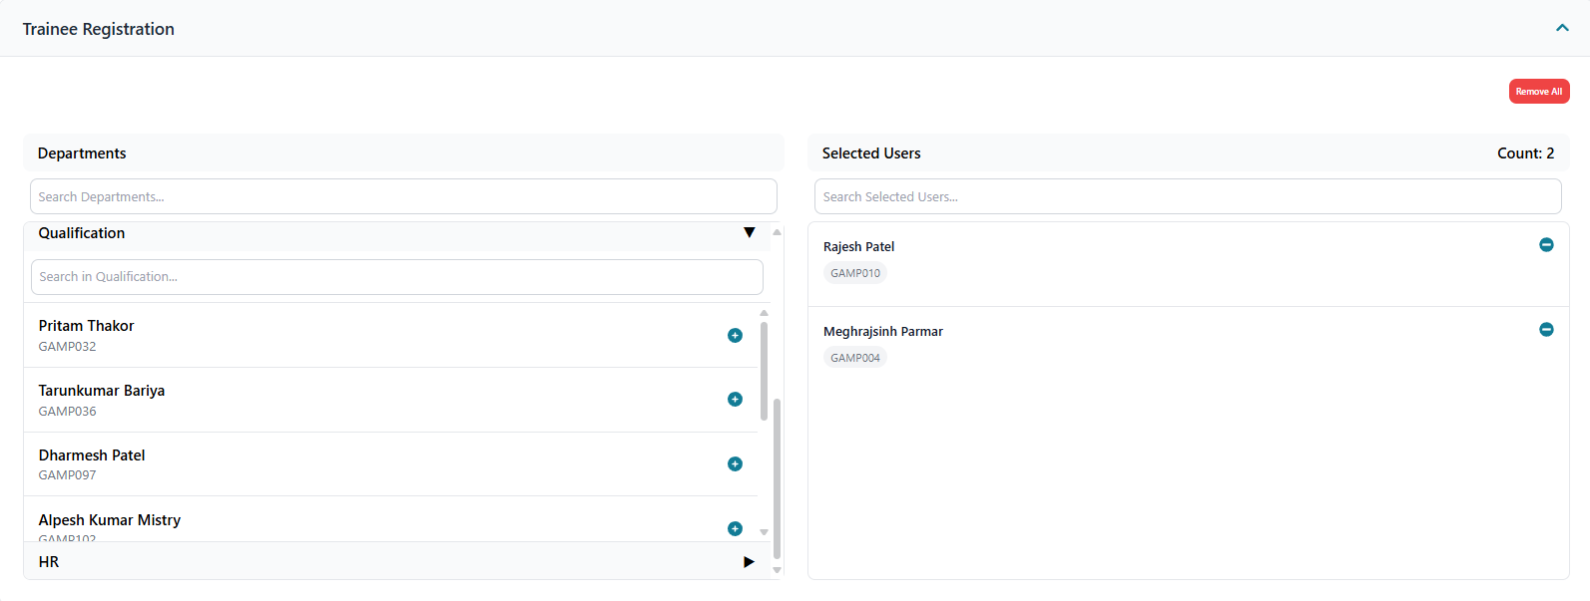

**Step 6: Training Execution**

**Status Indicators:**

* **Not Started:** Gray "Not Started" badge
* **In Progress:** Yellow "Training in Progress" badge with "End Training" button
* **Completed:** Green "Training Completed" badge

**Required Fields Check:**

* + Training title must be filled
  + Training document must be selected
  + At least one employee must be selected

1. **Start Training Process:**
   * Click **"Start Training"** button
   * Training status updated to "In Progress"
2. **Training Document Access:**
   * Click **"View"** button in Training Document section
   * **System Action:** Opens FileViewer modal overlay

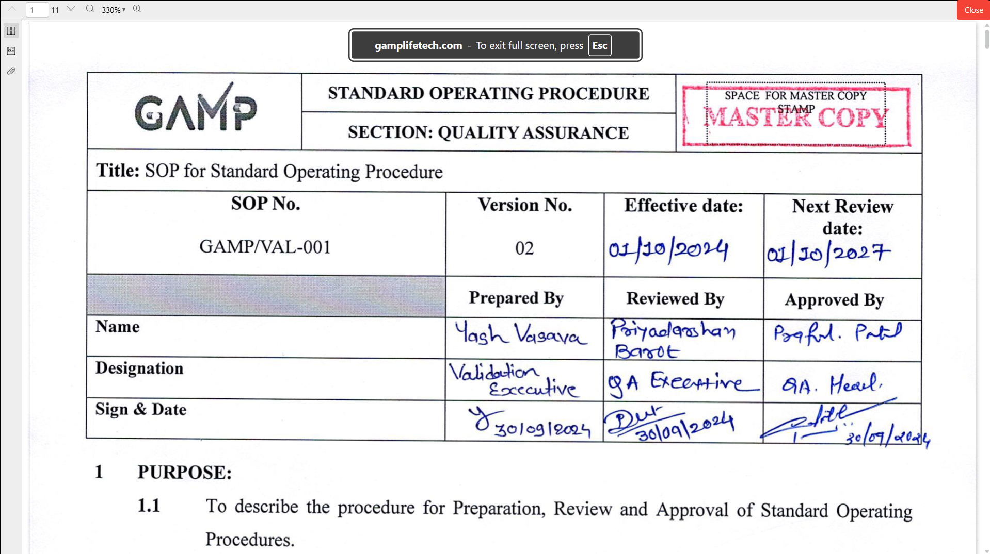

1. **Attachments Viewing:**
   * Click **"View"** button in Uploaded Attachments section
   * **System Action:** Opens attachments modal
   * **Display:** List of uploaded files with view options

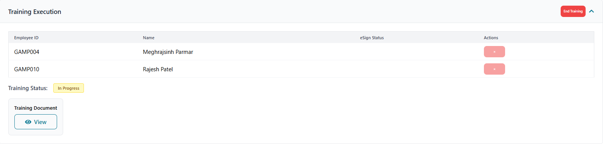

**Employee Status Tracking:**

1. **eSign Status Column:** Shows signing status for each employee
2. **Status Options:**
   * Blank: Not signed
   * "Signed": Blue badge indicating completion
   * "eSign": Button to initiate electronic signature (post-training)

**Step 7: Ending Training Session**

**End Training Process:**

1. Click **"End Training"** button
2. Training status changed to "Completed".
3. Actual date/time recorded.
4. eSign buttons become available for employees

**Post-Training State:**

1. **Status Display:** Green "Training Completed" badge
2. **eSign Availability:** eSign buttons appear for all employees
3. **Employee Removal:** Re-enabled for unsigned employees

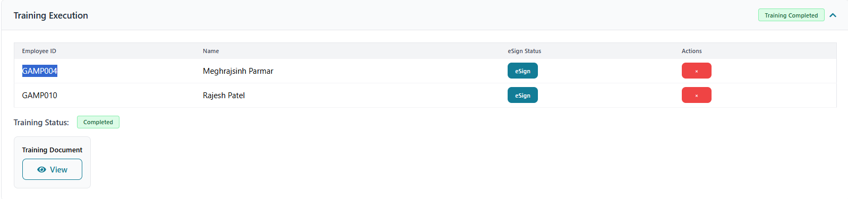

**Step 8: Electronic Signature**

**eSign Button Availability:**

1. **Condition:** Training must be completed
2. **Display:** Blue "eSign" button in eSign Status column
3. Available for all employees who haven't signed

**eSign Modal Process:**

1. Click **"eSign"** button for specific employee
2. **Modal Opens:** Electronic signature modal appears

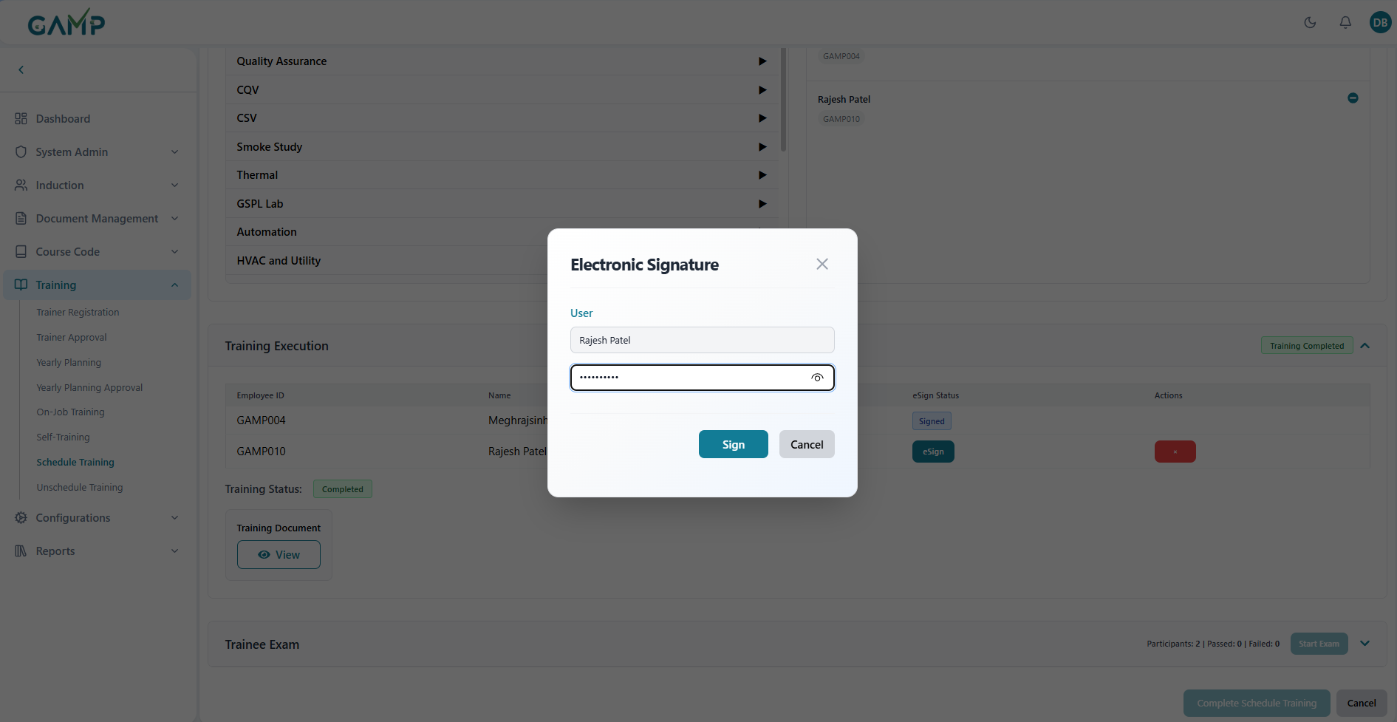

1. **Required Fields:**
   * Employee information (pre-populated)
   * Password field for authentication
2. Click **"Submit"** to process signature
3. **Success Handling:**

* **Status Update:** Employee marked as "Signed"
* **Visual Change:** eSign button replaced with "Signed" badge

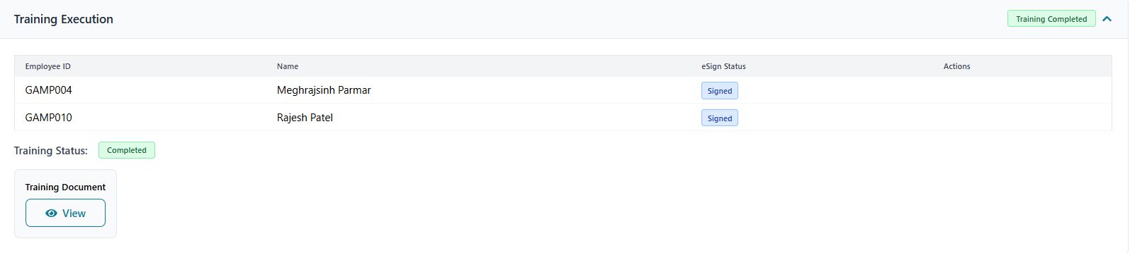

**Step 9: Trainee Exam Section (If Required)**

**Section Visibility:**

1. **Condition:** Only visible if "Exam Required" is set to "Yes"
2. **Header Display:** "Trainee Exam" with statistics
3. **Statistics:** Participants count, Passed count, Failed count

**Exam Status Indicators:**

1. **Not Started:** No exam has been initiated
2. **Ongoing Exam:** Yellow "Ongoing Exam" badge
3. **Exam Completed:** Green "Exam Completed" badge

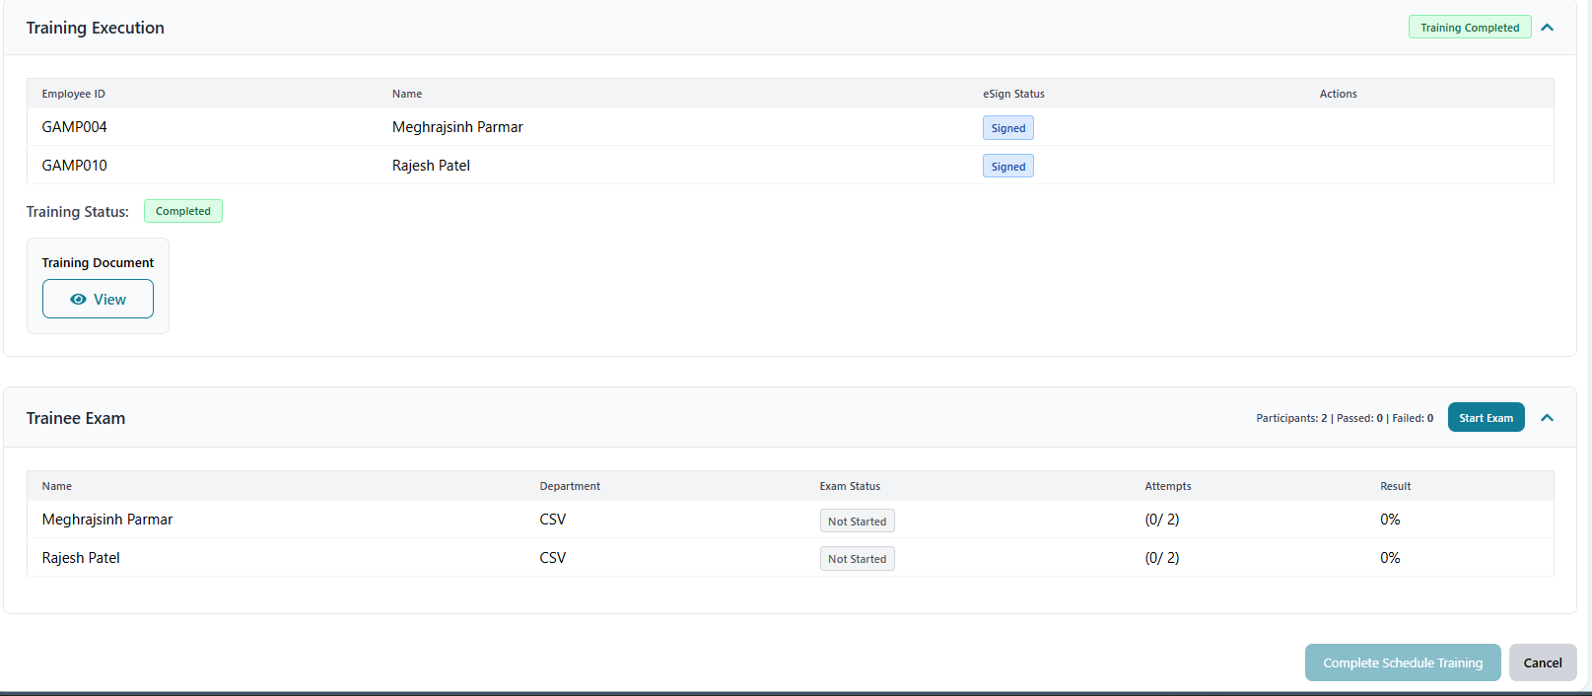

**Step 10: Starting Examination**

**Pre-Exam Validations:**

1. **eSign Requirement:** All employees must be electronically signed
2. **Button State:** "Start Exam" disabled until all signatures complete
3. **Tooltip:** Indicates requirement for complete signatures

**Exam Initiation Process:**

1. Click **"Start Exam"** button (when enabled)
2. **API Call:** startScheduledTrainingExam service
3. **Success Actions:**
   * Exam start time recorded
   * Status changed to "Ongoing Exam"
   * Individual employee exam access enabled

**Step 11: Employee Exam Status Tracking**

**Exam Status Table:**

1. **Columns:** Name, Department, Exam Status, Attempts, Result
2. **Status Options:**
   * "Not Started": Gray badge
   * "Passed": Green badge
   * "Failed": Red badge
3. **Attempts Display:** Current attempts / Maximum attempts format
4. **Result Display:** Percentage score achieved

**Exam Completion Tracking:**

1. **Individual Status:** Each employee's exam progress tracked
2. **Overall Status:** Section header shows aggregate statistics
3. **Completion Detection:** All exams completed when all employees finished

**Step 12: Exam Activation After Scheduled training Completion**

1. **Exam Button Activation**: Upon successful scheduled training completion, the **"Exam"** button becomes active in each of the trainees accounts in the Scheduled Training tab
2. **Exam Availability**: System automatically enables examination feature
3. **Access Examination**: Click the activated **"Exam"** button to start the assessment

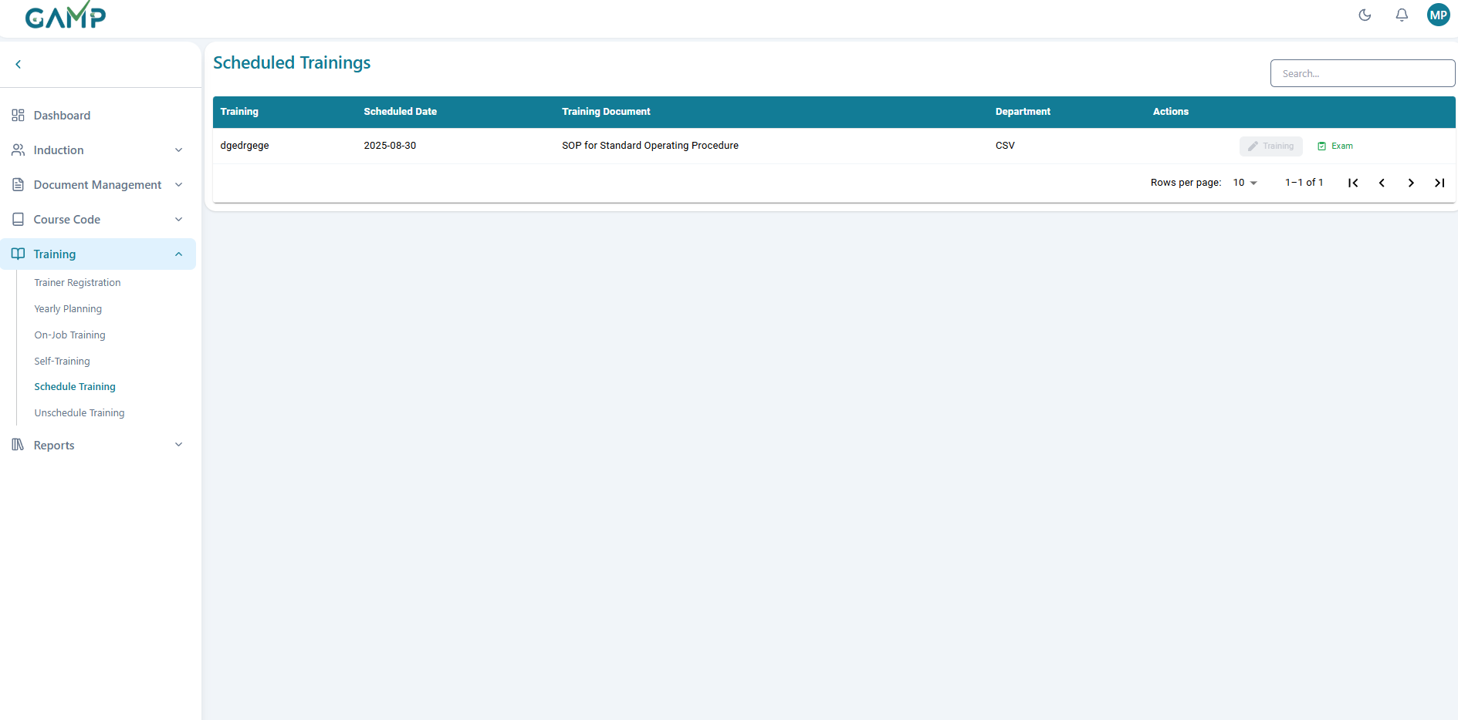

**Step 13: Examination Interface Overview**

**Exam Session Information:**

* **Training Title**: Shows the Document name

**Question Interface Structure:**

* **Question Progress**: Shows current question number (e.g., "Question 1 of 1")
* **Question Type**: Indicates question format (e.g., "Multiple Choice Question")
* **Question Content**: Displays the actual question from the questionnaire
* **Answer Options**: Multiple choice options with radio button selection

**Right Panel Information:**

* **Total Questions:** Shows total number of questions attempted
* **Attempted:** Number of questions answered
* **Best Score:** Highest score achieved (if multiple attempts allowed)
* **Not Attempted:** Questions not answered (if applicable)

**Status Indicators:**

* **Answered**: Green circle indicator for completed questions
* **Best**: Blue indicator for best performance
* **Not Attempted**: Orange indicator for skipped questions
* **Current Question**: Yellow indicator for active question

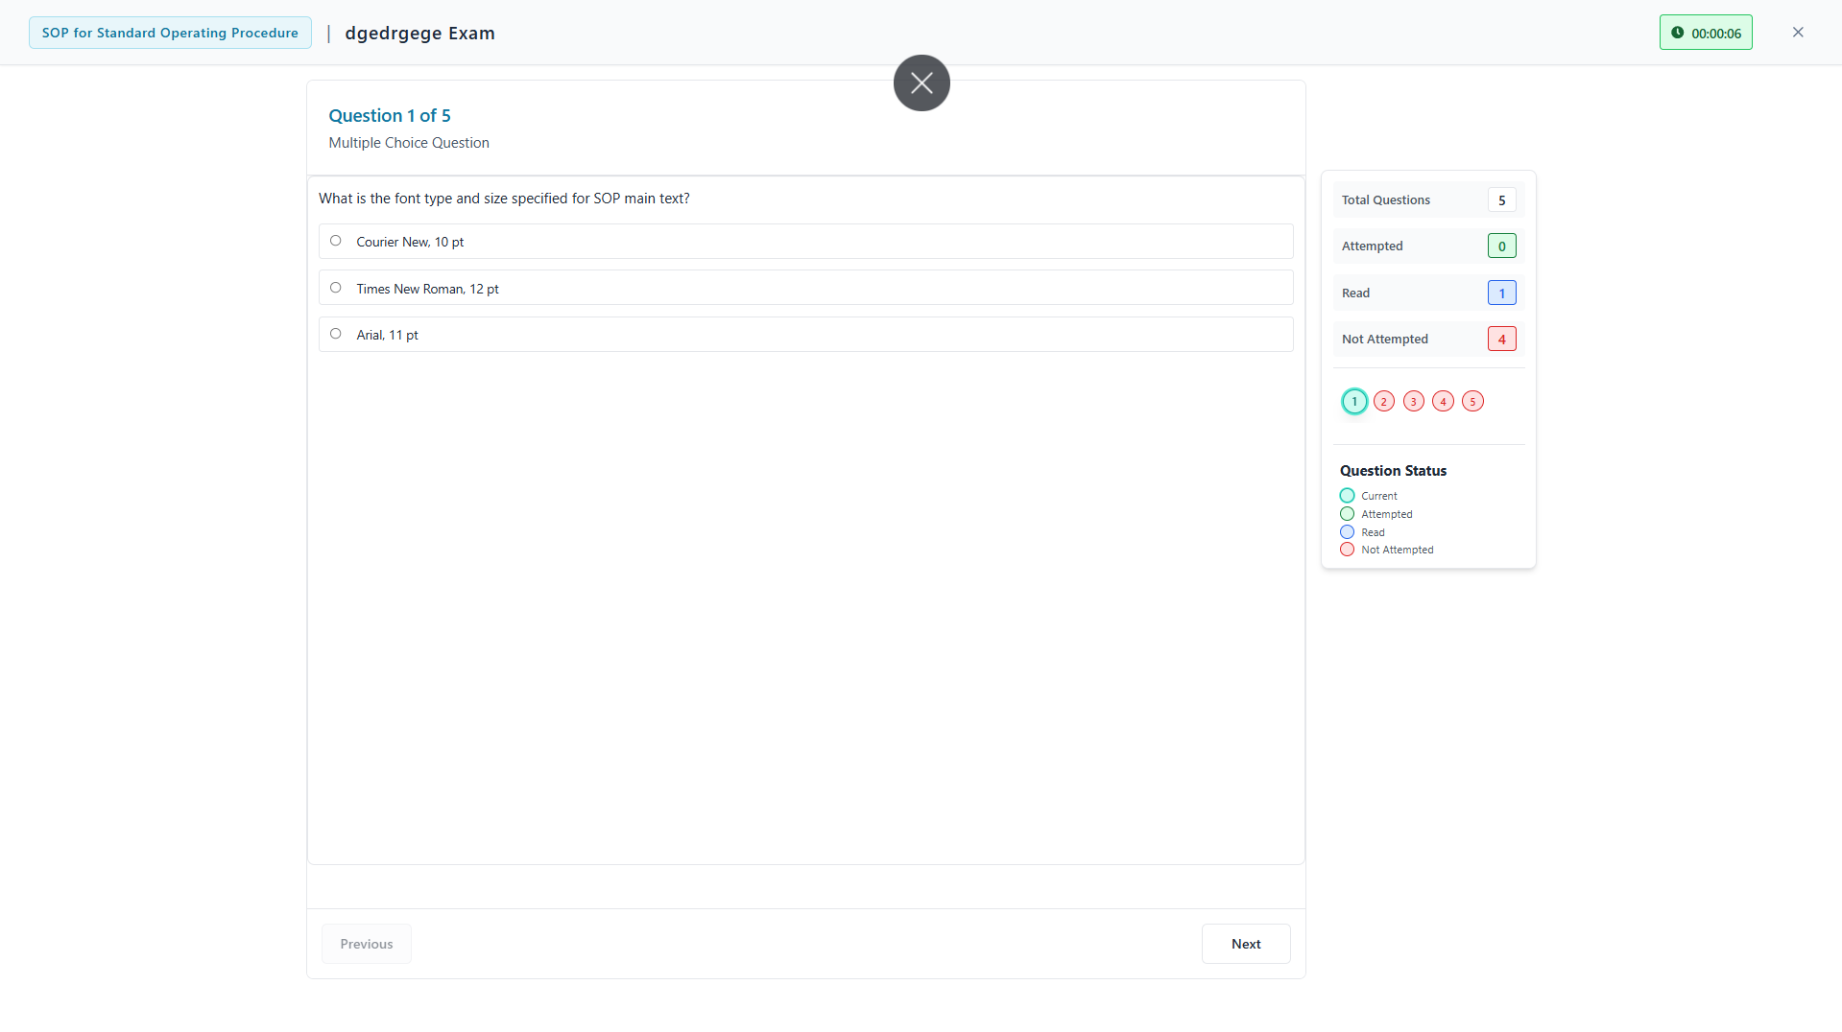

**Step 14: Taking the Examination**

**Question Navigation:**

1. **Question Display**: Each question appears individually on screen
2. **Question Type Identification**: System shows question format (Multiple Choice, True/False, etc.)
3. **Answer Selection**: Click radio buttons to select answers
4. **Progress Tracking**: Monitor current question vs total questions

**Sample Question Interface:**

* **Question 1**: Multiple choice format with selectable options
* **Answer Options**:
  1. Option 1 (radio button selection)
  2. Option 2 (radio button selection)
  3. Additional options as configured
* **Selection Feedback**: Selected answers are highlighted

**Step 15: Exam Submission and Results**

**During Examination:**

1. **Answer Selection**: Choose appropriate answers for each question
2. **Progress Monitoring**: Track completion through question sequence
3. **Review Answers**: Verify selections before submission
4. **Submit Exam**: Click **"Submit Exam"** button to complete assessment

**Results Display:**

* **Success Indicator**: Green checkmark for successful completion
* **Incorrect** questions and their correct answers.
* **Score Display**: Shows percentage score (e.g., "100.0%")
* **Pass/Fail Status**: Clear indication of result (e.g., "Passed!")
* **Score Breakdown**:
  1. Correct answers count (e.g., "Correct: 1")
  2. Wrong answers count (e.g., "Wrong: 0")

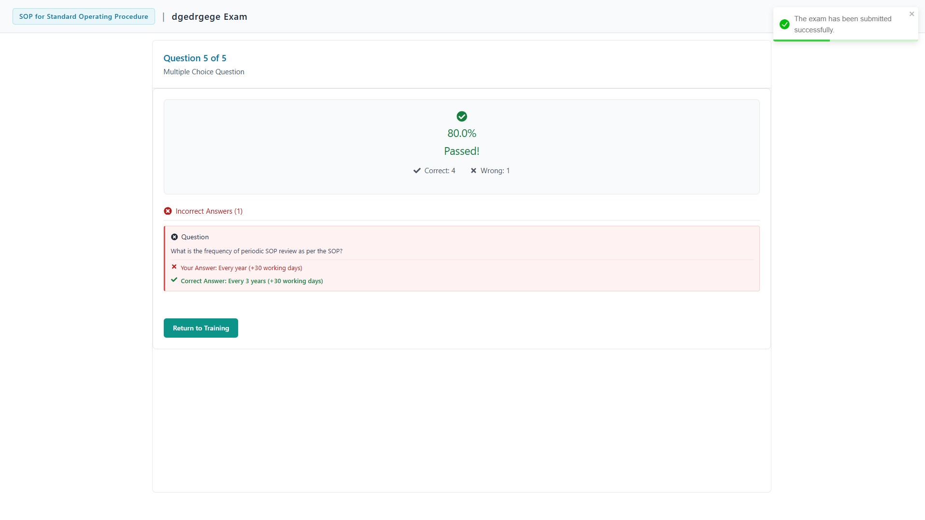

**Step 16: Post-Exam Actions**

**Completion Actions:**

1. **Results Review**: Examine score and pass/fail status
2. **Return to Training**: Click **"Return to Training"** button to go back
3. **Record Keeping**: System automatically saves exam results
4. **Certification Update**: Results feed into overall training completion status
5. If exam is **passed**, the **scheduled** disappears from the ending on job training records

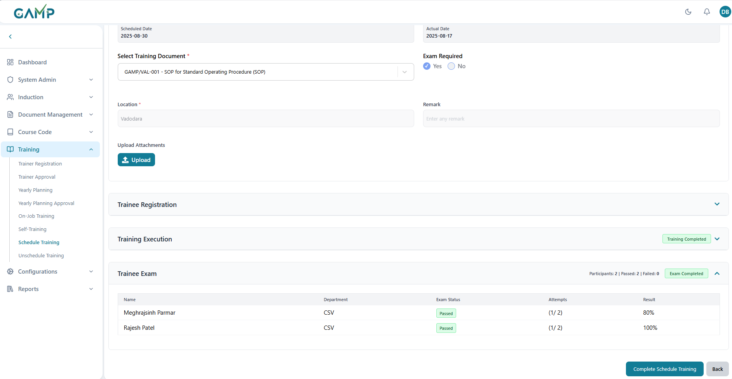

## 8.UnScheduled Trainings

The Unscheduled Training module allows trainers to conduct ad-hoc training sessions and manage failed users who need retraining. The system provides two main interfaces:

**Unscheduled Trainings Tab** - For creating and managing new training sessions

**Retrieved Users Tab** - For managing users who failed previous training/exams

**SECTION 1: UNSCHEDULED TRAININGS TAB**

**Step 1:**Log in to the **TMS** system. Navigate to the main dashboard and in left sidebar menu, click on **Training Session → Unscheduled Training**

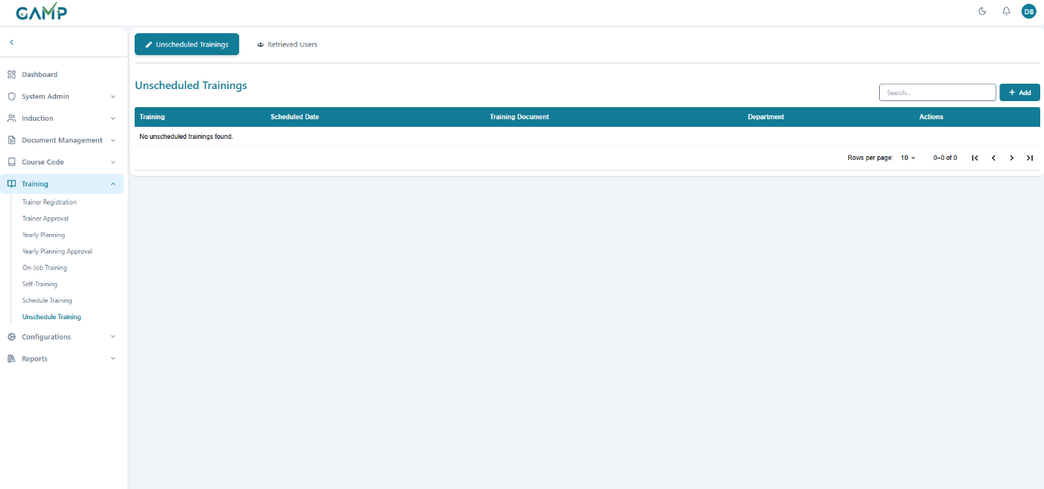

**Step 2: Understanding the Dashboard Interface**

Review the data table with columns:

* **Training:** Title of the scheduled training session
* **Scheduled Date:** Date when training is planned
* **Training Document:** Document used for training
* **Department:** Department conducting the training
* **Actions:** Available actions (Training/Exam buttons)

**Step 3: New unscheduled Training**

1. Click "**Add**" button to start a new unscheduled training

**2. Section Expansion:**

When it is opened, three different sections namely Training Setup, Trainee Registration and Training Execution are there with collapsible arrows for expanding the content for each of them and filling the details wherever required.

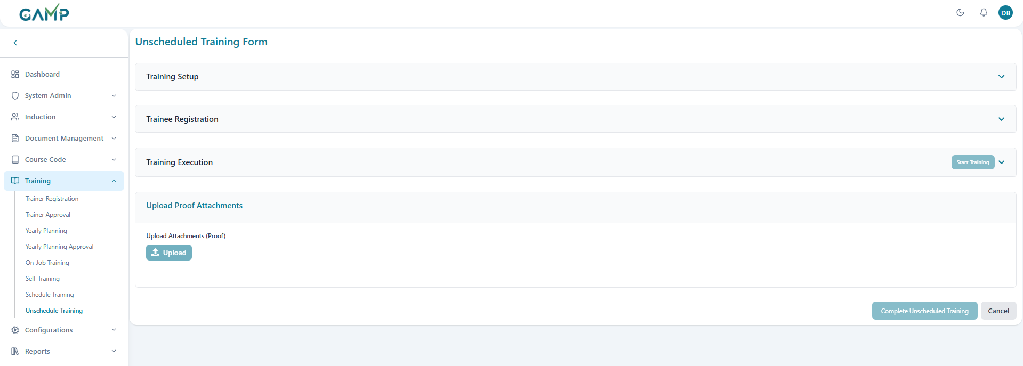

**Step 4: Training Setup:**

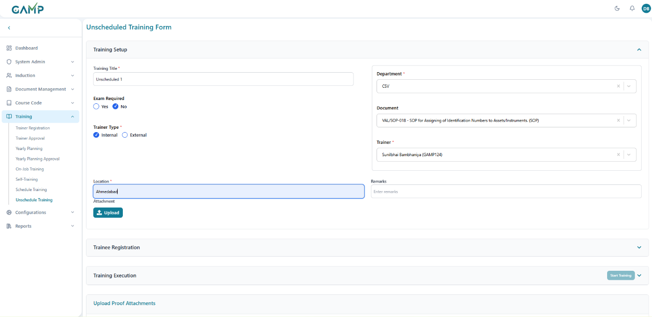

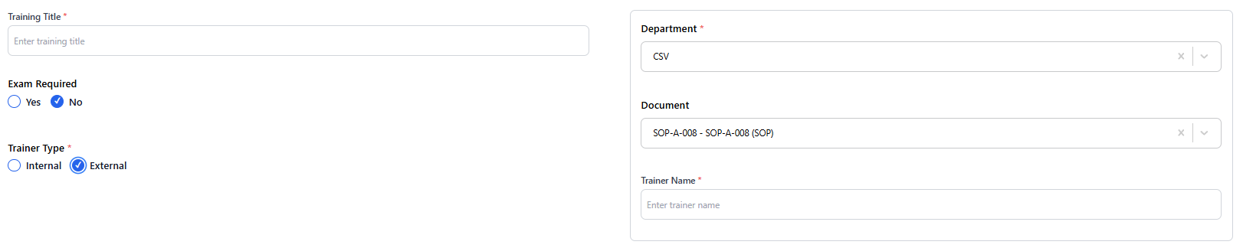

Fill in the training setup form:

* **Training title-** Input the name of the training
* **Department-** Choose the concerned department for the training
* **Document –** Choose the documents from the available documents of the chosen department
* **Trainer** – Choose the user who will lead this training
* **Trainer Type -**Toggle **External/Internal** depending on the training
* If **trainer type** is **external**, then manually input the name of the trainer
* **Exam Required** – Toggle **Yes/No** depending on whether an exam is linked.
* **Location** – Enter location/room for physical training or virtual link.
* **Remarks** – Provide any additional notes.
* **Attachment Upload** – Upload supporting files if required

**Step 5: Trainee Registration**

* Go to the **Trainee Registration section header**.
* Two-column layout with departments and selected employees opens where the departments are listed in a stack, which, on clicking the arrow next to it, expands to open the list of all users of that particular department.
* Search is first for searching the department and then searching for the user in the expanded department.
* Add trainees by clicking the **“+” icon** next to their name.
* Selected users will move to the trainee list on the right for the session.
* You can also click the **–** icon to remove the trainee from right side
* Once all are added, click **Save**.
* The training status updates to **“Planned”** with trainees registered.

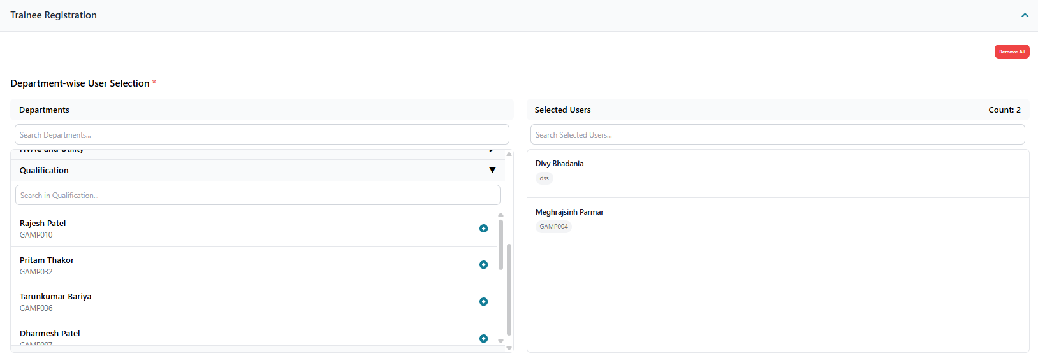

**Step 6: Training Execution**

**Status Indicators:**

* **Not Started:** Gray "Not Started" badge
* **In Progress:** Yellow "Training in Progress" badge with "End Training" button
* **Completed:** Green "Training Completed" badge

**Required Fields Check:**

* + Training title must be filled
  + Training document must be selected
  + At least one employee must be selected

**1. Start Training Process:**

* + Click **"Start Training"** button
  + Training status updated to "In Progress"

**2. Training Document Access:**

* + Click **"View"** button in Training Document section
  + **System Action:** Opens FileViewer modal overlay

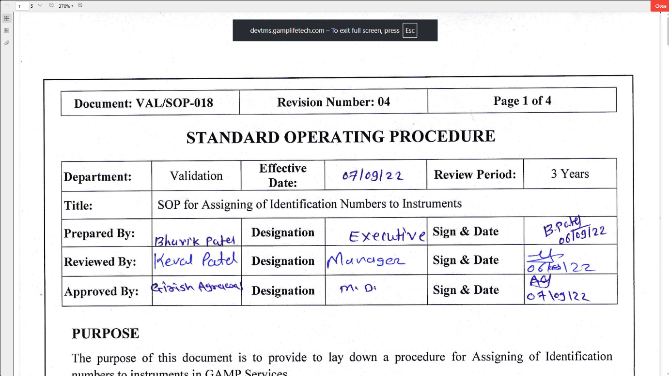

**3. Attachments Viewing:**

* + Click **"View"** button in Uploaded Attachments section
  + **System Action:** Opens attachments modal
  + **Display:** List of uploaded files with view options

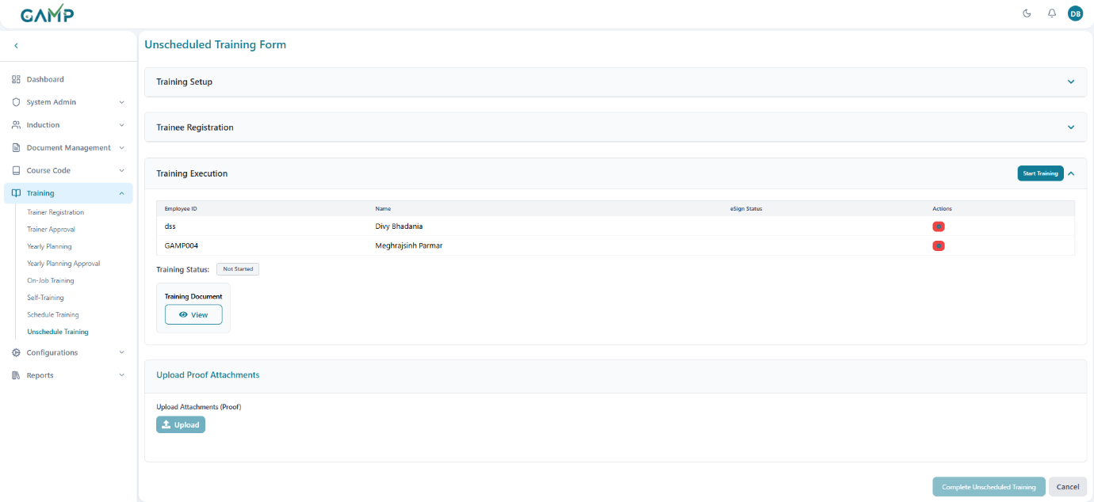

**Employee Status Tracking:**

1. **eSign Status Column:** Shows signing status for each employee
2. **Status Options:**
   * Blank: Not signed
   * "Signed": Blue badge indicating completion
   * "eSign": Button to initiate electronic signature (post-training)

**Step 7: Ending Training Session**

**End Training Process:**

1. Click **"End Training"** button
2. Training status changed to "Completed".
3. Actual date/time recorded.
4. eSign buttons become available for employees

**Post-Training State:**

1. **Status Display:** Green "Training Completed" badge
2. **eSign Availability:** eSign buttons appear for all employees
3. **Employee Removal:** Re-enabled for unsigned employees

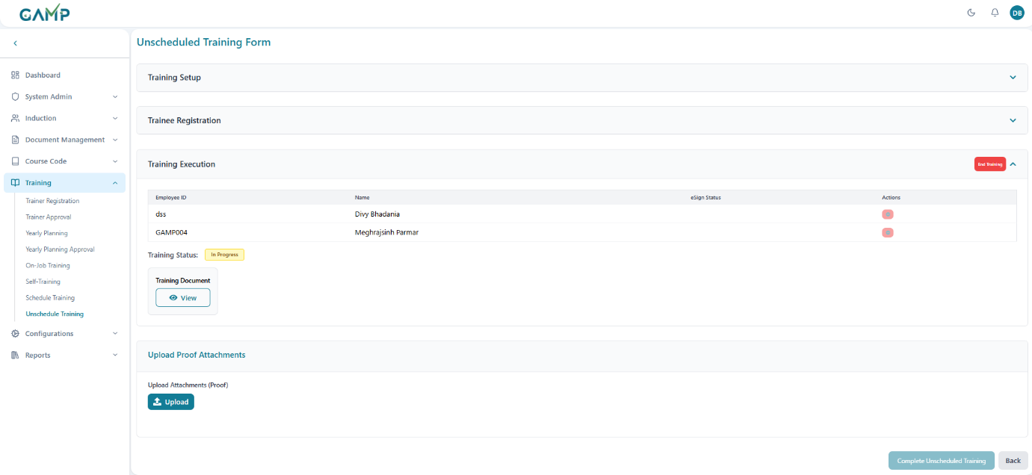

**Step 8: Electronic Signature**

**eSign Button Availability:**

1. **Condition:** Training must be completed
2. **Display:** Blue "eSign" button in eSign Status column
3. Available for all employees who haven't signed

**eSign Modal Process:**

1. Click **"eSign"** button for specific employee
2. **Modal Opens:** Electronic signature modal appears

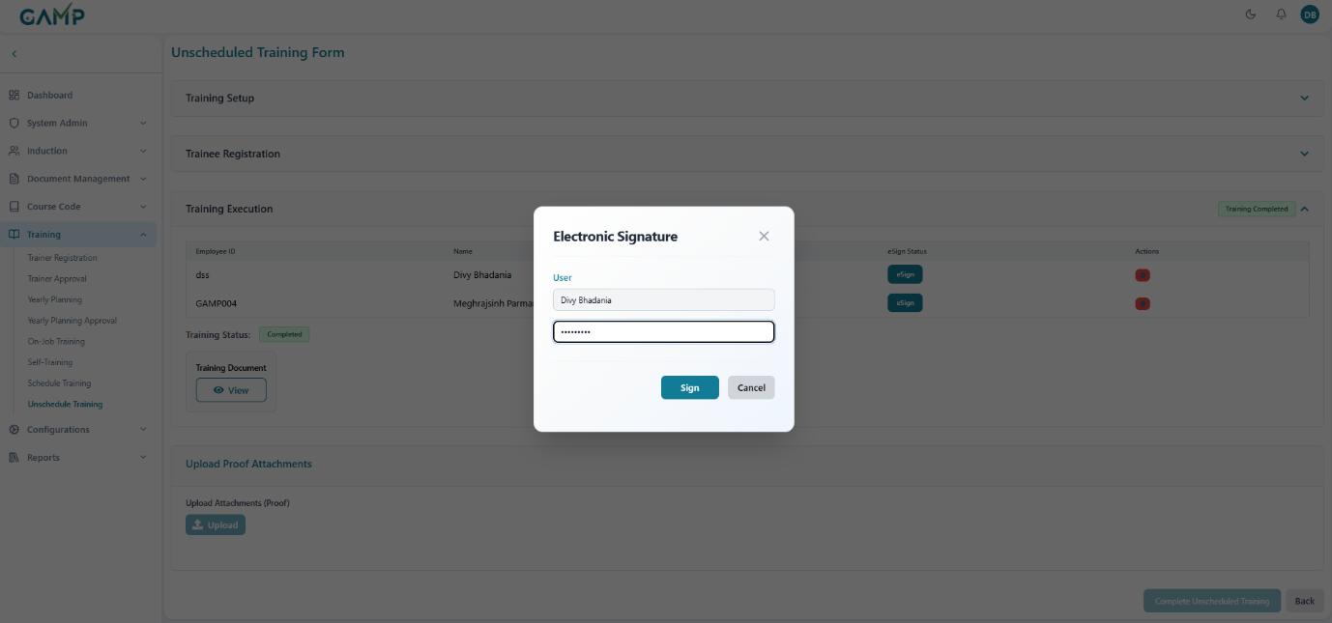

1. **Required Fields:**
   * Employee information (pre-populated)
   * Password field for authentication
2. Click **"Submit"** to process signature
3. **Success Handling:**

* **Status Update:** Employee marked as "Signed"
* **Visual Change:** eSign button replaced with "Signed" badge



**Step 9: Trainee Exam Section (If Required)**

**Section Visibility:**

1. **Condition:** Only visible if "Exam Required" is set to "Yes"
2. **Header Display:** "Trainee Exam" with statistics
3. **Statistics:** Participants count, Passed count, Failed count

**Exam Status Indicators:**

1. **Not Started:** No exam has been initiated
2. **Ongoing Exam:** Yellow "Ongoing Exam" badge
3. **Exam Completed:** Green "Exam Completed" badge

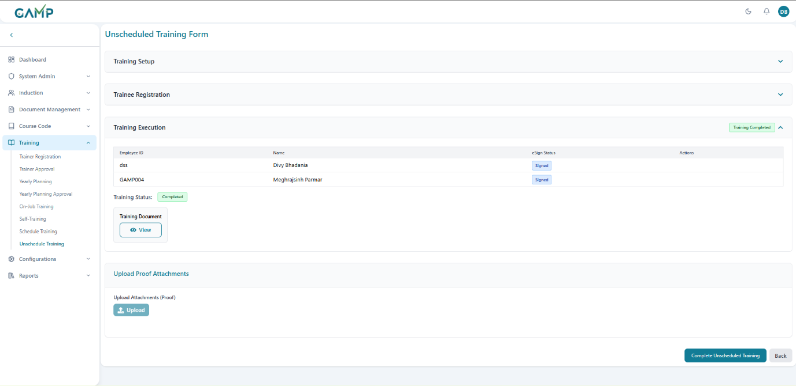

**Step 10: Starting Examination**

**Pre-Exam Validations:**

1. **eSign Requirement:** All employees must be electronically signed
2. **Button State:** "Start Exam" disabled until all signatures complete
3. **Tooltip:** Indicates requirement for complete signatures

**Exam Initiation Process:**

1. Click **"Start Exam"** button (when enabled)
2. **Success Actions:**
   * Exam start time recorded
   * Status changed to "Ongoing Exam"
   * Individual employee exam access enabled

**Step 11: Employee Exam Status Tracking**

**Exam Status Table:**

1. **Columns:** Name, Department, Exam Status, Attempts, Result
2. **Status Options:**
   * "Not Started": Gray badge
   * "Passed": Green badge
   * "Failed": Red badge
3. **Attempts Display:** Current attempts / Maximum attempts format
4. **Result Display:** Percentage score achieved

**Exam Completion Tracking:**

1. **Individual Status:** Each employee's exam progress tracked
2. **Overall Status:** Section header shows aggregate statistics
3. **Completion Detection:** All exams completed when all employees finished

**Step 12: Exam Activation After Scheduled training Completion**

1. **Exam Button Activation**: Upon successful scheduled training completion, the **"Exam"** button becomes active in each of the trainees accounts in the Scheduled Training tab
2. **Exam Availability**: System automatically enables examination feature
3. **Access Examination**: Click the activated **"Exam"** button to start the assessment



**Step 13: Examination Interface Overview**

**Exam Session Information:**

* **Training Title**: Shows the Document name

**Question Interface Structure:**

* **Question Progress**: Shows current question number (e.g., "Question 1 of 1")
* **Question Type**: Indicates question format (e.g., "Multiple Choice Question")
* **Question Content**: Displays the actual question from the questionnaire
* **Answer Options**: Multiple choice options with radio button selection

**Right Panel Information:**

* **Total Questions:** Shows total number of questions attempted
* **Attempted:** Number of questions answered
* **Best Score:** Highest score achieved (if multiple attempts allowed)
* **Not Attempted:** Questions not answered (if applicable)

**Status Indicators:**

* **Answered**: Green circle indicator for completed questions
* **Best**: Blue indicator for best performance
* **Not Attempted**: Orange indicator for skipped questions
* **Current Question**: Yellow indicator for active question



**Step 14: Taking the Examination**

**Question Navigation:**

1. **Question Display**: Each question appears individually on screen
2. **Question Type Identification**: System shows question format (Multiple Choice, True/False, etc.)
3. **Answer Selection**: Click radio buttons to select answers
4. **Progress Tracking**: Monitor current question vs total questions

**Sample Question Interface:**

* **Question 1**: Multiple choice format with selectable options
* **Answer Options**:
  1. Option 1 (radio button selection)
  2. Option 2 (radio button selection)
  3. Additional options as configured
* **Selection Feedback**: Selected answers are highlighted

**Step 15: Exam Submission and Results**

**During Examination:**

1. **Answer Selection**: Choose appropriate answers for each question
2. **Progress Monitoring**: Track completion through question sequence
3. **Review Answers**: Verify selections before submission
4. **Submit Exam**: Click **"Submit Exam"** button to complete assessment

**Results Display:**

* **Success Indicator**: Green checkmark for successful completion
* **Incorrect** questions and their correct answers.
* **Score Display**: Shows percentage score (e.g., "100.0%")
* **Pass/Fail Status**: Clear indication of result (e.g., "Passed!")
* **Score Breakdown**:
  1. Correct answers count (e.g., "Correct: 1")
  2. Wrong answers count (e.g., "Wrong: 0")



**Step 16: Post-Exam Actions**

**Completion Actions:**

1. **Results Review**: Examine score and pass/fail status
2. **Return to Training**: Click **"Return to Training"** button to go back
3. **Record Keeping**: System automatically saves exam results
4. **Certification Update**: Results feed into overall training completion status
5. If exam is **passed**, the **unscheduled** disappears from the ending on job training records.

# Configurations

The Configuration module provides centralized management of system-wide settings that control various aspects of the TMS. This includes password policies, notification settings, central configurations for workflows, and permission assignments. Proper configuration ensures security, compliance, and optimal system operation.

## Permission Assignment

Permission Assignment allows administrators to configure role-based access control by assigning specific permissions to user roles across different modules.

**Accessing Permission Assignment**

**Step 1:** Navigate to **Configurations** → **Permission Assignment**

**Step 2: Select Role**

* Use the role dropdown to select the role to configure
* Searchable dropdown shows all available roles
* Role selection loads current permission assignments

**Step 3: Review Module Permissions**

The interface displays permissions organized by modules:

**Step 4: Configure Module Permissions**

* Click on module sections to expand permission lists.
* **Check/Uncheck** permissions as needed:

**Step 5: Save Permission Changes**

* Click "**Save**" button
* Provide reason for permission changes
* Enter electronic signature
* Click "**Submit**" to apply changes

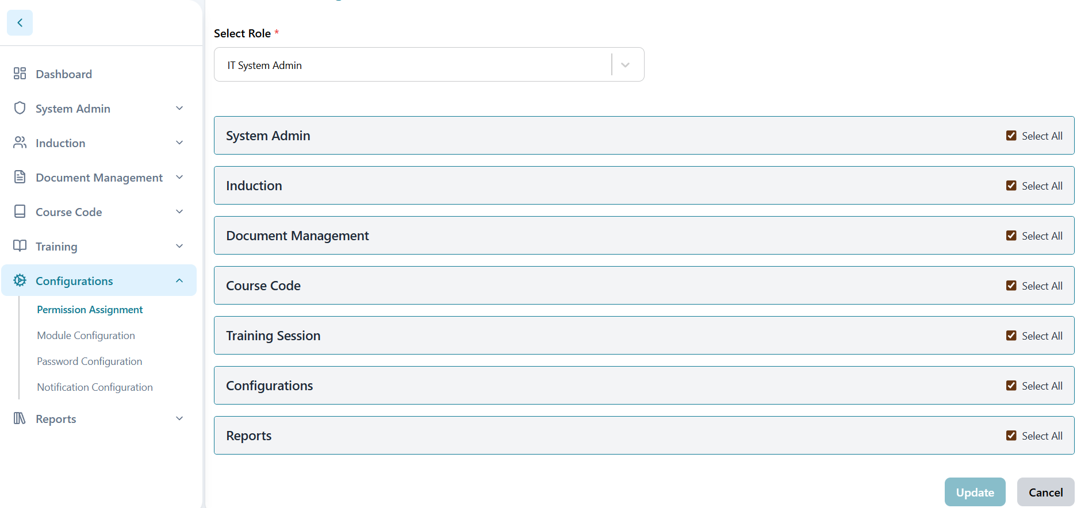

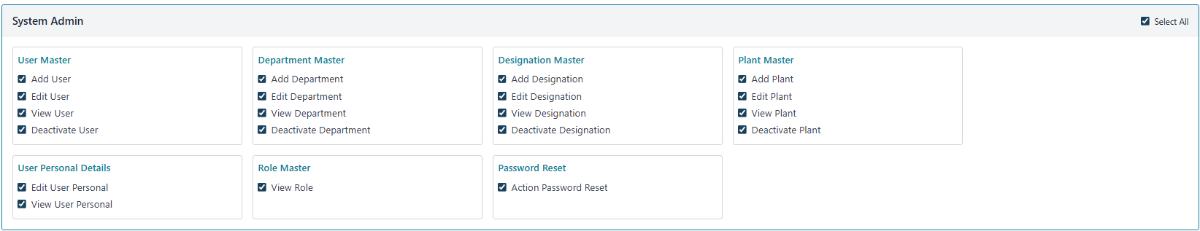

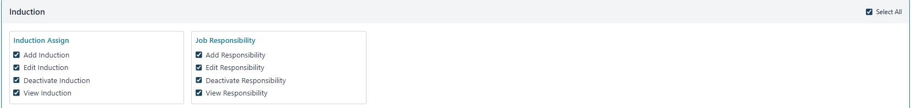

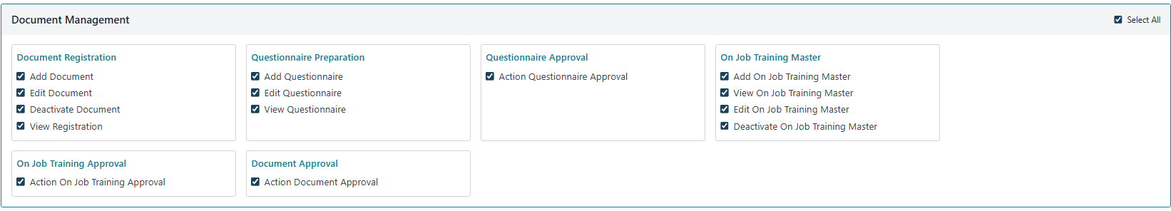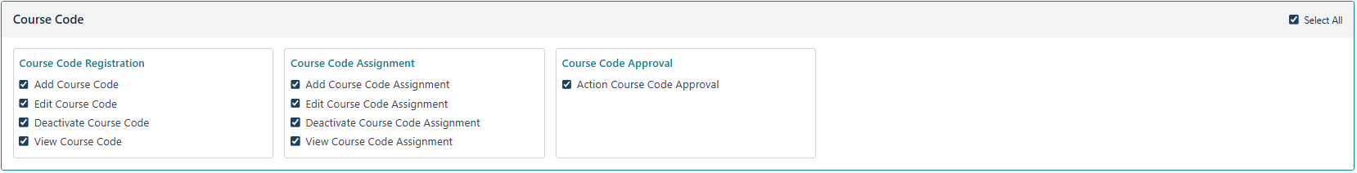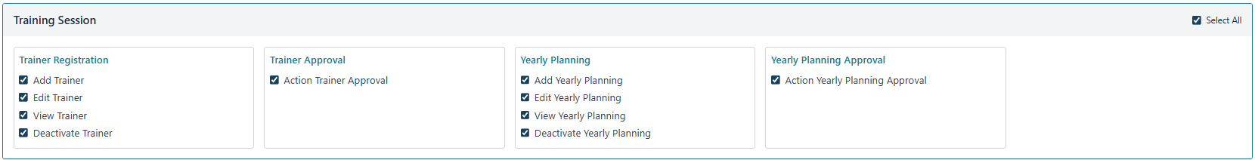



List of the permissions which can be assigned to the roles are

**1.User Master Module Permissions**

|  |  |
| --- | --- |
| **Permission Name** | **Description** |
| Add User | Create new user accounts |
| Edit User | Modify existing user information |
| View User | Read-only access to user details |
| Deactivate User | Deactivate user accounts |

**2. Plant Master Module Permissions**

|  |  |
| --- | --- |
| **Permission Name** | **Description** |
| View Plant | Read-only access to plant records |
| Add Plant | Create new plant records |
| Edit Plant | Modify existing plant records |
| Delete Plant | Deactivate plant records |

**3. Department Master Module Permissions**

|  |  |
| --- | --- |
| **Permission Name** | **Description** |
| Add Department | Create new department records |
| Edit Department | Modify existing department information |
| View Department | Read-only access to department details |
| Deactivate Department | Deactivate department records |

**4. Designation Master Module Permissions**

|  |  |
| --- | --- |
| **Permission Name** | **Description** |
| View Designation | Read-only access to designation records |
| Add Designation | Create new designation records |
| Edit Designation | Modify existing designation records |
| Delete Designation | Deactivate designation records |

**5. Role Master Module Permissions**

|  |  |
| --- | --- |
| **Permission Name** | **Description** |
| View Role | Read-only access to role definitions and assignments |
|  |  |

**6. User Personal Details Module Permissions**

|  |  |
| --- | --- |
| **Permission Name** | **Description** |
| Edit User Personal | Modify personal information of users |
| View User Personal | Read-only access to user personal details |

**7. Password Reset Module Permissions**

|  |  |
| --- | --- |
| **Permission Name** | **Description** |
| Action Password Reset | Process and approve password reset requests |

**8. Induction Assign Module Permissions**

|  |  |
| --- | --- |
| **Permission Name** | **Description** |
| View Induction | Read-only access to induction records |
| Add Induction | Create new induction assignments |
| Edit Induction | Modify existing induction assignments |
| Delete Induction | Remove induction assignments |

**9. Job Responsibility Module Permissions**

|  |  |
| --- | --- |
| **Permission Name** | **Description** |
| View Job Responsibility | Read-only access to job responsibility |
| Add Job Responsibility | Create new job responsibility records |
| Edit Job Responsibility | Modify existing job responsibility |
| Delete Job Responsibility | Remove job responsibility records |

**10. Document Registration Module Permissions**

|  |  |
| --- | --- |
| **Permission Name** | **Description** |
| Add Document | Create new document records |
| Edit Document | Modify existing document information |
| Deactivate Document | Disable or remove document records |
| View Registration | Read-only access to document registration details |

**11. Document Approval Module Permissions**

|  |  |
| --- | --- |
| **Permission Name** | **Description** |
| Action Document Approval | Approve, reject, or return document submissions |

**12 Questionnaire Preparation Module Permissions**

|  |  |
| --- | --- |
| **Permission Name** | **Description** |
| Add Questionnaire | Create new questionnaire templates and questions |
| Edit Questionnaire | Modify existing questionnaire content |
| View Questionnaire | Read-only access to questionnaire details |

**13. Questionnaire Approval Module Permissions**

|  |  |
| --- | --- |
| **Permission Name** | **Description** |
| Action Questionnaire Approval | Approve, reject, or return questionnaire submissions |

**14. On Job Training Master Module Permissions**

|  |  |
| --- | --- |
| **Permission Name** | **Description** |
| Add On Job Training Master | Create new OJT training programs |
| View On Job Training Master | Read-only access to OJT program |
| Edit On Job Training Master | Modify existing OJT training programs |
| Deactivate On Job Training Master | Disable or remove OJT training |

**15. On Job Training Approval Module Permissions**

|  |  |
| --- | --- |
| **Permission Name** | **Description** |
| Action On Job Training Approval | Approve or reject OJT training program submissions |

**16. Course Code Registration Module Permissions**

|  |  |
| --- | --- |
| **Permission Name** | **Description** |
| Add Course Code | Create new course code records |
| Edit Course Code | Modify existing course code information |
| Deactivate Course Code | Disable or remove course code records |
| View Course Code | Read-only access to course code details |

**17. Course Code Approval Module Permissions**

|  |  |
| --- | --- |
| **Permission Name** | **Description** |
| Action Course Code Approval | Approve or reject course code submissions |

**18. Course Code Assignment Module Permissions**

|  |  |
| --- | --- |
| **Permission Name** | **Description** |
| Add Course Code Assignment | Assign course codes to users |
| Edit Course Code Assignment | Modify existing course code assignments |
| Deactivate Course Code Assignment | Remove or disable course code assignments |
| View Course Code Assignment | Read-only access to assignment details |

**19. Trainer Registration Module Permissions**

|  |  |
| --- | --- |
| **Permission Name** | **Description** |
| Add Trainer | Create new trainer registration |
| Edit Trainer | Modify existing trainer registration |
| View Trainer | Read-only access to trainer registration |
| Deactivate Trainer | deactivate trainer registrations |

**20. Trainer Approval Module Permission**

|  |  |
| --- | --- |
| **Permission Name** | **Description** |
| Action Trainer Approval | Approve, reject, or return trainer registration requests |

**21. Yearly Planning Module Permissions**

|  |  |
| --- | --- |
| **Permission Name** | **Description** |
| Add Yearly Planning | Create new yearly training plans and events |
| Edit Yearly Planning | Modify existing yearly planning records |
| View Yearly Planning | Read-only access to yearly planning |
| Deactivate Yearly Planning | Disable or remove yearly planning |

**22. Yearly Planning Approval Module Permissions**

|  |  |
| --- | --- |
| **Permission Name** | **Description** |
| Action Yearly Planning Approval | Approve or return yearly planning submissions |

**23. Permission Assignment Module Permissions**

|  |  |
| --- | --- |
| **Permission Name** | **Description** |
| View Permission Assignment | Read-only access to role-based permission configurations |

**24. Central Configuration Module Permissions**

|  |  |
| --- | --- |
| **Permission Name** | **Description** |
| Edit Central Configuration | Modify system-wide configuration settings for workflows and approvals |

**25. Password Configuration Module Permissions**

|  |  |
| --- | --- |
| **Permission Name** | **Description** |
| Edit Password Configuration | Modify password policies and security settings |

**26. Notification Configuration Module Permissions**

|  |  |
| --- | --- |
| **Permission Name** | **Description** |
| Edit Notification Configuration | Configure system notification settings and preferences |

**27. Reports Module Permissions**

|  |  |
| --- | --- |
| **Permission Name** | **Description** |
| View Reports Dashboard | Access to main reports dashboard |

**28. Print Approval Module Permissions**

|  |  |
| --- | --- |
| **Permission Name** | **Description** |
| Action Print Approval | Approve and process print requests |
| View Print Approval | Read-only access to print approval |

**29. Document Training Certificate Module Permissions**

|  |  |
| --- | --- |
| **Permission Name** | **Description** |
| Action Document Training Certificate | Generate and approve training certificates |

**30. Authorization Certificate Module Permissions**

|  |  |
| --- | --- |
| **Permission Name** | **Description** |
| Action Authorization Certificate | Generate and approve authorization certificates |

**The following table describes the permission for each role in software:**

| **Sr. No.** | **Permission Name** | **IT System Admin** | **GAMP Central training Coordinator** | **QA Admin** | **Dep. Hed (Reporting Manager)** | **Department Training Coordinator** | **Human Resource** | **Trainee** |
| --- | --- | --- | --- | --- | --- | --- | --- | --- |
| User Master | | | | | | | | |
|  | Add User | Yes | No | No | No | No | No | No |
|  | Edit User | Yes | No | No | No | No | No | No |
|  | View User | Yes | No | No | No | No | No | No |
|  | Deactivate User | Yes | No | No | No | No | No | No |
| Department Master | | | | | | | | |
|  | Add Department | Yes | No | No | No | No | No | No |
|  | Edit Department | Yes | No | No | No | No | No | No |
|  | View Department | Yes | No | No | No | No | No | No |
|  | Deactivate Department | Yes | No | No | No | No | No | No |
| Designation Master | | | | | | | | |
|  | Add Designation | Yes | No | No | No | No | No | No |
|  | Edit Designation | Yes | No | No | No | No | No | No |
|  | View Designation | Yes | No | No | No | No | No | No |
|  | Deactivate Designation | Yes | No | No | No | No | No | No |
| Plant Master | | | | | | | | |
|  | Add Plant | Yes | No | No | No | No | No | No |
|  | Edit Plant | Yes | No | No | No | No | No | No |
|  | View Plant | Yes | No | No | No | No | No | No |
|  | Deactivate Plant | Yes | No | No | No | No | No | No |
| User Personal Details | | | | | | | | |
|  | Edit User Personal | Yes | No | No | No | No | Yes | No |
|  | View User Personal | Yes | No | No | No | No | Yes | No |
| Role Master | | | | | | | | |
|  | View Role | Yes | No | No | No | No | No | No |
| Password Reset | | | | | | | | |
|  | Action Password Reset | Yes | No | No | No | No | No | No |
| Induction Assign | | | | | | | | |
|  | Add Induction | Yes | No | Yes | No | No | Yes | No |
|  | Edit Induction | Yes | No | Yes | No | No | Yes | No |
|  | Deactivate Induction | Yes | No | Yes | No | No | Yes | No |
|  | View Induction | Yes | No | Yes | No | Yes | Yes | No |
| Job Responsibility | | | | | | | | |
|  | Add Responsibility | Yes | No | Yes | Yes | No | No | No |
|  | Edit Responsibility | Yes | No | Yes | Yes | No | No | No |
|  | Deactivate Responsibility | Yes | No | Yes | Yes | No | No | No |
|  | View Responsibility | Yes | No | Yes | Yes | Yes | No | No |
| Document Registration | | | | | | | | |
|  | Add Document | Yes | Yes | Yes | No | Yes | No | No |
|  | Edit Document | Yes | Yes | Yes | No | Yes | No | No |
|  | Deactivate Registration | Yes | Yes | Yes | No | Yes | No | No |
|  | View Registration | Yes | Yes | Yes | Yes | Yes | No | Yes |
| Questionnaire Preparation | | | | | | | | |
|  | Add Questionnaire | Yes | Yes | Yes | No | Yes | No | No |
|  | Edit Questionnaire | Yes | Yes | Yes | No | Yes | No | No |
|  | View Questionnaire | Yes | Yes | Yes | Yes | Yes | No | No |
| Questionnaire Approval | | | | | | | | |
|  | Action Questionnaire Approval | Yes | Yes | Yes | No | No | No | No |
| On Job Training Master | | | | | | | | |
|  | Add On Job Training Master | Yes | Yes | Yes | No | Yes | No | No |
|  | View On Job Training Master | Yes | Yes | Yes | Yes | Yes | No | Yes |
|  | Edit On Job Training Master | Yes | Yes | Yes | No | Yes | No | No |
|  | Deactivate On Job Training Master | Yes | Yes | Yes | No | Yes | No | No |
| On Job Training Approval | | | | | | | | |
|  | Action On Job Training Approval | Yes | Yes | Yes | No | No | No | No |
| Document Approval | | | | | | | | |
|  | Action Document Approval | Yes | Yes | Yes | No | No | No | No |
| Document Obsolete | | | | | | | | |
|  | Action Document Obsolete | Yes | No | No | No | No | No | No |
| Course Code Registration | | | | | | | | |
|  | Add Course Code | No | Yes | Yes | No | Yes | No | No |
|  | Edit Course Code | No | Yes | Yes | No | Yes | No | No |
|  | Deactivate Course Code | No | Yes | Yes | No | Yes | No | No |
|  | View Course Code | No | Yes | Yes | Yes | Yes | No | No |
| Course Code Assignment | | | | | | | | |
|  | Add Course Code Assignment | No | Yes | Yes | No | Yes | No | No |
|  | Edit Course Code Assignment | No | Yes | Yes | No | Yes | No | No |
|  | Deactivate Course Code Assignment | No | Yes | Yes | No | Yes | No | No |
|  | View Course Code Assignment | No | Yes | Yes | Yes | Yes | No | No |
| Course Code Approval | | | | | | | | |
|  | Action Course Code Approval | No | Yes | **Yes** | No | No | No | No |
| Trainer Registration | | | | | | | | |
|  | Add Trainer | Yes | Yes | Yes | No | Yes | No | No |
|  | Edit Trainer | Yes | Yes | Yes | No | Yes | No | No |
|  | View Trainer | Yes | Yes | Yes | Yes | Yes | No | No |
|  | Deactivate Trainer | Yes | Yes | Yes | No | Yes | No | No |
| Trainer Approval | | | | | | | | |
|  | Action Trainer Approval | Yes | Yes | **Yes** | No | No | No | No |
| Yearly Planning | | | | | | | | |
|  | Add Yearly Planning | Yes | Yes | Yes | No | No | No | No |
|  | Edit Yearly Planning | Yes | Yes | Yes | No | No | No | No |
|  | View Yearly Planning | Yes | Yes | Yes | Yes | Yes | No | No |
|  | Deactivate Yearly Planning | Yes | Yes | Yes | No | No | No | No |
| Yearly Planning Approval | | | | | | | | |
|  | Action Yearly Planning Approval | Yes | No | **Yes** | No | No | No | No |
| Permission Assignment | | | | | | | | |
|  | View Permission Assignment | Yes | No | No | No | No | No | No |
| Central Configuration | | | | | | | | |
|  | Edit Central Configuration | Yes | No | No | No | No | No | No |
| Password Configuration | | | | | | | | |
|  | Edit Password Configuration | Yes | No | No | No | No | No | No |
| Notification Configuration | | | | | | | | |
|  | Edit Notification Configuration | Yes | No | No | No | No | No | No |
| Reports Dashboard | | | | | | | | |
|  | View Reports Dashboard | Yes | Yes | Yes | Yes | Yes | Yes | Yes |
| Print Approval | | | | | | | | |
|  | Action Print Approval | Yes | Yes | Yes | Yes | No | No | No |
|  | View Print Approval | Yes | Yes | Yes | Yes | Yes | No | No |
| Document Training Certificate | | | | | | | | |
|  | Action Document Training Certificate | Yes | Yes | Yes | Yes | Yes | Yes | No |
| Authorization Certificate | | | | | | | | |
|  | Action Authorization Certificate | Yes | Yes | Yes | Yes | Yes | Yes | No |

## Notification Configuration

Notification Configuration manages system-wide notification settings for various TMS events and alerts. Users can configure different notification channels (In-App, Email) and set frequency preferences for each notification type.

**Accessing Notification Configuration**

**Step 1:** Navigate to **Configurations** → **Notification Configuration**

**Notification Types and Configuration**

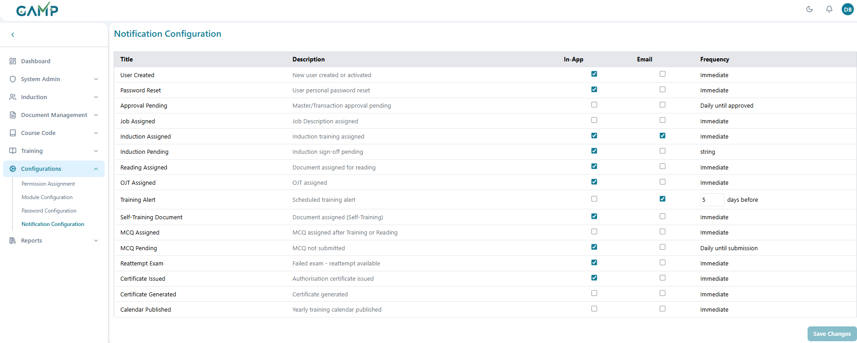

**Step 2: Review Available Notifications**

The system displays various notification types:

* **Training Scheduled Alerts**
* **Approval Pending Notifications**
* **Training Completion Reminders**
* **Document Revision Alerts**
* **System Maintenance Notifications**

**Step 3: Configure Notification Channels**

For each notification type, configure:

* **In-App Notifications:** Enable/disable in-application alerts
* **Email Notifications:** Enable/disable email delivery

**Step 4: Set Notification Timing**

* **Immediate:**Instant notification when event occurs
* **Daily until [action]:**Daily reminders until action is completed
* **X days before:**Advance notification (configurable number of days)
* Configure Training Alert Timing For "**Training Alert**" notifications:
  + Set the number of days before scheduled training
  + Default is 5 days, can be customized (1-30 days) for both the channels.

**Step 5: Save Notification Settings**

* Click "**Save**" button when changes are made
* Provide reason for configuration change
* Enter electronic signature
* Click "**Submit**" to apply changes

## Password Configuration

Password Configuration manages security policies for user authentication, including password complexity, tenure, session management, and security controls. This module ensures organizational security standards are maintained across the TMS system.

**Step 1: Accessing Password Configuration**

Navigate to **Configurations** → **Password Configuration**   
**Step 2: Set Basic Password Requirements**

* **Minimum Password Length:** Enter minimum character count (8 recommended)
* **Password Expiry:** Set password validity period in days (90 recommended)
* **Password History:** Define number of previous passwords to remember (3 recommended)
* **Wrong Attempt Limit:** Set maximum failed login attempts (4 recommended)

**Step 3: Configure Security Alerts**

* **Password Change Alert:** Set advance notification days (7 recommended)
* **Ideal Session Time:** Define session timeout in minutes (10-60 recommended)

**Step 4: Select Password Complexity** Choose appropriate complexity level:

* **Low:** Basic alphanumeric (not recommended for production)
* **Medium:** Mixed case with special characters (good for standard security)
* **High:** Complete character set requirements (recommended for high security)

**Step 5: Save Configuration**

* Click "**Save Configuration**" button
* Provide reason for change in the modal dialog
* Enter electronic signature (password)
* Click "**Submit**" to apply changes

## Module Configuration

**Step 1: Select Module and Transaction**

* + - **Module Name:** Choose from available modules (e.g., Course Code, Training Session, Document Management)
    - **Transaction Name:** Select specific transaction within the module
    - Configuration settings apply to the selected module-transaction combination  
      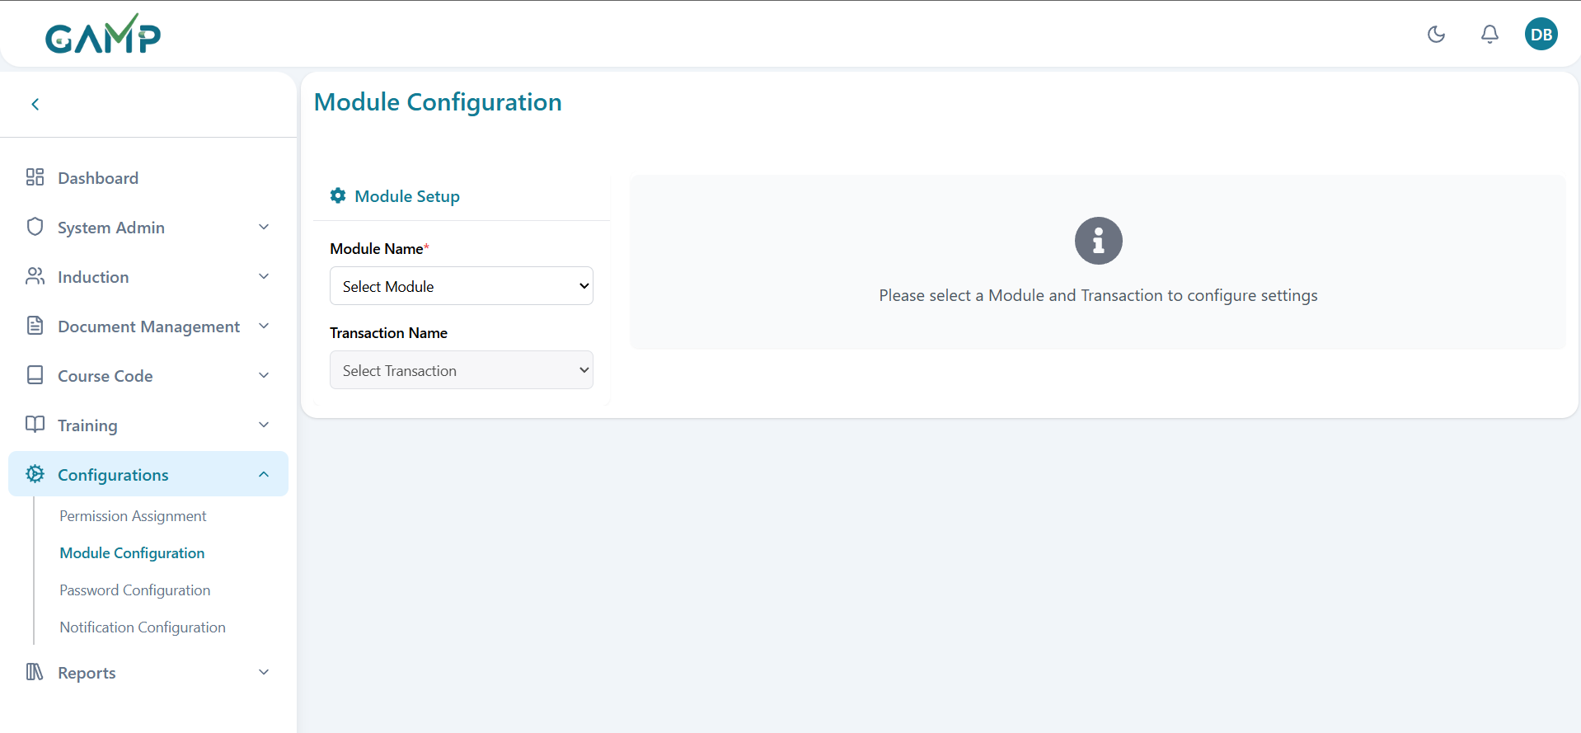

**Configuration Types by Transaction**

**Type 1: Having Change Management Configuration**

Applicable to: **Document Registration, OJT Master**

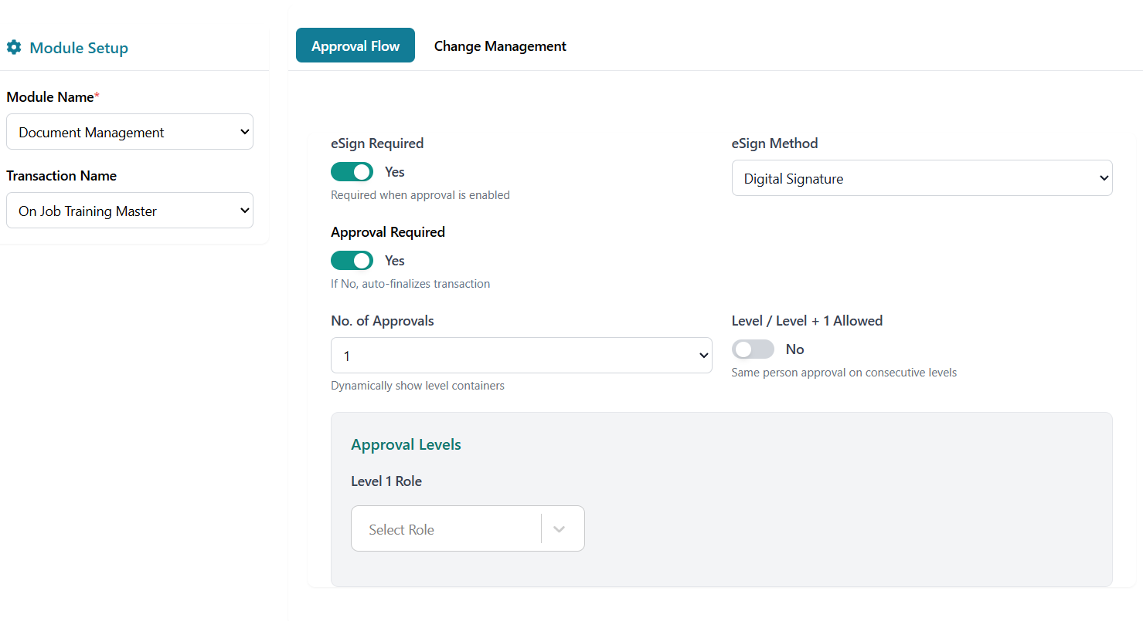

**Approval Flow Configuration:**

* **Approval Required:**Enable/disable approval workflow
* **Number of Approvals:**Set required approval levels (1-5)
* **Approval Levels:**Configure role-based approval hierarchy
* **L+1 Allowed:**Enable supervisor bypass option

**eSignature Configuration:**

* **eSign Required:**Enable/disable electronic signature
* **eSign Method:**Select signature method
* **eSign at Level:**Specify which approval levels require eSignature

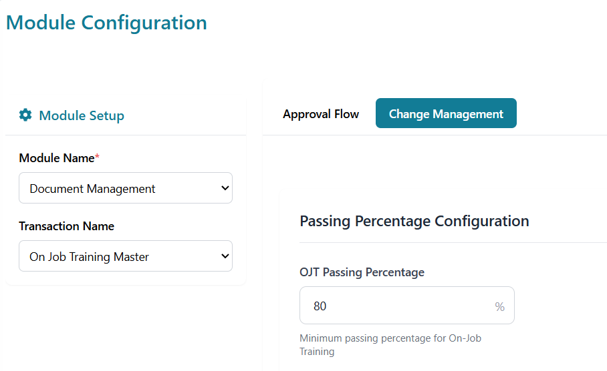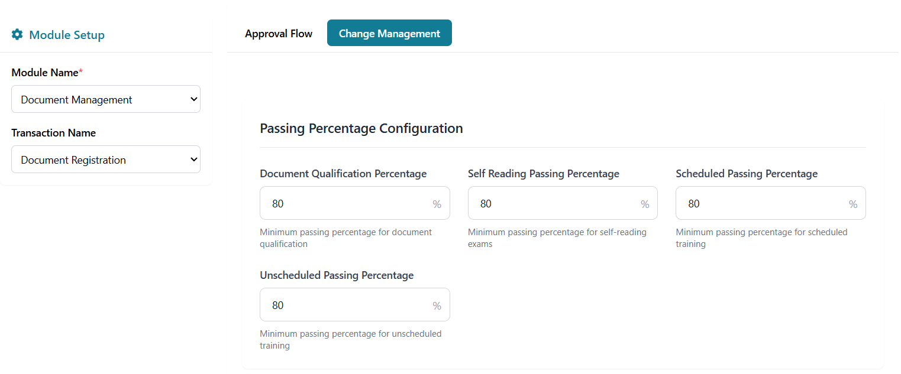

**Change management**

All can be configured from 0-100

* **Document Qualification Percentage:** Minimum percentage for document qualification
* **Self-Reading Passing Percentage:** Minimum passing percentage for Self-Training **Scheduled Passing Percentage:** Minimum passing percentage for Scheduled Training
* **Unscheduled Passing Percentage:** Minimum passing percentage for Unscheduled Training
* **OJT Passing Percentage:** Minimum passing percentage for On-Job Training

**Type 2: eSignature Configuration Only**

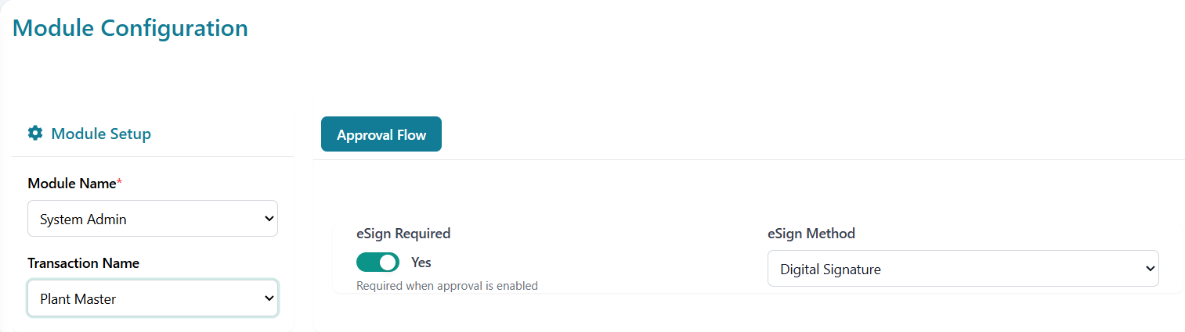

Applicable to: **System Admin, Induction, Course Code Assignment, Yearly Planning transactions**

**eSignature Settings:**

* **eSign Required**: Enable/Disable (Yes/No toggle)
* **eSign Method**: Select signature method-Digital Signature (recommended)

**Type 3: Full Approval Flow + eSignature Configuration**

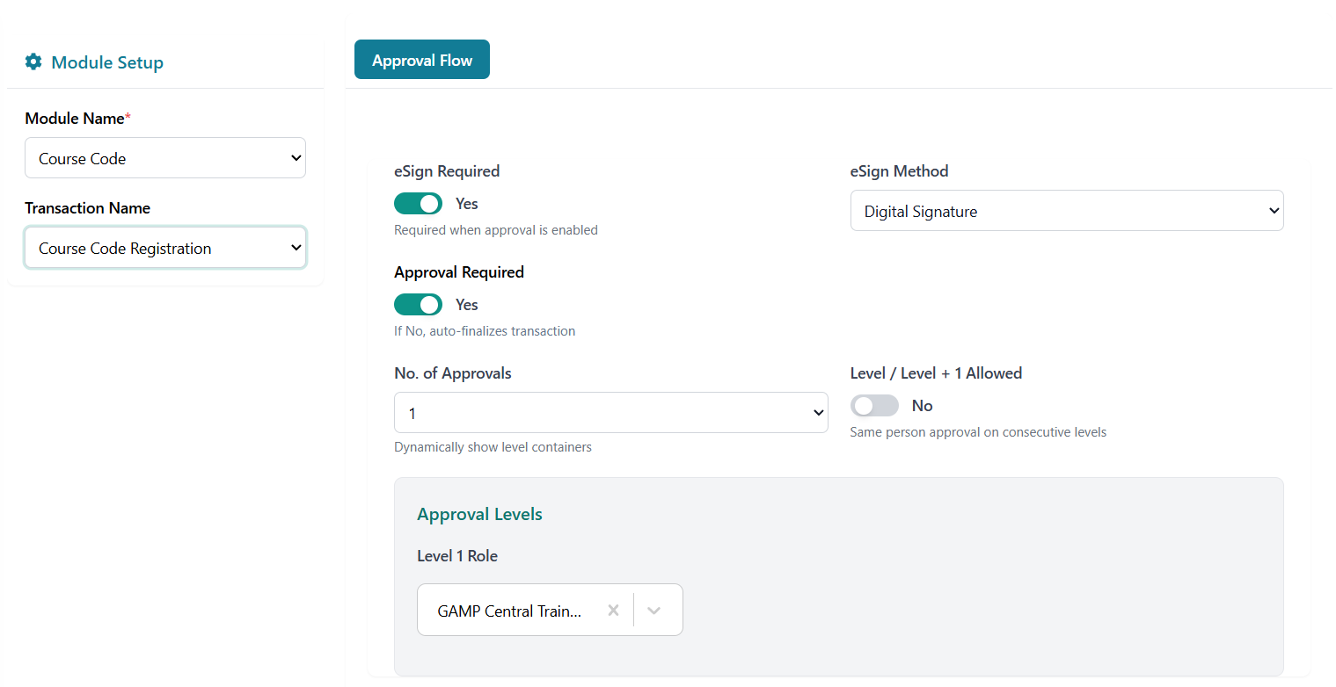

**Applicable to:** All other transactions not covered in Types 1 and 2

**Approval Flow Configuration:**

* **Approval Required:** Enable/disable approval workflow
* **Number of Approvals:** Set required approval levels (1-5)
* **Approval Levels:** Configure role-based approval hierarchy
* **L+1 Allowed:** Enable supervisor bypass option

**eSignature Configuration:**

* **eSign Required:** Enable/disable electronic signature
* **eSign Method:** Select signature method
* **eSign at Level:** Specify which approval levels require eSignature

**Steps:**

* Make whatever changes you want to in configurations and then Click "**Save Configuration**" button.
* Provide reason for change
* Enter electronic signature if required
* Confirm to apply changes

# Reports

## Reports Dashboard

### Audit Report

Track and monitor all system activities and changes for compliance and audit trails.

**Step 1: Access Audit Report**

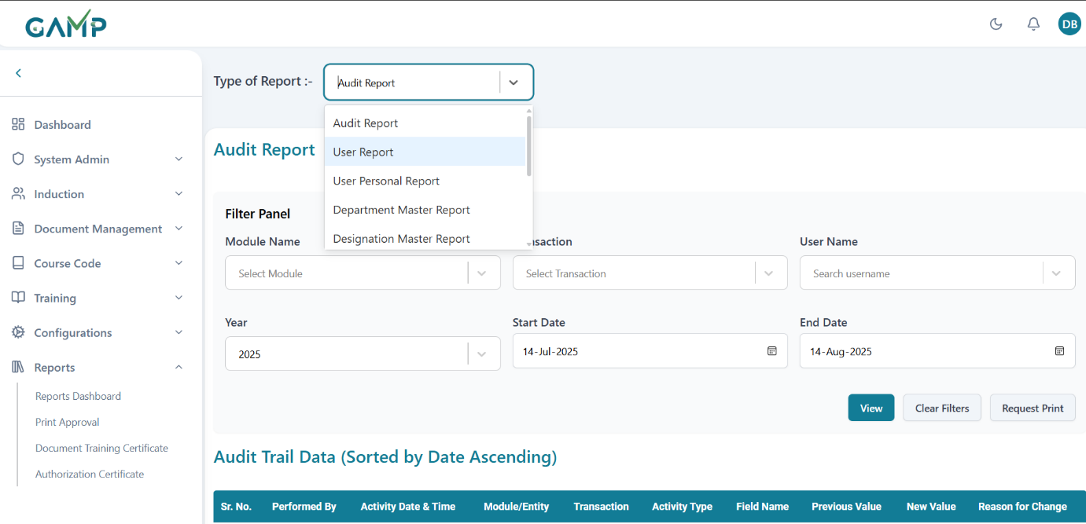

1. Navigate to the Reports Dashboard
2. Select "Audit Report" from the Type of Report dropdown
3. The Audit Report interface will load

**Step 2: Configure Filter Panel**

1. **Module Name**: If you want, select the specific module to audit
   * Options: Document Management, Induction, System Admin, Course Code, Configuration, All
   * Default: No selection, meaning all are selected
2. **Transaction**: If you want to choose specific transaction type
   * Options vary based on selected module and all for all the transactions
   * Example: For Document Management: Document Management, On Job Training Master, Questionnaire Preparation, All
3. **User Name**: If you want, select specific user whose activities to track
4. **Year**: Select the year for audit trail
   * Current year is pre-selected
5. **Start Date**: Select beginning date for audit period
   * Default: One month prior to current date
6. **End Date**: Select ending date for audit period
   * Default: Current date
   * Must be after start date

**Step 3: Generate Report**

1. Click **"View"** button to generate the audit trail data
2. System validates date range (start date must be before end date)
3. Data loads in the table below with pagination

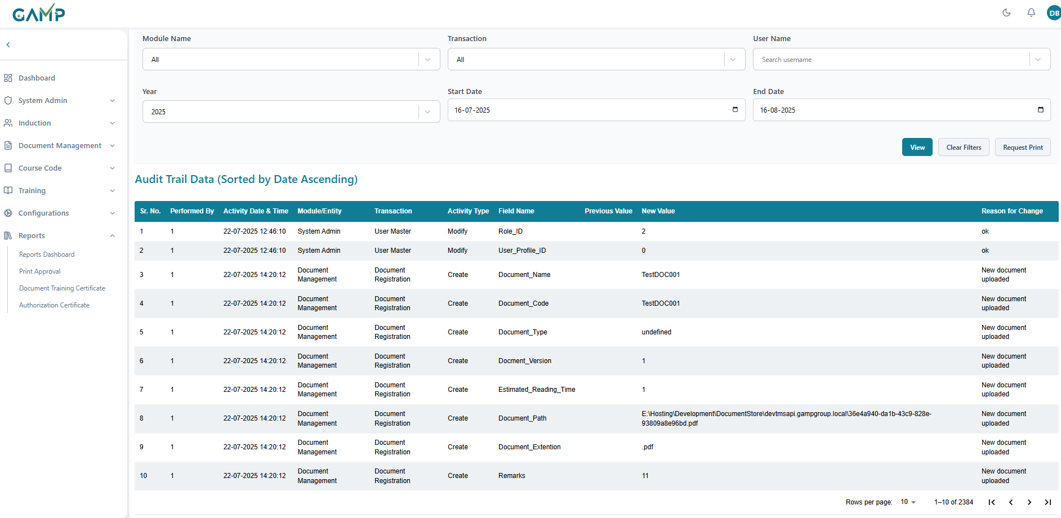

**Step 4: Review Audit Trail Data**

The audit trail table displays:

* **Sr. No.**: Sequential number
* **Performed By**: User who performed the action
* **Activity Date & Time**: When the action occurred
* **Module/Entity**: Which module was affected
* **Transaction**: Type of transaction performed
* **Activity Type**: Type of activity (Create, Update, Delete, etc.)
* **Field Name**: Which field was changed
* **Previous Value**: Value before change
* **New Value**: Value after change
* **Reason for Change**: Justification provided

**Step 5: Print Request**

1. Click **"Request Print"** button
2. System creates a print request for approval
3. Button shows status:
   * "Request Print": Initial state
   * "Requesting...": Processing
   * "Already Requested": Request submitted

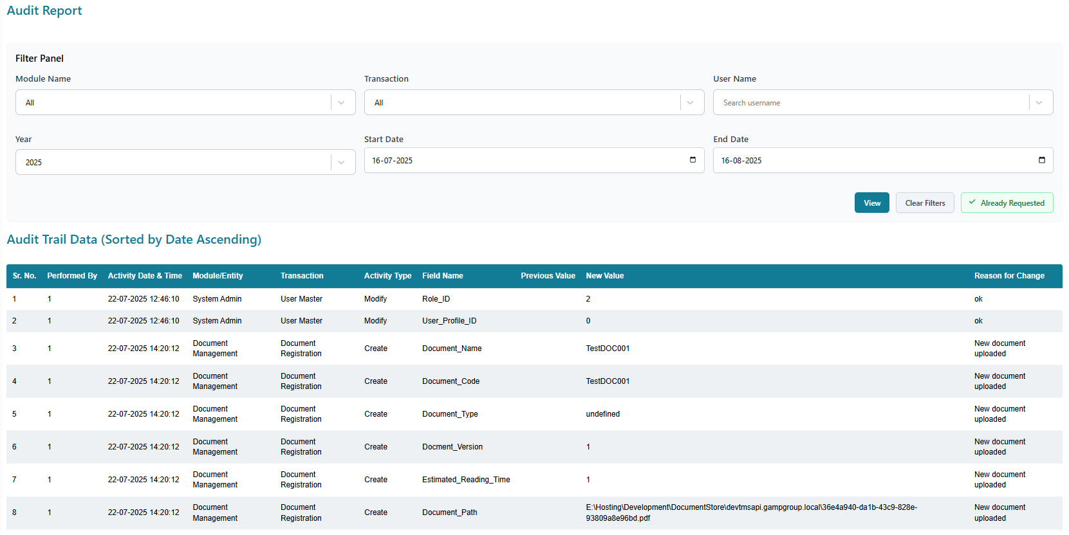

**Step 6: Clear Filters (Optional)**

1. Click **"Clear Filters"** to reset all filter fields
2. Resets to default values (one month date range, All modules)

### User Report

Generate comprehensive reports on user master data.

**Step 1: Access User Report**

1. Navigate to Reports Dashboard
2. Select "User Report" from the Type of Report dropdown

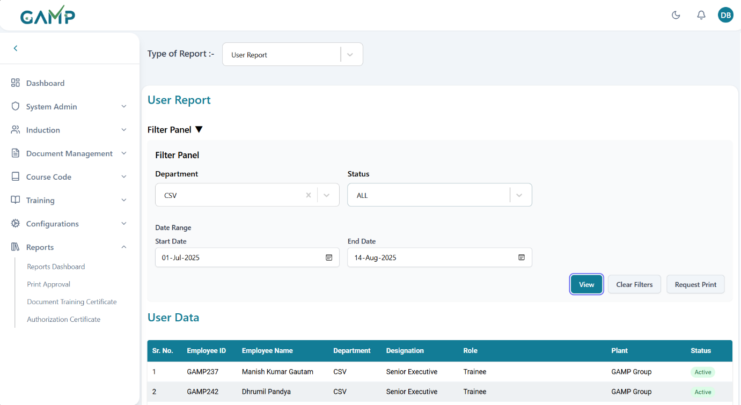

**Step 2: Configure Filter Panel**

1. **Department**: Select specific department
   * Searchable dropdown with pagination
   * Loads departments dynamically
2. **Status**: Choose user status
   * Options: ALL, ACTIVE, INACTIVE
   * Default: ALL
3. **Start Date**: Select report period start date
   * Required field
   * Used for filtering user data
4. **End Date**: Select report period end date
   * Required field
   * Must be after start date

**Step 3: Generate Report**

1. Ensure all required fields are filled
2. Click **"View Report"** button
3. System validates date range
4. User data loads in the table.

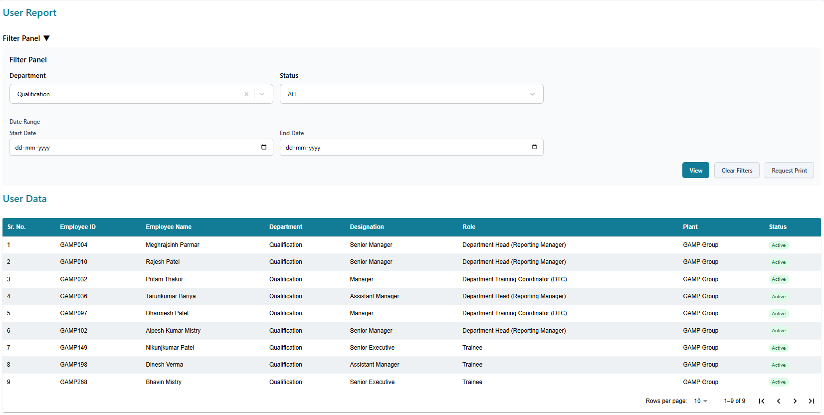

**Step 4: Review User Data**

The user report table displays:

* **Sr. No.**: Sequential number
* **User Name**: Full name of the user
* **Employee ID**: Employee identification number
* **Login ID**: System login identifier
* **Department**: User's department
* **Designation**: User's job designation
* **Email**: Email address
* **Status**: Active/Inactive status
* **Created Date**: When user was added to system

**Step 5: Print Request**

1. Click **"Request Print"** button after generating report
2. System creates print request for approval
3. Status indicator shows request progress

### User Personal Report

Generate detailed personal information reports for individual users.

**Step 1: Access User Personal Report**

1. Navigate to Reports Dashboard
2. Select "User Personal Report" from dropdown

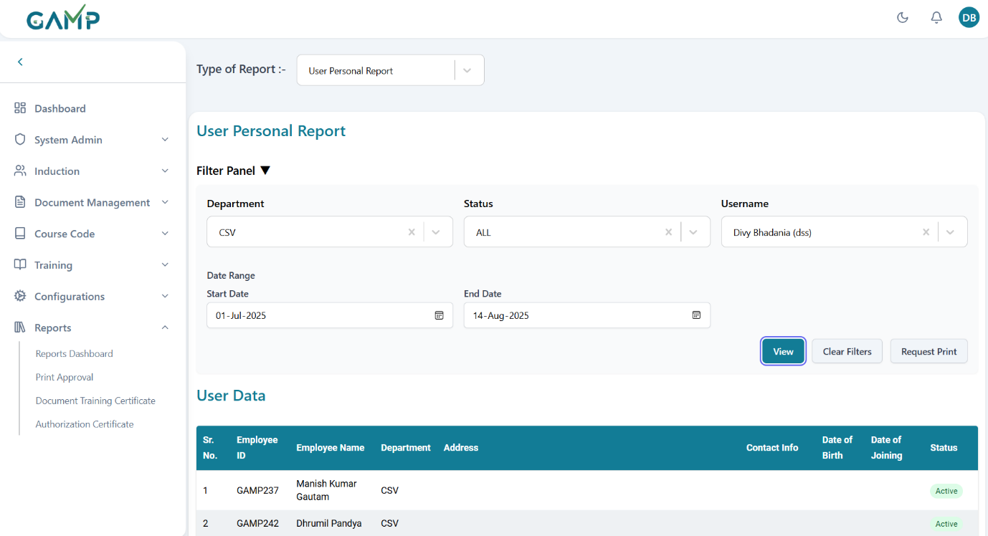

**Step 2: Configure Filters**

1. **Department**: Filter by department (optional)
   * Can be left blank for all departments
2. **Status**: Choose user status
   * Options: ALL, ACTIVE, INACTIVE
   * Default: ALL
3. **User Selection**: Select specific user from the selected department (if selected) or else no options will be available
4. **Date Range**: Set reporting period
   * Start Date: Beginning of report period
   * End Date: End of report period

**Step 3: Generate Report**

1. Ensure user is selected and dates are set
2. Click **"Generate Report"** button
3. Personal data loads in detailed view

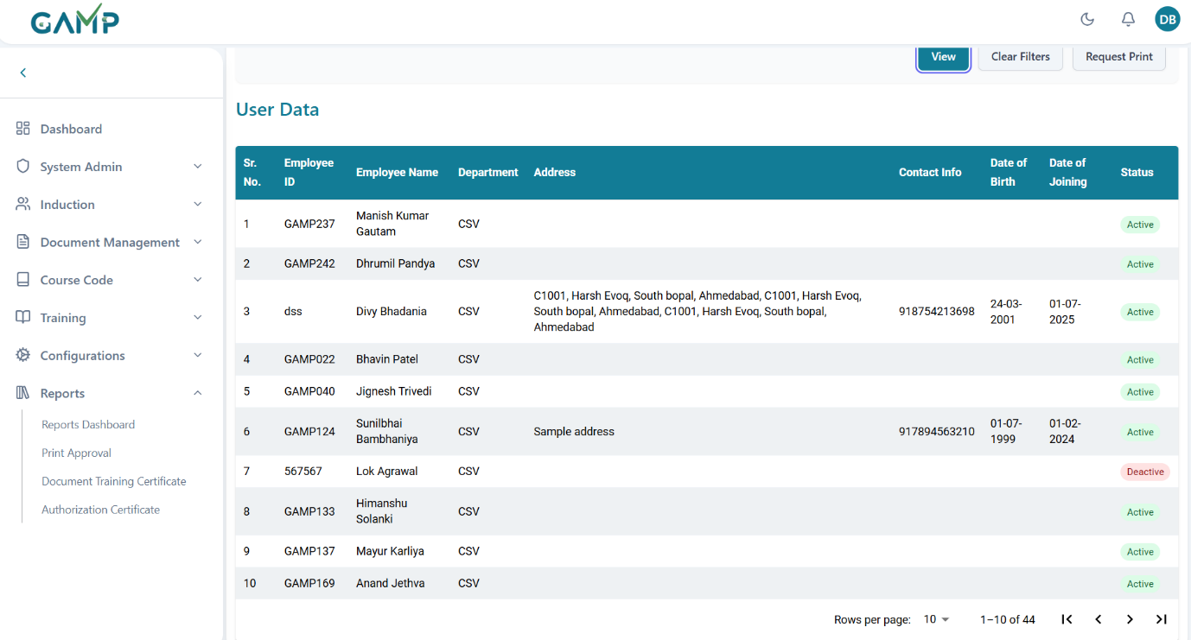

**Step 4: Review Personal Data**

The report displays comprehensive personal information:

* **Personal Details**: Name, employee ID, contact info, DOB
* **Professional Information**: Department, DOJ
* **Status**

**Step 5: Print Request**

1. Click **"Request Print"** button after generating report
2. System creates print request for approval
3. Status indicator shows request progress

Department Master Report  
Generate reports on department master data including department details and status.

**Step 1: Access Department Master Report**

1. Navigate to Reports Dashboard
2. Select "Department Master Report" from dropdown

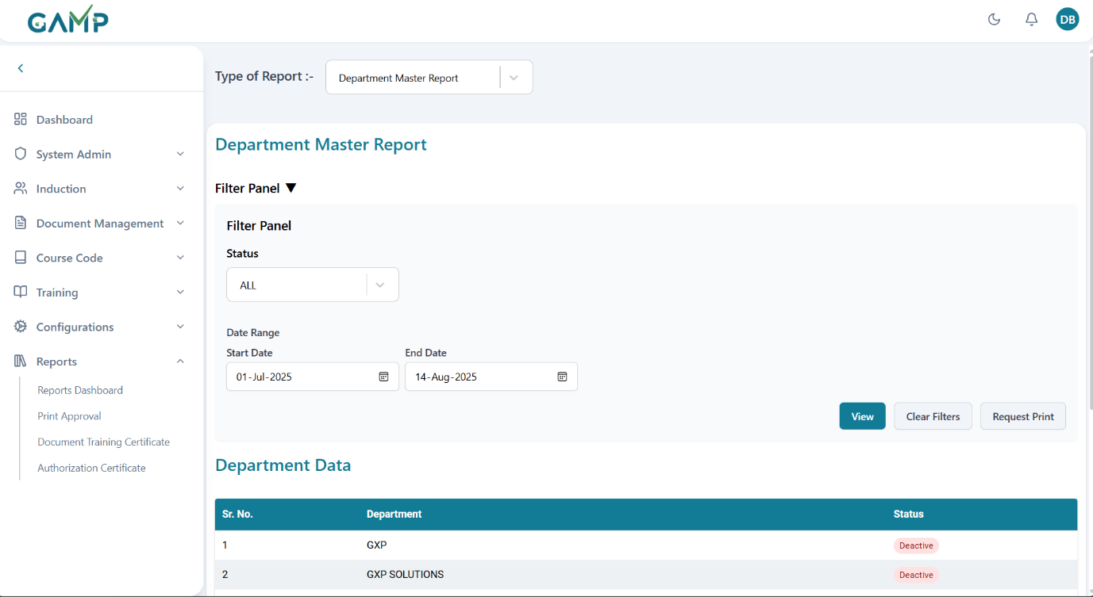

**Step 2: Configure Filter Panel**

1. **Status**: Select department status
   * Options: ALL, ACTIVE, INACTIVE
   * Default: ALL
2. **Date Range**: Set reporting period
   * Start Date: Required
   * End Date: Required
   * Used for filtering department records

**Step 3: Generate Report**

1. Select status and date range
2. Click **"View Report"** button
3. Department data loads in table format

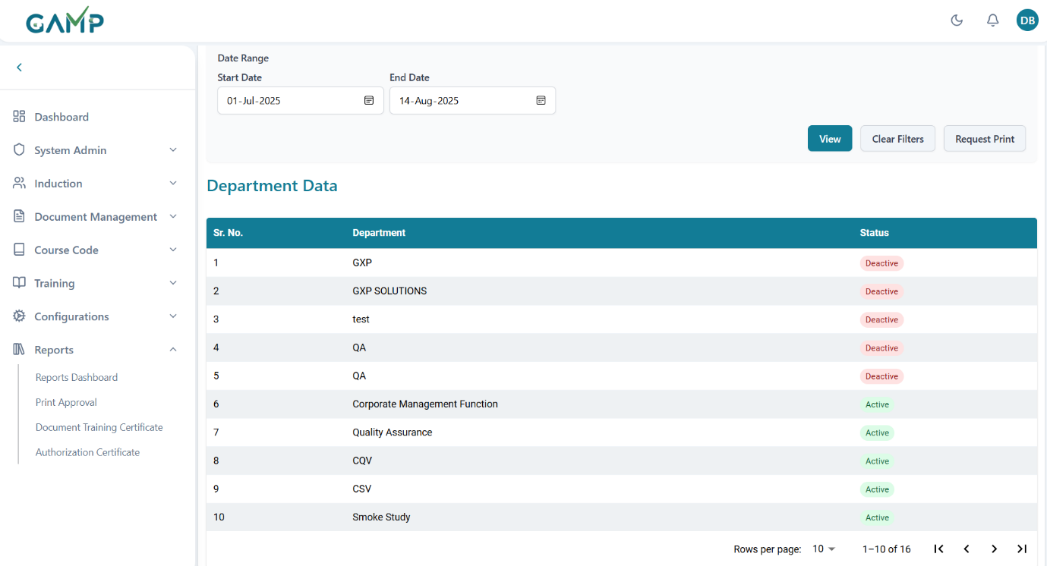

**Step 4: Review Department Data**

The department report displays:

* **Sr. No.**: Sequential number
* **Department Name**: Name of the department
* **Status**: Active/Inactive status

**Step 5: Print Request**

1. Click **"Request Print"** for approved printing
2. System tracks print request status
3. Follow organizational approval process

### Designation Master Report

**Step 1: Access Designation Master Report**

1. Navigate to Reports Dashboard
2. Select "Designation Master Report" from dropdown

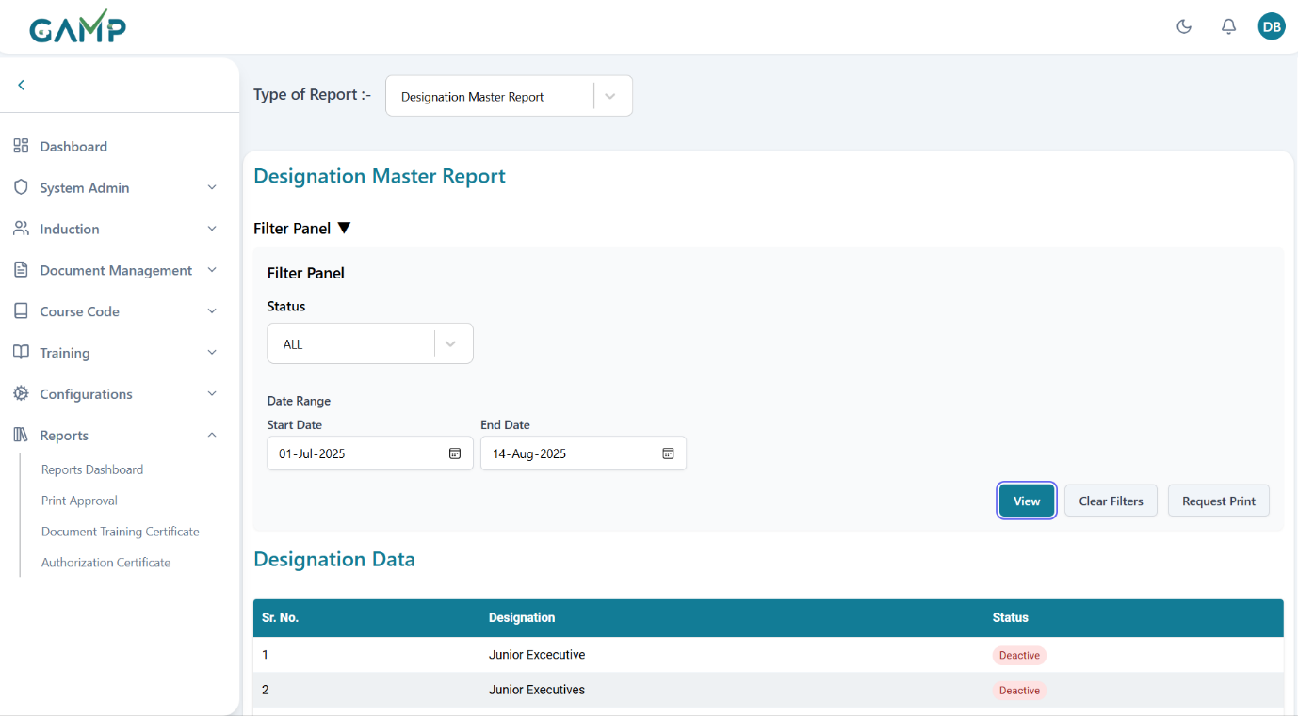

**Step 2: Configure Filter Panel**

1. **Status**: Select designation status
   * Options: ALL, ACTIVE, INACTIVE
   * Default: ALL
2. **Date Range**: Set reporting period
   * Start Date: Required
   * End Date: Required
   * Used for filtering department records

**Step 3: Generate Report**

1. Select status and date range
2. Click **"View Report"** button
3. Designation data loads in table format

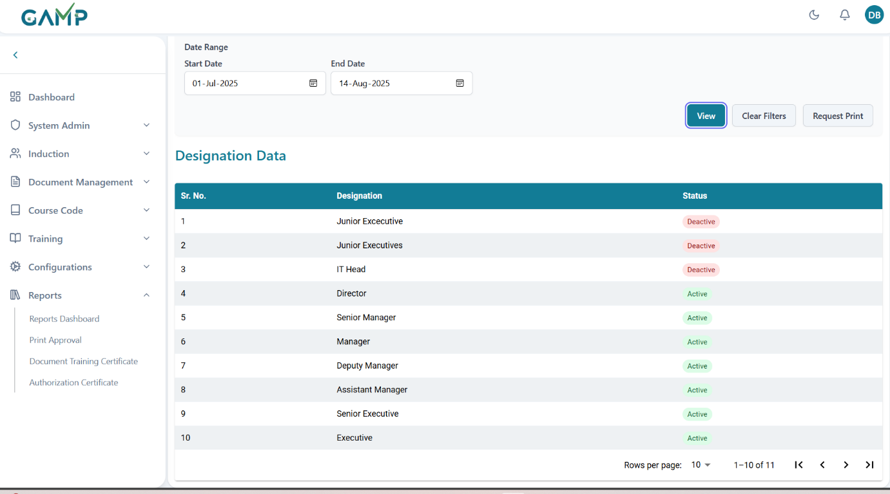

**Step 4: Review Designation Data**

The designation report displays:

* **Sr. No.**: Sequential number
* **Designation Name**: Name of the designation
* **Status**: Active/Inactive status

**Step 5: Print Request**

1. Click **"Request Print"** for approved printing
2. System tracks print request status
3. Follow organizational approval process

### Role Master

**Step 1: Access Role Master Report**

1. Navigate to Reports Dashboard
2. Select "Role Master Report" from dropdown

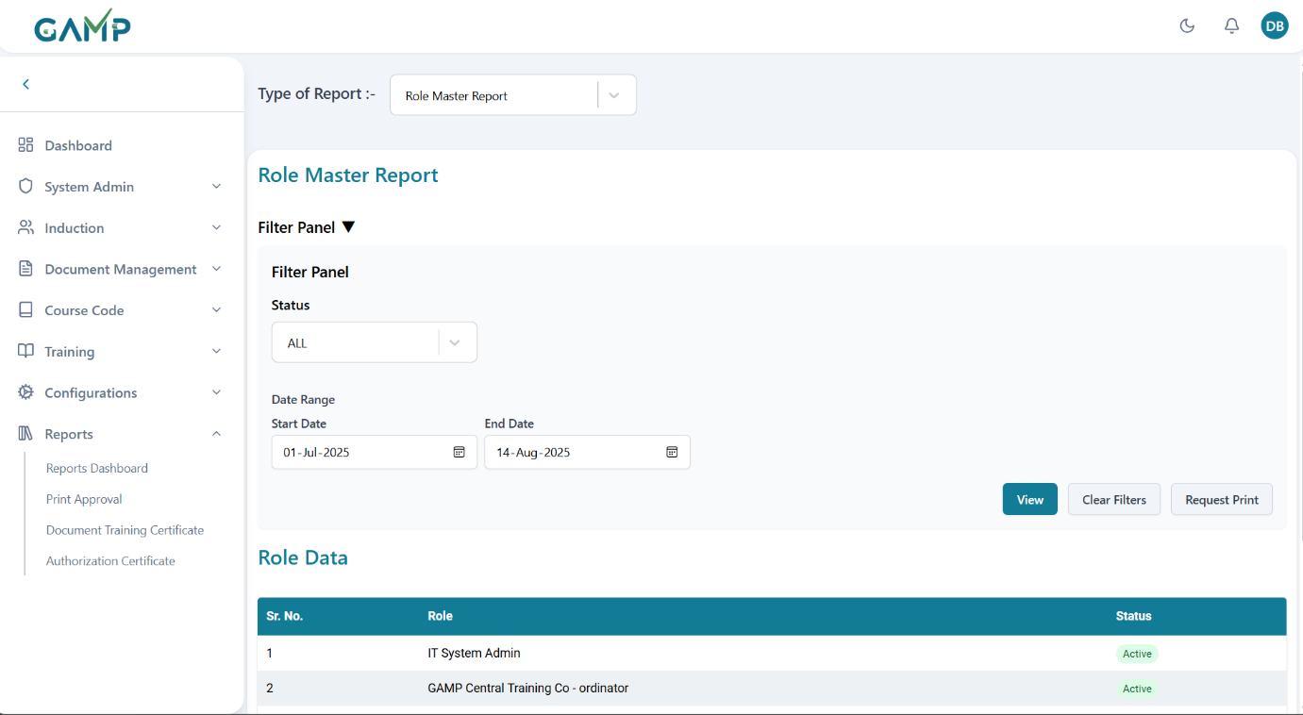

**Step 2: Configure Filter Panel**

1. **Status**: Select role status
   * Options: ALL, ACTIVE, INACTIVE
   * Default: ALL
2. **Date Range**: Set reporting period
   * Start Date: Required
   * End Date: Required
   * Used for filtering role records

**Step 3: Generate Report**

1. Select status and date range
2. Click **"View Report"** button
3. Role data loads in table format

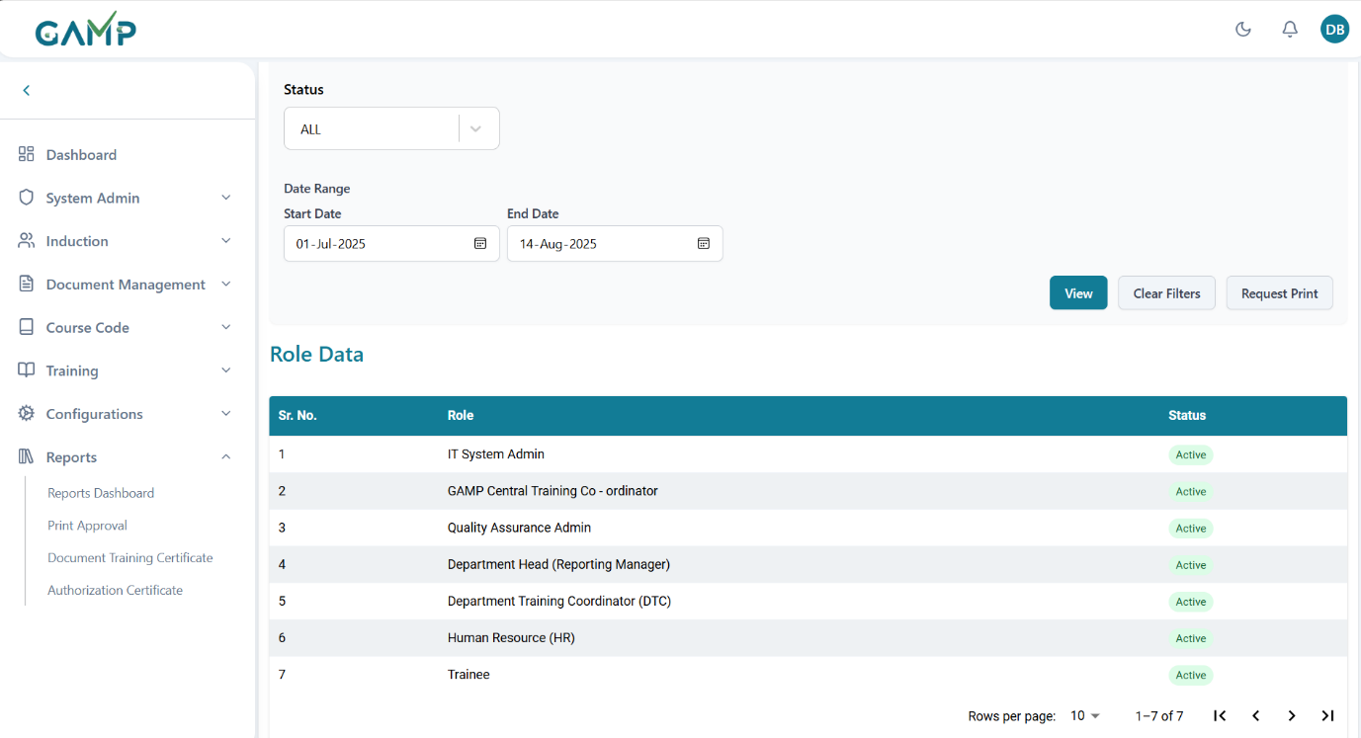

**Step 4: Review Role Data**

The Role report displays:

* **Sr. No.**: Sequential number
* **Role Name**: Name of the role
* **Status**: Active/Inactive status

**Step 5: Print Request**

1. Click **"Request Print"** for approved printing
2. System tracks print request status
3. Follow organizational approval process

Plant Master Report  
**Step 1: Access Plant Master Report**

1. Navigate to Reports Dashboard
2. Select "Plant Master Report" from dropdown

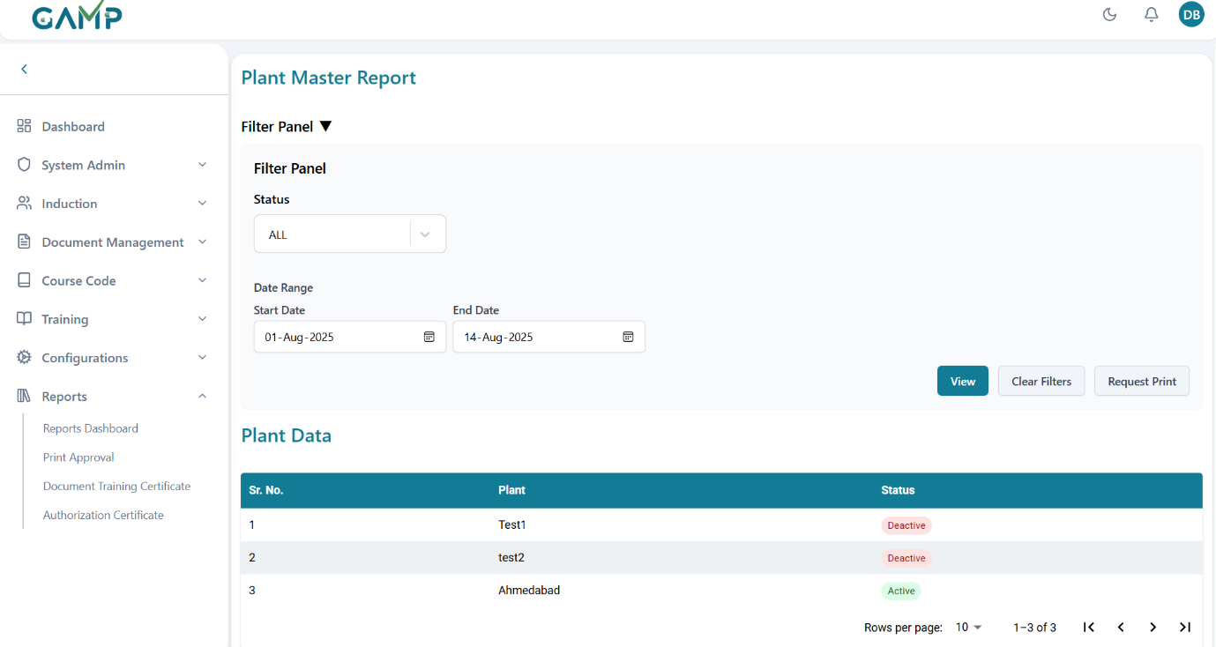

**Step 2: Configure Filter Panel**

1. **Status**: Select plant status
   * Options: ALL, ACTIVE, INACTIVE
   * Default: ALL
2. **Date Range**: Set reporting period
   * Start Date: Required
   * End Date: Required
   * Used for filtering plant records

**Step 3: Generate Report**

1. Select status and date range
2. Click **"View Report"** button
3. Plant data loads in table format

**Step 4: Review Plant Data**

The plant report displays:

* **Sr. No.**: Sequential number
* **Department Name**: Name of the plant
* **Status**: Active/Inactive status

**Step 5: Print Request**

1. Click **"Request Print"** for approved printing
2. System tracks print request status
3. Follow organizational approval process

### Schedule Report

**Step 1: Access Schedule Report**

1. Navigate to Reports Dashboard
2. Select "Schedule Report" from dropdown

**Step 2: Configure Schedule Filters**

1. **Department**: Select target department(optional )
2. **Date Range**: Set schedule timeframe
   * Start Date: Schedule period beginning
   * End Date: Schedule period end

**Step 3: Generate Schedule Report**

1. Configure all relevant filters
2. Click **"View Schedule"** button
3. Training schedule data loads with details

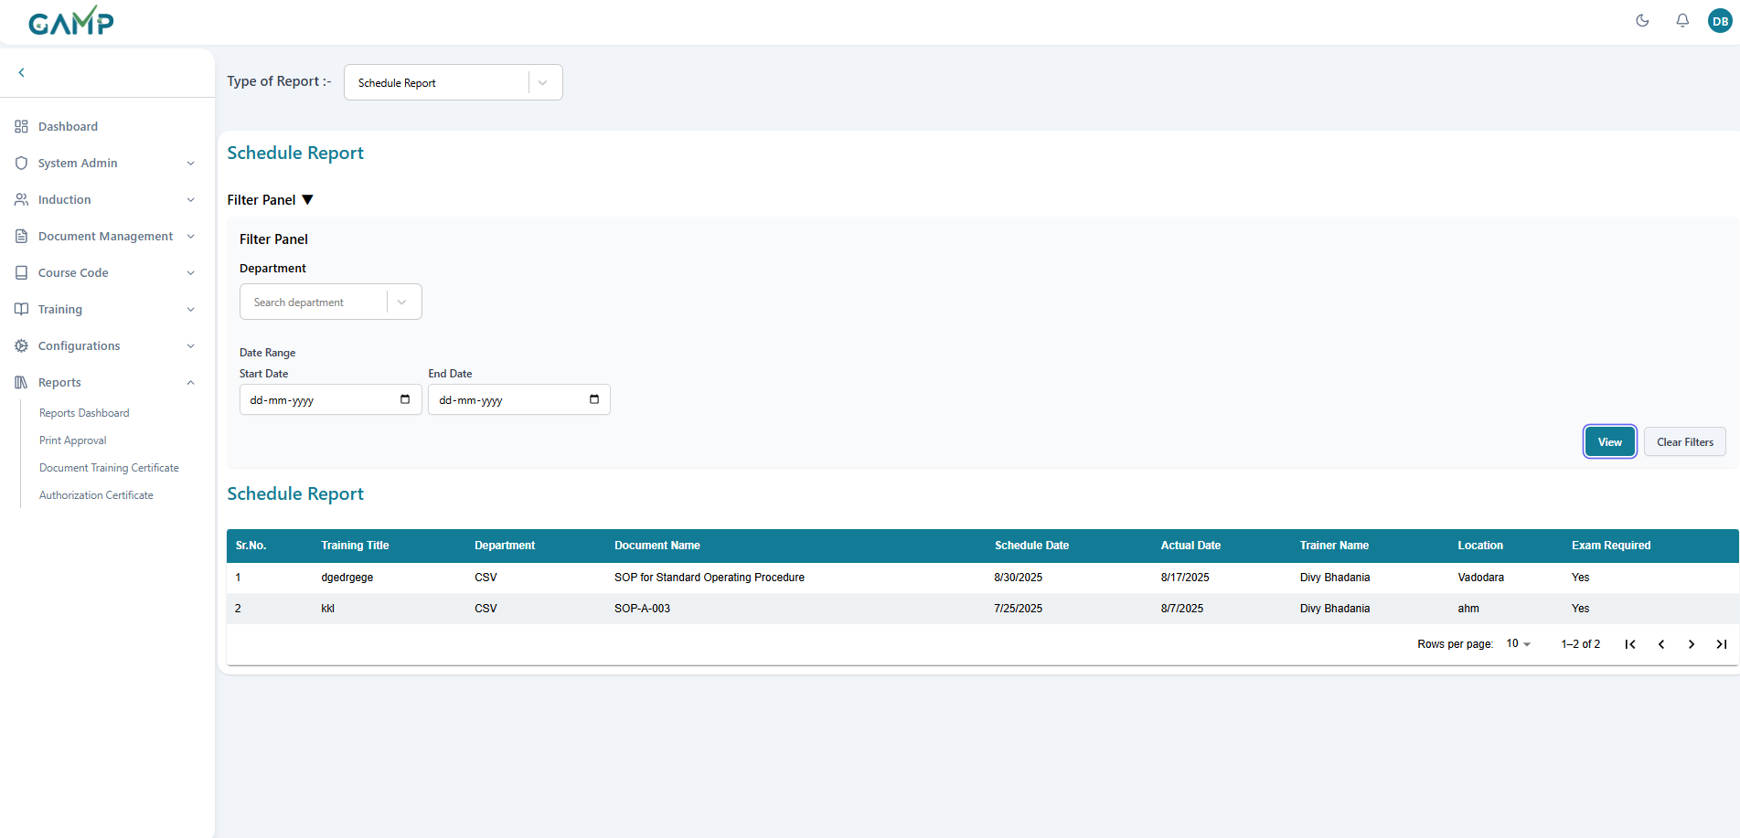

**Step 4: Review Schedule Data**

The schedule report shows:

* **Sr. No.**: Sequential identifier
* **Training Title**: Name of training session
* **Department**: Target department
* **Document Name** : Name of document on which training was conducted
* **Scheduled Date**: Planned date and time
* **Actual Date**: Date of training
* **Trainer Name**: Name of the trainer who conducted
* **Exam Required**: Whether exam is compulsory or not
* **Location**: Training venue

**Step 5: Analyse Scheduled Details**

1. **Expand Row Details**: Click on rows to see additional information
   * **Training Details**
   * **View Documents and Attachments**
   * **Scheduled and Actual Date**
   * **Training Start and End times**
   * **Training participants table having**
     1. **Sr No**
     2. **Employee Id**
     3. **Employee Name**
     4. **Exam start and end times**
     5. **Exam Result**

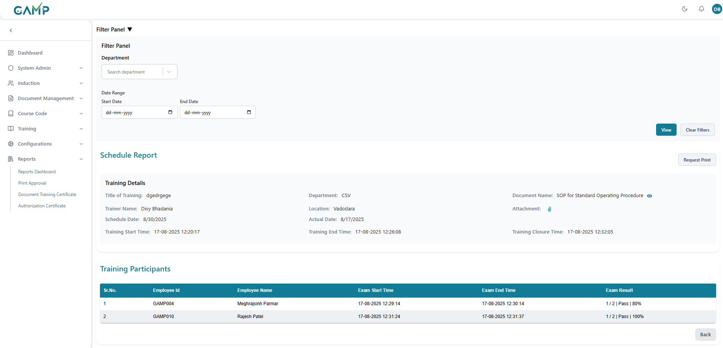  
  
Unschedule Report

**Step 1: Access Schedule Report**

1. Navigate to Reports Dashboard
2. Select "Schedule Report" from dropdown

**Step 2: Configure Schedule Filters**

1. **Department**: Select target department(optional )
2. **Date Range**: Set schedule timeframe
   * Start Date: Schedule period beginning
   * End Date: Schedule period end

**Step 3: Generate Schedule Report**

1. Configure all relevant filters
2. Click **"View Schedule"** button
3. Training schedule data loads with details

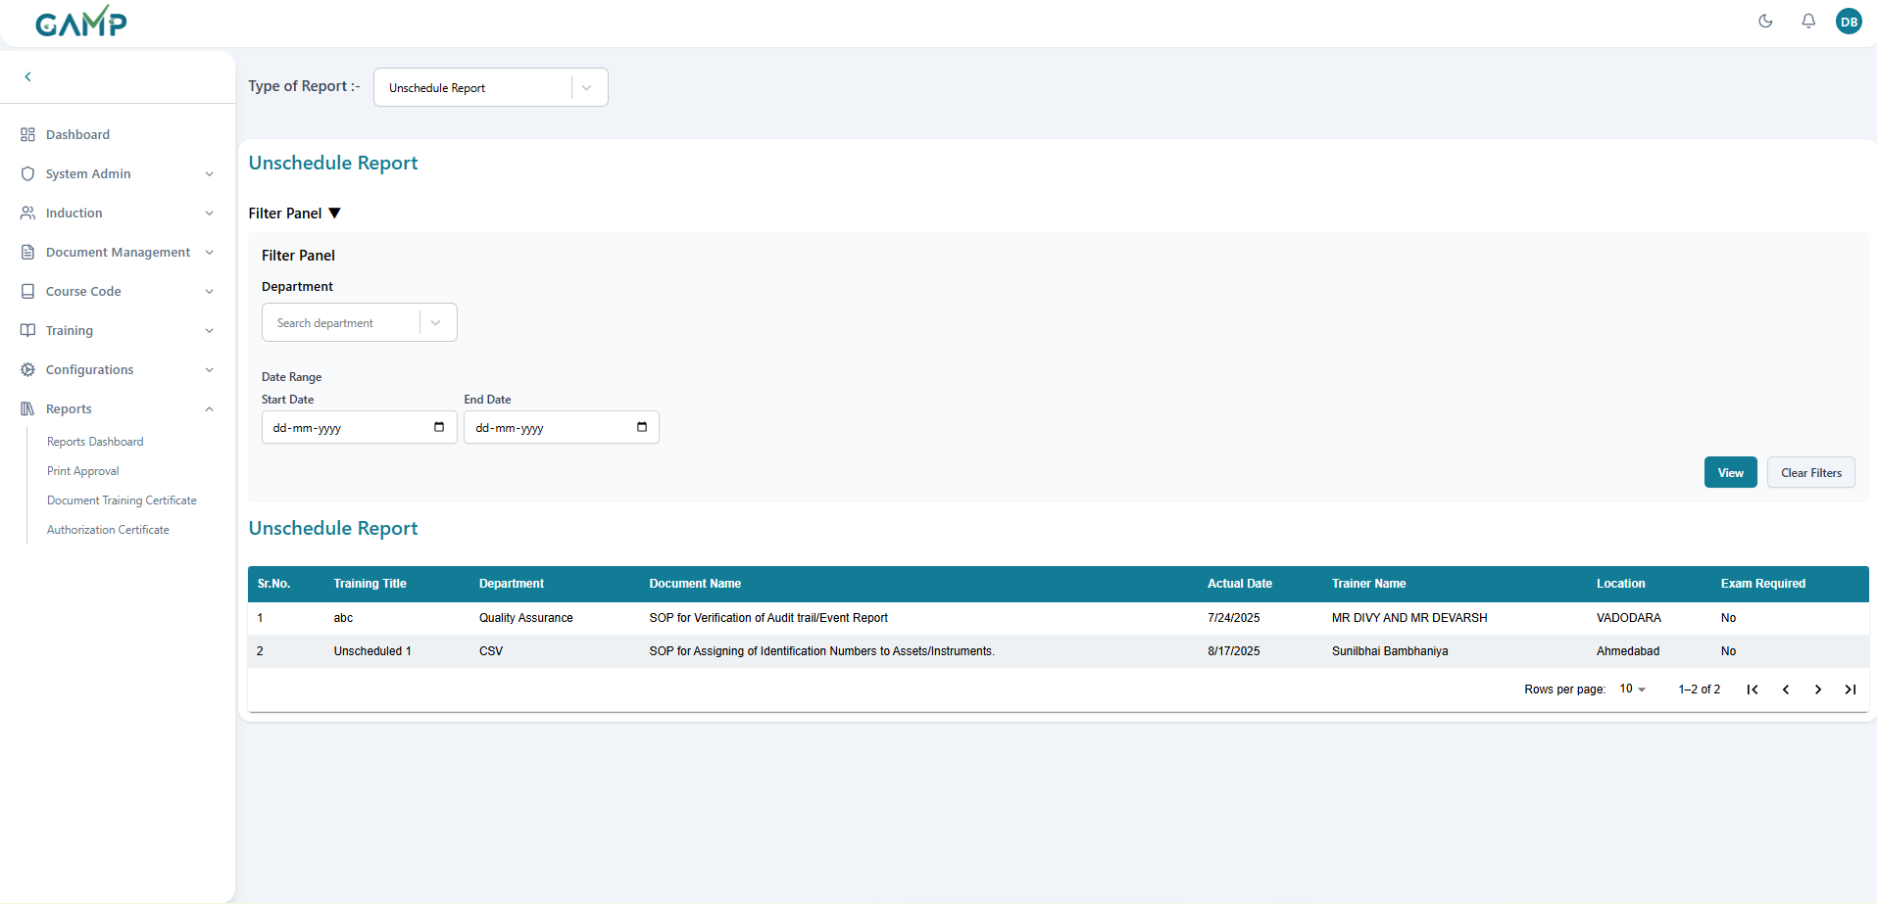

**Step 4: Review Schedule Data**

The schedule report shows:

* **Sr. No.**: Sequential identifier
* **Training Title**: Name of training session
* **Department**: Target department
* **Document Name** : Name of document on which training was conducted
* **Actual Date**: Date of training
* **Trainer Name**: Name of the trainer who conducted
* **Exam Required**: Whether exam is compulsory or not
* **Location**: Training venue

**Step 5: Analyse Unscheduled Details**

1. **Expand Row Details**: Click on rows to see additional information
   * **Training Details**
   * **View Documents and Attachments**
   * **Training Start and End times**
   * **Training participants table having**
     1. **Sr No**
     2. **Employee Id**
     3. **Employee Name**
     4. **Exam start and end times**
     5. **Exam Result**

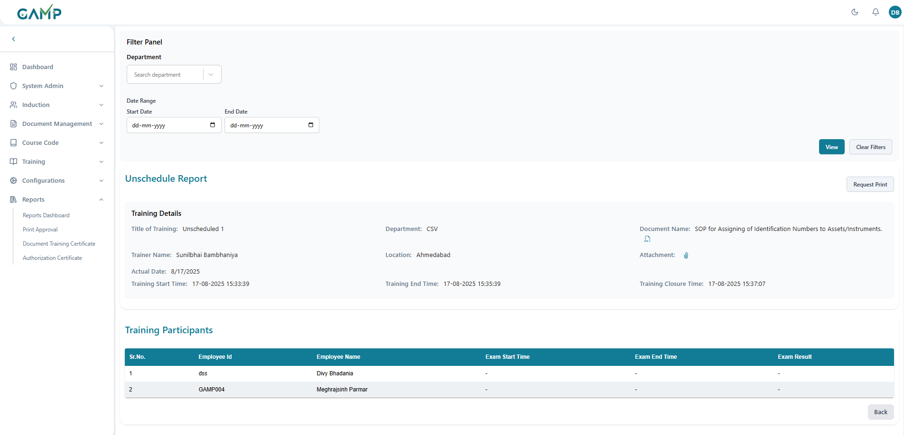  
  
Course Code Report

Generate comprehensive reports on course code registrations, assignments, and linked documents with detailed drill-down capabilities.

**Step 1: Access Course Code Report**

1. Navigate to Reports Dashboard (accessible from left sidebar under "Reports")
2. Select "Course Code Report" from the Type of Report dropdown

**Step 2: Configure Filter Panel**

**Filter Panel Options:**

1. **Department** (Optional):
   * Search for specific department (e.g., "Search department")
   * Can be left blank to show all departments
2. **Start Date** (Optional):
   * Select beginning date for analysis
3. **End Date** (Optional):
   * Select ending date for analysis
   * Must be after Start Date if both dates are provided

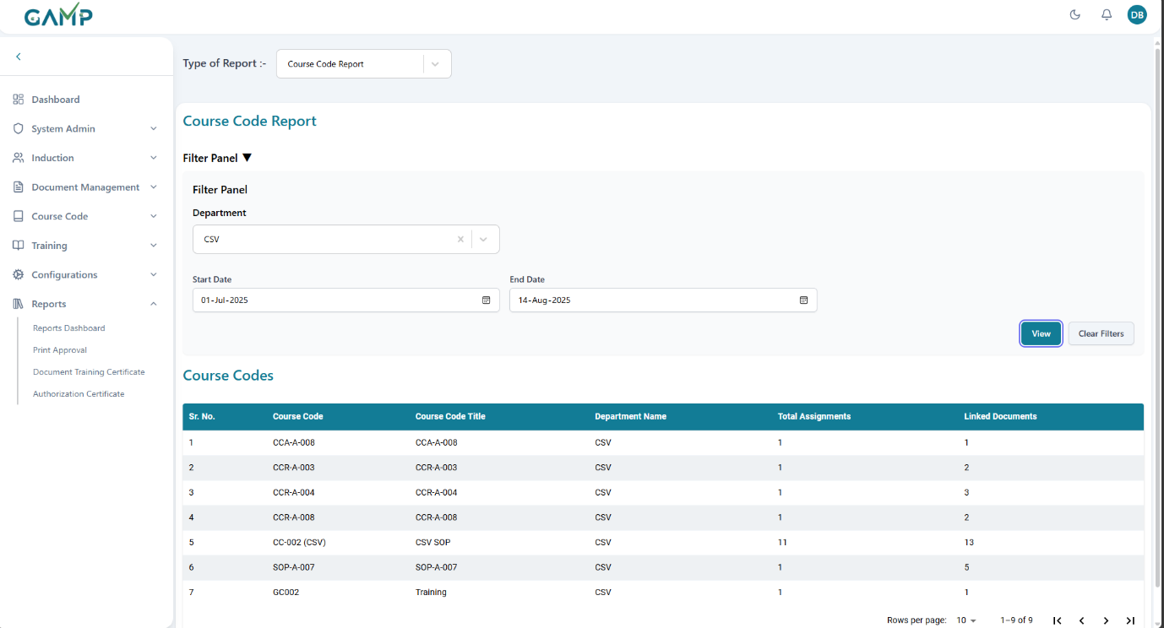

**Step 3: Generate Course Code Report**

1. Configure filters as needed (all filters are optional)
2. Click **"View"** button to generate the course codes list
3. Course code data loads in the main table
4. Use **"Clear Filters"** to reset all filter selections

**Step 4: Review Course Codes Summary Table**

The main **Course Codes** table displays:

**Column Headers:**

* **Sr. No.**
* **Course Code**: Unique course identifier
* **Course Code Title**: Full descriptive name
* **Department Name**: Associated department
* **Total Assignments**: Number of people assigned to this course
* **Linked Documents**: Number of documents associated with the course

**Step 5: Access Detailed Course Information**

1. **Click on any course row** in the main table to view detailed information
2. The system expands to show **Course Code Details** section
3. Detailed view replaces the main table view

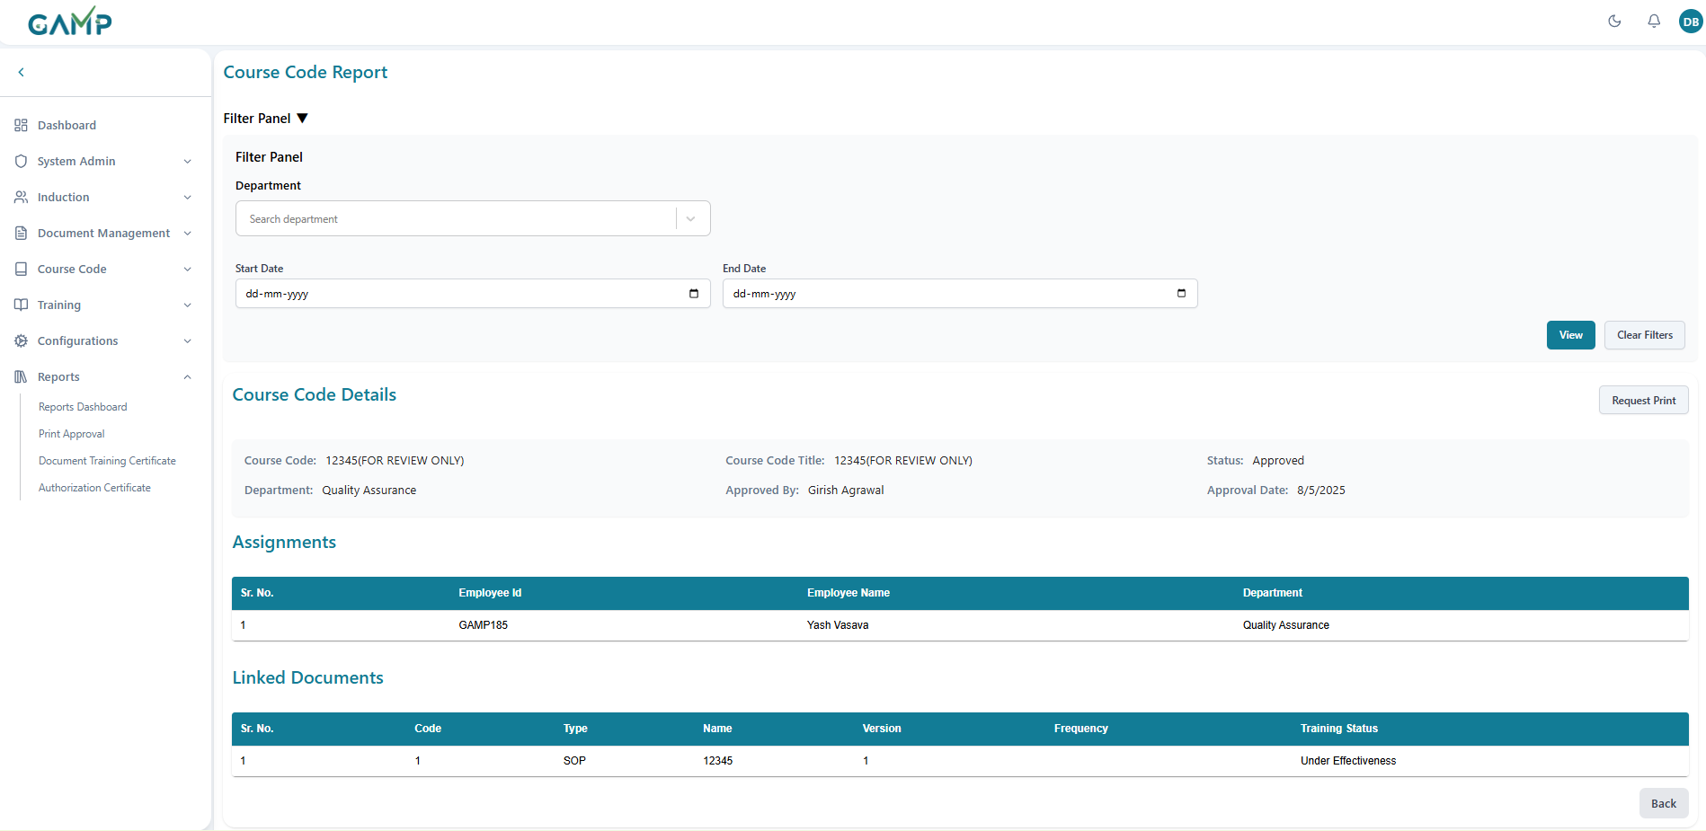

**Step 6: Review Couse Code Details**

**Course Information Section:**

* **Course Code:** Unique identifier
* **Course Code Title:** Full course name
* **Status:** Current status
* **Department:** Associated department
* **Approved By:** Person who approved the course
* **Approval Date:** When course was approved

**Assignments Table:**Shows all people assigned to this course:

**Column Headers:**

* **Sr. No.**
* **Employee Id:**
* **Employee Name:**
* **Department**

**Linked Documents Table**: Shows all documents associated with this course:

**Column Headers:**

* **Sr. No**
* **Code:** Document code
* **Type:** Document type
* **Name:** Document name/number
* **Version:** Document version
* **Frequency:** Training frequency requirement
* **Training Status:** Current training status

Document Report  
The **Document Report** provides training details linked to a specific document (e.g., SOP, Policy, Guideline). It helps administrators track employee training status, completion progress, and exam results for the selected document.  
**Step 2: Configure Document Report Filters**

1. **Department**: Select the department to which the document belongs (optional).
2. **Document**: Choose the required document (e.g., SOP, Work Instruction, Policy) from the dropdown list.

After configuring the filters, click the **View** button.

**Step 3: Generate Document Training Report**

Once filters are applied, the system loads the selected document training details including:

* **Name** – Title of the document.
* **Version** – Current version of the document under training.
* **Code** – Unique reference code of the document.
* **Department** – Department responsible for the document.
* **Type** – Document type (e.g., SOP, Policy).
* **Approved By** – Approver’s name.
* **Status** – Document approval status.
* **Training Status** – Indicates whether the training is completed or under progress.

**Step 4: Review Training Participants Data**

The **Training Participants** section lists all employees assigned to the training linked with the selected document.

The table includes:

* **Sr. No.** – Sequential identifier.
* **Employee ID** – Unique employee code.
* **Employee Name** – Name of the trainee.
* **Department** – Trainee’s department.
* **Training Type** – Training mode (e.g., Self Training, Classroom).
* **Training Status** – Status of training (e.g., Pending, Completed).
* **Training Period** – Start and End timestamps of training (if available).
* **Exam Result** – Exam performance details in percentage.

**Step 5: Export or Print Report**

* **Request Print** – Generates a print-friendly version of the document report.
* **Export** – Allows exporting the report data for further analysis or archival.

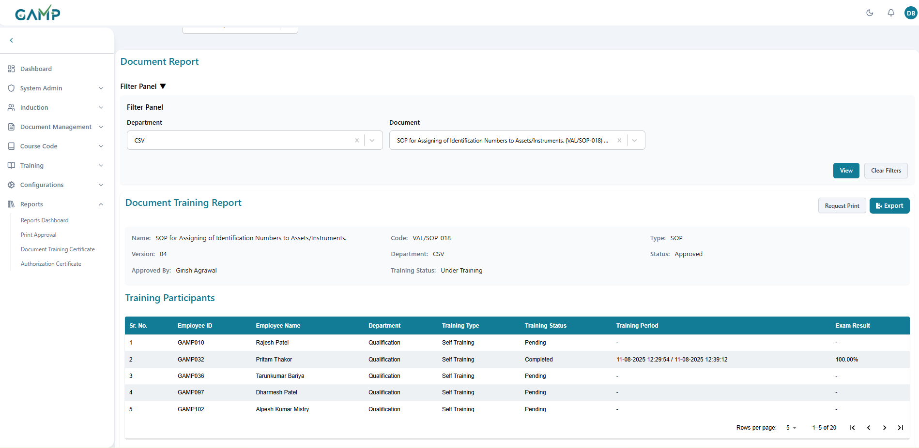

### On-job Training Report

The **On Job Training Report** provides a detailed overview of training conducted directly on equipment, processes, or tasks at the workplace. It helps administrators and managers evaluate trainee participation, trainer performance, and activity-level results.

**Step 1: Access On Job Training Report**

1. Navigate to **Reports Dashboard**.
2. From the **Type of Report** dropdown, select **On Job Training Report**.

**Step 2: Configure On Job Training Filters**

1. **Department** – Select the department under which the on-job training was conducted.
2. **On Job Training** – Choose the specific OJT title/code (e.g., *Particle Counter Machine 002*).
3. **Date Range** – Define the training period.
   * **From Date**: Select the start date.
   * **To Date**: Select the end date.

Click **View** to generate the report.

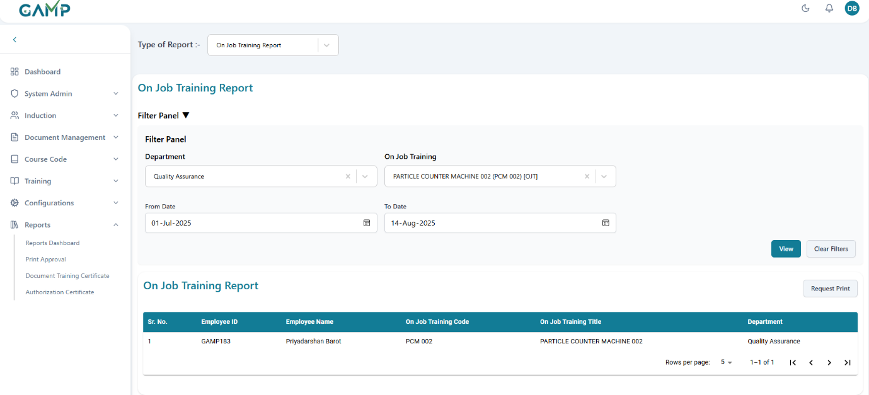

**Step 3: Review On Job Training Report (Summary View)**

The summary table lists employees who participated in the selected OJT program.

It includes:

* **Sr. No.** – Sequential record number.
* **Employee ID** – Unique trainee identifier.
* **Employee Name** – Name of the trainee.
* **On Job Training Code** – OJT reference code.
* **On Job Training Title** – Title of the OJT program.
* **Department** – Department of the trainee.

**Step 4: Review Training Participants (Detailed View)**

Expanding the OJT details displays the **Training Participants** table with deeper insights:

* **Sr. No.** – Sequential number.
* **Employee ID** – Unique identifier of the trainee.
* **Employee Name** – Trainee’s name.
* **Department** – Department to which the trainee belongs.
* **Set Number** – Training set or batch assigned.
* **Activity Number** – Specific training activity within the OJT.
* **Demonstrated By** – Trainer who conducted/demonstrated the activity.
* **Observed By** – Trainer or supervisor who validated the activity.
* **Result** – Outcome of the activity (e.g., Pass/Fail, 1/2 Pass).

**Step 5: Print Report**

* **Request Print** – Generate a print-friendly version of the report.  
    
  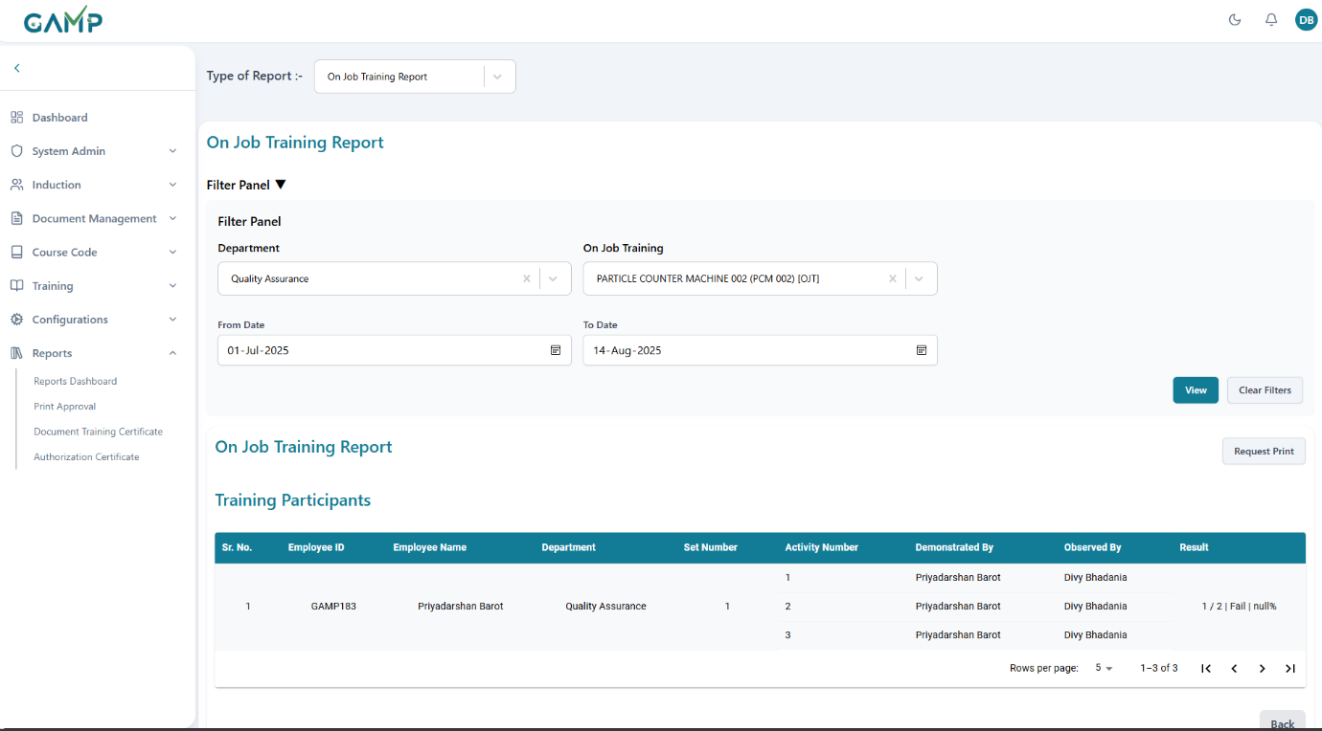  
    
    
  Trainer Report  
  Generate comprehensive reports on trainer activities, qualifications, and performance.

**Step 1: Access Trainer Report**

1. Navigate to Reports Dashboard
2. Select "Trainer Report" from dropdown

**Step 2: Set Filters**

The **Filter Panel** allows filtering of report data to generate specific trainer-wise reports. The following options are available:

* **Department**  
  Select the department to which the trainer belongs.
* **Trainer Name**  
  Choose the trainer(user) from the chosen department whose training report is to be generated.
* **Training Type**
  + **Scheduled** – Select to view reports of planned training sessions.
  + **Unscheduled** – Select to view reports of impromptu or ad-hoc training sessions.
* **Date Range**
  + **From Date**: Define the starting date for the report.
  + **To Date**: Define the end date for the report.

**Step 3:View Report**

After clicking on view button, The **Trainer Trainings** table displays details of training sessions conducted by the selected trainer.

The table includes the following fields:

* **Sr. No.** – Serial number of the record.
* **Training Title** – Name or subject of the training program.
* **Training Type** – Indicates whether the training was scheduled or unscheduled.
* **Document Name** – Name of the training material/document used.
* **Document Code** – Reference code for the training document.
* **Training Date** – Date when the training was conducted.
* **Total Participants** – Number of trainees who attended the session.
* **Passed Participants** – Number of trainees who successfully passed the training assessment/exam.

### User Activity Report

Monitor and report on specific user system activities, login patterns, and electronic signature activities within a defined date range.

**Step 1: Access User Activity Report**

1. Navigate to Reports Dashboard (accessible from left sidebar under "Reports")
2. Select "User Activity Report" from the Type of Report dropdown

**Step 2: Configure Filter Panel (All Fields Mandatory)**

**Filter Panel Requirements:**

1. **User Name** (Required):
   * Search and select a specific user.
   * This field is mandatory - you cannot generate report without selecting a user
   * Only one user can be selected at a time
2. **Start Date (Required):**

* Click on the **Start Date** field
* Select the beginning date for activity analysis (e.g., 16-07-2025)
* This field is mandatory for generating the report
* Format: **DD-MM-YYYY** with date picker

1. **End Date (Required):**

* Click on the **End Date** field
* Select the ending date for activity analysis (e.g., 17-08-2025)
* This field is mandatory for generating the report
* Must be after or equal to **Start Date**
* Format: DD-**MM-YYYY** with date picker

**Step 3: Generate User Activity Report**

1. Click **"View"** button to generate the activity report
2. System validates the date range and user selection
3. User activity data loads in the table below

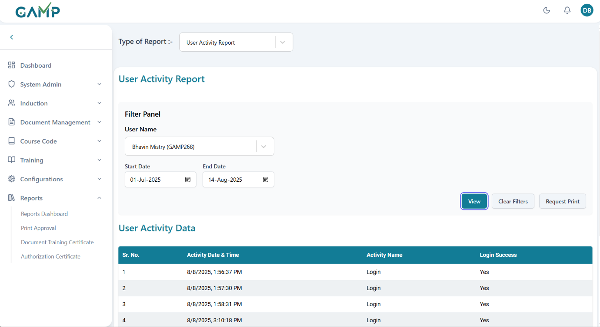

**Step 4: Review User Activity Data**

The User Activity Data table displays:

**Column Headers:**

* **Sr. No.**
* **Activity Date & Time**: Exact timestamp of the activity
* **Activity Name**: Type of system activity performed
* **Login Success**: Whether the activity was successful (Yes/No)

**Activity Types Shown:**

* **Login**: User login activities
* **ESign**: Electronic signature activities

### Trainee Report

Generate detailed reports on trainee progress, assignments, and completion status.

**Step 1: Access Trainee Report**

1. Navigate to Reports Dashboard
2. Select "Trainee Report" from dropdown

**Step 2: Configure Trainee Filters**

1. **Department**: Select department for trainee analysis
2. **User**: Select specific trainee from that department
3. **Training Type**: Filter by training category
   * Scheduled Training
   * Unscheduled Training
   * Self Reading
4. **Date Range**: Set analysis period
   * Start Date: Report period beginning
   * End Date: Report period end

**Step 3: Generate Trainee Report**

1. Configure all relevant filters
2. Click **"View Trainee Report"** button
3. Trainee data loads with progress details

**Step 4: Review Trainee Data**

The trainee report displays:

* **Sl. No.** – Serial number of the training record.
* **Training Title** – Title of the training material or document (e.g., SOP reference).
* **Training Type** – Category of training (e.g., Self Reading).
* **Trainer Name** – Displays the trainer’s name (if applicable).
* **Training Date** – Date on which the training was conducted.
* **Exam Result** – Shows trainee’s performance in the associated exam, including:
* Status (Pending, Pass, Fail)
* Score (e.g., 2/2 | Pass | 100%)

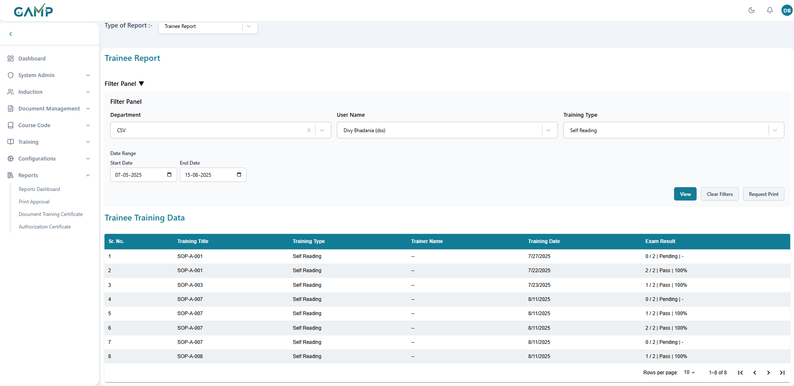  
  
  
Job Responsibility Report

Generate detailed reports on individual user job responsibilities, role definitions, and competency requirements by department and user selection.

**Step 1: Access Job Responsibility Report**

1. Navigate to Reports Dashboard
2. Select "Job Responsibility Report" from the Type of Report dropdown

**Step 2: Configure Filter Panel**

1. **Department Selection** (Required):
   * Click on the Department dropdown
   * Search and firstly select the target department (e.g., "Quality Assurance")
2. **User Name Selection** (Required):
   * After selecting department, the User Name dropdown becomes available
   * Select a specific user from the chosen department (e.g., "Yash Vasava (GAMP185)")
   * Only users from the selected department will be available

**Step 3: Generate Job Responsibility Report**

1. Ensure both Department and User Name are selected
2. Click **"View"** button to generate the report
3. User's job responsibility data will load below

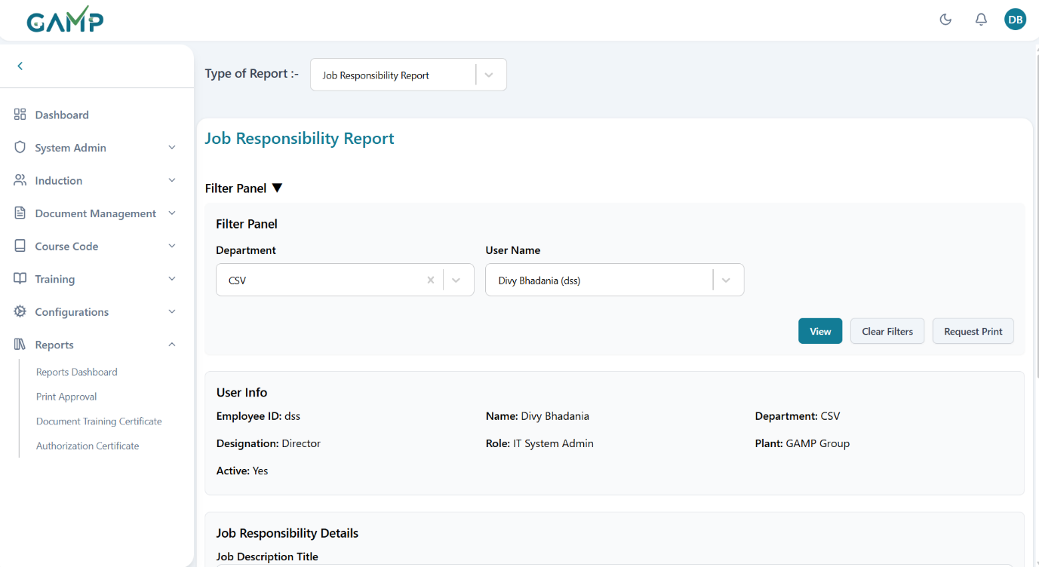

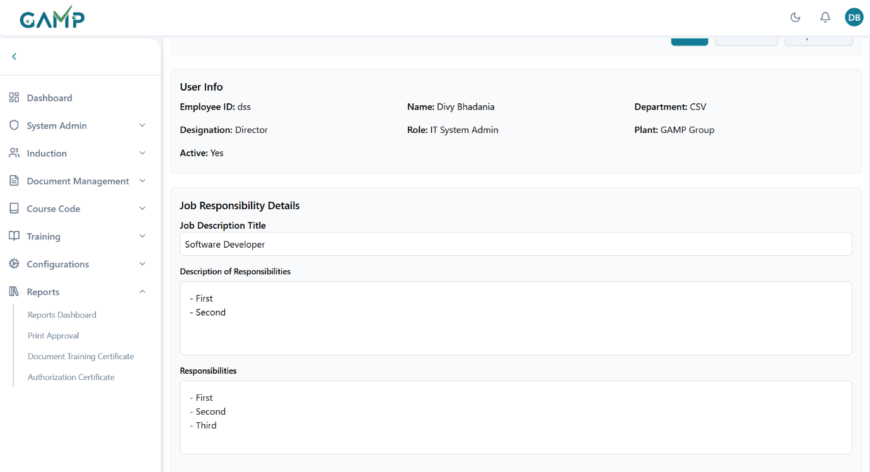

**Step 4: Review User Information**

The report displays comprehensive user details:

**User Info Section:**

* **Employee ID**: User's employee identifier
* **Name**: Full user name
* **Department**: Selected department
* **Designation**: User's job title
* **Role**: System role assignment
* **Plant**: Assigned plant/facility
* **Active**: Current status

**Step 5: Review Job Responsibility**

The report shows detailed job responsibility information:

**Job Responsibility Details Section:**

1. **Job Description Title**:
   * Shows the formal job title
   * May display as "-" if not configured
2. **Description of Responsibilities**:
   * Large text area showing detailed job responsibilities
   * Lists all duties and obligations for the role
   * May be empty if not yet configured
3. **Responsibilities**:
   * Additional detailed listing of specific responsibilities
   * Comprehensive breakdown of job duties
   * Role-specific requirements and expectations

## Print Approval

**Step 1:**Log in to the **TMS** system. Navigate to the main dashboard and in left sidebar menu, click on **Reports → Print Approval**

Page loads with two main tabs: "**Under Review**" and "**Approved**"

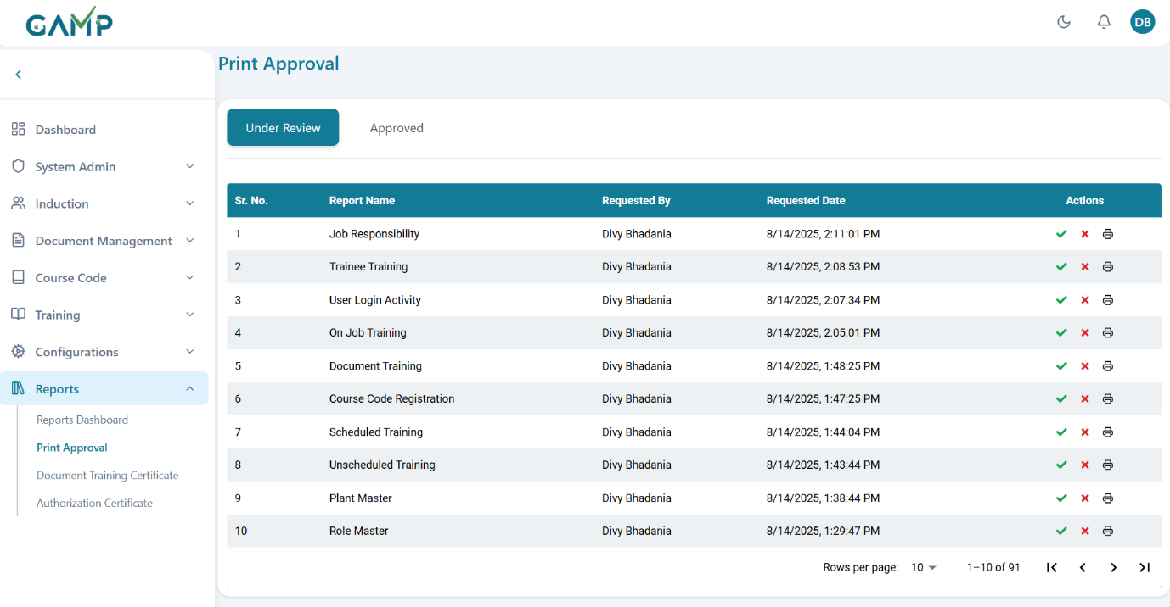

**Step 2: Understanding Print Approval Interface**

**Tab Structure:**

* **Under Review Tab:** Shows pending print requests awaiting approval
* **Approved Tab:** Shows already approved print requests

**Table Columns**

* **Report Name:** Type of report requested for printing
* **Request By:** User who requested the print
* **Requested Date:** Date and time of print request
* **Approved By: Approved tab only)** User who approved the request
* **Approved Date: (Approved tab only)** Date and time of approval
* **Actions:** Available actions (Approve/Reject/Print)

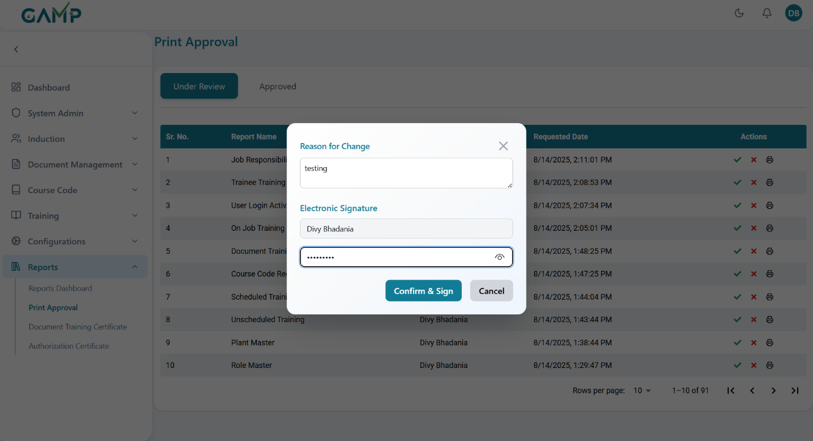

**Step 3: Managing Print Requests (Under Review)**

**1. Approve Print Request**

* + Click the **Green Check (✔)** icon to approve the **print request**.
  + The **Electronic Signature** pop-up will appear:
    1. Enter the approval remarks in the reason for change input field.
    2. The **Username** is auto-fetched.
    3. Enter your **Password** to authenticate the action.
  + If the password is incorrect, the system prompts for re-entry until correct.
  + Upon successful authentication, a confirmation message appears.
  + Once approved, the **Print Request** moves to the Approved Tab and then one can print the approved report there

1. **Reject Print Request**
   * Click the **Red Cross (✖)** icon to reject the document.
   * The **Electronic Signature** pop-up will appear:
     1. Enter the rejection remarks (why it is rejected**)** in the reason for change input field.
     2. The **Username** is auto-fetched.
     3. Enter your **Password** to authenticate the action.
   * If the password is incorrect, the system prompts for re-entry until correct.
   * Upon successful authentication, a confirmation message appears.
   * The **print request** will be removed from the system and no further transactions can be done with that.

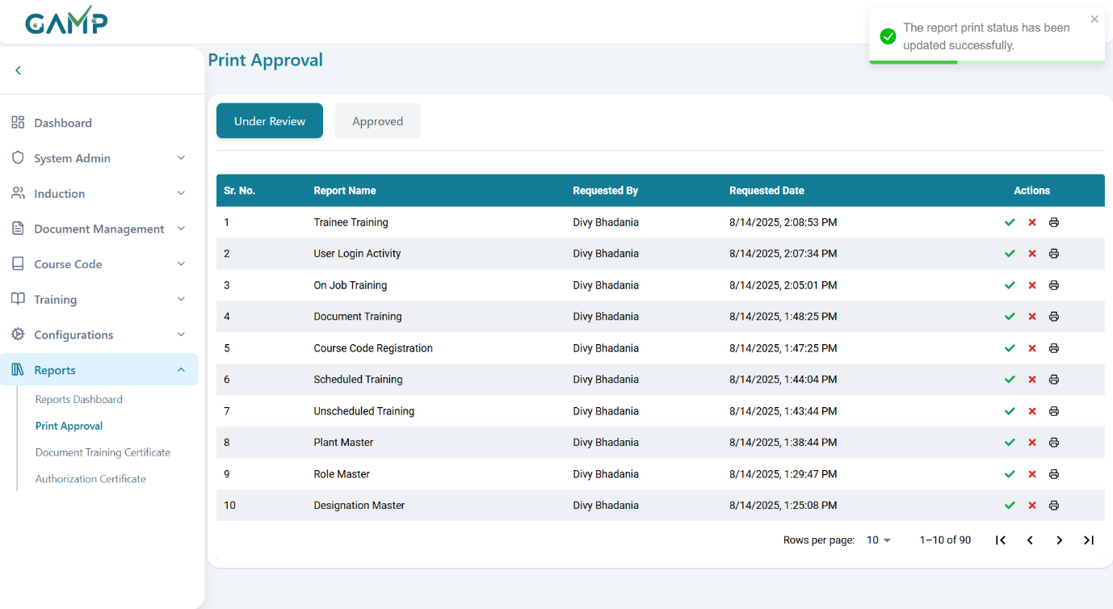

1. **Print Process:**

* **Available for:** Both Under Review and Approved requests
* **Click Print Button:** Printer icon in actions column.

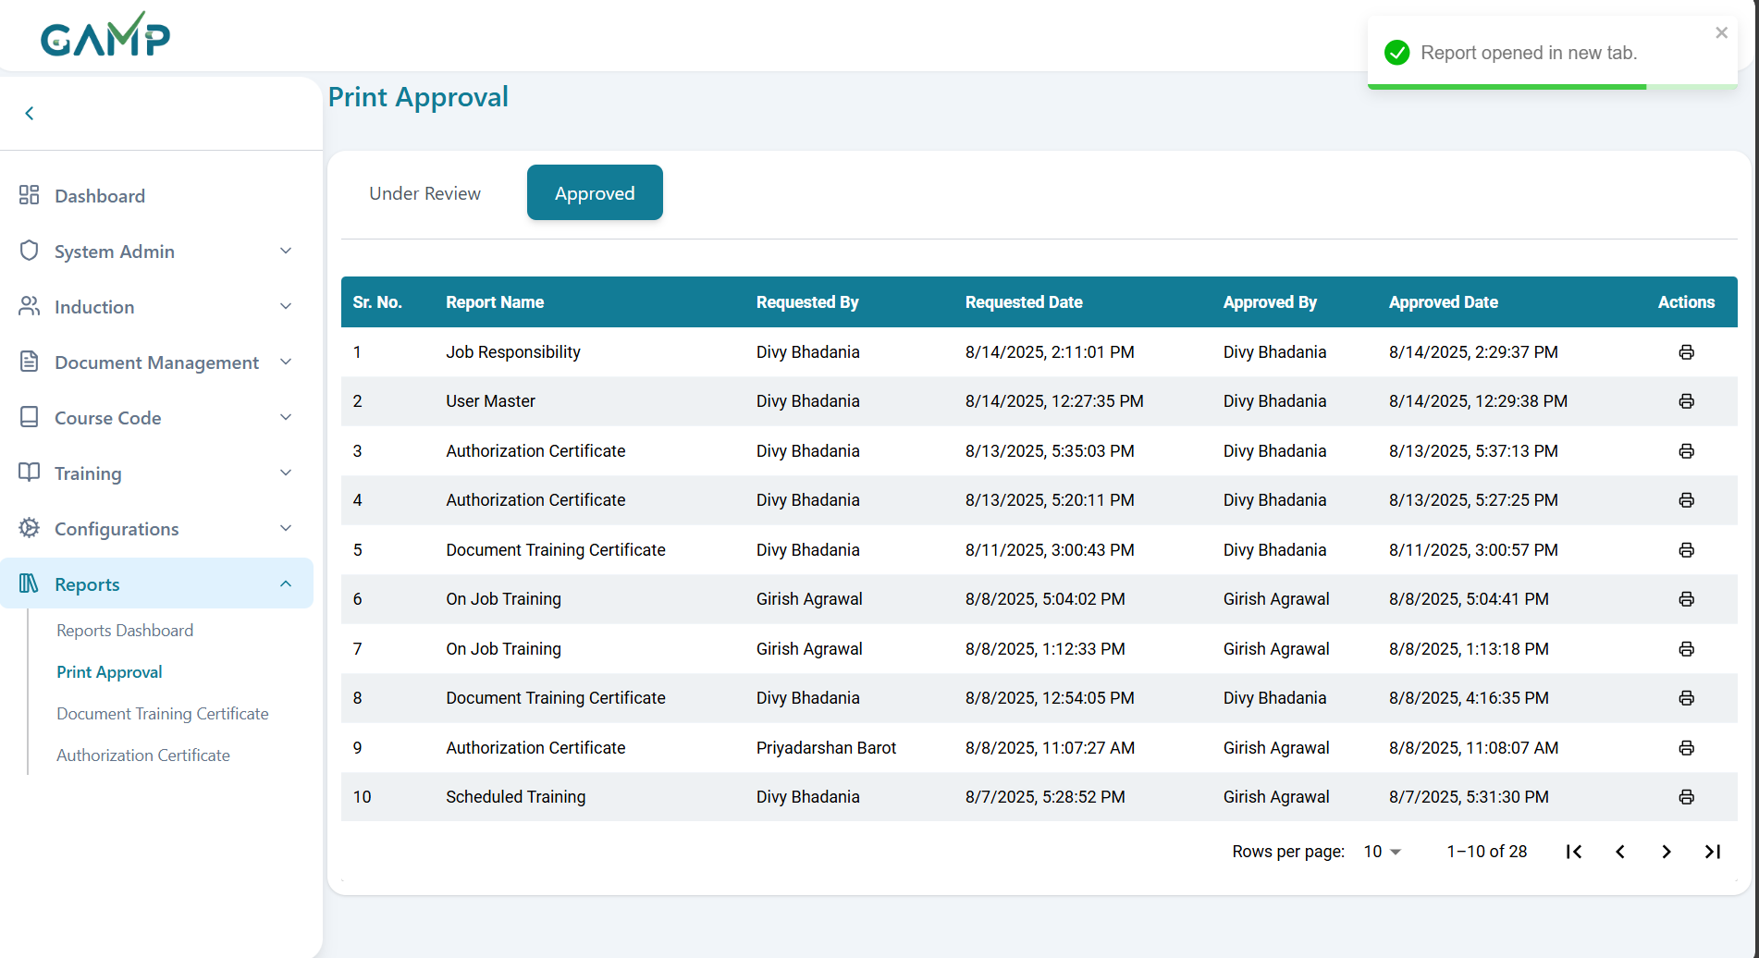

* Generates PDF based on report type in a new browser tab

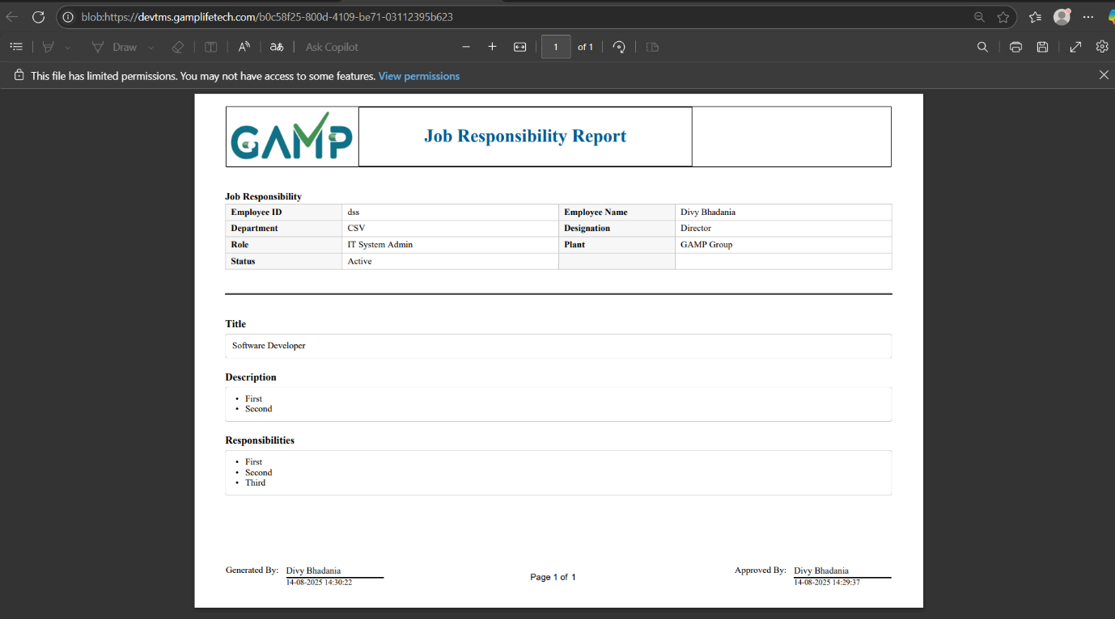  
  
Document Training Certificate

Generate training certificates for document-based training completion

**Step 1:**Log in to the **TMS** system. Navigate to the main dashboard and in left sidebar menu, click on **Reports → Document Training Certificate**

**Step 2: Apply Filters**

Use the available filters to search for training records:

* + **Department** – Select the department of the trainee
  + **Document** – Choose a document from the list of the docs of the chosen department.

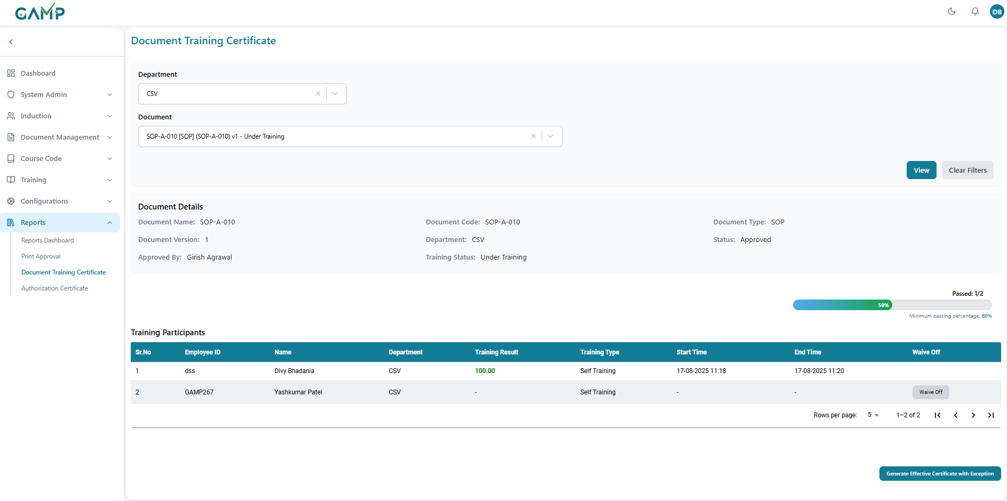

**Step 3:View Report**

Click **View** to display the filtered report / certificate. It contains the following

**1. Document Details Section:**

* **Document Name:** Full document title
* **Document Code:** Unique document identifier
* **Document Type:** SOP, Policy, Procedure, etc.
* **Document Version:** Current version number
* **Department:** Owning department
* **Status:** Document effectiveness status
* **Approved By:** Document approver
* **Training Status:** Overall training completion status

**Training Statistics:**

* **Total Trainee:** Shows total assigned participants (e.g., 1)
* **Qualified Trainee:** Shows passed participants (e.g., 1)
* **Required Qualified Percentage:** Minimum pass rate (e.g., 40.00%)
* **Current Qualified Percentage:** Actual pass rate (e.g., 100.00%)

**3. Participant Table Columns:**

* **Sr. No**
* **Employee ID** -Unique employee identifier
* **Name Full –** full employee name
* **Department -** Employee's department
* **Training Result -**Pass/Fail status
* **Training Type-** Self/Schedule/OJT training
* **Start Time -** Training start timestamp
* **End Time -**Training completion timestamp
* **Waive Off -** Waiver status

**Training Result Interpretation:**

* **Numeric Value (e.g., 100.00):**Participant passed with score
* **Dash (-):**Training not completed or failed
* Empty: No training attempt recorded

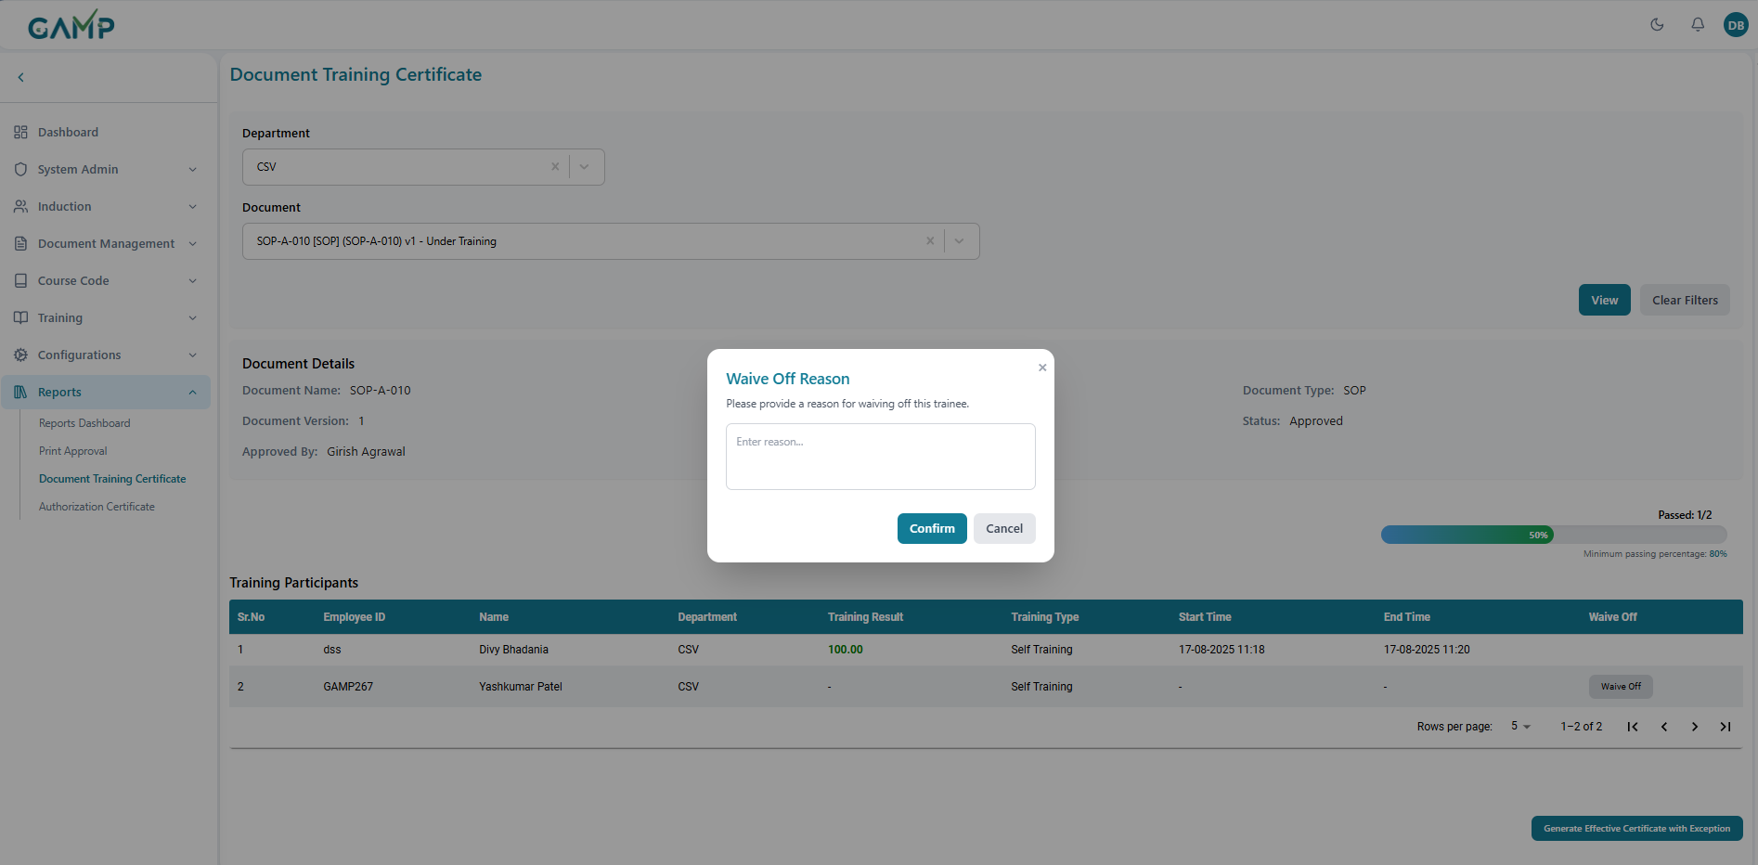

**4. Waive Off Process:**

1. **Identify Failed Participant:**Look for participants with "-" or ones not active
2. **Click Waive Off Button:(**Available for failed participants)
3. **Waive Off Modal** opens with manual input to enter detailed justification
4. **Enter Reason:** Type comprehensive justification in text area
5. **Confirm Button:**Submit waiver (enabled only when reason provided)
6. **Cancel Button:**Close modal without saving

**Waive Off Rules**

* **Mandatory Reason:**Cannot waive without providing justification
* **Permanent Action:**Waive off cannot be easily undone
* **Certificate Impact:**Waived participants included in certificate

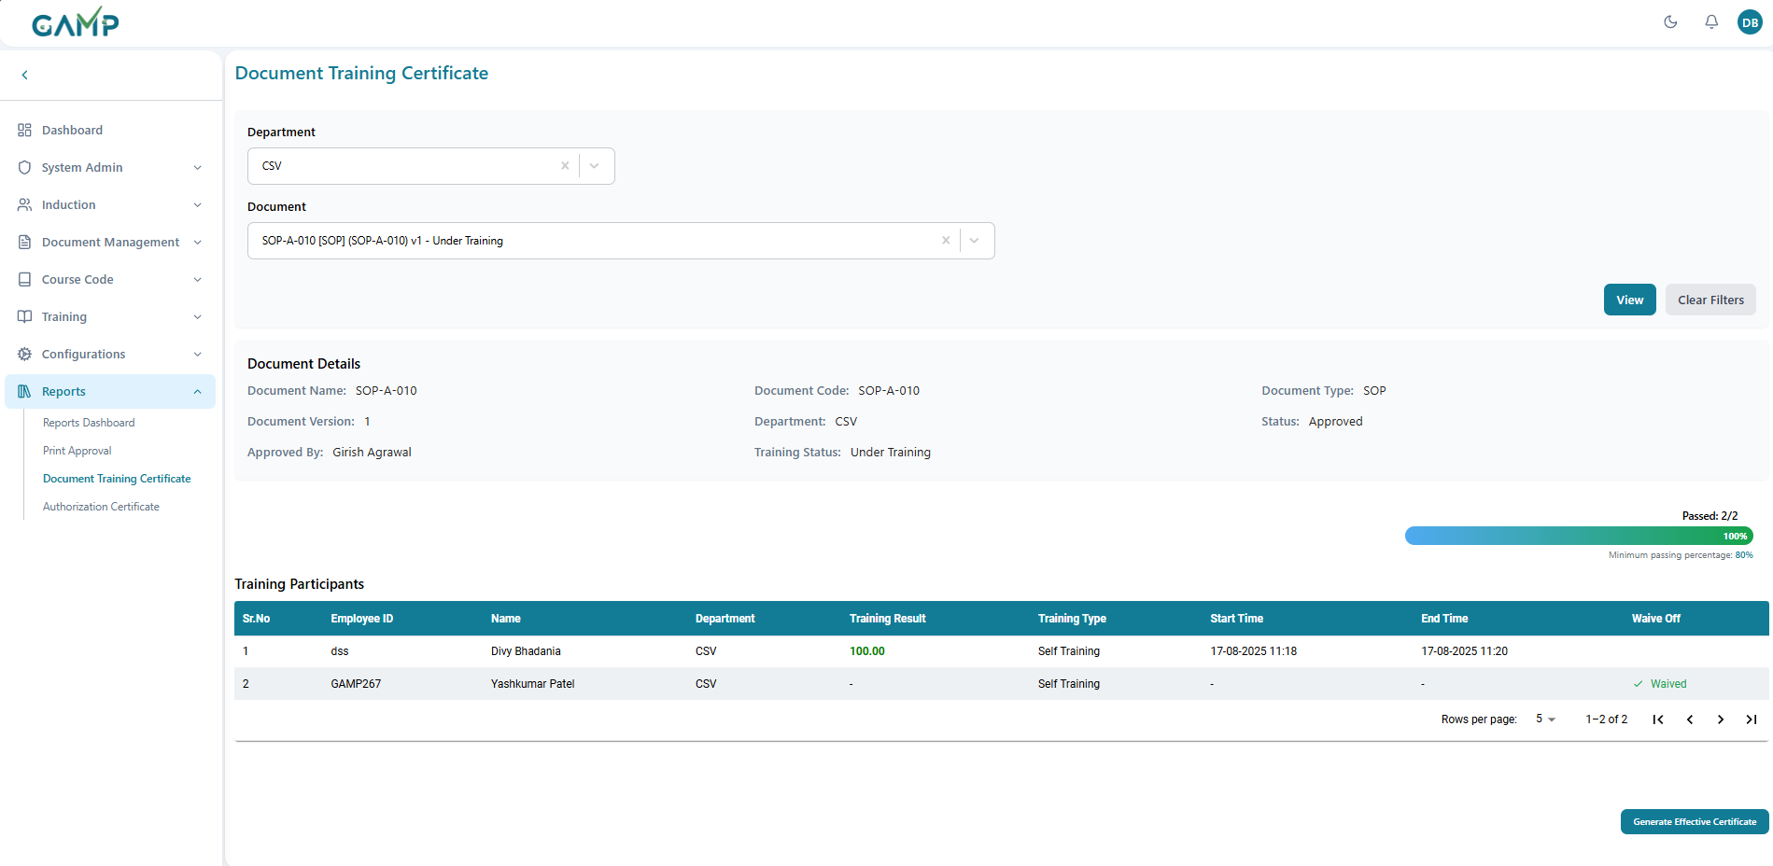

**5. Progress Bar Analysis**

The progress bar shows training completion status:

**Progress Display Elements:**

* **Passed Count:**"Passed: 1/2" (example)
* **Visual Bar:**Color-coded progress indicator
* **Percentage:**Calculated completion rate
* **Minimum Threshold:**Minimum passing percentage: 40%"

**Colour Coding:**

* **Green:**Good progress, above minimum threshold
* **Yellow:**Approaching minimum, needs attention
* **Red:**Below minimum, cannot generate certificate without exceptions

**Step 4: Certificate Generation Steps:**

1. **Check Eligibility:**System validates minimum pass rate
2. **Handle Exceptions:**Address failed participants
3. **Electronic Signature:**Provide authorization credentials
4. **Generate PDF:**Create official certificate document

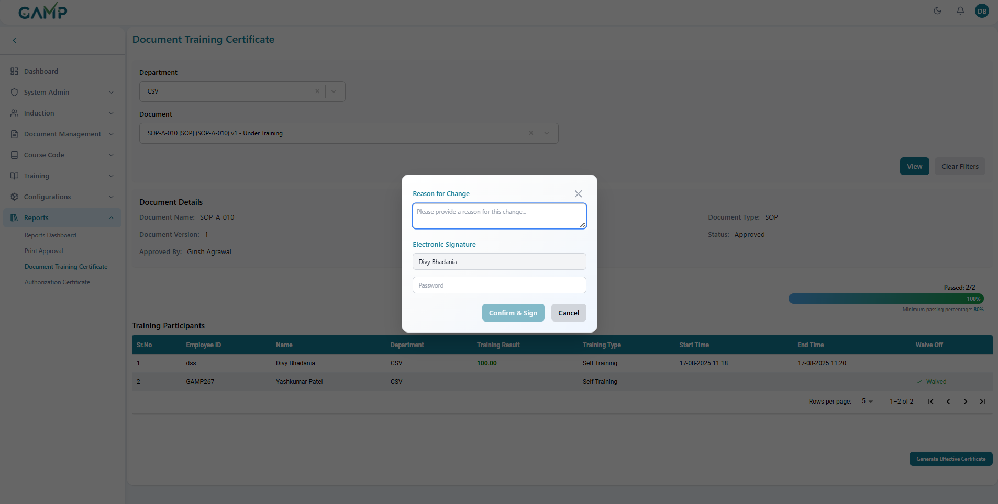

**Step 5: Print Approval**

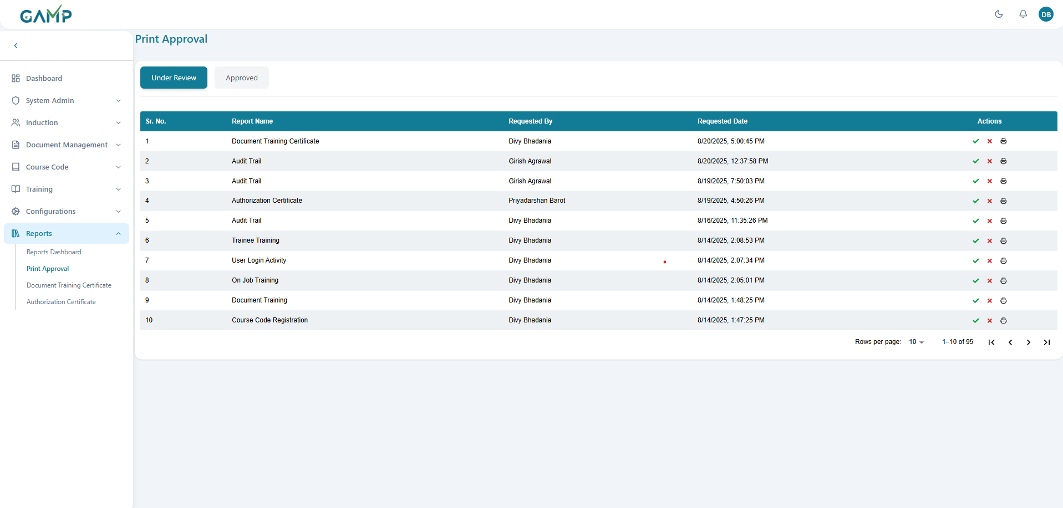

* Request goes to **Print Approval screen**
* Navigate to **Reports → Print Approval**.
* The screen displays two tabs:
  + **Under Review** – All pending print requests are shown here.
  + **Approved** – All requests approved by an authorized person are listed here.

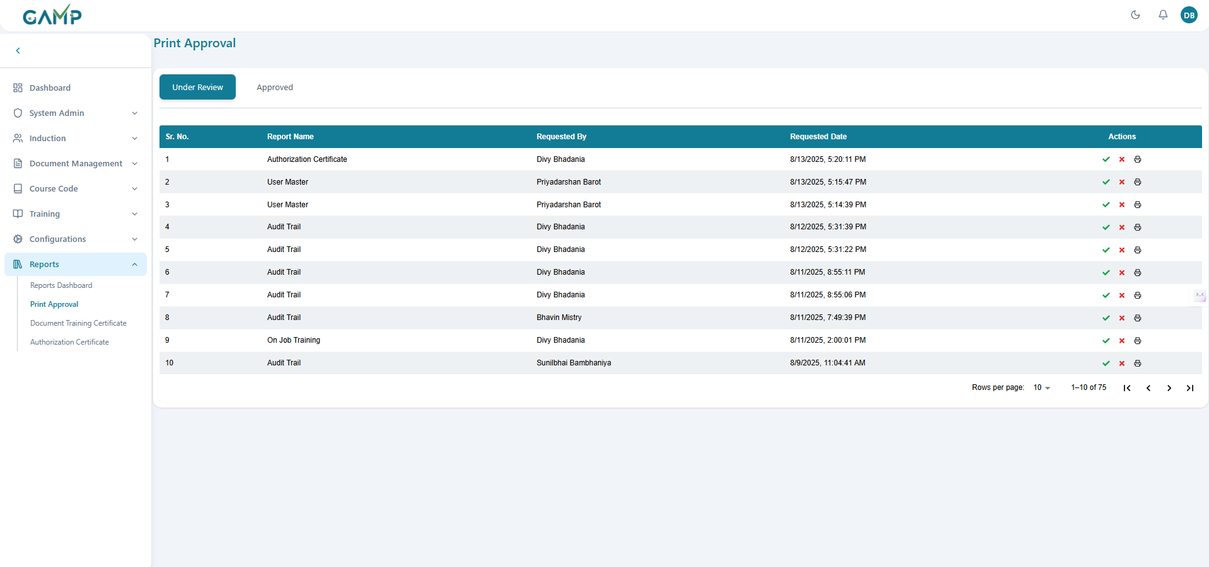

* Details such as **Report Name, Requested By, Requested Date** are displayed.
* The approver reviews the request and takes action:
  + **✔ Approve** – If the details are correct.
  + **✖ Reject** – If the request is invalid or incorrect.
  + **Print –** View the certificate without being approved**(***i.e the sign of approver will not be there*)
* Once approved, the request automatically moves to the **Approved** tab.

**Step 5: Certificate Generation**

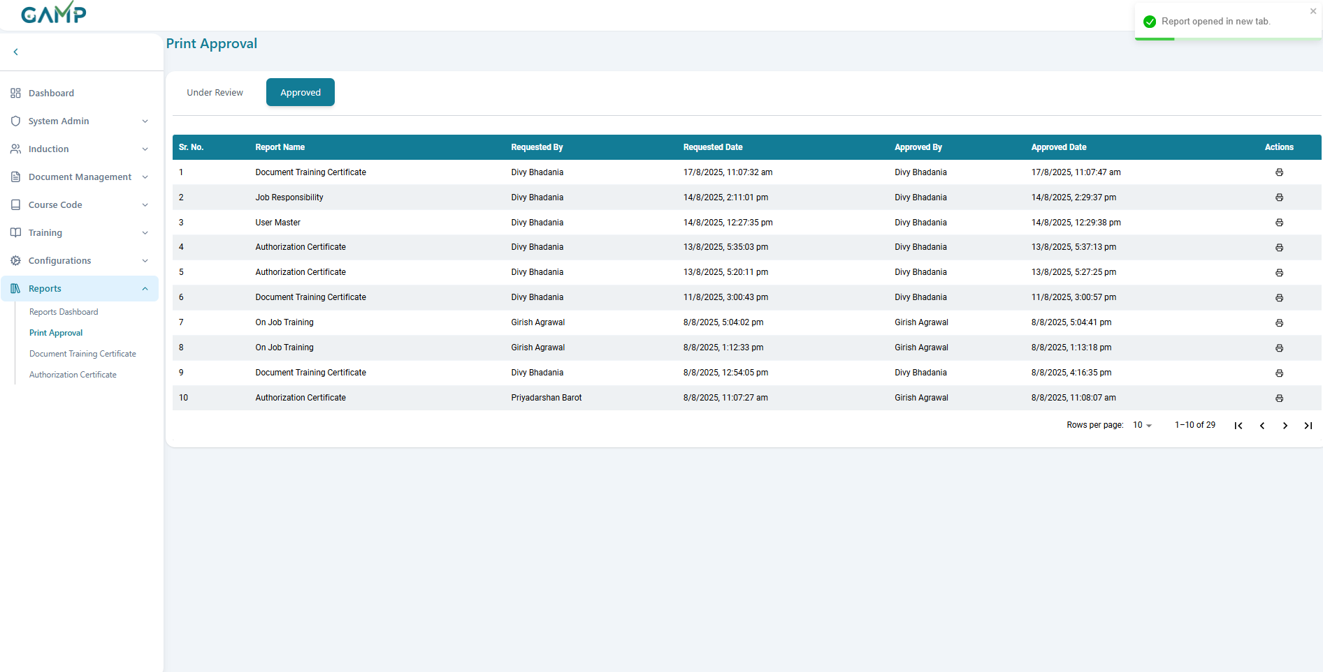

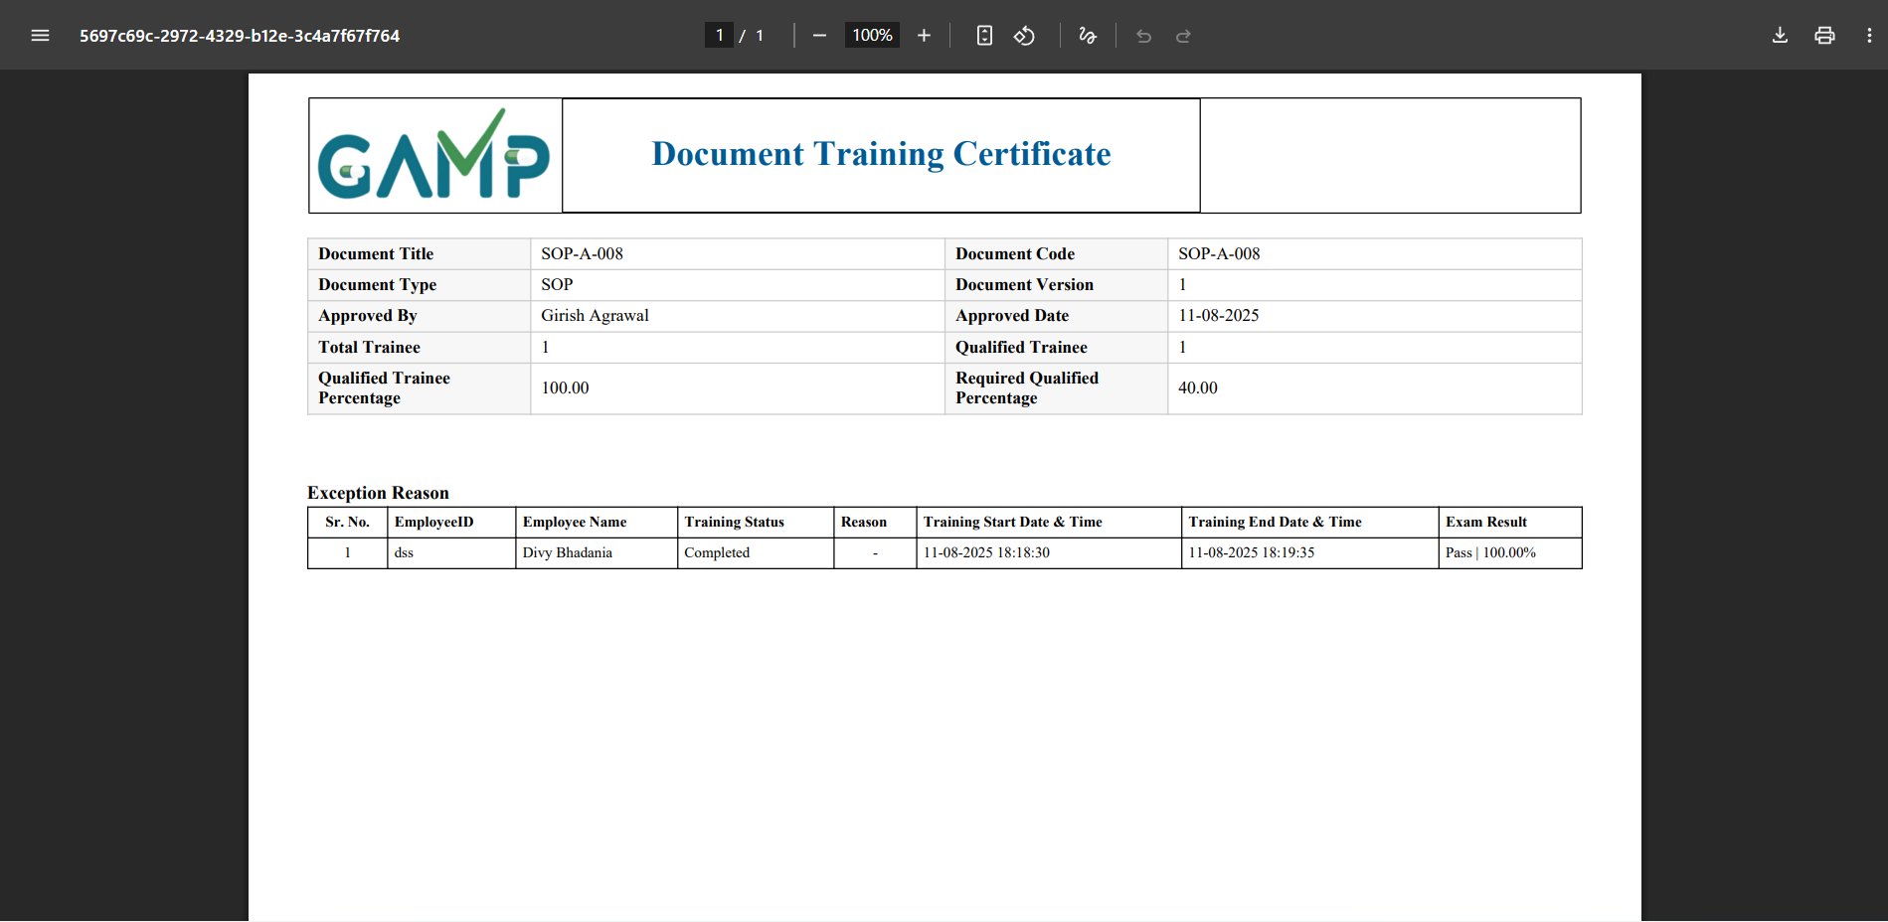

* In the **Approved tab**, when clicking on the **Print** icon, the system generates the **Authorization Certificate** with a**pproval signature and corresponding date and time**.
* The certificate includes:
  + **Document Title and Type**
  + **Document Code and Version**
  + **Total Trainee and Approved by**
  + **Qualified Trainee**
  + **Qualified Trainee percentage**
  + **Required Qualified percentage**
  + **Approved Date**
  + **Authorized By details**
  + **Official Certificate Seal/Stamp**



## Authorization Certificate

The Authorization Certificate is issued to users who have successfully completed course code training under the Training Management System (TMS).

**Step 1:** Log in to the **TMS system**. Navigate to the main **dashboard** and in left sidebar menu, click on **Reports → Authorization Certificate**.

**Step 2: Apply Filters**

Use the available filters to search for training records:

* + **Department** – Select the department of the trainee
  + **User** – Choose the trainee’s name from the list of the users of the chosen department.
  + **Course Code** – The course code for which user wants to generate the certificate

**Step 3:View Report**

* Click **View** to display the filtered report / certificate.It contains the following

**User Information Display:**

* **Employee ID:**
* **Name:** Full name of the user
* **Department:**  department of the user
* **Designation:** Job title/position
* **Role:** Role which is assigned to that user
* **Plant:** Belonging to that physical location
* **Active Status:** Yes/No

**Authorization Training Grid has**

* **Id:**
* **Code:** Code of the document
* **Name:** Name of the document
* **Type:** Document type (WI/protocol/SO)
* **Training Status:** Yes/No completion status
* **Training Result: (%)** Percentage score achieved

**Authorization Criteria:**

* **All Training Completed:**User must complete all required training
* **Passing Scores:**Must achieve minimum required scores
* **Current Status:**All training must be up-to-date
* **No Pending Items:**No incomplete training remaining

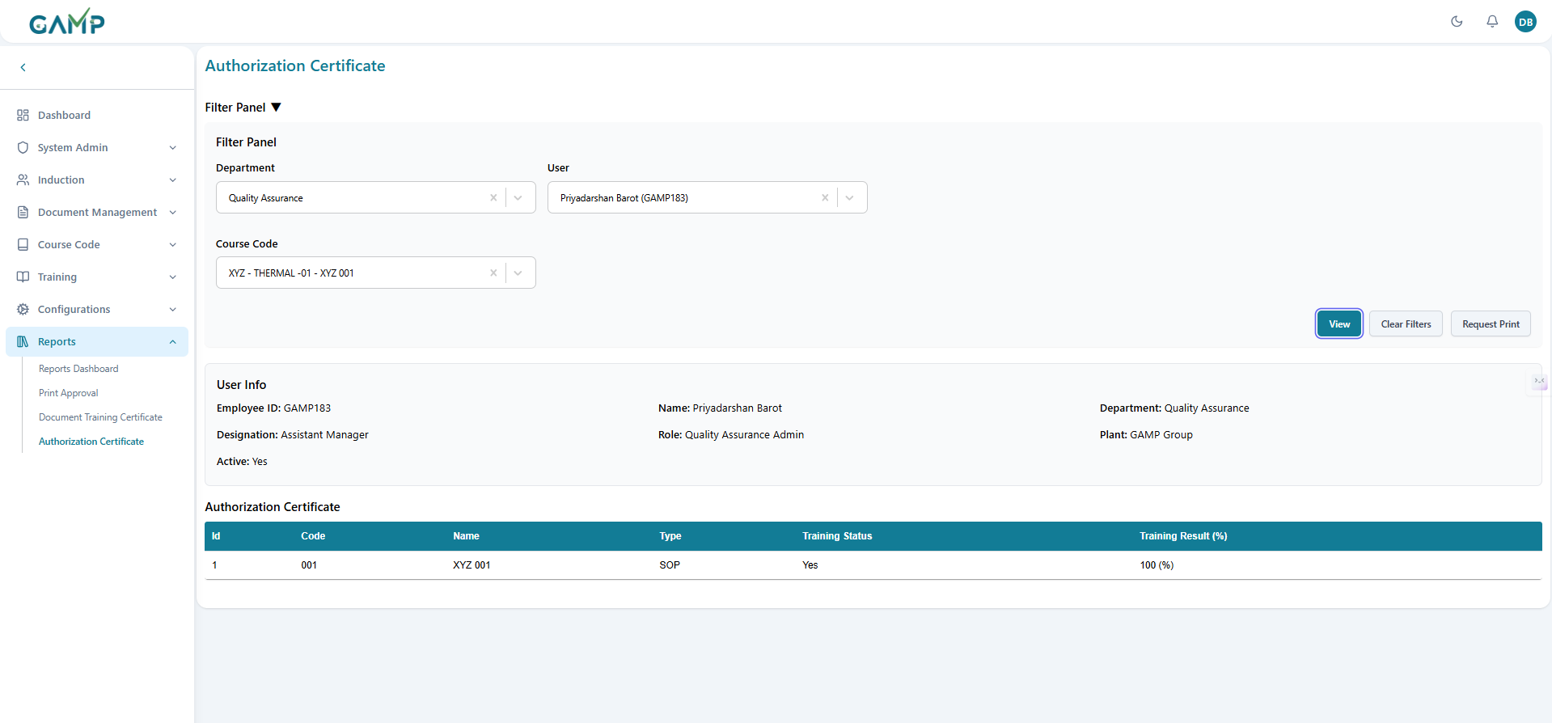

**Step 4: Print Approval**

* **Click Request Print** and request goes to **Print Approval screen**
* Navigate to **Reports → Print Approval**.
* The screen displays two tabs:
  + **Under Review** – All pending print requests are shown here.
  + **Approved** – All requests approved by an authorized person are listed here.



* Details such as **Report Name, Requested By, Requested Date** are displayed.
* The approver reviews the request and takes action:
  + **✔ Approve** – If the details are correct.
  + **✖ Reject** – If the request is invalid or incorrect.
  + **Print –** View the certificate without being approved**(***i.e the sign of approver will not be there*)

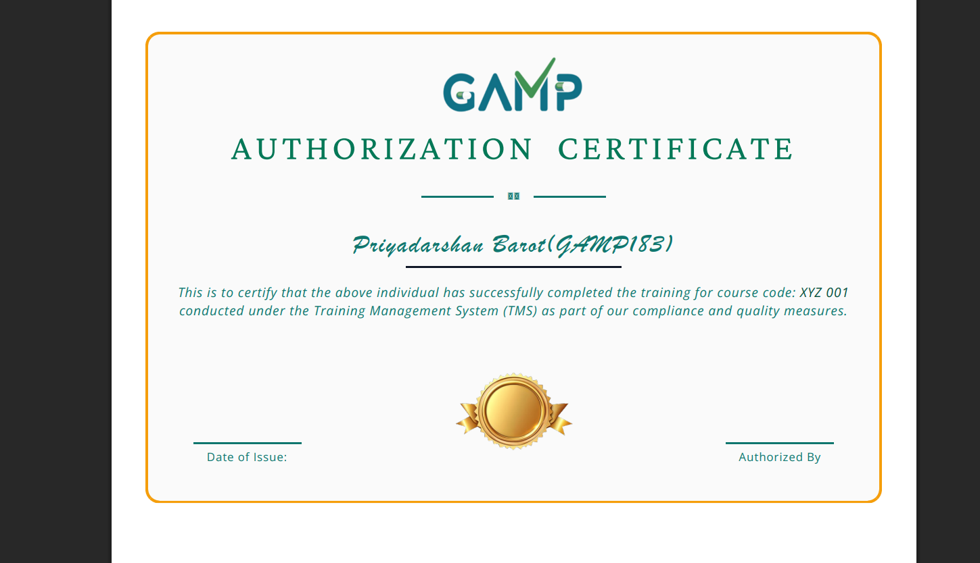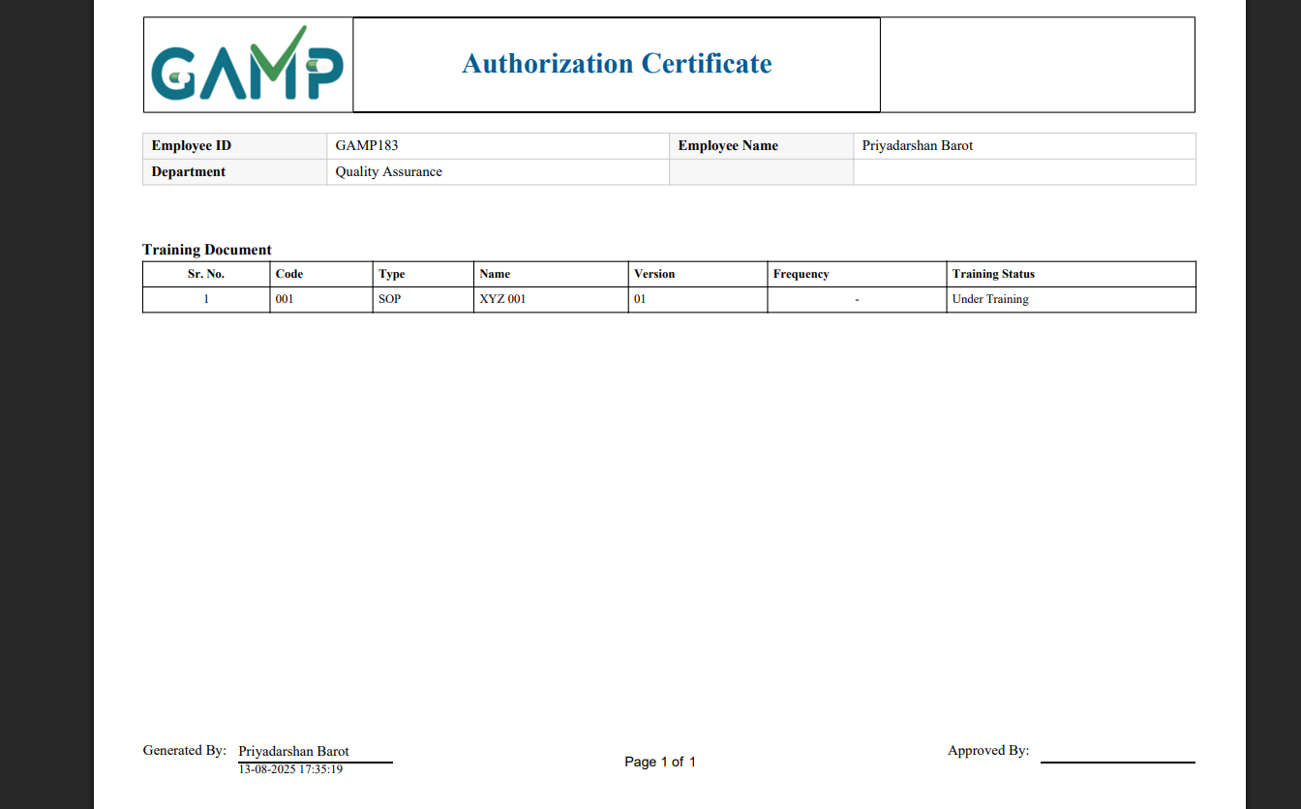

* Once approved, the request automatically moves to the **Approved** tab.

**Step 5: Certificate Generation**

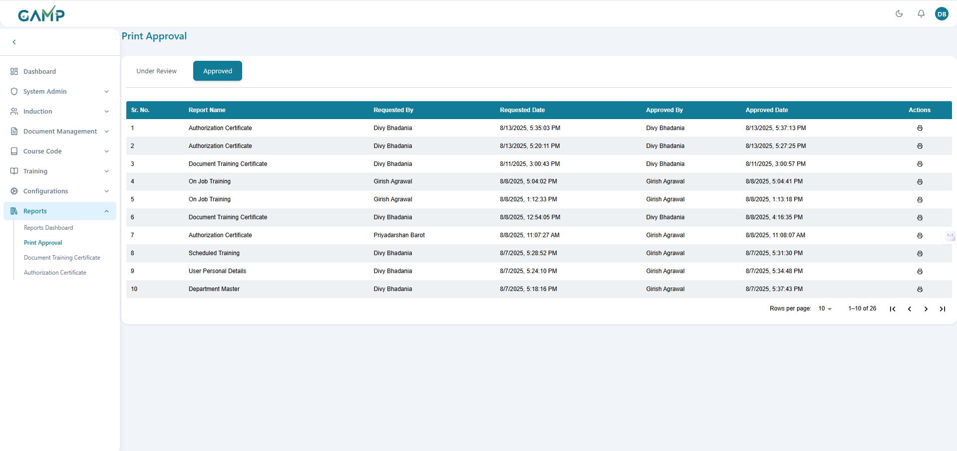

* In the **Approved tab**, when clicking on the **Print** icon,the system generates the **Authorization Certificate** with a**pproval signature and corresponding date and time**.
* The certificate includes:
  + **Trainee’s Name and ID**
  + **Training Title and Course Code**
  + **Date of Issue**
  + **Authorized By details**
  + **Official Certificate Seal/Stamp**

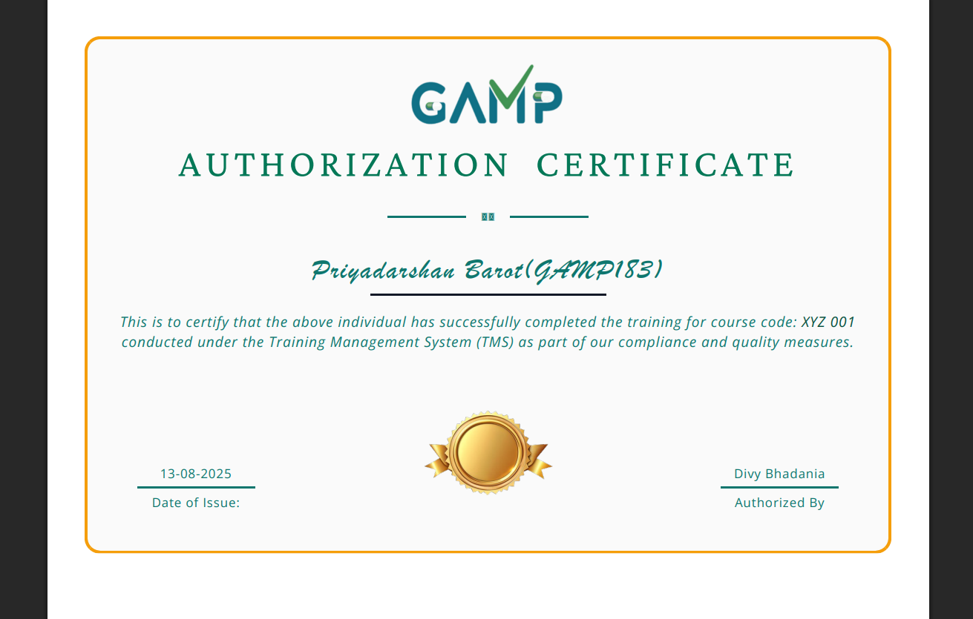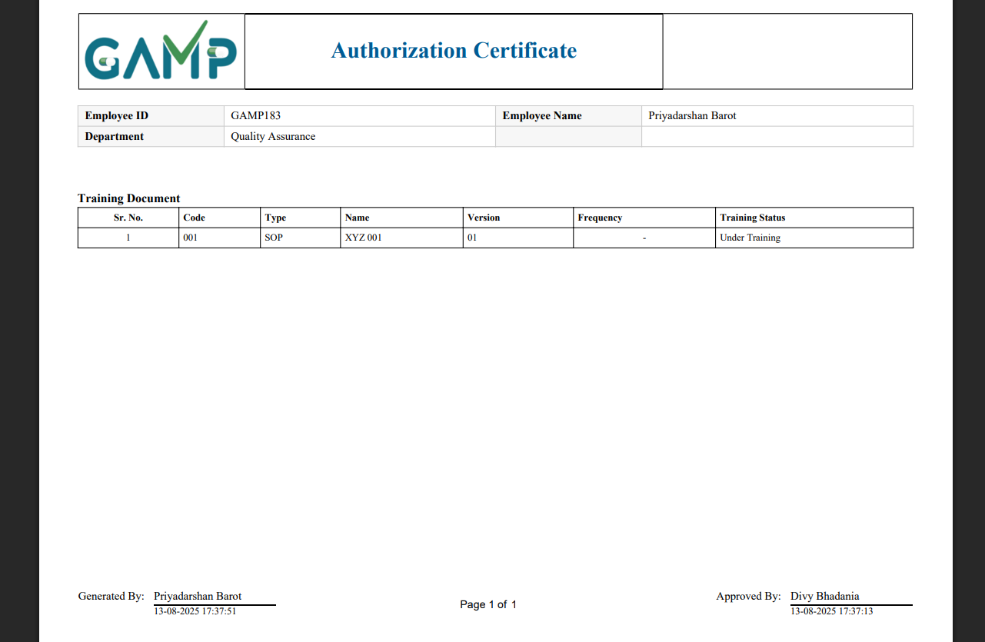

**Step 6: Printing and Downloading**

* Once generated, the certificate can be printed or downloaded.
* Click on **Print/Download** to obtain the final copy of the Authorization Certificate.
* Of course, here is a classification of the messages in the DomainConstants.cs file into success, error, and warning categories, along with their meanings.

# Toast Notifications

Various messages are shown in the interface whenever some transactions are successful/failed or showing some error messages. They are classified as-

### Success Messages

|  |  |
| --- | --- |
| **Message** | **Meaning** |
| Login successful. | The user has successfully logged into the system. |
| The password has been updated successfully. | The user's password has been successfully changed. |
| The user has been created successfully. | A new user account has been successfully created in the system. |
| The user information has been updated successfully. | The information for an existing user has been successfully updated. |
| The user information has been fetched successfully. | The system has successfully retrieved the requested user's information. |
| The user has been deactivated successfully. | The specified user account has been successfully deactivated. |
| The configuration has been created successfully. | A new configuration setting has been successfully created. |
| The configuration has been updated successfully. | An existing configuration setting has been successfully updated. |
| Configuration data has been fetched successfully. | The system has successfully retrieved configuration data. |
| The department has been created successfully. | A new department has been successfully created. |
| Department information has been updated successfully. | The information for an existing department has been successfully updated. |
| Department information has been fetched successfully. | The system has successfully retrieved department information. |
| The department has been deactivated successfully. | The specified department has been successfully deactivated. |
| The designation has been created successfully. | A new designation has been successfully created. |
| Designation information has been updated successfully. | The information for an existing designation has been successfully updated. |
| Designation information has been fetched successfully. | The system has successfully retrieved designation information. |
| The designation has been deactivated successfully. | The specified designation has been successfully deactivated. |
| The plant has been created successfully. | A new plant has been successfully created. |
| Plant information has been updated successfully. | The information for an existing plant has been successfully updated. |
| Plant information has been fetched successfully. | The system has successfully retrieved plant information. |
| The plant has been deactivated successfully. | The specified plant has been successfully deactivated. |
| The role has been created successfully. | A new role has been successfully created. |
| Role information has been updated successfully. | The information for an existing role has been successfully updated. |
| Role information has been fetched successfully. | The system has successfully retrieved role information. |
| The role has been deactivated successfully. | The specified role has been successfully deactivated. |
| The password reset request has been created successfully. | A request to reset the user's password has been successfully initiated. |
| Password reset information has been fetched successfully. | The system has successfully retrieved information related to a password reset request. |
| The role assignment has been created successfully. | A role has been successfully assigned to a user. |
| The role assignment has been updated successfully. | An existing role assignment has been successfully updated. |
| Role assignment information has been fetched successfully. | The system has successfully retrieved role assignment information. |
| The role assignment has been deactivated successfully. | A user's role assignment has been successfully deactivated. |
| The plant assignment has been created successfully. | A plant has been successfully assigned to a user. |
| The plant assignment has been updated successfully. | An existing plant assignment has been successfully updated. |
| Plant assignment information has been fetched successfully. | The system has successfully retrieved plant assignment information. |
| The plant assignment has been deactivated successfully. | A user's plant assignment has been successfully deactivated. |
| The induction has been assigned successfully. | An induction has been successfully assigned to a user. |
| The induction assignment has been updated successfully. | An existing induction assignment has been successfully updated. |
| Induction assignment details have been fetched successfully. | The system has successfully retrieved induction assignment details. |
| The induction assignment has been deactivated successfully. | An induction assignment has been successfully deactivated. |
| Available users for induction assignment have been fetched successfully. | The system has successfully retrieved a list of users available for induction assignment. |
| The induction has been signed off successfully. | An induction has been successfully signed off, indicating completion. |
| The job responsibility has been assigned successfully. | A job responsibility has been successfully assigned to a user. |
| The job responsibility assignment has been updated successfully. | An existing job responsibility assignment has been successfully updated. |
| Job responsibility assignments have been fetched successfully. | The system has successfully retrieved job responsibility assignments. |
| The job responsibility assignment has been deactivated successfully. | A job responsibility assignment has been successfully deactivated. |
| Available users for job responsibility assignment have been fetched successfully. | The system has successfully retrieved a list of users available for job responsibility assignment. |
| The communication template has been fetched successfully. | The system has successfully retrieved a communication template. |
| Document types have been fetched successfully. | The system has successfully retrieved a list of available document types. |
| Document statuses have been fetched successfully. | The system has successfully retrieved a list of available document statuses. |
| The document has been deactivated successfully. | The specified document has been successfully deactivated. |
| The document status has been updated successfully. | The status of a document has been successfully updated. |
| The document has been updated successfully. | The specified document has been successfully updated. |
| The document registration has been deactivated successfully. | A document registration has been successfully deactivated. |
| Document information has been fetched successfully. | The system has successfully retrieved information for a document. |
| The document has been created successfully. | A new document has been successfully created. |
| Document effective date updated successfully. | The effective date of a document has been successfully updated. |
| The question preparation has been deactivated successfully. | The question preparation for a document has been successfully deactivated. |
| The question preparation status has been updated successfully. | The status of a question preparation has been successfully updated. |
| The question preparation has been created successfully. | The question preparation for a document has been successfully created. |
| Available documents for question preparation have been fetched successfully. | The system has successfully retrieved a list of documents available for question preparation. |
| Question preparation data has been fetched successfully. | The system has successfully retrieved question preparation data. |
| The question preparation has been updated successfully. | An existing question preparation has been successfully updated. |
| The on the job training has been deactivated successfully. | The On-the-Job Training (OJT) has been successfully deactivated. |
| The on the job training has been created successfully. | A new On-the-Job Training (OJT) has been successfully created. |
| The on the job training has been updated successfully. | An existing On-the-Job Training (OJT) has been successfully updated. |
| The on the job training status has been updated successfully. | The status of an On-the-Job Training (OJT) has been successfully updated. |
| On the job training information has been fetched successfully. | The system has successfully retrieved On-the-Job Training (OJT) information. |
| The course code status has been updated successfully. | The status of a course code has been successfully updated. |
| The course code has been deactivated successfully. | The specified course code has been successfully deactivated. |
| Course code information has been fetched successfully. | The system has successfully retrieved course code information. |
| The course code has been updated successfully. | An existing course code has been successfully updated. |
| The course code has been created successfully. | A new course code has been successfully created. |
| The course code assignment has been created successfully. | A course code has been successfully assigned. |
| The course code assignment has been updated successfully. | An existing course code assignment has been successfully updated. |
| Course code assignments have been fetched successfully. | The system has successfully retrieved course code assignments. |
| The trainer has been registered successfully. | A new trainer has been successfully registered in the system. |
| Trainer details have been updated successfully. | The details of an existing trainer have been successfully updated. |
| The trainer record has been deactivated successfully. | The record of a trainer has been successfully deactivated. |
| The trainer status has been updated successfully. | The status of a trainer has been successfully updated. |
| Trainer information has been fetched successfully. | The system has successfully retrieved trainer information. |
| Self training items have been fetched successfully. | The system has successfully retrieved a list of self-training items. |
| The self training reading session has started successfully. | A self-training reading session has been successfully started for the user. |
| The self training reading session has been saved successfully. | The progress of a self-training reading session has been successfully saved. |
| The self training reading session has been submitted successfully. | A self-training reading session has been successfully submitted for completion. |
| The self training reading session has been stopped successfully. | A self-training reading session has been successfully stopped. |
| The exam preparation has been created successfully. | An exam preparation has been successfully created. |
| The exam has been submitted successfully. | An exam has been successfully submitted. |
| On the job training sessions have been fetched successfully. | The system has successfully retrieved On-the-Job Training (OJT) sessions. |
| Available users for the on the job training session have been fetched successfully. | The system has successfully retrieved a list of users available for an OJT session. |
| The on the job training session time has been updated successfully. | The time for an OJT session has been successfully updated. |
| The on the job training session activity e signature has been updated successfully. | The e-signature for an OJT session activity has been successfully updated. |
| The attachment has been uploaded successfully. | An attachment has been successfully uploaded to an OJT session. |
| The on the job training session attachment has been removed successfully. | An attachment has been successfully removed from an OJT session. |
| On the job training session attachments have been fetched successfully. | The system has successfully retrieved attachments for an OJT session. |
| The yearly planning has been fetched successfully. | The system has successfully retrieved the yearly planning. |
| The yearly plan has been created successfully. | A new yearly plan has been successfully created. |
| The yearly plan has been updated successfully. | An existing yearly plan has been successfully updated. |
| The yearly calendar entry has been removed successfully. | An entry in the yearly calendar has been successfully removed. |
| Pending approval yearly calendar fetched successfully. | The system has successfully retrieved the yearly calendar entries that are pending approval. |
| Yearly planning status updated successfully. | The status of the yearly planning has been successfully updated. |
| Scheduled trainings have been fetched successfully. | The system has successfully retrieved a list of scheduled trainings. |
| Available users for the scheduled training have been fetched successfully. | The system has successfully retrieved a list of users available for a scheduled training. |
| The scheduled training has been started successfully. | A scheduled training session has been successfully started. |
| The scheduled training has been stopped successfully. | A scheduled training session has been successfully stopped. |
| The scheduled training assignment has been removed successfully. | An assignment for a scheduled training has been successfully removed. |
| The scheduled training e signature has been updated successfully. | The e-signature for a scheduled training has been successfully updated. |
| The scheduled training exam has been started successfully. | An exam for a scheduled training has been successfully started. |
| The scheduled training exam has been completed successfully. | An exam for a scheduled training has been successfully completed. |
| Permissions fetched successfully. | The system has successfully retrieved user permissions. |
| Permission mapping created successfully. | A new permission mapping has been successfully created. |
| Users fetched successfully. | The system has successfully retrieved a list of users. |
| Audit trail fetched successfully. | The system has successfully retrieved the audit trail. |
| Print request for audit trail records has been created successfully. | A request to print audit trail records has been successfully created. |
| Audit trail records have been printed successfully. | The audit trail records have been successfully printed. |
| Print request for report records has been created successfully. | A request to print report records has been successfully created. |
| Report records have been printed successfully. | The report records have been successfully printed. |
| Report records fetched successfully | The system has successfully retrieved report records. |
| The report print status has been updated successfully. | The print status of a report has been successfully updated. |
| User Personal records fetched successfully. | The system has successfully retrieved personal records for a user. |
| Report history fetched successfully. | The system has successfully retrieved the report history. |
| Unscheduled trainings have been fetched successfully. | The system has successfully retrieved a list of unscheduled trainings. |
| Available users for the unscheduled training have been fetched successfully. | The system has successfully retrieved a list of users available for an unscheduled training. |
| The unscheduled training has been started successfully. | An unscheduled training session has been successfully started. |
| The unscheduled training has been stopped successfully. | An unscheduled training session has been successfully stopped. |
| The unscheduled training assignment has been removed successfully. | An assignment for an unscheduled training has been successfully removed. |
| The unscheduled training e signature has been updated successfully. | The e-signature for an unscheduled training has been successfully updated. |
| The unscheduled training exam has been started successfully. | An exam for an unscheduled training has been successfully started. |
| The unscheduled training exam has been completed successfully. | An exam for an unscheduled training has been successfully completed. |
| The unscheduled training attachment has been uploaded successfully. | An attachment for an unscheduled training has been successfully uploaded. |
| The unscheduled training attachment has been removed successfully. | An attachment for an unscheduled training has been successfully removed. |
| Unscheduled training attachment has been fetched successfully. | The system has successfully retrieved attachments for an unscheduled training. |
| Dashboard data has been fetched successfully. | The system has successfully retrieved data for the dashboard. |
| In-app notifications have been fetched successfully. | The system has successfully retrieved in-app notifications. |
| In-app notification has been marked as read successfully. | An in-app notification has been successfully marked as read. |

### Error Messages

|  |  |
| --- | --- |
| Message | Meaning |
| The request cannot be empty. | The request sent to the server was empty and could not be processed. |
| The specified file format is not valid. | The format of the uploaded file is not supported. |
| An unexpected error occurred. Please contact the administrator. | An unspecified error has occurred; the user should contact technical support. |
| The specified user account was not found. | The user account with the provided credentials does not exist. |
| The credentials provided are invalid. | The username or password provided is incorrect. |
| User login failed. | The login attempt was unsuccessful for an unspecified reason. |
| Failed to update the password. Please contact the administrator. | The system failed to change the user's password. |
| E-Signature failed. Please try again. | The electronic signature could not be processed. |
| The specified user does not exist. | The user being referenced does not exist in the system. |
| Failed to create the user. Please contact the administrator. | The system failed to create a new user account. |
| This Login ID is already in use. Please choose a different one. | The chosen Login ID is already taken by another user. |
| This Employee ID is already in use. Please choose a different one. | The chosen Employee ID is already assigned to another user. |
| Failed to update user information. Please contact the administrator. | The system failed to update the user's information. |
| Failed to fetch user information. Please contact the administrator. | The system could not retrieve the requested user's information. |
| Failed to deactivate the user. Please contact the administrator. | The system failed to deactivate the specified user account. |
| The configuration request cannot be empty. | The request to create or update a configuration was empty. |
| Failed to create the configuration. Please contact the administrator. | The system failed to create a new configuration setting. |
| Failed to update the configuration. Please contact the administrator. | The system failed to update an existing configuration setting. |
| Failed to fetch configuration data. Please contact the administrator. | The system could not retrieve configuration data. |
| The specified department does not exist. | The department being referenced does not exist. |
| Failed to create the department. Please contact the administrator. | The system failed to create a new department. |
| This department name is already in use. Please choose a different one. | The chosen department name is already in use. |
| Failed to update department information. Please contact the administrator. | The system failed to update the department's information. |
| Failed to fetch department information. Please contact the administrator. | The system could not retrieve department information. |
| Failed to deactivate the department. Please contact the administrator. | The system failed to deactivate the specified department. |
| The specified designation does not exist. | The designation being referenced does not exist. |
| Failed to create the designation. Please contact the administrator. | The system failed to create a new designation. |
| This designation name is already in use. Please choose a different one. | The chosen designation name is already in use. |
| Failed to update designation information. Please contact the administrator. | The system failed to update the designation's information. |
| Failed to fetch designation information. Please contact the administrator. | The system could not retrieve designation information. |
| Failed to deactivate the designation. Please contact the administrator. | The system failed to deactivate the specified designation. |
| The specified plant does not exist. | The plant being referenced does not exist. |
| Failed to create the plant. Please contact the administrator. | The system failed to create a new plant. |
| This plant name is already in use. Please choose a different one. | The chosen plant name is already in use. |
| Failed to update plant information. Please contact the administrator. | The system failed to update the plant's information. |
| Failed to fetch plant information. Please contact the administrator. | The system could not retrieve plant information. |
| Failed to deactivate the plant. Please contact the administrator. | The system failed to deactivate the specified plant. |
| The specified role does not exist. | The role being referenced does not exist. |
| Failed to create the role. Please contact the administrator. | The system failed to create a new role. |
| This role name is already in use. Please choose a different one. | The chosen role name is already in use. |
| Failed to update role information. Please contact the administrator. | The system failed to update the role's information. |
| Failed to fetch role information. Please contact the administrator. | The system could not retrieve role information. |
| Failed to deactivate the role. Please contact the administrator. | The system failed to deactivate the specified role. |
| Failed to create the password reset request. Please contact the administrator. | The system failed to initiate a password reset request. |
| Failed to fetch password reset information. Please contact the administrator. | The system could not retrieve information for a password reset. |
| The specified role assignment does not exist. | The role assignment being referenced does not exist. |
| Failed to create the role assignment. Please contact the administrator. | The system failed to assign a role to a user. |
| This role has already been assigned. Please choose a different one. | The specified role has already been assigned to the user. |
| Failed to update the role assignment. Please contact the administrator. | The system failed to update a role assignment. |
| Failed to fetch role assignment information. Please contact the administrator. | The system could not retrieve role assignment information. |
| Failed to deactivate the role assignment. Please contact the administrator. | The system failed to deactivate a role assignment. |
| The specified plant assignment does not exist. | The plant assignment being referenced does not exist. |
| Failed to create the plant assignment. Please contact the administrator. | The system failed to assign a plant to a user. |
| This plant has already been assigned to the user. Please choose a different one. | The specified plant has already been assigned to the user. |
| Failed to update the plant assignment. Please contact the administrator. | The system failed to update a plant assignment. |
| Failed to fetch plant assignment information. Please contact the administrator. | The system could not retrieve plant assignment information. |
| Failed to deactivate the plant assignment. Please contact the administrator. | The system failed to deactivate a plant assignment. |
| The specified induction assignment does not exist. | The induction assignment being referenced does not exist. |
| Failed to assign the induction. Please contact the administrator. | The system failed to assign an induction to a user. |
| This induction has already been assigned to the user. | The specified induction has already been assigned to the user. |
| Failed to update the induction assignment. Please contact the administrator. | The system failed to update an induction assignment. |
| Failed to fetch induction assignment details. Please contact the administrator. | The system could not retrieve induction assignment details. |
| Failed to deactivate the induction assignment. Please contact the administrator. | The system failed to deactivate an induction assignment. |
| Failed to fetch available users for induction assignment. Please contact the administrator. | The system failed to retrieve a list of users for induction assignment. |
| Failed to sign off the induction. Please contact the administrator. | The system failed to sign off an induction. |
| This induction process has already been completed and signed off. | The induction has already been completed and cannot be signed off again. |
| The specified job responsibility assignment does not exist. | The job responsibility assignment being referenced does not exist. |
| Failed to assign the job responsibility. Please contact the administrator. | The system failed to assign a job responsibility. |
| This job responsibility has already been assigned to the user. | The specified job responsibility has already been assigned to the user. |
| Failed to update the job responsibility assignment. Please contact the administrator. | The system failed to update a job responsibility assignment. |
| Failed to fetch job responsibility assignments. Please contact the administrator. | The system could not retrieve job responsibility assignments. |
| Failed to deactivate the job responsibility assignment. Please contact the administrator. | The system failed to deactivate a job responsibility assignment. |
| Failed to fetch available users for job responsibility assignment. Please contact the administrator. | The system failed to retrieve a list of users for job responsibility assignment. |
| Failed to fetch the communication template. Please contact the administrator. | The system could not retrieve a communication template. |
| Failed to fetch document types. Please contact the administrator. | The system failed to retrieve the list of document types. |
| Failed to fetch document statuses. Please contact the administrator. | The system failed to retrieve the list of document statuses. |
| Failed to deactivate the document. Please contact the administrator. | The system failed to deactivate the specified document. |
| The specified document does not exist. | The document being referenced does not exist. |
| Failed to update the document status. Please contact the administrator. | The system failed to update the status of the document. |
| The provided document status is not valid. | The status provided for the document is not a valid status. |
| Failed to update the document. Please contact the administrator. | The system failed to update the document. |
| Failed to deactivate the document registration. Please contact the administrator. | The system failed to deactivate the document registration. |
| Failed to fetch document information. Please contact the administrator. | The system could not retrieve information for the document. |
| Failed to create the document. Please contact the administrator. | The system failed to create a new document. |
| This document code is already in use. Please choose a different one. | The chosen document code is already in use. |
| Failed to update document effective date. | The system failed to update the effective date of the document. |
| Failed to deactivate the question preparation. Please contact the administrator. | The system failed to deactivate the question preparation. |
| Failed to update the question preparation status. Please contact the administrator. | The system failed to update the status of the question preparation. |
| The specified question preparation document ID is not valid. | The ID provided for the question preparation document is not valid. |
| The provided question preparation status is not valid. | The status provided for the question preparation is not a valid status. |
| An unknown error occurred while updating the question preparation status. Please contact the administrator. | An unspecified error occurred while updating the question preparation status. |
| Failed to create the question preparation. Please contact the administrator. | The system failed to create the question preparation. |
| Question preparation has already been completed for the selected document. | Question preparation has already been done for this document. |
| Failed to fetch available documents for question preparation. Please contact the administrator. | The system failed to retrieve documents available for question preparation. |
| Failed to fetch question preparation data. Please contact the administrator. | The system could not retrieve question preparation data. |
| Failed to update the question preparation. Please contact the administrator. | The system failed to update the question preparation. |
| Question preparation for the selected document already exists. | A question preparation for this document already exists. |
| Failed to deactivate the on the job training record. Please contact the administrator. | The system failed to deactivate the OJT record. |
| The specified on the job training record is not valid. | The OJT record being referenced is not valid. |
| Failed to create the on the job training record. Please contact the administrator. | The system failed to create a new OJT record. |
| An on the job training record with this code already exists. | An OJT record with the same code already exists. |
| Failed to update the on the job training record. Please contact the administrator. | The system failed to update the OJT record. |
| Failed to update the on the job training status. Please contact the administrator. | The system failed to update the status of the OJT. |
| Failed to fetch on the job training information. Please contact the administrator. | The system could not retrieve OJT information. |
| Failed to update the course code status. Please contact the administrator. | The system failed to update the status of the course code. |
| The specified course code is not valid or does not exist. | The course code being referenced is not valid or does not exist. |
| Failed to deactivate the course code. Please contact the administrator. | The system failed to deactivate the course code. |
| Failed to fetch course code information. Please contact the administrator. | The system could not retrieve course code information. |
| Failed to update the course code. Please contact the administrator. | The system failed to update the course code. |
| Failed to create the course code. Please contact the administrator. | The system failed to create a new course code. |
| A course code with this code already exists. | A course code with the same code already exists. |
| Failed to create the course code assignment. Please contact the administrator. | The system failed to create a course code assignment. |
| Failed to update the course code assignment. Please contact the administrator. | The system failed to update a course code assignment. |
| Failed to fetch course code assignments. Please contact the administrator. | The system could not retrieve course code assignments. |
| Failed to register the trainer. Please contact the administrator. | The system failed to register a new trainer. |
| A trainer record for this user already exists. | A trainer record for the specified user already exists. |
| Failed to update trainer details. Please contact the administrator. | The system failed to update the trainer's details. |
| The specified trainer ID is not valid. | The trainer ID being referenced is not valid. |
| Failed to deactivate the trainer record. Please contact the administrator. | The system failed to deactivate the trainer's record. |
| Failed to update the trainer status. Please contact the administrator. | The system failed to update the trainer's status. |
| Failed to fetch trainer information. Please contact the administrator. | The system could not retrieve trainer information. |
| Failed to retrieve self training items. Please contact the administrator. | The system failed to retrieve the list of self-training items. |
| Failed to start the self training session. Please contact the administrator. | The system failed to start a self-training session. |
| The specified self training ID is not valid. | The self-training ID being referenced is not valid. |
| The specified self training transaction ID is not valid. | The transaction ID for the self-training is not valid. |
| Failed to stop the self training reading session. Please contact the administrator. | The system failed to stop the self-training reading session. |
| Failed to submit the self training reading session. Please contact the administrator. | The system failed to submit the self-training reading session. |
| Failed to create the exam preparation. Please contact the administrator. | The system failed to create the exam preparation. |
| Failed to submit the exam. Please contact the administrator. | The system failed to submit the exam. |
| The specified Preparation ID or Self Training Reading ID is not valid. | The provided ID for the preparation or self-training reading is not valid. |
| This exam has already been submitted. | The exam has already been submitted and cannot be submitted again. |
| Failed to fetch on the job training sessions. Please contact the administrator. | The system failed to retrieve OJT sessions. |
| Failed to fetch available users for the on the job training session. Please contact the administrator. | The system failed to retrieve the list of users for the OJT session. |
| Failed to update the on the job training session time. Please contact the administrator. | The system failed to update the time for the OJT session. |
| The specified on the job training activity ID is not valid. | The activity ID for the OJT is not valid. |
| Invalid Demonstrator and/or Observer credentials. Please verify your login information. | The credentials provided for the Demonstrator and/or Observer are incorrect. |
| Failed to update the e signature for the on the job training session activity. Please contact the administrator. | The system failed to update the e-signature for the OJT session activity. |
| The specified session ID or set number is not valid. | The session ID or set number provided is not valid. |
| Failed to upload the attachment. Please contact the administrator. | The system failed to upload the attachment. |
| The specified attachment ID is not valid or has already been removed. | The attachment ID is not valid or the attachment has already been deleted. |
| Failed to remove the attachment. Please contact the administrator. | The system failed to remove the attachment. |
| Failed to fetch attachment details. Please contact the administrator. | The system could not retrieve attachment details. |
| Failed to fetch the yearly planning. Please contact the administrator. | The system failed to retrieve the yearly planning. |
| Failed to create the yearly plan. Please contact the administrator. | The system failed to create a new yearly plan. |
| A yearly plan with this title and date already exists. | A yearly plan with the same title and date already exists. |
| Failed to update the yearly plan. Please contact the administrator. | The system failed to update the yearly plan. |
| The specified yearly plan does not exist. | The yearly plan being referenced does not exist. |
| Failed to remove the yearly calendar entry. Please contact the administrator. | The system failed to remove an entry from the yearly calendar. |
| Failed to remove the yearly calendar entry as the scheduled training has already started. | Cannot remove the calendar entry because the associated training has already begun. |
| Failed to fetch pending approval yearly calendar. | The system failed to retrieve the yearly calendar entries pending approval. |
| Failed to update yearly planning status. | The system failed to update the status of the yearly planning. |
| Failed to fetch scheduled trainings. Please contact the administrator. | The system failed to retrieve the list of scheduled trainings. |
| Failed to fetch available users for the scheduled training. Please contact the administrator. | The system failed to retrieve the list of users for the scheduled training. |
| Failed to start the scheduled training. Please contact the administrator. | The system failed to start the scheduled training. |
| Failed to stop the scheduled training. Please contact the administrator. | The system failed to stop the scheduled training. |
| Failed to remove the scheduled training assignment. Please contact the administrator. | The system failed to remove an assignment from the scheduled training. |
| Failed to update the e signature for the scheduled training. Please contact the administrator. | The system failed to update the e-signature for the scheduled training. |
| Failed to start the scheduled training exam. Please contact the administrator. | The system failed to start the exam for the scheduled training. |
| Failed to completed the scheduled training. Please contact the administrator. | The system failed to complete the scheduled training. |
| Failed to fetch permissions. Please contact administrator. | The system failed to retrieve user permissions. |
| Failed to create permission mapping. Please contact administrator. | The system failed to create a permission mapping. |
| Failed to fetch users. Please contact administrator. | The system failed to retrieve the list of users. |
| Failed to create print request for audit trail records, Please contact the administrator. | The system failed to create a print request for the audit trail. |
| Failed to print audit trail records, Please contact the administrator. | The system failed to print the audit trail records. |
| Failed to fetch audit trail records. | The system failed to retrieve the audit trail records. |
| Failed to create print request for report records, Please contact the administrator. | The system failed to create a print request for the report. |
| Failed to print report records, Please contact the administrator. | The system failed to print the report records. |
| Failed to fetch report records, Please contact the administrator. | The system failed to retrieve the report records. |
| Failed to update the report print status. Please contact the administrator. | The system failed to update the print status of the report. |
| Failed to fetch User Personal records. | The system failed to retrieve the personal records for a user. |
| Failed to fetch report history records. | The system failed to retrieve the report history. |
| Failed to create the print request for the Authorization Certificate. Please ensure all required exams are completed first. | The system failed to create a print request for the Authorization Certificate because not all required exams are complete. |
| Failed to fetch unscheduled trainings. Please contact the administrator. | The system failed to retrieve the list of unscheduled trainings. |
| Failed to fetch available users for the unscheduled training. Please contact the administrator. | The system failed to retrieve the list of users for the unscheduled training. |
| Failed to start the unscheduled training. Please contact the administrator. | The system failed to start the unscheduled training. |
| Failed to stop the unscheduled training. Please contact the administrator. | The system failed to stop the unscheduled training. |
| Failed to remove the unscheduled training assignment. Please contact the administrator. | The system failed to remove an assignment from the unscheduled training. |
| Failed to update the e signature for the unscheduled training. Please contact the administrator. | The system failed to update the e-signature for the unscheduled training. |
| Failed to start the unscheduled training exam. Please contact the administrator. | The system failed to start the exam for the unscheduled training. |
| Failed to completed the unscheduled training. Please contact the administrator. | The system failed to complete the unscheduled training. |
| Failed to upload the unscheduled training attachment. Please contact the administrator. | The system failed to upload an attachment for the unscheduled training. |
| Failed to remove the unscheduled training attachment. Please contact the administrator. | The system failed to remove an attachment from the unscheduled training. |
| The specified unscheduled training attachment ID is not valid or has already been removed. | The attachment ID for the unscheduled training is not valid or has already been deleted. |
| Failed to fetch unscheduled training attachment details. Please contact the administrator. | The system failed to retrieve attachment details for the unscheduled training. |
| Failed to fetch dashboard data. Please contact the administrator. | The system failed to retrieve data for the dashboard. |
| Failed to fetch in-app notifications. Please contact the administrator. | The system failed to retrieve in-app notifications. |
| Failed to mark in-app notification as read. Please contact the administrator. | The system failed to mark an in-app notification as read. |
| The specified notification ID is not valid. | The notification ID being referenced is not valid. |

### Warning Messages

|  |  |
| --- | --- |
| Message | Meaning |
| This user account has been locked. Please contact the administrator. | The user's account is locked and requires administrator intervention to unlock. |
| You must change your password before proceeding. | The user is required to change their password before they can continue. |
| The new password cannot be the same as a previous passwords. Please choose a different one. | The user has attempted to use a password that they have used before, which is not allowed. |
| This user has one or more users reporting to them. Please reassign the reporting users before deactivating this user. | An attempt was made to deactivate a user who has other users reporting to them. The reporting users must be reassigned first. |
| This department is already assigned to one or more users. Please remove the assignments before deactivating the department. | An attempt was made to deactivate a department that is still assigned to users. The assignments must be removed first. |
| This designation is already assigned to one or more users. Please remove the assignments before deactivating the designation. | An attempt was made to deactivate a designation that is still assigned to users. The assignments must be removed first. |
| This plant is already assigned to one or more users. Please remove the assignments before deactivating the plant. | An attempt was made to deactivate a plant that is still assigned to users. The assignments must be removed first. |
| This role is already assigned to one or more users. Please remove the assignments before deactivating the role. | An attempt was made to deactivate a role that is still assigned to users. The assignments must be removed first. |
| A password reset request already exists for this account. Please check your email. | The user has already requested a password reset and another cannot be initiated at this time. |
| You have already requested a password reset. Please try again later. | A duplicate password reset request has been made in a short period. |
| Plant assignment details are not available for this user. | No plant assignment details could be found for the specified user. |
| Induction assignment details are not available. | No induction assignment details could be found. |
| There are no available users for induction assignment. | There are currently no users who can be assigned to an induction. |
| The induction is not completed. Please complete the induction. | An action was attempted on an induction that is not yet complete. |
| Job responsibility assignment details are not available. | No job responsibility assignment details could be found. |
| There are no available users for job responsibility assignment. | There are currently no users who can be assigned to a job responsibility. |
| No document types were found. | The system could not find any document types. |
| No document statuses were found. | The system could not find any document statuses. |
| This document is already approved and cannot be modified or deactivated. | The document is in an approved state and is locked from further changes or deactivation. |
| This document is assigned to one/more course code, Please remove first from course code. | An action on a document failed because it is currently assigned to a course code. |
| The current version of the document is under training/effectiveness; therefore, a new version cannot be added at this time. | A new version of a document cannot be created while the current version is actively being used for training. |
| Document current traing status is not 'Under Effectives'. Please check the document status before updating the effective date. | The effective date of a document cannot be updated because its training status is not 'Under Effectives'. |
| The training certificate for this document has not been generated. Please generate the certificate before updating the effective date. | The effective date cannot be updated until the training certificate for the document has been generated. |
| The document effective date must be later than the training certificate generation date. | The effective date for a document must be set to a date after the training certificate was generated. |
| This question preparation has already been approved and cannot be modified. | The question preparation is in an approved state and is locked from further changes. |
| No approved documents are available for question preparation. | There are no documents in an 'approved' state that can be used for question preparation. |
| This on the job training record has already been approved or rejected. | The OJT record has already been either approved or rejected and cannot be modified. |
| This on the job training is assigned to one/more course code, Please remove first from course code. | An action on an OJT failed because it is currently assigned to a course code. |
| The specified course code is not valid or not approved. | The course code is either invalid or has not been approved yet. |
| The specified course code has one/more assignment. | The course code cannot be modified or deleted because it has active assignments. |
| This course code has already been approved or rejected. | The course code has already been either approved or rejected and cannot be modified. |
| There are some trainings pending in the removed document. Please complete those trainings first. | A document cannot be removed from a course code because there are pending trainings associated with it. |
| There are some trainings pending in the removed users. Please complete those trainings first. | Users cannot be removed from a course code assignment because they have pending trainings. |
| There are some trainings pending in the specified assignment. Please complete those trainings first. | A course code assignment cannot be deleted because there are pending trainings associated with it. |
| This course code has already been assigned to the user. | The specified course code has already been assigned to the user. |
| The reading duration was insufficient. A new session has been started. | The user did not spend enough time in the reading session, so a new session has been initiated. |
| One or more activities in the on the job training session have not been stopped. | An action on an OJT session failed because not all activities within it have been stopped. |
| No pending approval yearly calendar found. | The system could not find any yearly calendar entries that are pending approval. |
| No permissions found for the specified user. | The system could not find any permissions for the specified user. |
| No users found. | The system could not find any users matching the criteria. |
| No audit trail records found. | The system could not find any audit trail records. |
| No report records found. | The system could not find any report records. |
| No User Personal records found. | The system could not find any personal records for the user. |
| No report history records found. | The system could not find any report history records. |